|  |  |  |
| --- | --- | --- |
| **Lesson Title: The Role of IT in an Organization**  **Lesson Objectives:**  At the end of the lesson, students can:   1. list the latest trends in hardware and software; 2. identify latest web and network technologies; 3. discuss the benefits of managing data and information. |  | **Materials:**  Student Activity Sheets  **References:**  PASMETH MODULE SYSTEM |

|  |
| --- |
| Productivity Tip:  Take Notes: Always take notes for better retention / highlight keywords for better retention of learned concepts. |

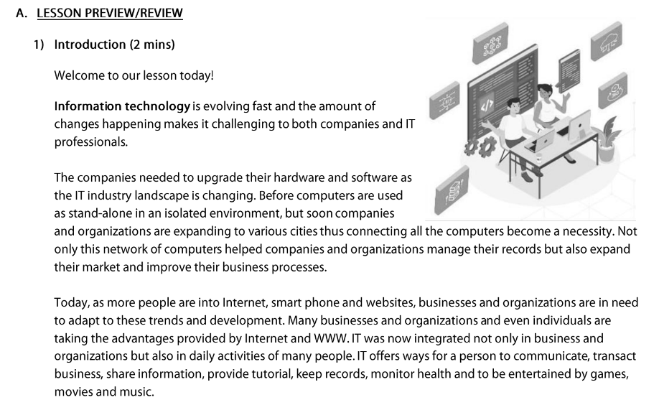

**B.MAIN LESSON**

1. Activity 2: Content Notes

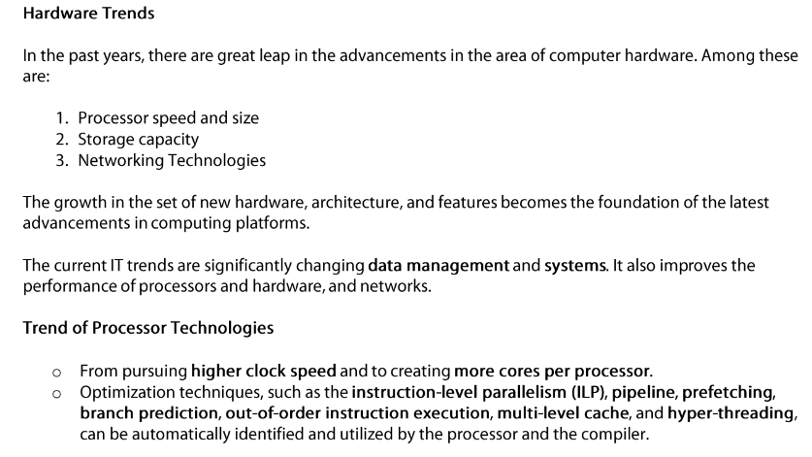

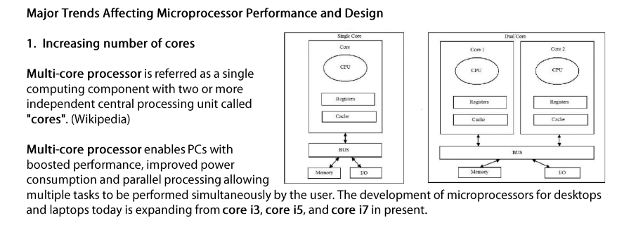

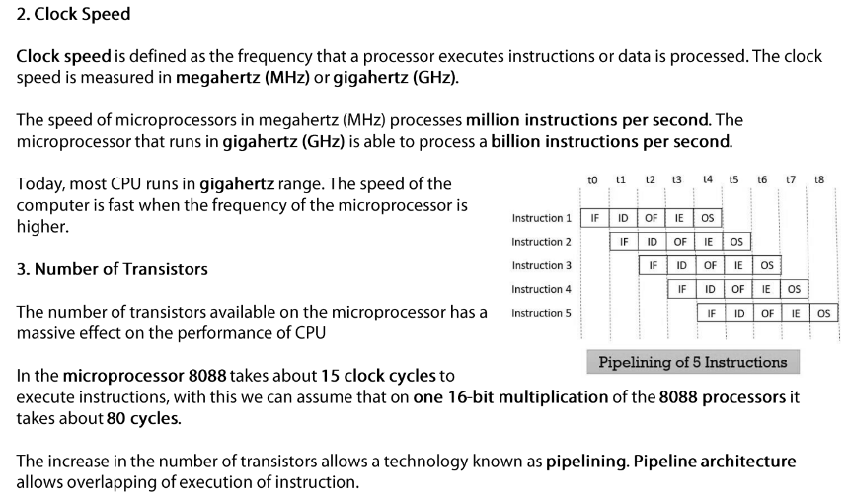

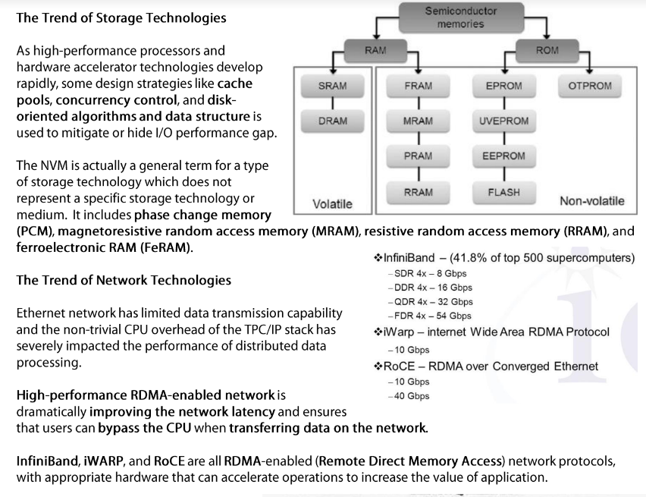

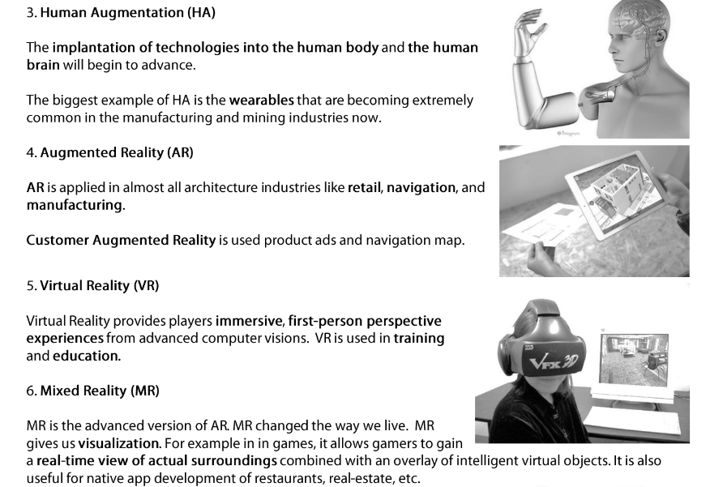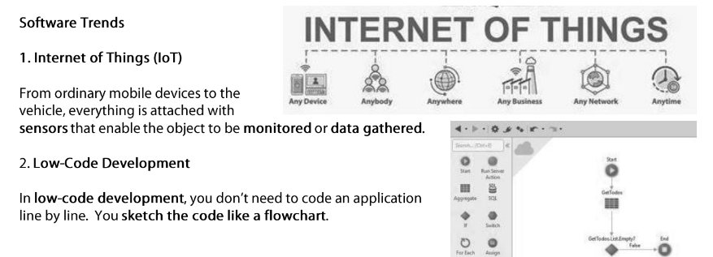

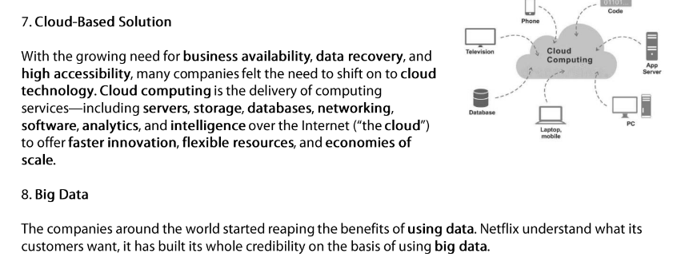

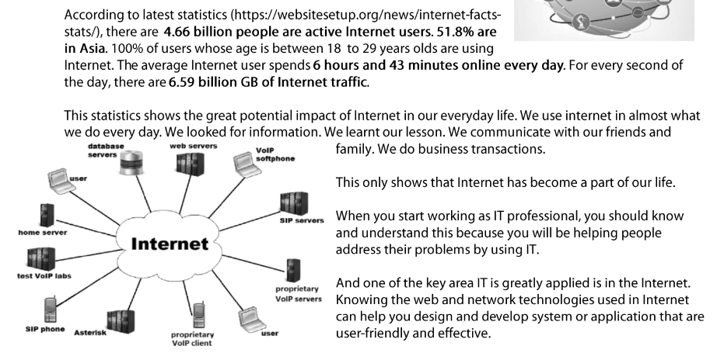

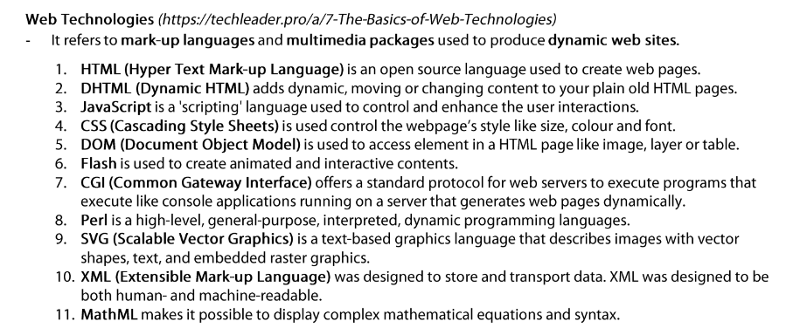

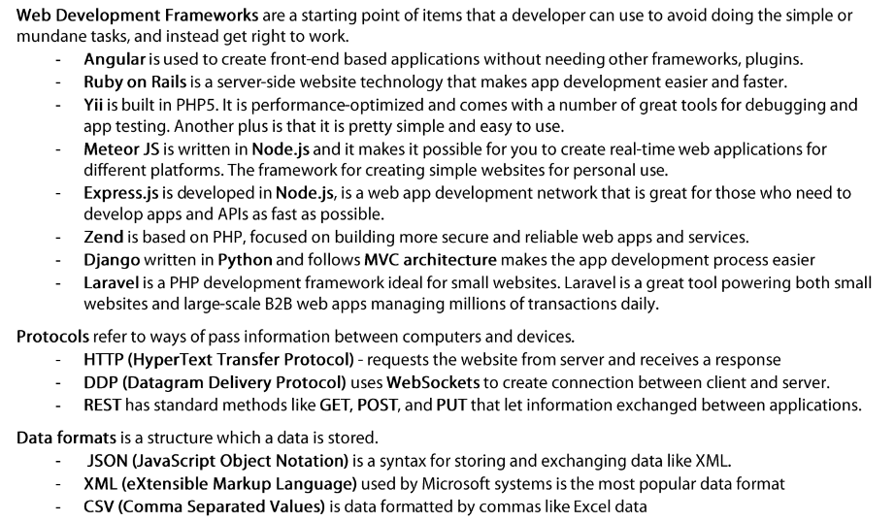

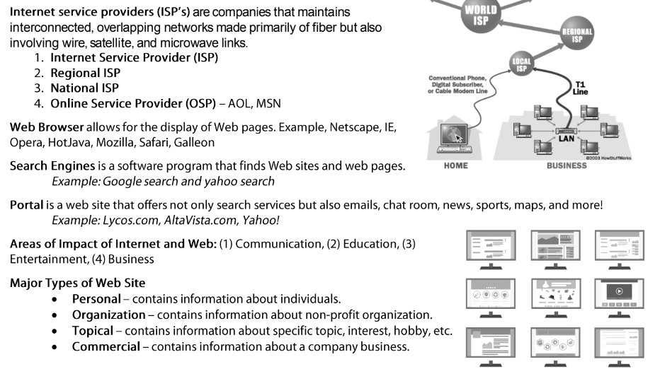

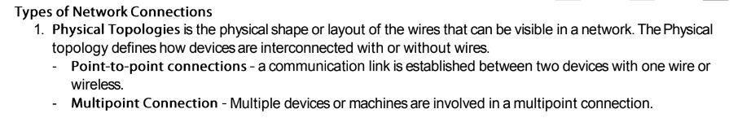

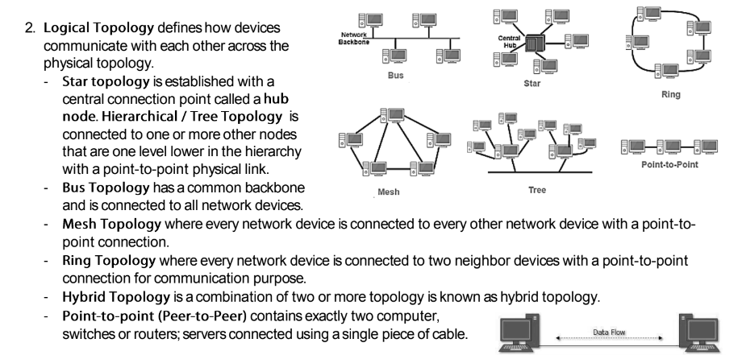

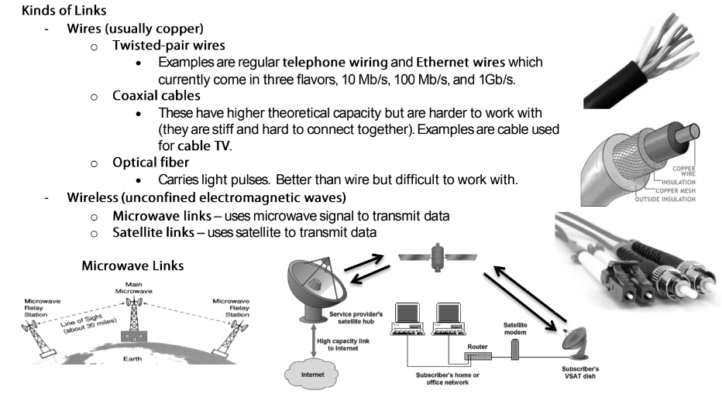

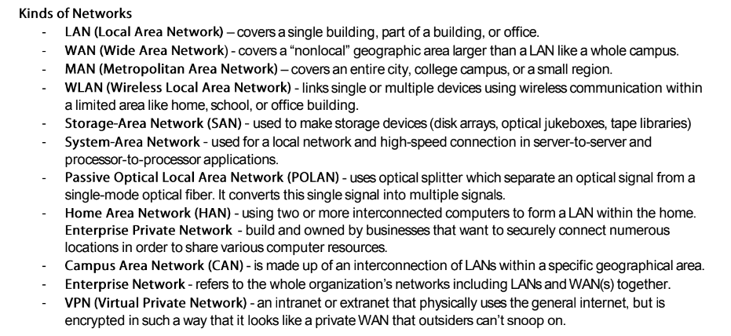

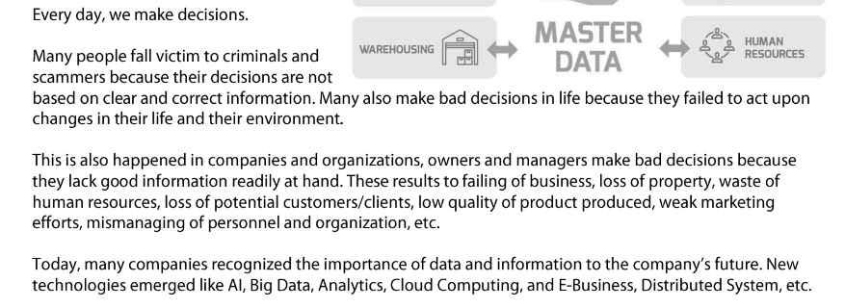

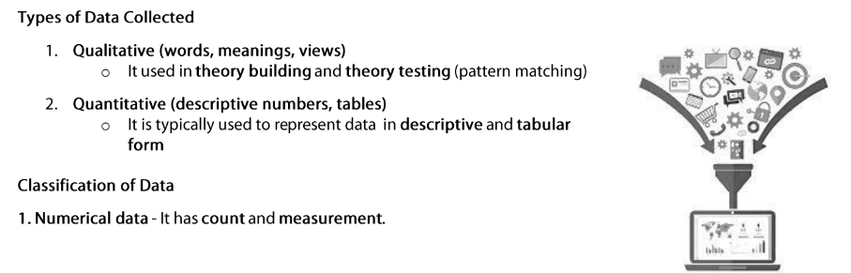

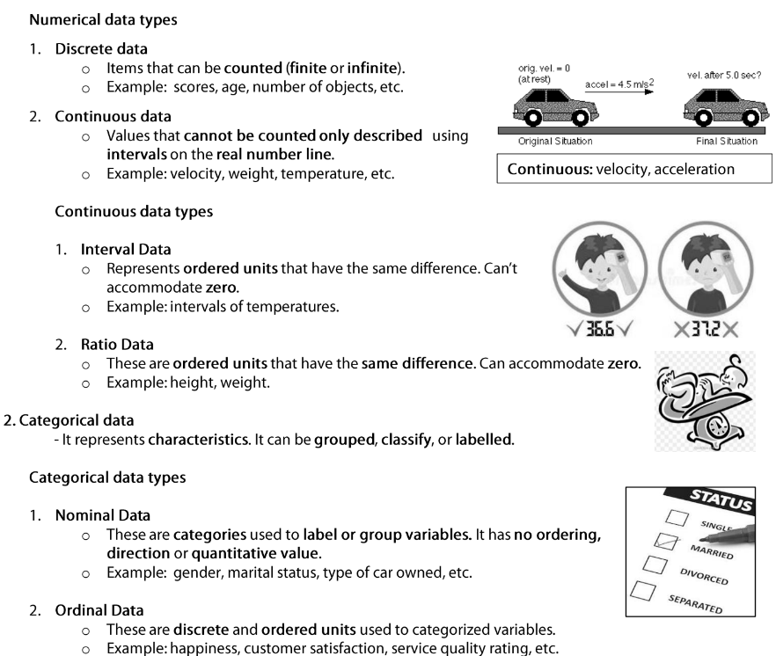

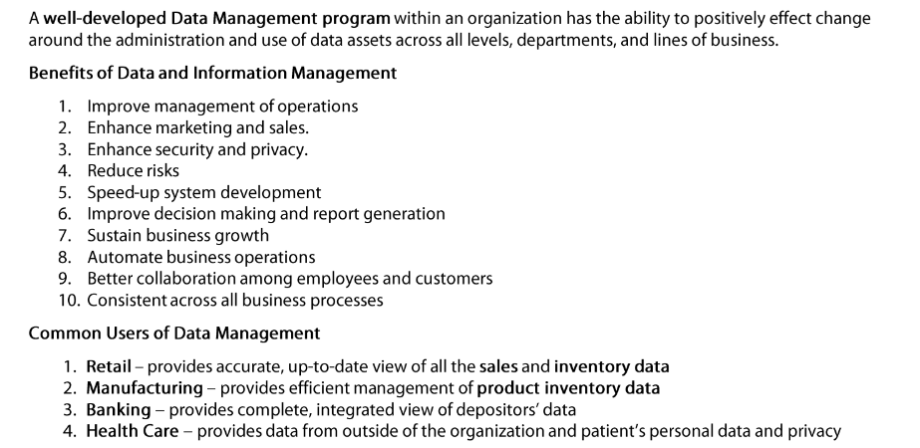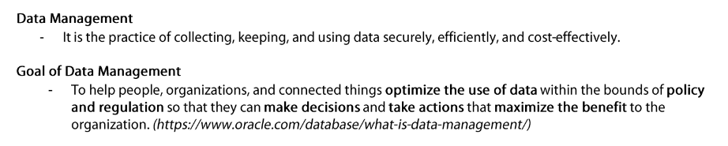

***For Skill Building Activity and Check Your Understanding, please refer to the CHECK part in the Google Classroom***

**C. LESSON WRAP-UP**

1. Activity 6: Thinking about Learning (5 mins)
2. Work Tracker

You are done with this session! Let’s track your progress. Shade the session number you just completed.



1. Think about your Learning
   * + 1. What was the most useful or the most meaningful thing you learned on this topic?

_______________________________________________________________________________________________________________________________________________________________________________________________________________________________________

* + - 1. In today’s lesson, what was least clear to you?

_______________________________________________________________________________________________________________________________________________________________________________________________________________________________________