TicketHub — AWS Deployment Guide (Step by Step)
This guide explains how to deploy the TicketHub solution to AWS. The architecture is two free-tier EC2 instances - one for the Node.js + React application and one for MongoDB - provisioned with Terraform and driven by GitHub Actions. There are two paths: (A) the automated GitHub CI/CD path, and (B) a manual Terraform path from your own machine. Both end with the same running stack.

Architecture overview
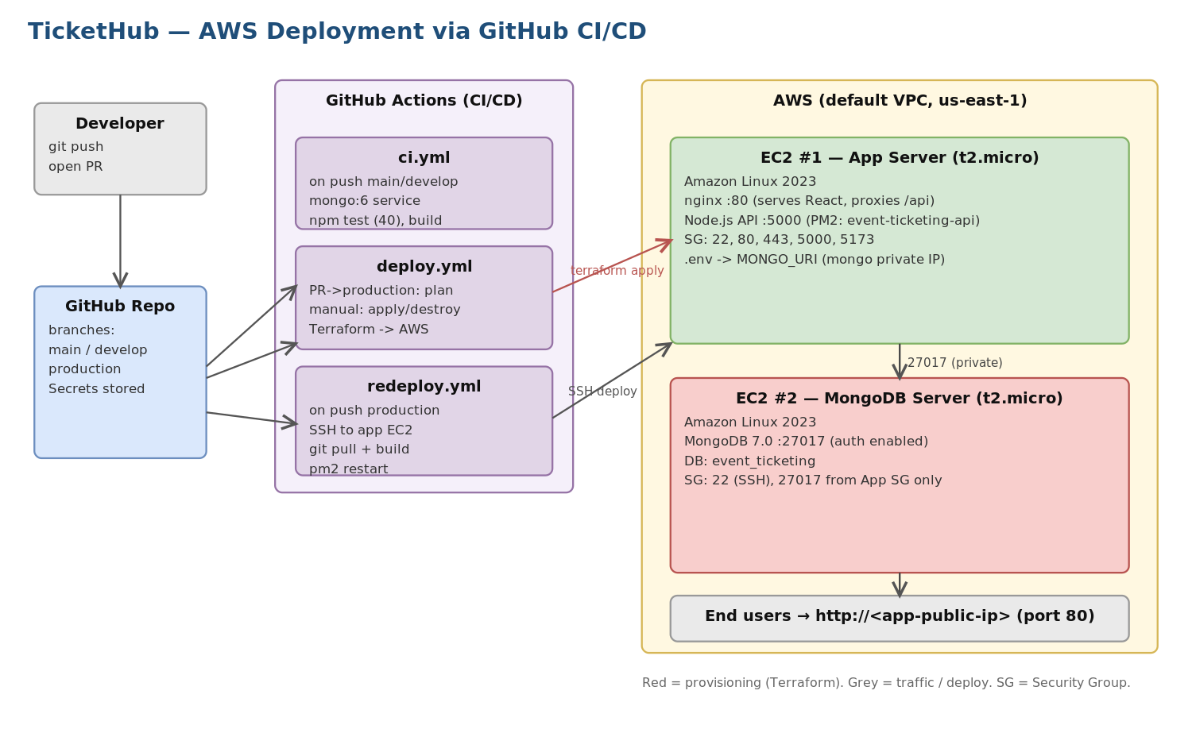
Figure 1 - Deployment architecture and CI/CD flow
The MongoDB instance is private: its port 27017 is only reachable from the app server's security group, never the public internet. The app server runs nginx on port 80 (serving the built React app and proxying /api to the Node API on port 5000, kept alive by PM2). Terraform injects MongoDB's private IP into the app server's backend .env automatically.

Prerequisites (one-time)
Before any deployment, set these up once:
- An AWS account with an IAM user that has programmatic access and permissions for EC2 and VPC.
- An EC2 Key Pair created in the us-east-1 region (EC2 -> Key Pairs -> Create). Download the .pem file; you will need its name and contents.
- Terraform >= 1.6 and the AWS CLI installed locally (only needed for Path B).
- Your GitHub repository pushed, with the repo URL matching the github_repo value used by Terraform.

Path A - Deploy with GitHub CI/CD (recommended)

Step 1 - Add the GitHub secrets
In your repository: Settings -> Secrets and variables -> Actions -> New repository secret. Add each of these (the workflows read them by name):
GitHub Secret | What it is
AWS_ACCESS_KEY_ID | IAM access key for an account with EC2/VPC permissions
AWS_SECRET_ACCESS_KEY | IAM secret key matching the above
AWS_KEY_PAIR_NAME | Name of the EC2 key pair you created in us-east-1 (for SSH)
MONGO_PASSWORD | Password for the MongoDB app/admin user (injected into Terraform)
JWT_SECRET | Secret used by the Node.js backend to sign JWTs
EC2_APP_HOST | Public IP of the app EC2 (used by redeploy.yml SSH)
EC2_SSH_KEY | Private key (.pem contents) for SSH into the app EC2

Step 2 - Create the production environment
In Settings -> Environments, create an environment named production. The deploy/destroy jobs reference it, and you can add a required-reviewer rule here so infrastructure changes need approval.

Step 3 - Verify the app code passes CI
Push to main (or open a PR). The ci.yml workflow installs dependencies, starts a temporary MongoDB service, runs the 40 backend unit tests and builds the frontend. Confirm it is green before provisioning.

Step 4 - Review the infrastructure plan
Open a Pull Request targeting the production branch. The deploy.yml workflow runs terraform plan and posts the full plan as a comment on the PR so you can review exactly what will be created (2 EC2 instances + 2 security groups).

Step 5 - Provision the servers (Terraform apply)
Go to the Actions tab -> select "AWS Infrastructure CI/CD" -> Run workflow -> set action = apply. This runs terraform apply, creates both EC2 instances, and prints the outputs (public IPs, SSH commands, frontend/API URLs) to the run summary. The user-data bootstrap scripts then automatically: install MongoDB 7.0 with auth; install Node 20, PM2 and nginx; clone the repo; write the backend .env; run npm install and npm run seed; start the API under PM2; build the React app; and configure the nginx reverse proxy.
Provisioning + bootstrap takes roughly 3-5 minutes. Copy the app server public IP from the run summary.

Step 6 - Ship code updates (continuous deployment)
After the infrastructure exists, every push to the production branch triggers redeploy.yml, which SSHes into the app EC2 and runs: git reset --hard origin/production, reinstall backend deps, rebuild the frontend into nginx, and pm2 restart event-ticketing-api. No re-provisioning needed.
# What redeploy.yml runs on the app server:
cd ~/app
git fetch origin production && git reset --hard origin/production
cd backend && npm install --production && cd ..
cd frontend && npm install && VITE_API_URL=/api npm run build
sudo cp -r dist/* /usr/share/nginx/html/ && cd ..
pm2 restart event-ticketing-api && pm2 status

Path B - Deploy manually with Terraform
If you prefer to provision from your own machine instead of GitHub Actions:

Step 1 - Configure AWS and the key pair
aws configure # enter Access Key, Secret, region us-east-1, json
# place your key pair locally and lock it down:
mv ~/Downloads/event-ticketing-key.pem ~/.ssh/
chmod 400 ~/.ssh/event-ticketing-key.pem

Step 2 - Set your variables
In the terraform/ folder, create terraform.tfvars with at least your key pair name and the repo URL (other values have defaults in variables.tf):
# terraform/terraform.tfvars
key_pair_name = "event-ticketing-key"
github_repo = "https://github.com/<you>/event-ticket.git"
mongo_password = "<strong-password>"
jwt_secret = "<strong-secret>"
environment = "production"

Step 3 - Init, plan, apply
cd terraform/
terraform init # downloads the AWS provider
terraform plan # preview the 2 EC2s + security groups
terraform apply # type 'yes' to create (~3-5 min)
terraform output summary # IPs, SSH commands, URLs

Step - Verify the deployment
Open the app in a browser and check the services on the instances:
# In a browser:
http://<app-public-ip> # React frontend (nginx :80)
http://<app-public-ip>:5000 # Node API (direct)

# SSH into the app server:
ssh -i ~/.ssh/event-ticketing-key.pem ec2-user@<app-public-ip>
pm2 status # event-ticketing-api should be 'online'
pm2 logs event-ticketing-api
sudo systemctl status nginx

# SSH into the MongoDB server:
ssh -i ~/.ssh/event-ticketing-key.pem ec2-user@<mongodb-public-ip>
sudo systemctl status mongod
You can also run the Postman collection against http://<app-public-ip> to exercise every API end to end.

Step - Tear down (avoid charges)
Remove all AWS resources when finished. Via GitHub: Actions -> AWS Infrastructure CI/CD -> Run workflow -> action = destroy. Or locally:
cd terraform/
terraform destroy # type 'yes' (removes both EC2s + security groups)
Both instances are t2.micro (free tier, 750 hrs/month for 12 months). Stop them when idle to preserve free-tier hours.

Important note - Terraform remote state
The current configuration stores Terraform state locally, so a GitHub Actions runner starts with empty state on each run. For a robust, repeatable pipeline (where apply and destroy reliably track the same resources), add an S3 backend with a DynamoDB lock table to the terraform block. For a one-off assignment demo, the local-state apply still stands the servers up correctly; just run apply and destroy from the same place (e.g. consistently via the workflow or consistently locally).

