TicketHub — Branch Merge & CI/CD Workflow
This guide explains how to merge the per-task feature branches into the codebase and promote them to deployment, and how the CI/CD pipeline reacts at each step. The model is feature-branch development with environment promotion: feature branches are integrated into main (where Continuous Integration runs), and main is then promoted to production (where Continuous Deployment runs).

Pipeline flow
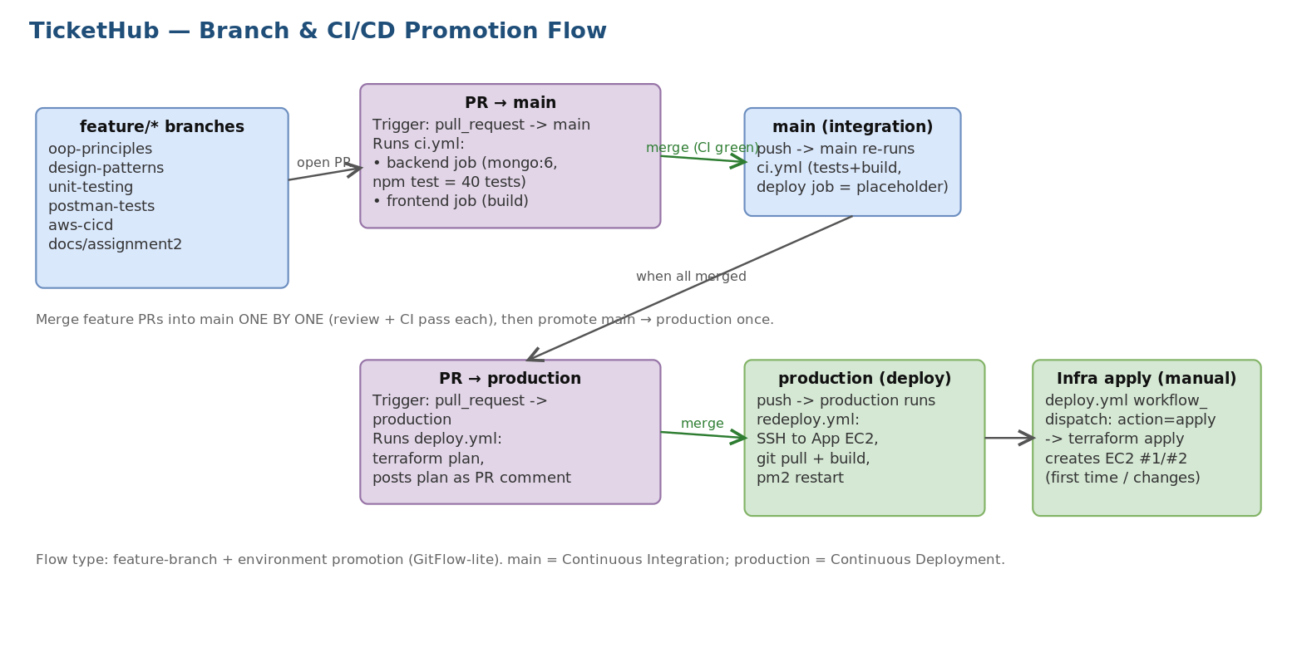
Figure 1 - Branch and CI/CD promotion flow
Branch roles: feature/* hold one task each; main is the integration branch (CI gate); production is the deployment branch (triggers the app redeploy). Infrastructure (the two EC2s) is created/updated by a separate manual Terraform apply.

Which workflows run, and when
Three GitHub Actions workflows make up the pipeline. They are wired to different branch events:
Workflow | Triggered by | What it does
ci.yml (CI/CD Pipeline) | PR to main; push to main/develop | Backend job (spins mongo:6, runs the 40 unit tests) + frontend job (build, upload dist). This is the quality gate.
deploy.yml (AWS Infra CI/CD) | PR to production; manual workflow_dispatch | On PR: terraform plan, posts plan as a PR comment. Manual apply/destroy provisions or tears down the two EC2s.
redeploy.yml (Redeploy App) | push to production; manual | SSH into the App EC2, git pull production, rebuild frontend, pm2 restart the API.

Step-by-step: merge each feature branch into main
Merge the branches one at a time, in dependency order, so each pull request shows a clean, reviewable diff and CI passes. Recommended order: oop-principles, design-patterns, unit-testing, then postman-tests, aws-cicd, docs/assignment2.
- Push the branch: git push -u origin feature/oop-principles.
- Open a Pull Request with base = main, compare = feature/oop-principles (GitHub shows a 'Compare & pull request' button, or use the gh CLI).
- CI runs automatically. Because the PR targets main, ci.yml fires: the backend job starts a temporary MongoDB and runs the 40 unit tests; the frontend job builds the React app. Both must be green.
- Review the diff and the green checks, then click 'Merge pull request' (squash or merge commit). Merging pushes to main, which re-runs ci.yml on main.
- Repeat for the next branch. For the stacked code branches (design-patterns, then unit-testing), merge them in order so the tests have the code they exercise. The independent branches (postman-tests, aws-cicd, docs) can be merged any time.
Tip: only the task's own files were committed to each branch, so each PR is small. Do not add the ~66 CRLF-only files.

Same thing with the GitHub CLI (optional script)
If you have the gh CLI authenticated, you can create and merge the PRs from the terminal:
for b in feature/oop-principles feature/design-patterns feature/unit-testing \
feature/postman-tests feature/aws-cicd docs/assignment2; do
git push -u origin "$b"
gh pr create --base main --head "$b" --fill
gh pr merge "$b" --merge --delete-branch # waits for required checks if set
done

Step-by-step: promote main to production (deploy)
Once every feature PR is merged into main and CI is green on main, promote main to production. This is the release step.
- Open a Pull Request with base = production, compare = main.
- deploy.yml runs on this PR: it executes terraform plan and posts the full plan as a comment, so you can review what (if any) infrastructure changes will happen before deploying.
- Review and merge the PR. The push to production triggers redeploy.yml, which SSHes into the App EC2, pulls the production branch, rebuilds the frontend, and restarts the API under PM2 - the new code is live.
- First-time infrastructure only: if the EC2 servers do not exist yet, run the infrastructure apply once - Actions -> AWS Infrastructure CI/CD -> Run workflow -> action = apply. After the servers exist, ordinary code releases just need the main -> production merge (redeploy.yml handles the rest).
# CLI equivalent of the promotion PR:
git push origin main
gh pr create --base production --head main \
--title 'Release: assignment-2 work' --body 'Promote integrated main to production'
# review the terraform plan comment, then:
gh pr merge --merge # push to production -> redeploy.yml runs

One-time reconciliation note
In the current repo main and production have diverged (main is ahead by 13 commits, production by 2). Before the first promotion, sync them so the main -> production PR is clean: merge production's 2 commits back into main (git checkout main; git merge origin/production; resolve any conflict; push). After that, main becomes a strict superset and future promotions are straightforward.

Summary of the pipeline flow used
The project uses a feature-branch + environment-promotion flow (a lightweight GitFlow): developers work on feature/* branches; pull requests into main run Continuous Integration (ci.yml - tests and build) as the merge gate; a pull request from main into production runs an infrastructure plan (deploy.yml) for review; and merging into production runs Continuous Deployment (redeploy.yml - SSH pull, build, pm2 restart). Infrastructure provisioning (Terraform apply) is a deliberate manual gate so servers are only created or changed on purpose.

