3.2 Implementation using OOP Principles
This section shows the specific backend code that implements each required Object-Oriented Programming concept in TicketHub, with a justification for each. The OOP design lives in the domain layer (backend/domain/), which models accounts as a class hierarchy: a base User with Admin, Member and Guest subclasses, created through UserFactory.
OOP concept | Where in the backend code | Why it matters
Classes & Objects | domain/User.js (base class); objects built by domain/UserFactory.js | Represents real things (User, Admin, Member, Guest) as self-contained types with their own data and behaviour.
Inheritance | domain/Admin.js, domain/Member.js, domain/Guest.js all extend domain/User.js | Admin and Member reuse User's code and only add or change what differs - no duplication.
Encapsulation | Private #id / #email / #role fields and getters in domain/User.js | Internal state is hidden; callers use a clean interface (maskedEmail, getPermissions) and cannot corrupt it.
Polymorphism (overriding) | getPermissions() / canManageEvents() overridden in Admin & Member | The same call behaves differently per object type, so calling code stays simple.
Polymorphism (overloading) | greet(...args) in domain/User.js | One method name handles different argument sets, mirroring method overloading.

Domain class diagram
The diagram below shows the OOP domain layer: an abstract User base class with private state and behaviour, the Admin, Member and Guest subclasses that inherit and override it, and the UserFactory that creates the correct concrete object at runtime. The editable source is provided as TicketHub_OOP_Class_Diagram.drawio (open at app.diagrams.net).
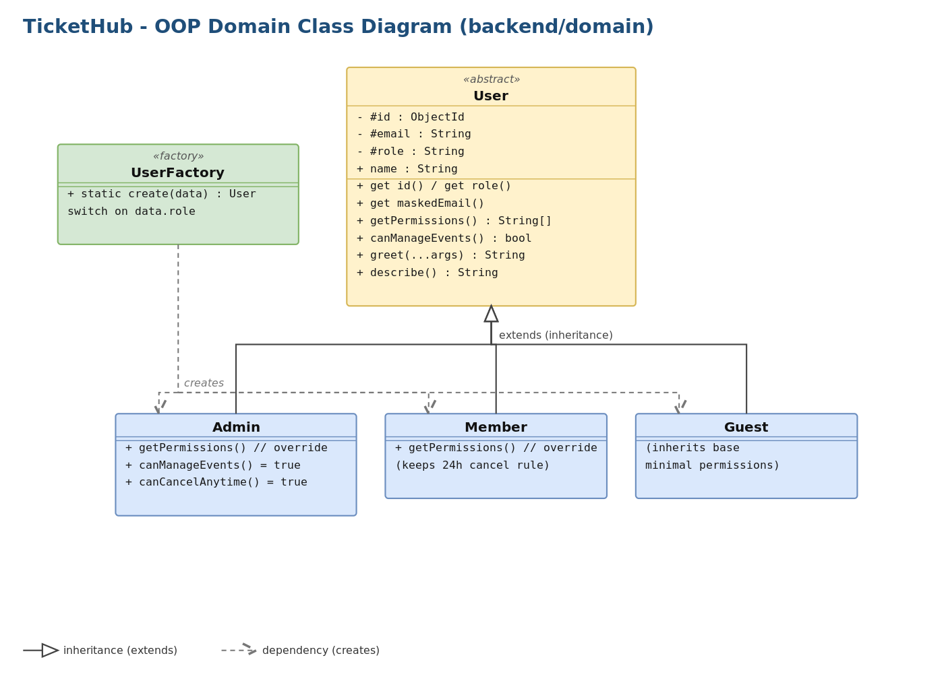
Figure 1 - TicketHub OOP domain class hierarchy

1. Classes & Objects
A class is a blueprint; an object is an instance of it. User is the base class that bundles a user's data with its behaviour. Concrete objects are produced by the factory, so callers receive a ready, correctly typed object.
// backend/domain/User.js
class User {
constructor({ id = null, name = 'Guest', email = '', role = 'guest' } = {}) {
this.name = name;
this.#id = id; this.#email = email; this.#role = role;
}
describe() {
return `${this.name} <${this.maskedEmail}> - role=${this.role}`;
}
}

// Creating objects (instances) via the factory:
const admin = UserFactory.create({ name: 'Asha', role: 'admin' });
const member = UserFactory.create({ name: 'Ravi', role: 'user' });
Why it matters: bundling state and behaviour into one type keeps related logic together, makes the code readable, and lets the rest of the system work with simple objects instead of loose variables.

2. Inheritance
Admin, Member and Guest extend User, reusing its constructor and methods and overriding only what differs. super() reuses the parent behaviour.
// backend/domain/Admin.js
class Admin extends User {
constructor(props = {}) { super({ ...props, role: 'admin' }); }
getPermissions() {
return [...super.getPermissions(), // reuse base permissions
'manage_events', 'manage_venues', 'manage_users', 'view_analytics'];
}
canManageEvents() { return true; }
}

// backend/domain/Member.js
class Member extends User {
constructor(props = {}) { super({ ...props, role: 'user' }); }
getPermissions() {
return [...super.getPermissions(), 'book_tickets', 'cancel_own_booking'];
}
}
Why it matters: shared logic is written once in User and reused. Adding a new account type means writing only its differences, not copying the whole class.

3. Encapsulation
Sensitive fields are declared as truly private (#) fields and exposed only through controlled accessors. Outside code can read a masked email but can never touch the raw value or the role directly.
// backend/domain/User.js
class User {
#id; // private - unreachable from outside the instance
#email;
#role;

get id() { return this.#id; }
get role() { return this.#role; }

get maskedEmail() { // controlled, read-only view
if (!this.#email) return '';
const [local, domain] = this.#email.split('@');
return `${local.slice(0, 2)}***@${domain || ''}`;
}
}
Why it matters: hiding internal state prevents accidental or malicious changes and lets the class guarantee its own rules. The public interface stays small and stable even if internals change.

4. Polymorphism - method overriding
The same method call resolves to different behaviour depending on the object's actual type. Calling getPermissions() on an Admin, a Member or a Guest returns a different result, with no type checks in the caller.
// Base default - backend/domain/User.js
getPermissions() { return ['view_public_events']; }
canManageEvents() { return false; }

// Overridden in Admin -> full permission set, canManageEvents() === true
// Overridden in Member -> booking permissions, canManageEvents() === false

// Same call, different behaviour by type:
admin.getPermissions(); // ['view_public_events','manage_events', ...]
member.getPermissions(); // ['view_public_events','book_tickets', ...]
guest.getPermissions(); // ['view_public_events']
Used in backend/controllers/authController.js (getMe), where UserFactory.create(req.user).getPermissions() returns the role-appropriate set polymorphically.

5. Polymorphism - method overloading (simulated)
JavaScript has no true overloading, so one method varies its behaviour by the number/type of arguments - the same effect achieved the JS way.
// backend/domain/User.js
greet(...args) {
if (args.length === 0) return `Hello, ${this.name}.`;
if (args.length === 1) return `Hello ${args[0]}, I am ${this.name}.`;
const [other, formal] = args;
return formal ? `Good day ${other}. I am ${this.name}.`
: `Hey ${other}! It's ${this.name}.`;
}

user.greet(); // 'Hello, Ravi.'
user.greet('Sam'); // 'Hello Sam, I am Ravi.'
user.greet('Sam', true); // 'Good day Sam. I am Ravi.'
Why it matters: one well-named method handles several call styles, keeping the public interface small and intuitive.

Summary
All four required OOP concepts are implemented in the domain layer: classes and objects (User and its instances), inheritance (Admin / Member / Guest extend User), encapsulation (private # fields with accessors), and polymorphism through both overriding (getPermissions, canManageEvents) and simulated overloading (greet). Automated coverage lives in backend/test/domain.test.js.

