Step 5 - Functional Testing (Unit Testing)
This section documents the unit tests that validate each backend functionality of TicketHub. Tests are written with Mocha (test runner) and Chai (assertions) and run against the pure logic layers - the booking service, the OOP domain classes and the design-pattern modules - so they execute in milliseconds without a database or HTTP server. This isolation is what makes them true unit tests: each one exercises a single function or class in isolation.
How to run: from the backend folder, run npm test (configured as "mocha --recursive --timeout 5000"). The complete suite contains 40 test cases across four files and all pass. The sections below give a pass screenshot from the terminal for each backend functionality.

Test coverage summary
Backend functionality | Test file | Cases | Validates | Result
Create booking (validate & price) | test/bookingService.test.js | 6 | Pricing, availability, guards | PASS
Seat inventory (deduct / restore) | test/bookingService.test.js | 2 | Seat counts stay correct | PASS
Booking orchestration (Facade) | test/newPatterns.test.js | 3 | End-to-end booking flow | PASS
Payment processing (Adapter) | test/patterns.test.js | 3 | Stripe / PayPal uniform charge | PASS
Cancel booking (Strategy) | test/patterns.test.js | 4 | Role-based cancel rules | PASS
Pricing add-ons (Decorator) | test/newPatterns.test.js | 4 | Fees / promo stacking | PASS
Notifications (Observer) | test/newPatterns.test.js | 4 | Event broadcast to observers | PASS
Clone event (Prototype) | test/newPatterns.test.js | 2 | Deep clone, reset sold | PASS
Analytics access (Proxy) | test/newPatterns.test.js | 3 | Admin-only access control | PASS
Logging (Singleton) | test/patterns.test.js | 2 | Single shared logger | PASS
User roles & domain (OOP) | test/domain.test.js | 7 | Encapsulation/inheritance/poly | PASS
40 unit tests across 4 files - all passing

Full suite run
Running the entire suite with npm test produces the following result:
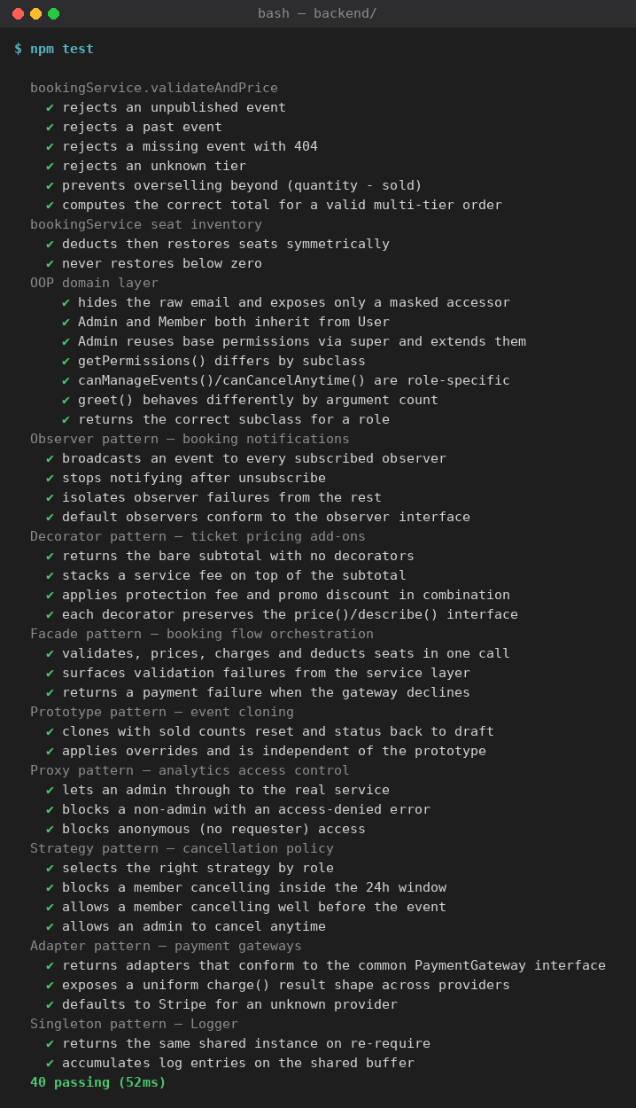
Terminal output - full suite (40 passing)
Per-functionality results

1. Create booking (validate & price)
Validates the core booking logic in bookingService.validateAndPrice: it blocks unpublished or past events, unknown ticket tiers and overselling, and computes the correct total for a valid multi-tier order.
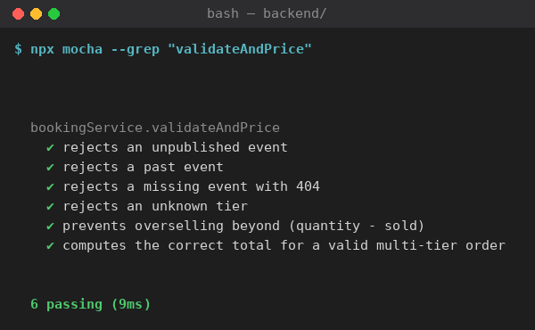
Terminal output — 1. Create booking (validate & price) (PASS)

2. Seat inventory (deduct / restore)
Confirms applySeatDeduction and restoreSeats keep seat counts correct and symmetric, and that restoring never drives the sold count below zero.
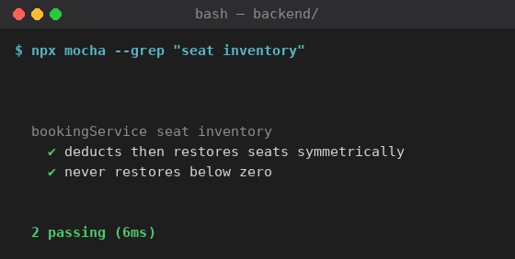
Terminal output — 2. Seat inventory (deduct / restore) (PASS)

3. Booking orchestration (Facade)
Validates BookingFacade.placeBooking end-to-end: it validates, prices, charges and deducts seats in one call, surfaces validation failures, and returns a payment failure when the gateway declines.
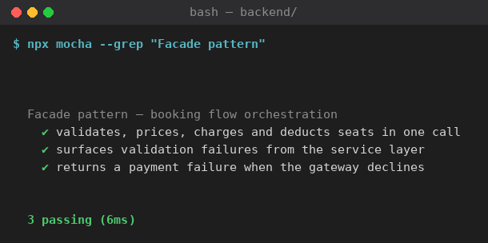
Terminal output — 3. Booking orchestration (Facade) (PASS)

4. Payment processing (Adapter)
Confirms the Stripe and PayPal adapters conform to one common PaymentGateway interface, return a uniform charge() result, and default to Stripe for an unknown provider.
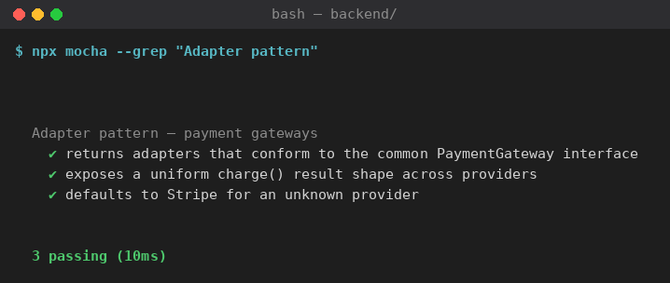
Terminal output — 4. Payment processing (Adapter) (PASS)

5. Cancel booking (Strategy)
Validates the cancellation policy: members are blocked inside the 24-hour window, allowed well before the event, and admins may cancel at any time.
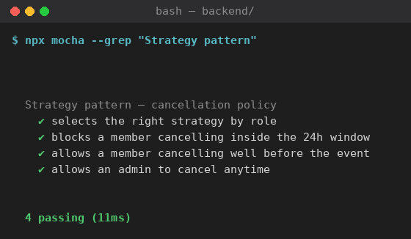
Terminal output — 5. Cancel booking (Strategy) (PASS)

6. Pricing add-ons (Decorator)
Confirms the pricing decorators correctly stack a service fee, ticket protection and a promo discount on top of the subtotal while preserving the price()/describe() interface.
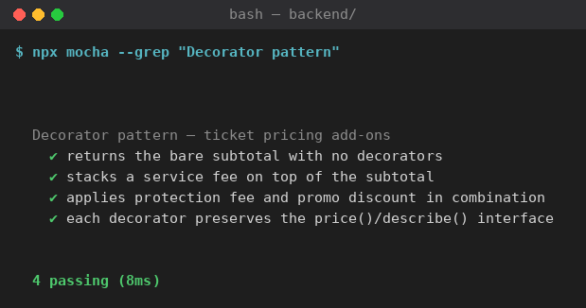
Terminal output — 6. Pricing add-ons (Decorator) (PASS)

7. Notifications (Observer)
Validates the booking notifier broadcasts events to every subscribed observer, stops after unsubscribe, and isolates a failing observer from the rest.
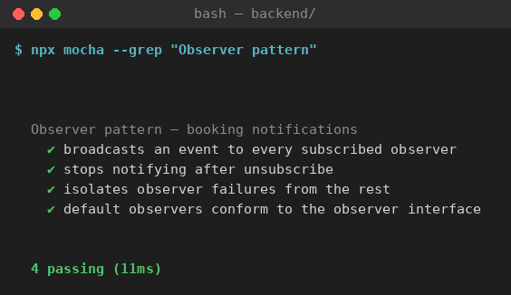
Terminal output — 7. Notifications (Observer) (PASS)

8. Clone event (Prototype)
Confirms EventPrototype.clone produces a deep, independent copy with sold counts reset and status set to draft, and applies overrides correctly.
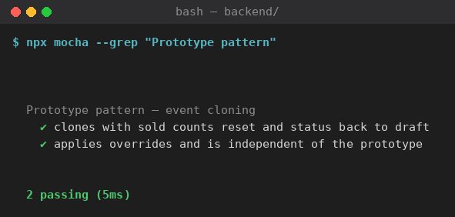
Terminal output — 8. Clone event (Prototype) (PASS)

9. Analytics access (Proxy)
Validates the analytics proxy lets an admin through to the real service and blocks both non-admins and anonymous callers with a 403 access-denied error.
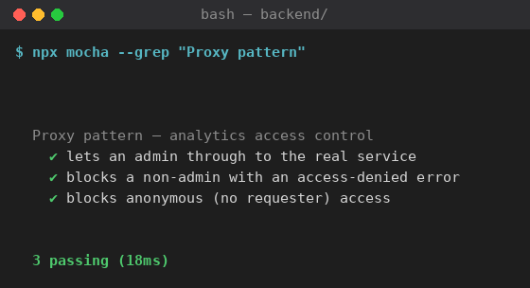
Terminal output — 9. Analytics access (Proxy) (PASS)

10. Logging (Singleton)
Confirms the Logger returns the same shared instance on every require and accumulates entries on one shared buffer.
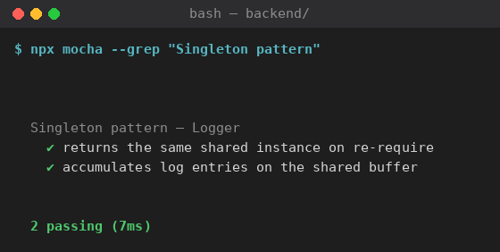
Terminal output — 10. Logging (Singleton) (PASS)

11. User roles & domain (OOP)
Validates the OOP domain layer: encapsulation (masked email, private fields), inheritance (Admin/Member/Guest extend User), polymorphism (overriding and overloading) and the UserFactory.
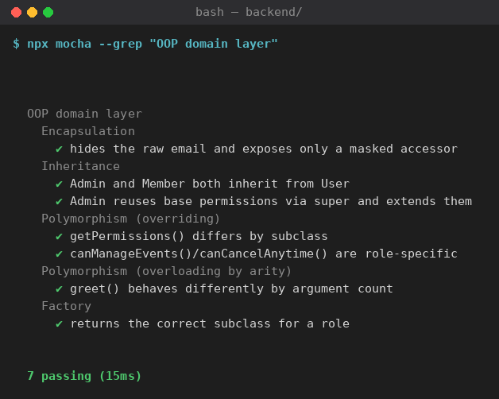
Terminal output — 11. User roles & domain (OOP) (PASS)

Conclusion
Every backend functionality is covered by passing unit tests (40/40). The pure-logic design lets these tests run fast and deterministically, giving confidence that the core booking, pricing, payment, cancellation, access-control and domain behaviours all operate correctly.

