**VISUAL CRYPTOGRAPHY**

A Dissertation Submitted

In partial fulfillment of the requirement for the award of the degree of

**Bachelor of Technology**

in

**Computer Science**

**By**

**A.Sravan A.Phani Sekhar Reddy**

**(12N31A0501) (12N31A0520)**

**Hanuman Prasad Asawa C.Sujith Kumar**

**(12N31A0519) (12N31A0545)**

Under the esteemed guidance of

**Kamal**

**Associate Professor**

**C.S.E Department**

**MRCET**



**Department of COMPUTER SCIENCE AND ENGINEERING**

**MALLA REDDY COLLEGE OF ENGINEERING AND TECHNOLOGY**

**Approved by AICTE & Affiliated to JNTU-H**

**Accredited by NBA, New Delhi, ISO 9001:2008 Certified Institution**

**Maisammaguda, Dulapally, Kompally, Secunderabad-500010 2015-16**

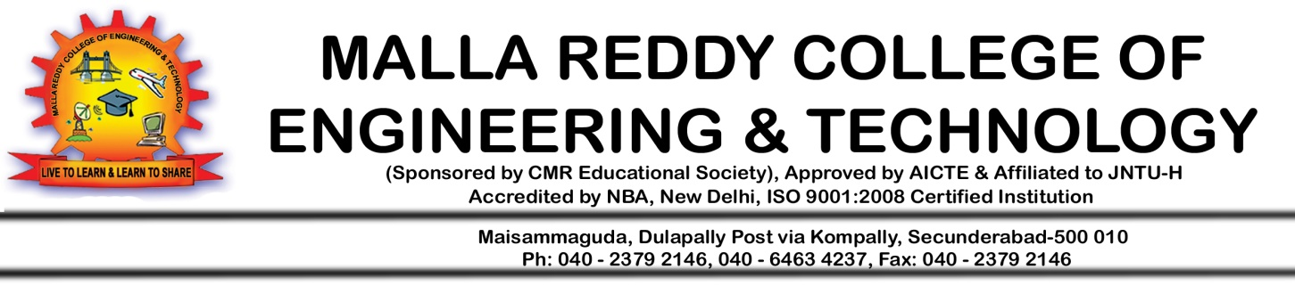

**DEPARTMENT OF COMPUTER SCIENCE AND ENGINEERING**

CERTIFICATE

This is to certify that major project entitled “Visual Cryptography” is a bonafide, work done by A.Sravan (12N31A0501), A.Phani Sekhar Reddy (12N31A0520) and Hanuman (12N31A0519) under my guidance and supervision have done the project and it is submitted to Jawaharlal Nehru Technological University, Hyderabad in fulfillment of requirements of Major Project in Computer Science and Engineering during the academic year 2015-16.

**Mv.Kamal(Associate Professor)**  **Prof.D.Sujatha**

**INTERNAL GUIDE HEAD OF DEPARTMENT**

EXTERNAL EXAMINER

-

**DECLARATION**

I hereby declare that the project entitled **“Visual Cryptography”** is submitted in the partial fulfillment of the requirements for the award of degree of Bachelor of technology in **Computer Science and Engineering** from **Malla** **Reddy College of Engineering and Technology** affiliated to **Jawaharlal Nehru** **Technology University, Hyderabad**. The results embodied in this project have not been submitted to any other university or Institution for the award of any degree or diploma. The work related to the project is solely carried out by the below stated team members under the guidance of the faculty and the **Department of Computer Science and** **Technology**.

A.Sravan (12N31A0501)

A.Phani Sekhar Reddy (12N31A0520)

Hanuman (12N31A0519)

C.Sujith Kumar (12N31A0545)

**ACKNOWLEDGEMENT**

There are many people who helped me directly and indirectly to complete my project successfully. I would like to take this opportunity to thank one and all.

First of all I would like to express my deep gratitude towards my internal guide **Mv**.**Kamal, Associate Professor,** Department of CSE for his support in the completion of my dissertation. I wish to express my sincere thanks to **Prof D.Sujatha, HOD, Dept. of CSE** and also to our principal **Dr. V.S.K. REDDY** for providing the facilities to complete the dissertation.

I would like to thank all our faculty and friends for their help and constructive criticism during the project period. Finally, I am very much indebted to our parents for their moral support and encouragement to achieve goals.

A.Sravan (12N31A0501)

A.Phani Sekhar Reddy (12N31A0520)

Hanuman (12N31A0519)

C.Sujith Kumar (12N31A0545)