# ml_wp_template_bg_new

MarkLogic MD DHR Combined Documentation

# Change History

|  |  |  |  |
| --- | --- | --- | --- |
| Version | Date | Description | Author |
| 1.0 | 8/26/2016 | Initial Version | Guy Duplantier |
|  |  |  |  |
|  |  |  |  |
|  |  |  |  |
|  |  |  |  |
|  |  |  |  |

1

Change History 2

Introduction 4

System Overview 4

Background 4

High Level Components 4

Assumptions and Constraints 5

Assumptions and Dependencies 5

General Constraints 5

Requirements 5

ABAWD Functional Requirements 5

System Requirements 8

Operational Requirements 8

Security Requirements 8

Architecture and Design 8

System Architecture 8

ABAWD Design 9

Test 13

Test Scope 13

Test Approach 13

Test Environments 13

Test Results 13

# Introduction

This document provides an overview, requirements, architecture, design and testing information for the MD DHR Data Modernization effort.

# System Overview

## Background

The ABAWD (Able Bodied Adults without Dependents) Generator is currently an Excel based tool that is used to determine if a person is in fact an ABAWD. There is a manual process for collecting the data, filtering it, distributing it to the districts and recording the result.

The modernized ABAWD application demonstrates the capabilities of MarkLogic to automate this process using the Shared Data Repository, Web Application and the Search API.

## High Level Components

Figure 1depicts the ABAWD system architecture. The ABAWD report may be used to screen customers who are potential ABAWDs. The tool will be web based and driven from data stored in MarkLogic. Filter criteria for the report are obtained using a REST API. The report uses the basic text search capabilities of MarkLogic. Users may also save the ABAWD determination after they have screened candidates. This determination is saved in MarkLogic and displayed in the report.

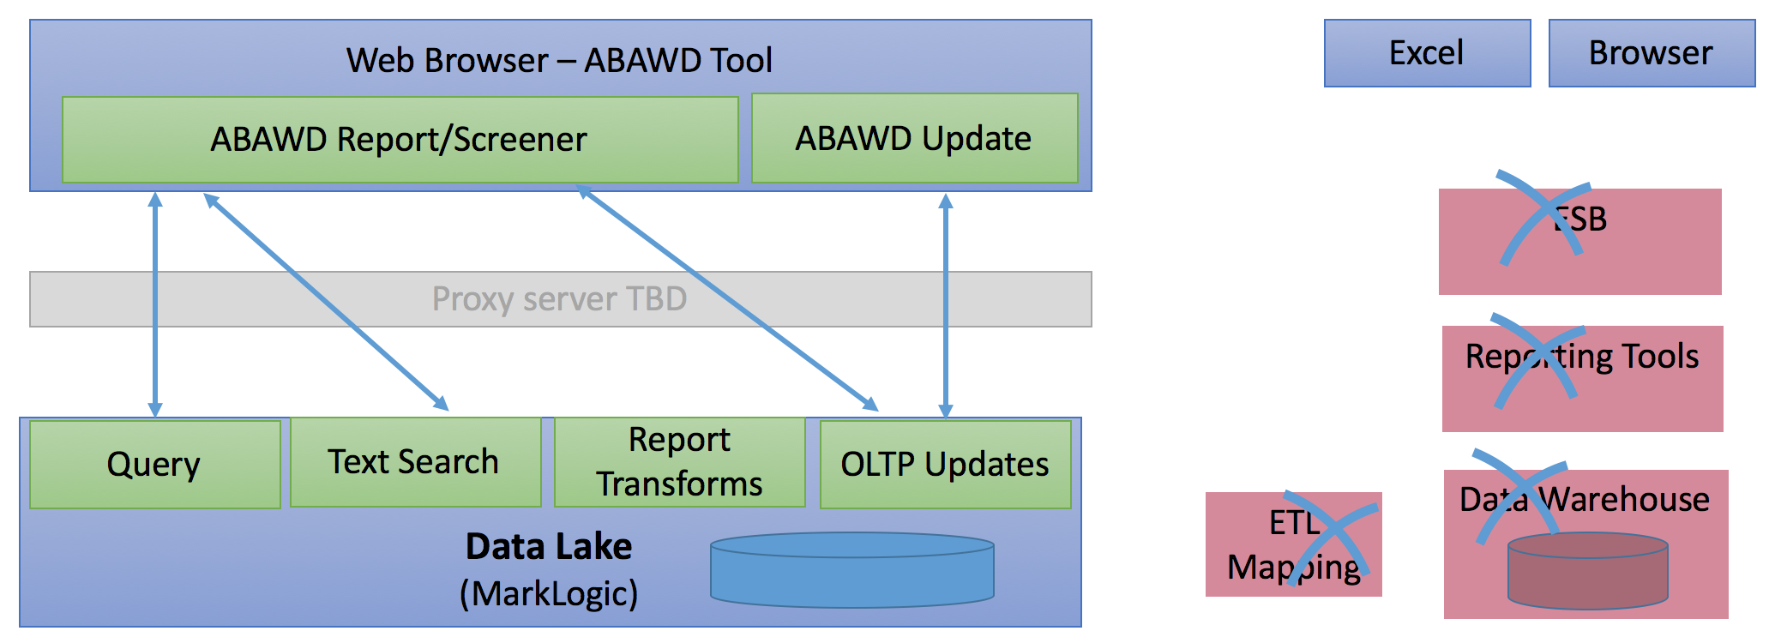

Figure 1- System Diagram(ABAWD)

# Assumptions and Constraints

## Assumptions and Dependencies

Assumptions:

* It is assumed that the MD DHR team will provide the source data from CARES in the form of a CSV similar to what the ABAWD Generator currently uses.

## General Constraints

Constraints:

* None

# Requirements

## ABAWD Functional Requirements

The table below lists the requirements for determining if a customer is an ABAWD. These criteria will be used to filter the ABAWD report. The report lists the following fields:

1. Exemption Parameters: The field for determining ABAWD status in the report
2. Summary of related policy: The policy that this requirement applies to
3. CARES FIELD: The field in the CARES system/source system
4. CARES Screen Location: The CARES screen where the CARES Field is displayed
5. Requirement: The requirement description

|  |  |  |  |  |
| --- | --- | --- | --- | --- |
| **Exemption Parameters** | **Summary of Related Policy** | **CARES Field/ Field Name** | **CARES Scree Location** | **Requirement** |
| **Age** | All SNAP (Food Stamps) Customers who are age 18-49 should be considered as potential ABAWDS | DOB | DEM 1 Screen | A customer's Age can be the first parameter used to determine if they are potentially ABAWD. Ages 0-17 and 50- are exempt from ABAWD policy. Any customer who turns 50 in the current month should be excluded (non-ABAWD/exempt) |
| **Residential District Office** | Currently customers living in the following Maryland District Offices are subject to ABAWD Requirements: 20, 21, 22, 30, 31, 32, 33, 34, 36, 60, 100, 130, 150, 151, 152, 154, 160, 161, 162, 210 \*\* \*\*This can change with high frequency, there will be a need for easy flexibility to change this parameter\*\* | DO | ADDR Screen | Customer's living in District Offices (DOs)20, 21, 22, 30, 31, 32, 33, 34, 36, 60, 100, 130, 150, 151, 152, 154, 160, 161, 162, 210 should be included as a Potential ABAWD. |
| **Pregnancy** | Customers who are pregnant are exempt from ABAWD | Pregnant - Due Date | DEM1 | Customers with pregnancy due dates in the future should not be included as a Potential ABAWD. Customers with due dates up to one year in the past should be "flagged" for contact; all other due dates in the past are to be considered potential ABAWDs (unless there is some other factor that would exempt them) |
| **Living Arrangements** | Customers who are chronically Homeless are exempt from ABAWD | Living Arrgmt | DEM 1 | Customers with the codes "HL" in the Living Arrgmt Field and "HO" on Special Circumstances Field which indicates Chronically Homeless, should not be included as a Potential ABAWD |
| **Living Arrangements** | Customers who are chronically Homeless are exempt from ABAWD | Special Circumstances | ADDR Screen | Customers with the codes "HL" in the Living Arrgmt Field and "HO" on Special Circumstances Field which indicates Chronically Homeless, should not be included as a Potential ABAWD |
| **Living Arrangements** | Customers who are living in Rehabilitation Residencies are exempt from ABAWD | Living Arrgmt | DEM 1 | Customers with the codes "RR" in the Living Arrgmt Field should be excluded (non-ABAWD/exempt) |
| **Living Arrangements** | Customers who are living in a Licensed Domicile Care setting are exempt from ABAWD | Living Arrgmt | DEM 1 | Customers with the codes "LD" in the Living Arrgmt Field should be excluded (non-ABAWD/exempt) |
| **Employment** | Working an average of 20 hours monthly meets the ABAWD requirements | Type | ERN 1 | If type = EI then the next two fields are "Earned income". User needs to see this. |
| **Employment** | Working an average of 20 hours monthly meets the ABAWD requirements | Amt | ERN 2 | Amount of Gross Earnings should be equal or greater to $217.50\*\* \*\*This parameter for the dollar amount is subject to change as the Federal Minimum Wage Changes\*\* |
| **Employment** | Working an average of 20 hours monthly meets the ABAWD requirements | Hrs | ERN 2 | Amount of Employed hours must average 20 hours for the month. Hours |
| **Self Employment** | Working a self employed average of 30 hours monthly meets the ABAWD requirements | Type | ERN 1 | Self Employment will be coded in CARES as "SE" |
| **Self Employment** | Working a self employed average of 30 hours monthly meets the ABAWD requirements | Amt | ERN 2 | Amount of Gross Earnings should be equal or greater to $217.50 \*\* \*\*This parameter for the dollar amount is subject to change as the Federal Minimum Wage Changes\*\* |
| **Self Employment** | Working a self employed average of 30 hours monthly meets the ABAWD requirements | Hrs | ERN 2 | Amount of Self Employed hours must average 30 hours for the month |
| **Unemployment Compensation** | Customers receiving Unemployment Compensation are not subject to ABAWD Requirements | Source | UINC Screen | Customers with Source Code "UC" and an unemployment compensation amount greater than $1 should not be included as a potential ABAWD |
| **Unemployment Compensation** | Customers receiving Unemployment Compensation are not subject to ABAWD Requirements | Amt 1 | UINC Screen | Customers with Source Code "UC" and an unemployment compensation amount greater than $1 should not be included as a potential ABAWD |
| **Supplemental Security Income (SSI - Social Security Benefits)** | Customers receiving SSI Benefits are not subject to ABAWD Requirements | Source | UINC Screen | Customers with Source Code "SI" and an SSI Benefit amount greater than $1 should not be included as a potential ABAWD |
| **Supplemental Security Income (SSI - Social Security Benefits)** | Customers receiving SSI Benefits are not subject to ABAWD Requirements | Amt 1 | UINC Screen | Customers with Source Code "SI" and an SSI Benefit amount greater than $1 should not be included as a potential ABAWD |
| **Social Security Disability Benefits** | Customers receiving SSDI are not subject to ABAWD Requirements | Source | UINC Screen | Customers with Source Code "SA" and an Social Security Disability Benefit amount greater than $1 should not be included as a potential ABAWD |
| **Social Security Disability Benefits** | Customers receiving SSDI are not subject to ABAWD Requirements | Amt 1 | UINC Screen | Customers with Source Code "SA" and an Social Security Disability Benefit amount greater than $1 should not be included as a potential ABAWD |
| **Disability** | Customers who are disabled are not subject to ABAWD Requirements | Exempt Reason | WORK | Customers with Exempt Reason Codes "DI" "UI" "PR" shoud not be included as a Potential ABAWD |

Figure 2 - ABAWD Requirements

## System Requirements

## Operational Requirements

## Security Requirements

## Architecture and Design

## System Architecture

The basic system architecture is similar to what was described in Figure 1 of the System Overview.

## ABAWD Design

Figure 3 depicts the data flow of ABAWD data into the Shared Data Repository as well as flow to the client applications.

ABAWD data comes from the CARES system. The data is collected monthly via SQL queries on the CARES tables. It is extracted into a CSV file. This extracted CSV is the same one used to serve the legacy ABAWD Generator.

*Note: The CSV file must be enriched with the certification period (month) prior to loading into MarkLogic.*

The CSV can reside on a local file sytem or on the DataHub server. The MarkLogic DataHub - ABAWD Load Flow, is used to load the CSV into the staging area. Once it is loaded into the staging area the ABAWD Harmonize Flow is run to put the data into a single master Person record in the DataHub Final repository. The DataHub Final repository is exposed through an API that clients may connect to.

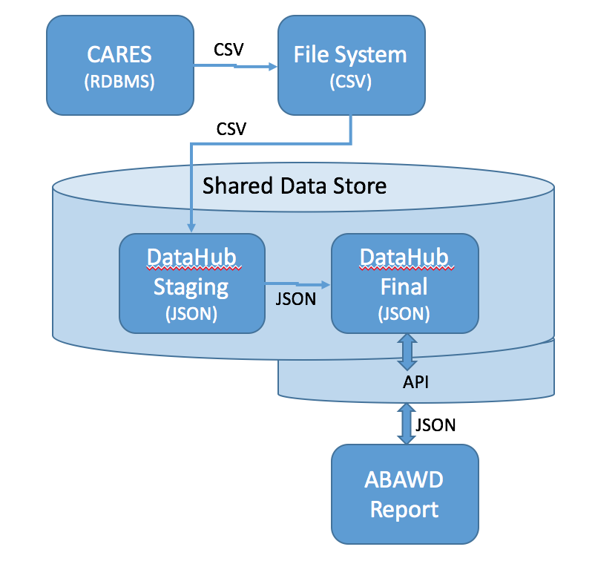

Figure - ABAWD Data Flow Diagram

**Duplicate Rows**

The CSV file extracted from CARES will include multiple rows for each Earned and Unearned Income Type and Benefit Date. We have requested a version of the CSV that eliminates duplicates but this will not come until later. In the short-term, we have resolved duplicates in the Harmonization flow by checking if the following fields are the same for a particular row: Income Type Code, Income Frequency Code, Income Amount and Income Work Hours for Earned Income. The resulting Person Document will include a list of Earned and Unearned incomes as well as summary property for Earned and Unearned income for each income type, normalized to a monthly frequency. The below figures depict the duplicate rows in the CSV (Figure 4) and what they are transformed to in the JSON document (Figure 5).

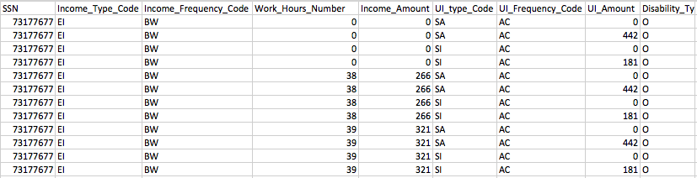

Figure 4 - Duplicate Rows in CSV (Excel view)

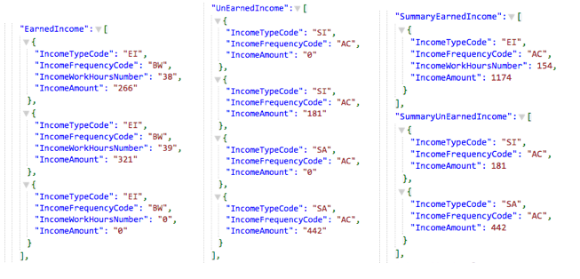

Figure 5 - Earned Income, Unearned Income, Income Summary

**Versioning**

Each time a record is imported from the CSV a new version is created and tagged with a collection for the current date. This allows unfiltered searches to include previous versions (Figure 6). It also allows the ABAWD report to include only versions for the current certification period (Figure 7).

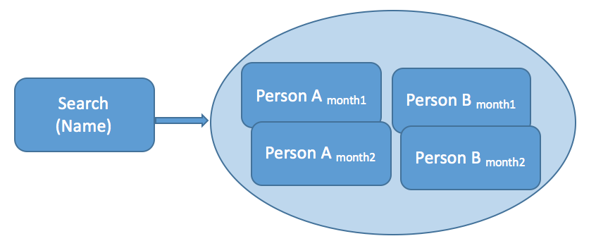

Figure - Unfiltered name Search returns multiple versions of Person A & B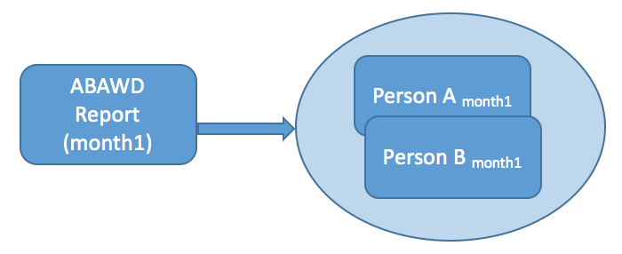

Figure - Report with current Certification Period returns a single version of each Person

**Screening**

The ABAWD screening tool can be referenced and used outside of the ABAWD report. This means it can be linked from myDHR and used even if the person is not in the CARES system yet. When the screening tool is linked from the ABAWD report, the Client ID is passed into the report and populated into the “Client ID” field. This can be done for other variables as well such as the Data of Birth or Case Worker name, depending on requirements.

The ABAWD screening tool saves all editable information including the results to a separate JSON document and associates it to the master person document using the Client ID. When used from the ABAWD report with a known Client ID, it will also save a document within the master person document.

**ABAWD Report API**

The ABAWD Report makes calls to an API on the Shared Data Repository. Figure 8 depicts the communication to the API. First the application Calls the ABAWD service to get a structured query that contains the filter criteria for the report. It then calls the Search service using the structured query in the previous step.

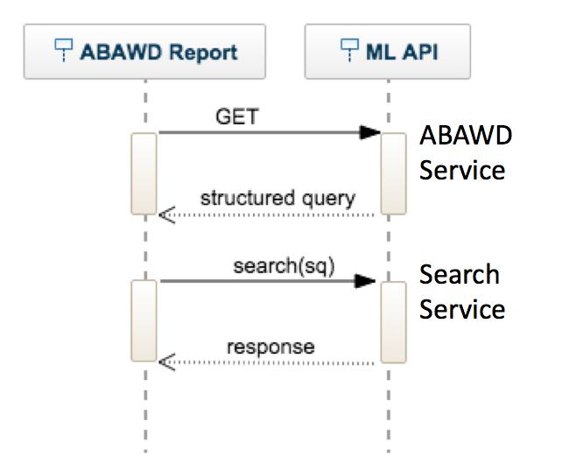

Figure - ABAWD Report, API Communication

# Test

## Test Scope

## Test Approach

## Test Environments

## Test Results