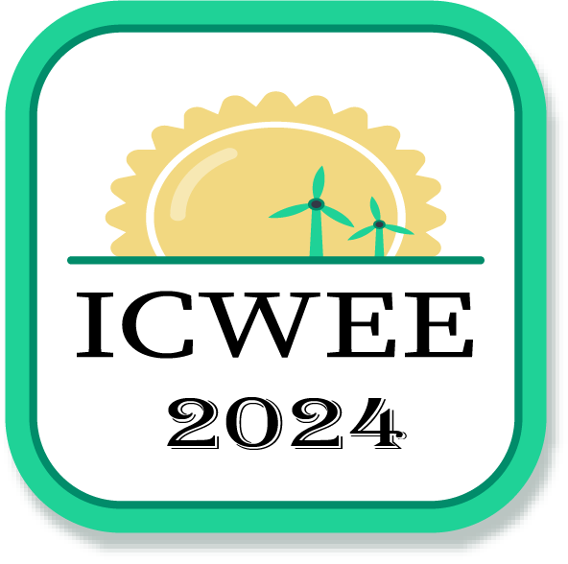 | SATHYABAMA  INSTITUTE OF SCIENCE AND TECHNOLOGY  [DEEMED UNIVERSITY]  Accredited Grade “A++” by NAAC  INTERNATIONAL CONFERENCE ON WASTE ENERGY AND ENVIRONMENT  (ICWEE-2024)  Date: 3rd to 5th JULY, 2024 | 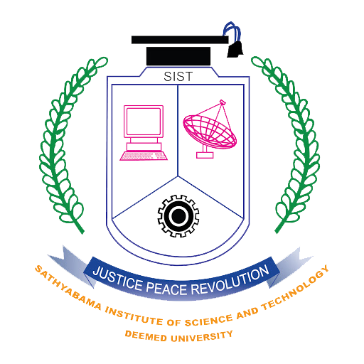

REGISTRATION FORM

- Nature of Participant :
- Name :
- Designation and Department :
- Organization :
- Address for Communication :
(Including postal code)

- Mobile :
- E-Mail ID :
- Title of the paper :

- Nature of participation : (Author / Delegate)

- Publication : Interested / Not interested

- Payment details

- Payment amount :
- Payment mode : GPay / PhonePe / DD / Netbanking
- Transaction identification number :
(For Demand draft provide DD number)
Send the screenshot of payment along with this registration form through mail
- Accommodation Required or Not :

- Send the completed registration form to E-Mail ID: energy.icwee@gmail.com

