Current Issues

The issues in the table below are not exhaustive – but they cover the major issues that are known:

|  |  |  |  |  |
| --- | --- | --- | --- | --- |
| Number | Task | Priority | Notes |  |
| 7 | Total score should be the average of all surveys – not the total. So if we have two surveys scoring 5,6,7 and 10,10,10, the total score should be the average of 18 and 30 = 24. At the moment it is showing 48. | 1 | Think this is now ok - need more testing |  |
| 18 | Detail reports missing data. I ran a report for the current month but it only showed one call when many more test calls have been made | 1 |  |  |
| 13 | Wallboard screens need tidying up – for all types, there should just be a heading, tickertape and then the data – as big as possible. Let me know if you need screenshots | 2 |  |  |
| 15 | Data reports need correcting Data reports should be summarised reports that show numerical information over time. For example, if there were 76 surveys completed in a day, we would have a detail report showing every call – but the data report would show a summary. Note: in data reports, detail components need to be shown as a count – eg Transcriptions will show the number of calls that have a transcription. Data reports should also allow drill down to the detail report that makes up the data report. Need to add a column showing number of surveys as standard. (See Test1011C for example) | 2 |  |  |
| 20 | Dates selected not showing in the title of the report – eg 1st August – 14th October or Last Month | 2 |  |  |
| 23 | Need reports to be defined by question score. So if we have Q1 between 1 and 5, I want to be able to show the number of surveys that have scored each of the questions. One way of doing this will be to add a question box into the Reference field as well – so that if the customer chooses reference Question, and then Numerical Question 1, the system will show the totals for each score | 2 |  |  |
| 2 | When setting up a user, the email doesn’t let the person know what their username is and it should as it will save time and also save them from having to chase us or their admin for the username. | 3 |  |  |
| 6 | Y-Axis midpoint not moving the Y axis | 3 |  |  |
| 11 | The Outpiut Requirements = email functionality is not working and also there should be a repetitive time to send the emails – as per the original spec. Daily, weekly, monthly. Can we add this at some stage please? | 3 |  |  |
| 17 | Show the data reports on wallboards as tables | 3 |  |  |
| 24 | Allowing data and detail reports to be sorted by clicking on columns | 3 |  |  |
| 19 | Custom Dates not working. I ran a report for August to current date and nothing was shown - now showing incorrect data. (See report Test1011B) | 4 |  |  |
| 21 | The display box should be defaulted to on-screen. It just shows as ‘select’ | 5 |  |  |
| 22 | Checkboxes not appearing on the reports screen (see screenshot). Also icons not appearing properly and X to go back from a screen have not appeared - although functionality still there - see reports table and expanded dashboard quadrant for examples (should be X in top right hand corner) | 1 |  |  |
| 23 | Report Headings make no sense (see report Test1011A) - should be total score not Q1 score. | 2 |  |  |
| 24 | Averages should be showing as max one decimal place. | 4 |  |  |

New Requirements

**Priority Table**

|  |  |
| --- | --- |
| TASK | Priority |
| NPS Score | 1 |
| Time Tags | 2 |
| Targets | Later |
| Alerts | Later |
| Transcription Changes | Later |

**Include NPS score**

NPS score is a standard that comes from scores from a single question “How likely are you to recommend us to your family or friends”. The score is between 0 and 10. 0 and 1 are detractors, 9 and 10 are promoters and all other scores are neutral. The formula for calculating the scores are:

*(Promoters-Detractors)/Total Surveys.*

The result is shown as a percent. The NPS score will simply be another way of displaying data in any of the reports and wallboards and should be at agent, tag and campaign level

As only one question can be designated as the NPS questions, we will send NPS=1 to the survey to indicate which question will have this above calculation applied.

**Create Time Tags**

Time Tags work in a similar way as Team Tags, but related to specific periods of time. They will enable reporting to drill down further – eg to look at scores for mornings, or between 5 and 6pm, for example.

The form to be added to the Time Tags page is as follows:



The tag name and colour pickers work exactly the same as Team Tags.

Start time will be a 24 hour clock time picker, and allow the user to put in a time that the Tag will start from. The end time will work in exactly the same way. The system will check to ensure Start Time < End Time.

Day of the week will be a list of the seven days. Multi-selection will be allowed. The user will select the day or days they want the Tag to represent. An example might be:

Tag Name: Tuesday Mornings

Start Time: 8:00

End Time: 12:00

Day of the week: Tuesday

For reporting filters, the system will only include records that relate to the times selected in the Time Tag. Multiple Time Tags can be collated to make a Group Tag.

NOTE: The following three requirements will be on hold until required:

**Alerts Functionality**

This section will take the functionality that is currently built as ‘display only’ and make it work in reality.

Steps required are:

* Expand the filter options to be the same as the reporting
* Allow multiple levels to be created
* Allow e-mails to be sent from alerting module
* Remove SMS option completely

Alerts will either be for specific calls or for a defined period. Examples might be:

‘If call score <5’ or ‘If less than 40 surveys in an hour across the campaign’

When sending the alert, the email should contain specific information about the call, to allow the user to process the information when it is received:

So an example call email would include:

* Campaign:
* Agent
* Time/Date
* Total Score (or question score or whatever)
* [Voice File] – as attachment

The example period email would have:

* Campaign
* Time/Date
* Target
* Actual

**Create ‘No Transfer’ reporting**

The Agent Indicator application allows an agent to put a ‘no transfer’ reason into the system when the customer does not want to be transferred or it is not appropriate to do so.

The system should have a specific report type added, that will sit alongside the existing types



The No transfer report will be able to be filtered by agent, campaign, time and time tags only. An example of the output will be:



In addition, we need to create a green data type of ‘No Transfer’ so that we can create any reports that count the no transfer reasons and to allow no transfer reasons to be shown as a Word Cloud.

**Transcription Changes**

At present, when a transcription is completed, the system goes back to the list of transcriptions, and the transcriber has to manually choose the next record.

We need to add two buttons to display for every transcription:

Next

End

Next will save the transcribed record and move onto the next record in the list, without returning to the list view. End will save the transcribed record but then return to the list view.

An error should be presented in both cases if the transcription has not been completed.

**Targets**

The purpose of targets is to compare actual with target levels and highlight, through reporting (and wallboards/dashboard) and through alerts.

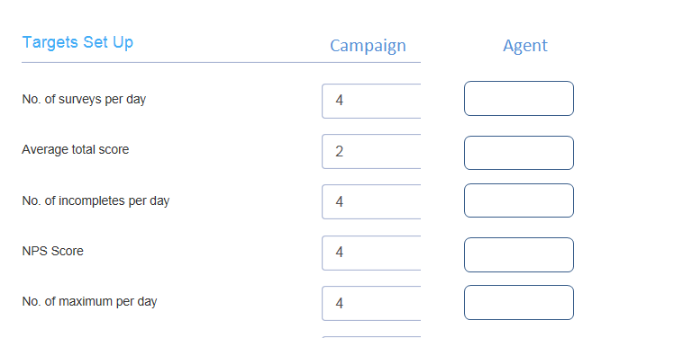

The targets are to be set at campaign and agent level, with the corresponding alerts and reporting using the correct target measure.

Step 1: Add a tick box to first reporting page for ‘Include Targets’

Step 2: Create a ‘TARGETS’ data source, making it green

Step 3: When a report is run, then the target needs to be shown next to the actual data, using a dotted line (whether graph, pie or bar)

Step 4: For data or detail reports, allow a column of Target to be added in next to any column that is chosen in the report and has a target listed, and the relevant target data should be shown:

Step 5: For live reports, there is a need to show the target ahead of time. So if a live report showing progress over the day, the target line should display for the whole day and the actual catch up – eg:



Targets can be changed by the administrator at any stage.

We will also need to add a simple open/closed system that will allow administrators to identify the opening hours for each day of the week.