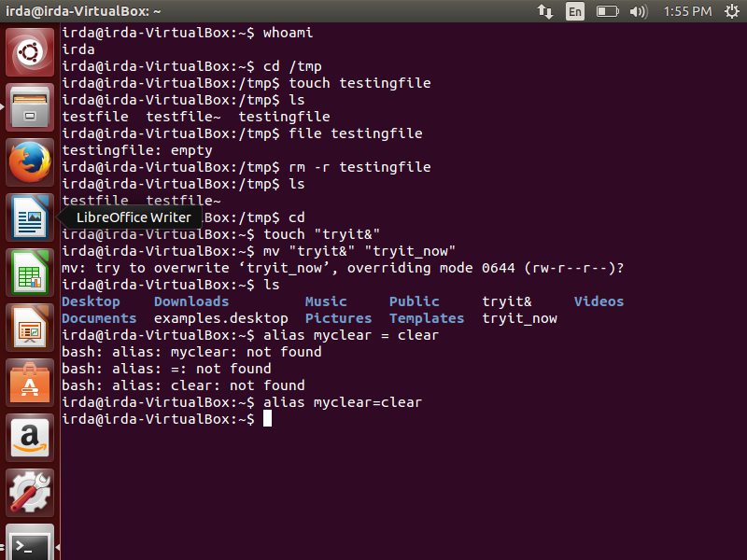

**Q1**

**Commands**

1. Whoami
2. touch/tmp/testingfile
3. File /tmp/testingfile
4. rm removes the empty and non-empty directoriesand file while rmdir removes only an empty directory.
5. cd
6. mv “tryit&” “tryit_now”
7. alias myclear=clear
8. a. cls: command is not found

b. mkdir:can’t create the directory ‘d1’ : file exists

_________________________

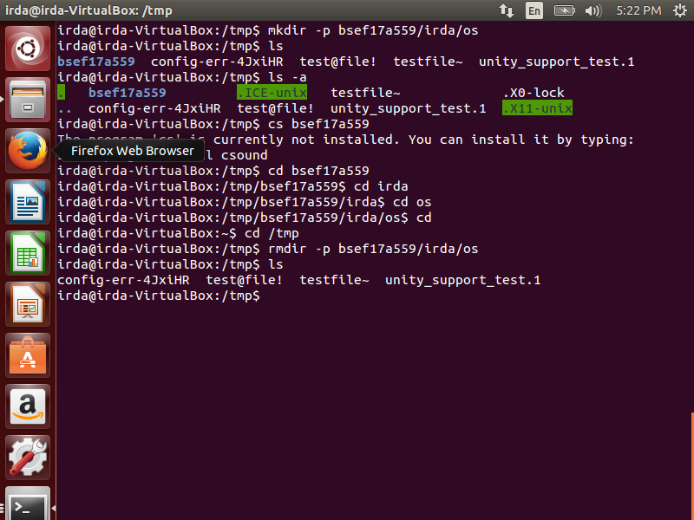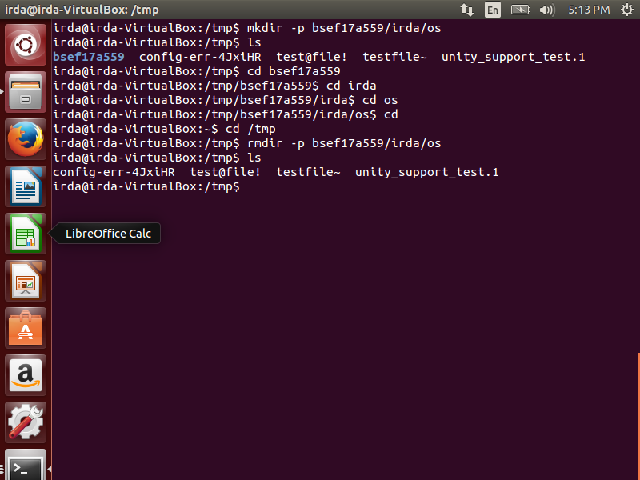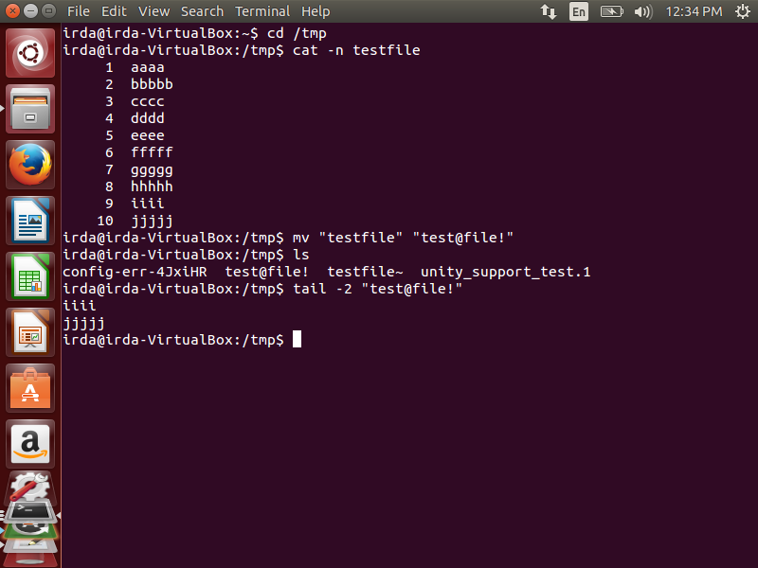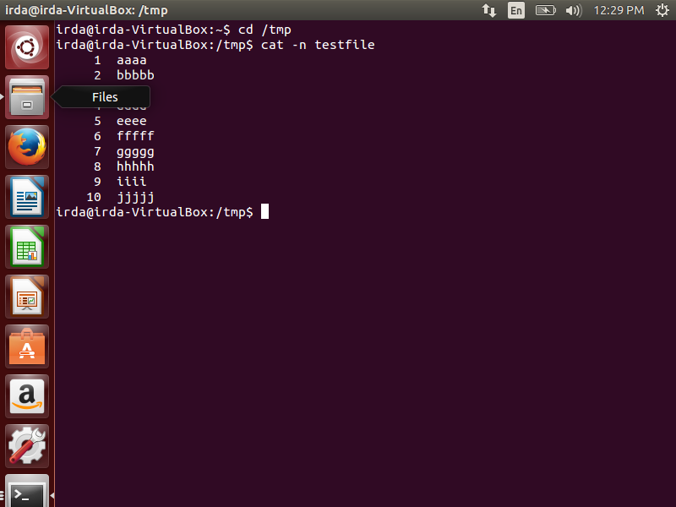

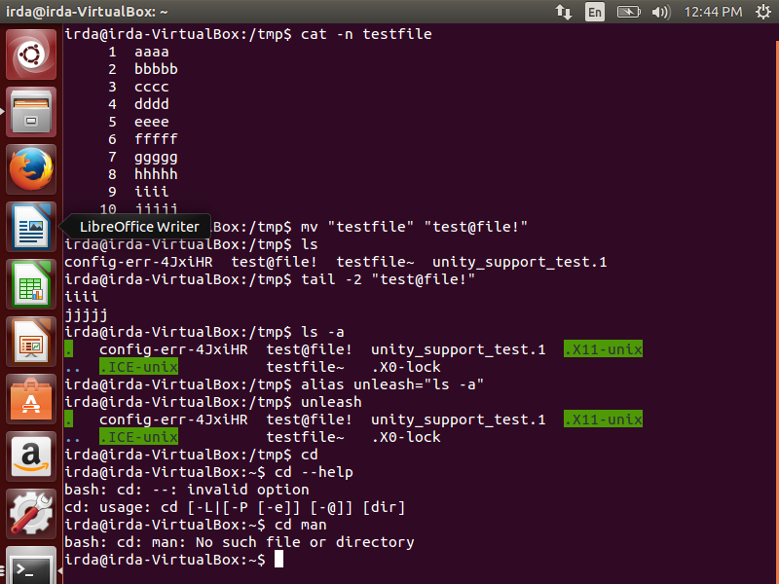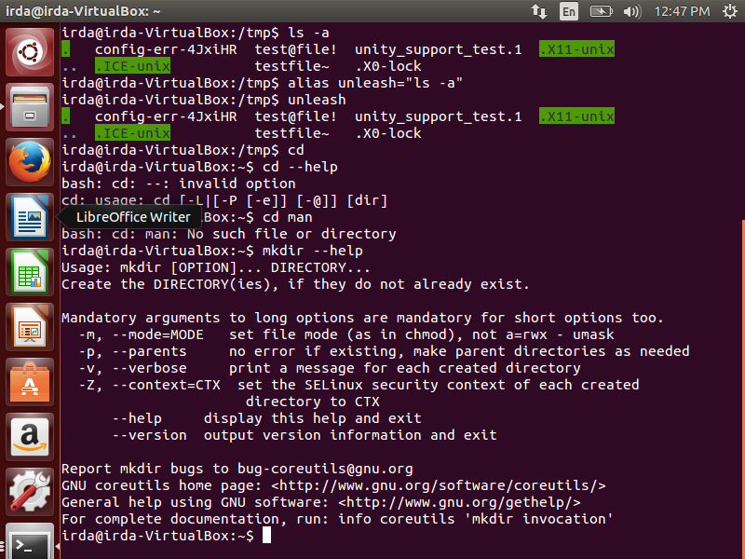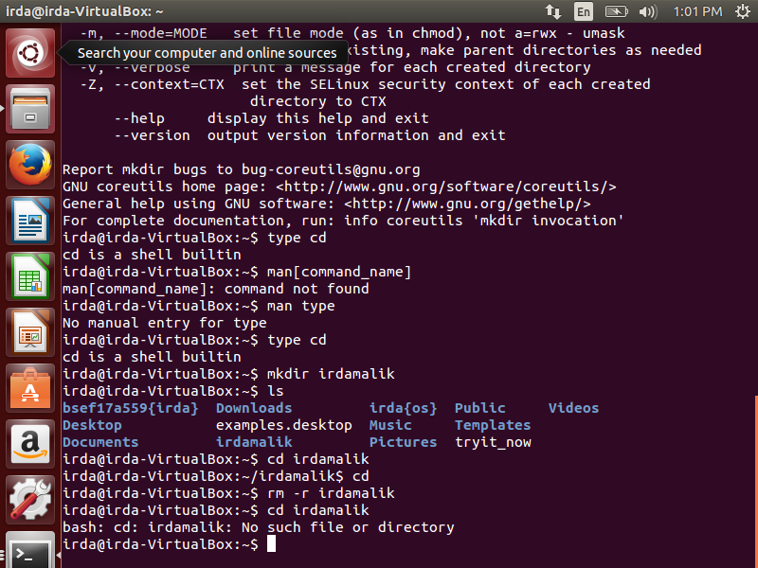

**Q2**

Commands

1. mkdir -p bsef17a559/irda/os
2. ls -a
3. a). rmdir -p bsef17a559/irda/os

b). rm -r bsef17a559

1. The file named testfile was created in tmp and by using gedit lines were written in the text editor and then contents were displayed with line numbers by using

cat -n testfile

1. mv “testfile” “test@file!”
2. tail -2 “test@file!”
3. alias unleash=”ls -a”
4. mkdir --help or man[command_name]
5. type cd or man type

cd is a shell builtin

1. rm -r [directory_name]

_______________________

Q3 commands

Using relative and absolute paths

1. mkdir -p /home/dilawer/reports
2. /home/dilawer/reports#

mkdir /home/abdul

cd ../..

1. /home/dilawer/reports#

touch ../../abdul/file1

cd ../..

1. /home/abdul#

mkdir -p ../staff/arif

mkdir -p ../staff/rauf

1. /home/staff#

touch arif/file2

touch rauf/file3

1. /home/staff#

cp /home/staff/arif/file2/home/abdul

cp /home/staff/rauf/file3/home/abdul

1. Mkdir ../dilawer/newdir

cp -r ../staff ../dilawer/newdir

1. rm -r ../../staff/

cd ../..

____________________________

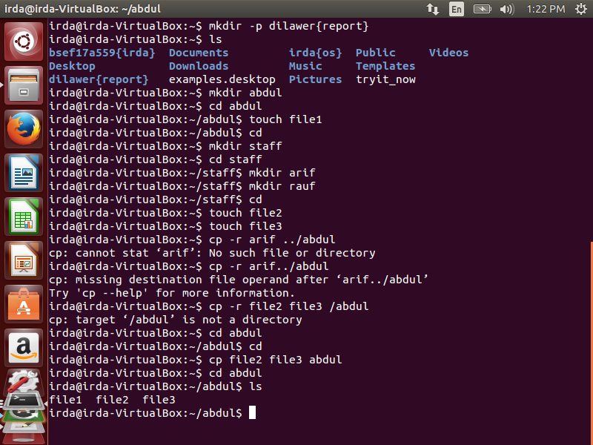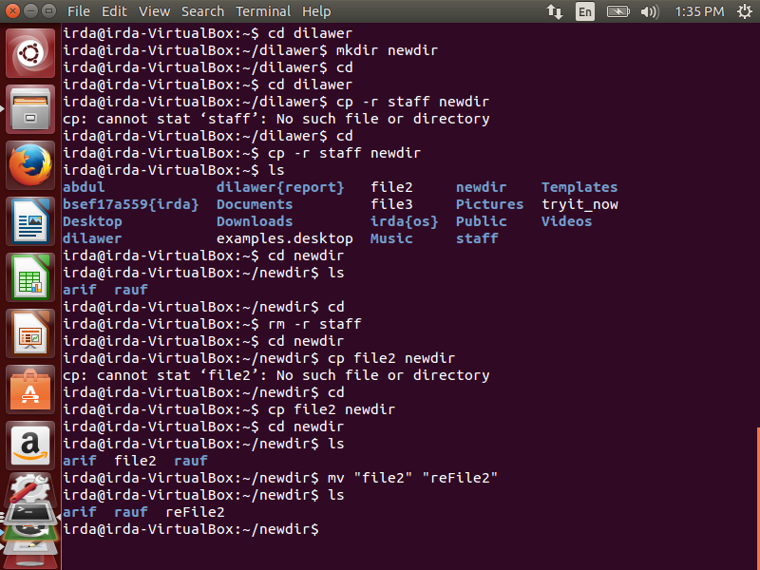

Commands

1. mkdir -p dilawer/report
2. In home we’ll create a directory called abdul

mkdir abdul

1. cd abdul

touch file1

or mkdir ../ ../ abdul/file1

1. pressing cd to get out of abdul’s directory

mkdir staff

cd staff

mkdir arif

mkdir rauf

1. after pressing cd

touch file2

touch file3

1. cp file2 file3 abdul
2. cd dilawer

mkdir newdir

cd

cp -r staff newdir

1. after pressing cd

rm -r staff

1. first copying file2 in newdir and then changing the name of file2

cp file2 newdir

mv “file2” reFile2”

________________________