|  |  |
| --- | --- |
| **Ex. No: 3** | **Bitbucket Operations using Git** |
| **06.08.2024** |

# Aim:

To practice fundamental Git operations using Bitbucket, including repository creation, cloning, making changes, branching, pushing changes, collaborating through merge requests, and syncing changes.

# Procedure:

1. Create a Repository

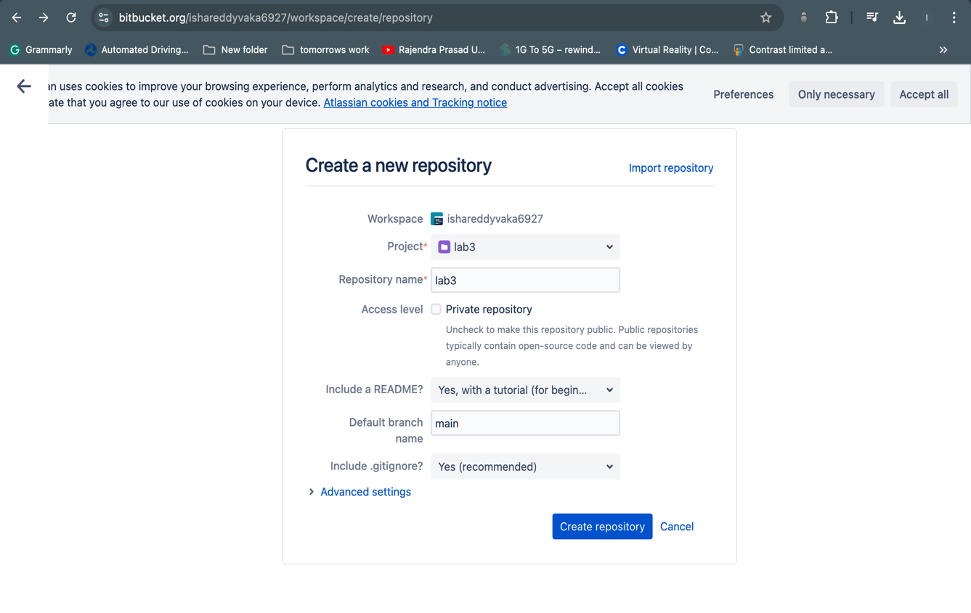

1. Cloning a Repository
   1. Use **git clone <repository_url>** with the URL you copied from Bitbucket

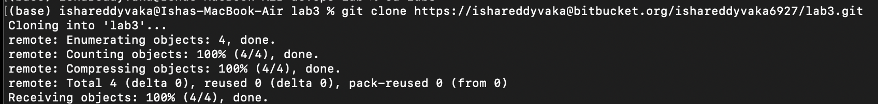

1. Making Changes and Creating a Branch
   1. Navigate into the cloned repository



* 1. Create a new text file named "filename.txt" using a text editor.
  2. Add some content to the " filename.txt" file.
  3. Save the file and return to the command line.
  4. Check the status of the repository

* 1. Stage the changes for commit
  2. Commit the changes with a descriptive message "Edited_example.txt"

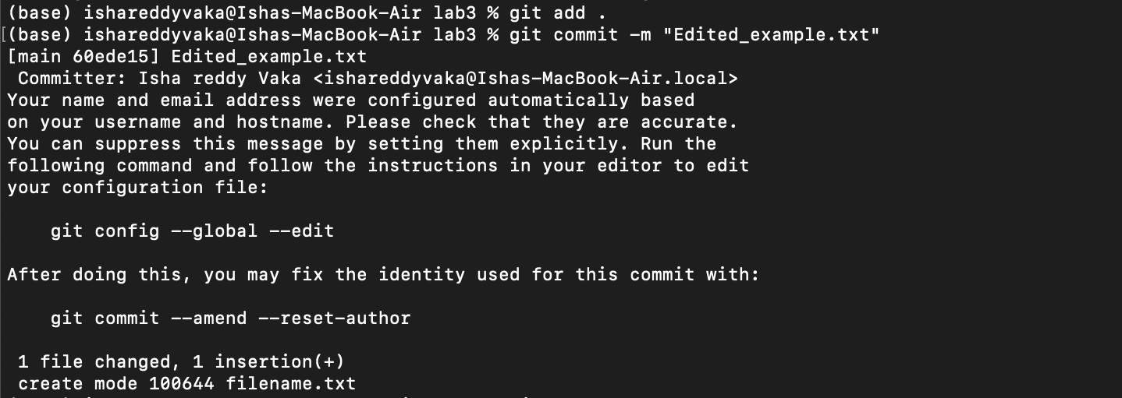

* 1. Create a new branch named "feature"
  2. Switch to the "feature" branch
  3. Pushing Changes to Bitbucket



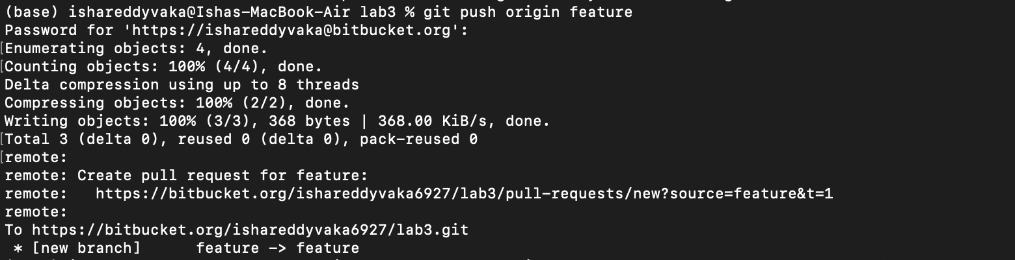

1. Add Repository URL in a variable
   1. Add Repository URL in a variable
   2. Replace <repository_url> with the URL you copied from Bitbucket
   3. Push the "feature" branch to Bitbucket
   4. Check your Bitbucket repository to confirm that the new branch "feature" is available.

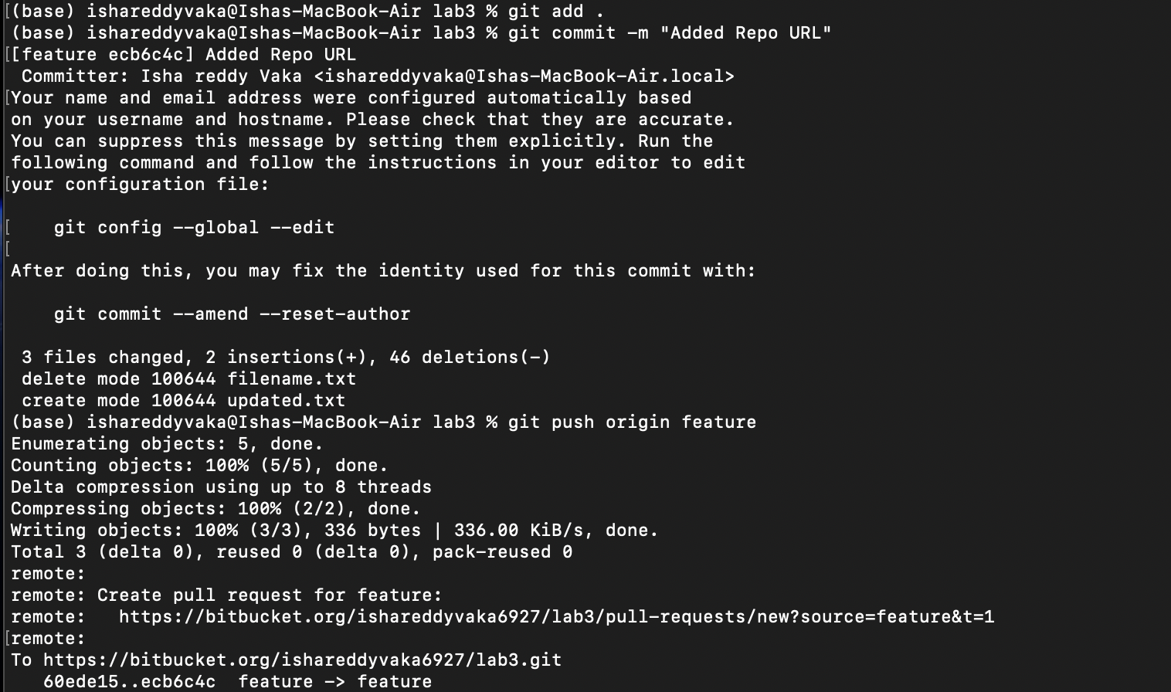

1. Collaborating through Merge Requests
   1. Create a merge request on Bitbucket
   2. Review and merge the merge request

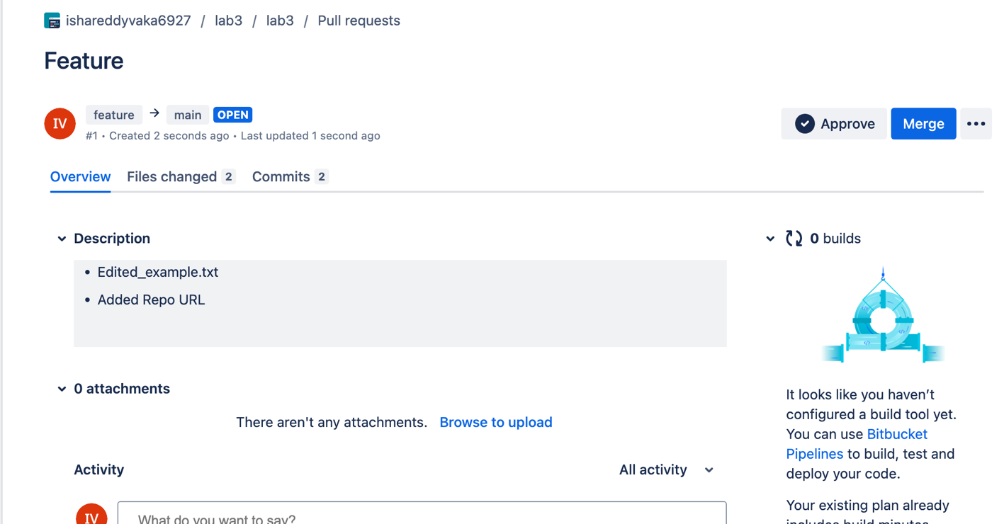

1. Syncing Changes
   1. After the merge request is merged, update your local repository

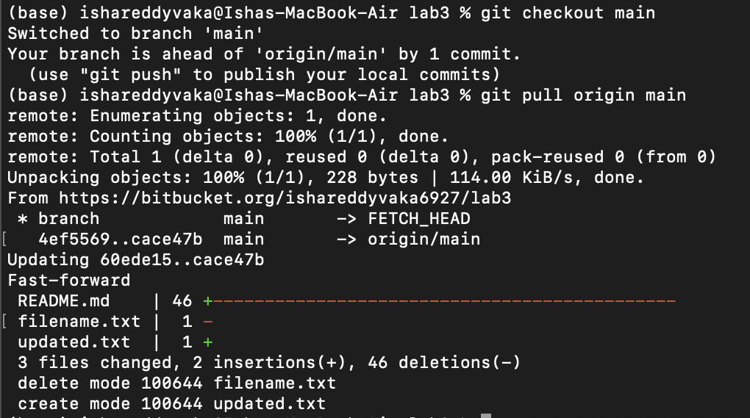

# Result:

Therefore, we've successfully performed all the Bitbucket operations using Git.