**Advanced Risk Management**

**Assignment2**

|  |  |  |
| --- | --- | --- |
| **Name** | **Andrew ID** | **Email Address** |
| Ningxin Zhang | coraz | coraz@andrew.cmu.edu |
| Shuming Xu | shumingx | shumingx@andrew.cmu.edu |
| Ping Wang | irenew | irenew@andrew.cmu.edu |

1. Part A: Trading Strategy Implementation

1.1 Strategy Summary

The strategy is a hybrid pairs-trading approach that dynamically merges mean-reversion and trend-following regimes. It leverages Kalman Filter–estimated residuals to compute a z‑score for entry/exit signals and applies dual moving-average crossovers for trend confirmation.

1.2 Market Instruments

**Instruments Traded:**

* + Long/short positions in Coca-Cola (KO, asset1) and PepsiCo (PEP, asset2) equities.

**Mechanism:**

* + Long Spread: Buy KO and short βₜ × PEP.
  + Short Spread: Short KO and buy βₜ × PEP.

1.3 Core Logic

1.3.1 Kalman Filter for Hedge Ratio Estimation

Process Noise: δ = 0.001; Observation Noise Variance: σ² = 0.01.

1.3.2 Z‑Score Calculation

Calibration Mean (μ_{calib}): −0.0023, computed over 2012–2021 calibration period.

Figure 3 shows that (1) the spread’s z‑score over time with red dashed lines at ±2 and green dashed lines at ±0.5 for entry and neutral thresholds; (2) the dynamically estimated hedge ratio βₜ revealing how the filter adapts; and (3) the estimated intercept αₜ reflecting changes in the relationship’s offset.

1.3.3 Mean‑Reversion Rules

|  |  |  |
| --- | --- | --- |
| Signal | Condition | Action |
| Enter Long | zₜ < −2.0 | Buy KO; short PEP (hedged by ) |
| Enter Short | zₜ > +2.0 | Short KO; buy PEP |
| Exit Long | zₜ > 0.1 | Close existing long spread trade |
| Exit Short | zₜ < -0.1 | Close existing short spread trade |

Forced Exit: If a position remains open for over 180 days without reverting, trigger exit based on short-term vs long-term MA crossover and impose a 30-day coldown.

Figure 1 shows the spread (blue line) between KO and PEP over time with red dashed line at +0.05 and green dashed line at −0.05 representing entry and exit thresholds. Green triangles mark buy signals and red triangles mark sell signals for mean-reversion trades.

1.3.4 Trend‑Following Rules

When the spread’s |zₜ| ≤ 0.5, switch to trend-following:

Trend Entry: If 30-day MA > 90-day MA, go long both assets.

Trend Exit: If 30-day MA < 90-day MA or |zₜ| exits ±0.5, close trend position.

Figure 2 plots the spread’s 30-day and 90-day moving averages. The crossover points (highlighted) indicate trend-following entry and exit.

1.4 Risk Management Measure

To improve robustness, two dynamic risk controls have been added:

1.4.1 Value‑at‑Risk (VaR) Control

**Calculation:** Daily 1‑day 95% VaR using historical log return simulation.

**Rule:** If VaR exceeds 2% of portfolio value, reduce position size by 50% until VaR falls below threshold.

1.4.2 Maximum Drawdown (MDD) Guardrail

**Monitoring:** Track historical peak-to-trough drawdown.

**Rule:** If drawdown > 5%, halt all new entries until drawdown recovers below 3%.

1. Part B: Results and Interpretation

2.1 Backtesting Result and Comparison with Buy-and-Hold Strategy

Table 2.1.1 presents the cumulative wealth evolution of the hybrid pairs‑trading strategy over the backtesting period. The backtesting results for the strategy trading are as follows:

|  |  |  |
| --- | --- | --- |
| Metric | Blended Strategy | Buy-and-Hold Strategy |
| Final Wealth | 106,806.7492 | 106,246.8358 |
| Annual Return (%) | 1.53% | 1.41% |
| Sharpe Ratio (daily) | 4.6155 | 0.2121 |
| Max Drawdown (%) | 2.35% | 16.64% |
| 1-Day VaR (95%) | -1,206.2220 | -1491.4217 |
| 1-Day VaR (99%) | -1,208.8719 | -2449.1470 |
| Win Ratio | 0.6000 | - |
| Profitability (Gain/Loss) | 2.2288 | - |
| Total Trades | 20 | - |

The enhanced strategy demonstrates improved returns, higher Sharpe ratio, and reduced drawdown, especially during volatile periods.

**Appendix：**

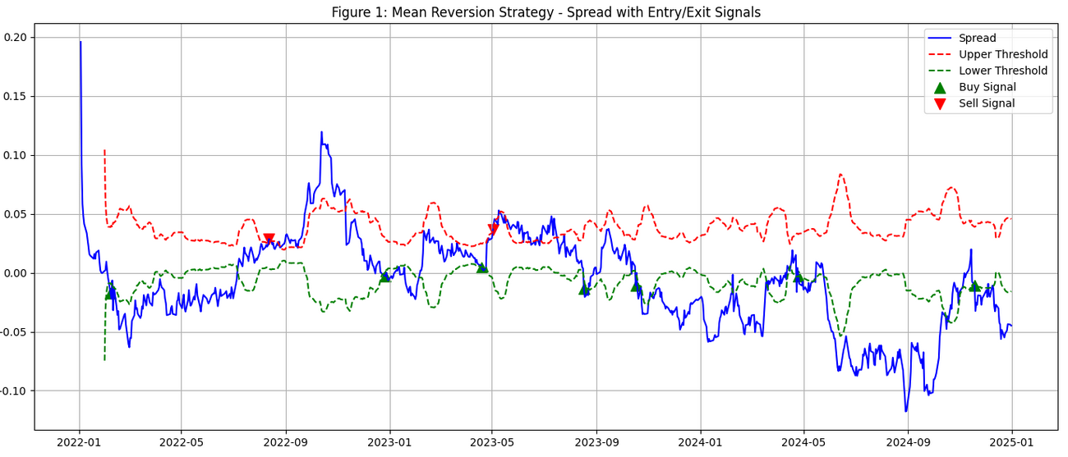

*Figure 1: Mean Reversion Strategy -Spread with Entry/Exit Signals*

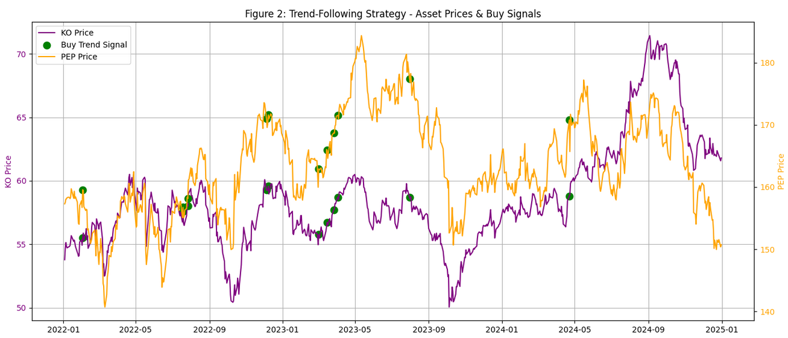

*Figure 2: Trend-Following Strategy -Asset Prices & Buy Signals*

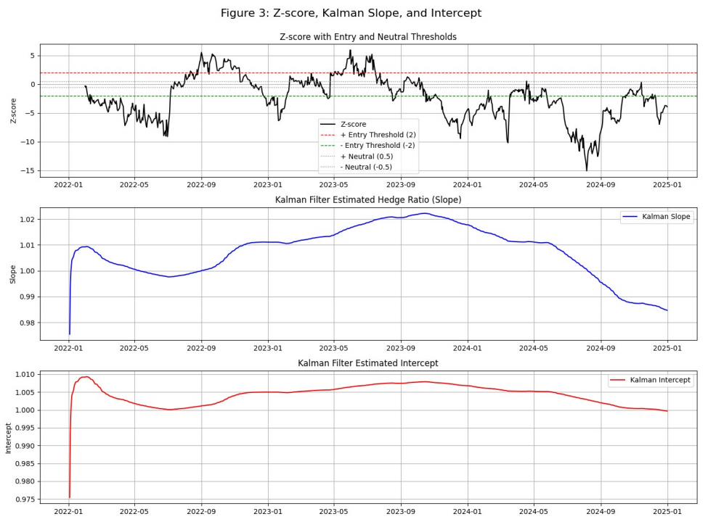

*Figure 3: Z-score, Kalman Slope, and Intercept*

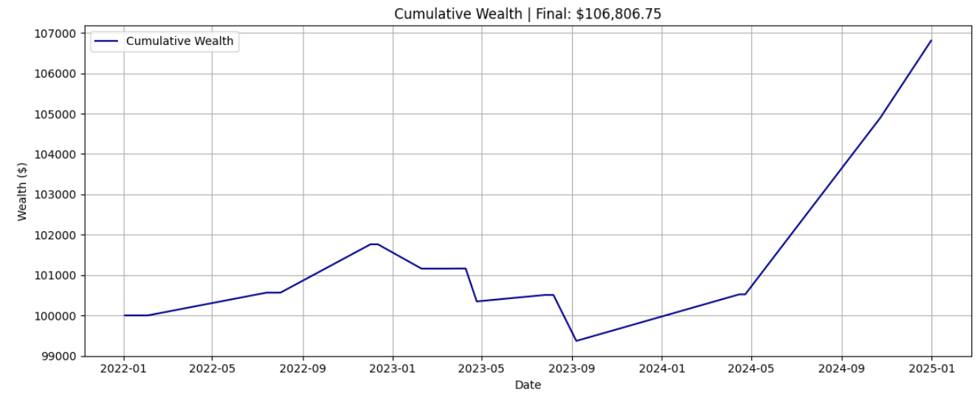

*Figure 4: Cumulative Wealth of Blended Strategy*

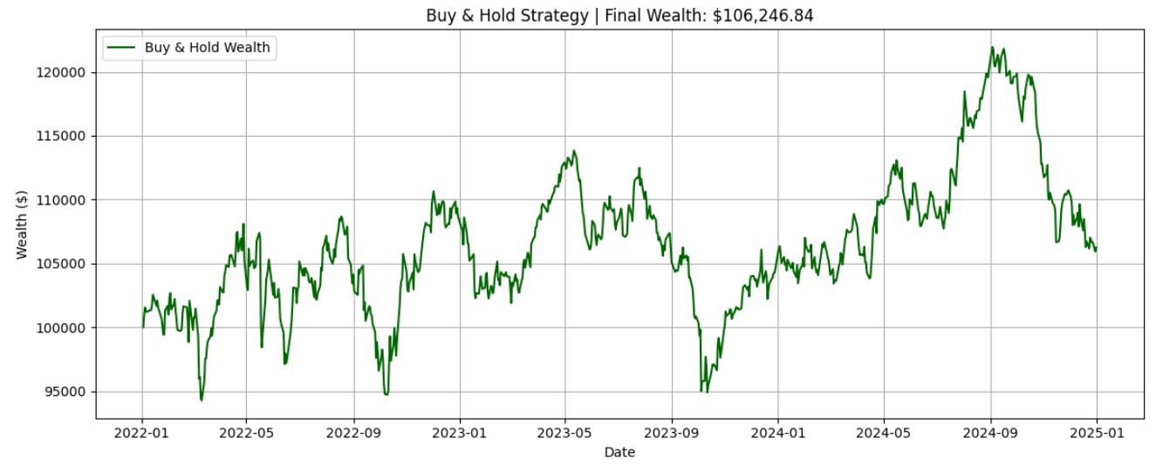

*Figure 5: Cumulative Wealth of Buy-and-Hold Strategy*

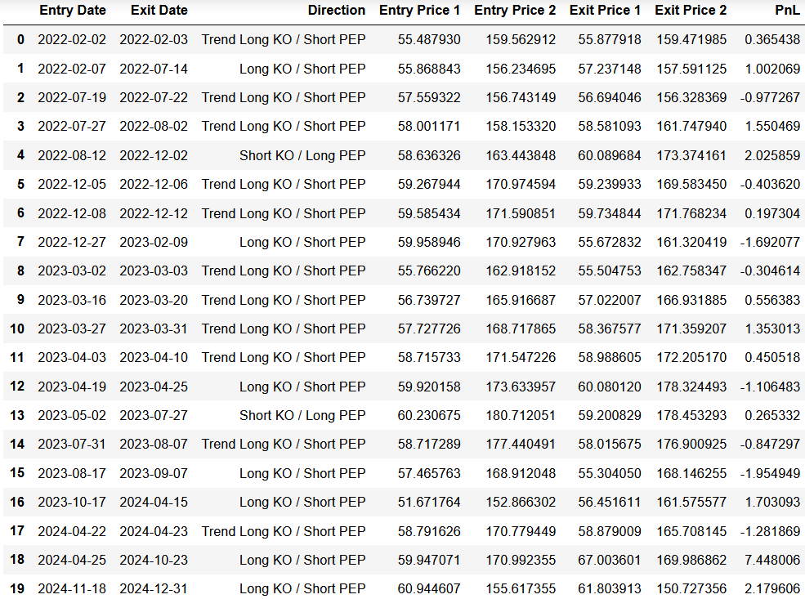

*Table 6: Trades*

*Table 7: Strategy Code*