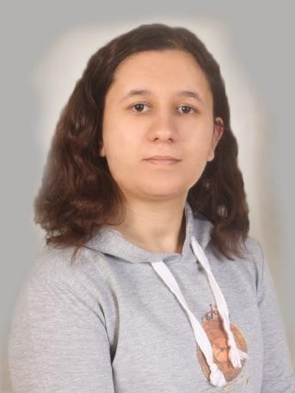İREM ADAY

GEOMATICS ENGINEER

**ABOUT**

My name is İrem and I was born in august 8 2002 in Ankara. Currently I am majoring in Geomatics Engineering. Within this major I become familiar with photogrammetry, geodesy and GIS technologies.

<https://github.com/irem-pg>

**SKILLS AND COMPETENCIES**

PROGRAMS

* Microsoft Office Programs –

Intermediate

* TBC - Beginner/Intermediate
* SQL -

Beginner/Intermediate

* Phyton - Beginner/Intermediate
* GeoSlam – Beginner
* C++ - Beginner
* Agisoft Metashape PRO - Beginner
* VisualStudio Code- Intermediate

LANGUAGES

* + English – Advanced
  + Korean – Beginner
  + Japanese - Beginner

**HOBIES**

Reading, poetry, Anime, Video games

**CONTACTS**

0545 900 85 92

[aday_irem17@hotmail.com](mailto:aday_irem17@hotmail.com) https://[www.linkedin.com/in/irem-](http://www.linkedin.com/in/irem-) aday-6285ba277/ Yenimahalle/ANKARA

# Intern

## Geomatics Mapping

**EXPERIENCE**

**15.08.2022-26.08.2022**

Worked in the engineering department. Gained experience in usage of different lidar techniques and processing of point cloud.

# Intern

## Doruk Mapping

**15.08.2022-26.08.2022**

Worked in the engineering department. Gained experience in cadaster laws and macrostation.

# Sales associate

## 7eleven Maryland USA

**13.06.2022 - 08.07.2022**

Worked as a sales associate within work and travel program in USA. Gained experience in the language and team work.

# Part-time Sales associate

## Billy’s Sub Shop Maryland USA

***15.11.2021- 16.06.2022***

Also worked as a sales associate within work and travel program in USA. Gained experience in the language and team work.

# Active Member

## Hacettepe HUMAT Community

***09 . 2018 - Still working***

Took part in HUCON event in 2021 as a staff member. Did cosplay and drawing with the community.

# Volunteer Translator

## HUMAT Comunity

***2018 - 2019***

Translated the English/Japanese subtitles of the anime into Turkish. Made subtitles timing if needed.

**EDUCATION**

# Hacettepe University

## Geomatics Engineering (Eng.)

***2020 - , GPA – 3.36***

# Selçuklu Anatolian Highschool

***2016 - 2020 , GPA – 96.43***

**PROJECTS**

**‘Güvenli Yaşam’ An initiative project design *(Still on going)***

**Designing an app to help visually impaired people to navigate**

# Graduation Project (Still on going)

**After the earthquake we observed that the need for better damage identification and classification is necessary therefore we are doing a project where we use machine learning to do so.**

# ‘Engelsiz Sevgi Çemberi’ Social project for disability

**awareness and support**

**Volunteer**

# GIS Course Final Project

**IMSA , Web Based Trafic Analysis Database ( Postgre SQL - Python)**

# TÜBİTAK Middle School Students Research Projects Competition (Technology)

**Ahmet Hamdi Tanpınar in Ankara - Project member**