



Algorıthmıc tradıng bot

CSE 491 Senior Design Project Final Report



**by**

İrem sultan bulut

**Supervised by**

Mustafa Berkay Yılmaz

# CONTENTS

CONTENTS 1

1. INTRODUCTION 1

1.1. Related Works 2

1.1.1. Indicators For Trading 2

1.1.1.1. Indicators Used 2

1.1.1.1.1. Moving Average Convergence Divergence (MACD) 2

1.1.1.1.2. 50-Day EMA and 200-Day EMA 3

1.1.1.1.3. Relative Strength Index (RSI) 4

1.1.1.1.4. On-Balance-Volume (OBV) 5

1.1.1.1.5.Bollinger Bands 6

1.1.1.2. Results and Analysis 7

1.1.2. Data For Trading Bots 8

2.METARIAL and METHODS 9

2.1.MetaTrader 4 139

3. EXPECTED BENEFITS 10

4. IMPACT 10

5. CONCLUSION 10

6.PROBLEMS, DIFFICULTIES AND SOLUTIONS 11

7. DATASET……………………………………………………………………………………………………………………………….………12

8. PLATFORMS…………………………………………………………………………………………………………………………………13

8.1.MetaTrader4 13

8.2.TradingView 13

9. REFERENCES…………………………………………………………………………………………………………………………………14

i

# 1. INTRODUCTION

The trading robot is an application that can run in accordance with set parameters. They consist of instructions and certain algorithms, which are configured to recognize trends and automate tradingIn this work, Trade was done on paper back in the days of trading. For example, in order to trade stocks, you had to be on the floor of a brokerage to get the real job done, or assign a broker who will be there to do the processes for you. (In fact, even in those days, many traders had a method for them when dealing with these transactions. This shows us that there was algorithmic trading even then.) Later, when the dematerialization process known as DEMAT emerged, these papers were gradually being replaced by electronic systems. After working on electronic systems, trading became easier due to computers working with algorithms. The next step after this process was to create methods according to predetermined criteria and create algorithms based on it. This is one of the most common methods of trading. Because computers work with algorithms, a computer can follow and perform operations much faster than a human according to the criteria you set. This means performing an operation that will take a person days in minutes. Based on these situations, performing the trade with bots through algorithms will not include situations that will affect emotions, political reasons, etc.

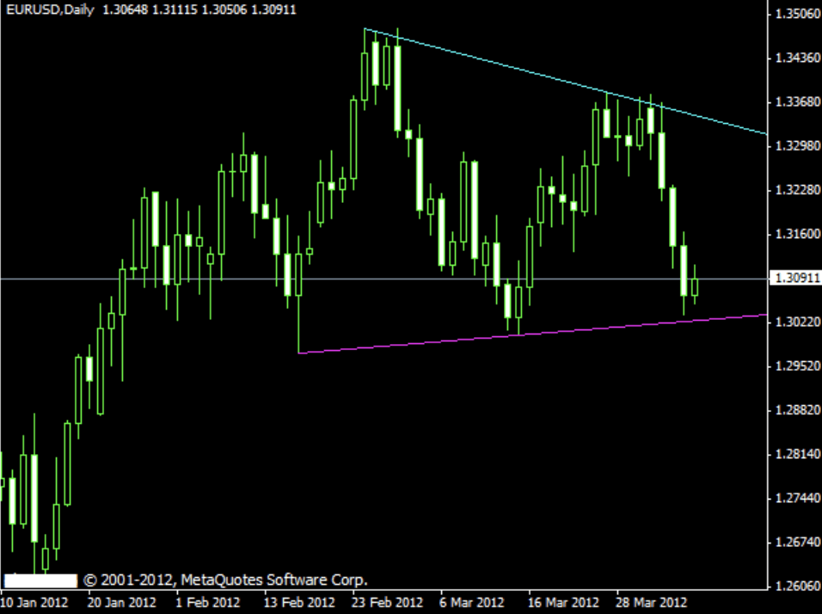

**Figure 1** Automated ForexTrading

In this work, I will develop an algorithm for trading transactions and buildings a trading robot that can automatically trade by following financial developments with this algorithm

## 1.1. Related Works

### 1.1.1. Indicators for Trading

#### 1.1.1.1. Indicators Used

To examine the best technical indicators to know on a trading bot. Indicators that need to be known for this: Moving Average Convergence Divergence (MACD), 50-Day EMA and 200-Day EMA, Relative Strength Index (RSI), On-Balance-Volume (OBV), Bollinger Bands.

##### 1.1.1.1.1. Moving Average Convergence Divergence (MACD)

Moving averages are the easiest basic indicator to examine and understand. These indicators show an average for past days for a certain number of days. Moving averages helps us understand the complexity in the chart. Thus, we can see that the price increases, decreases and remains constant according to the direction of the lines.

Moving Average Convergence Divergence (MACD) is a measure of trend and momentum. MACD works in the same way as moving Averages, but differently it includes other features to create a better view.

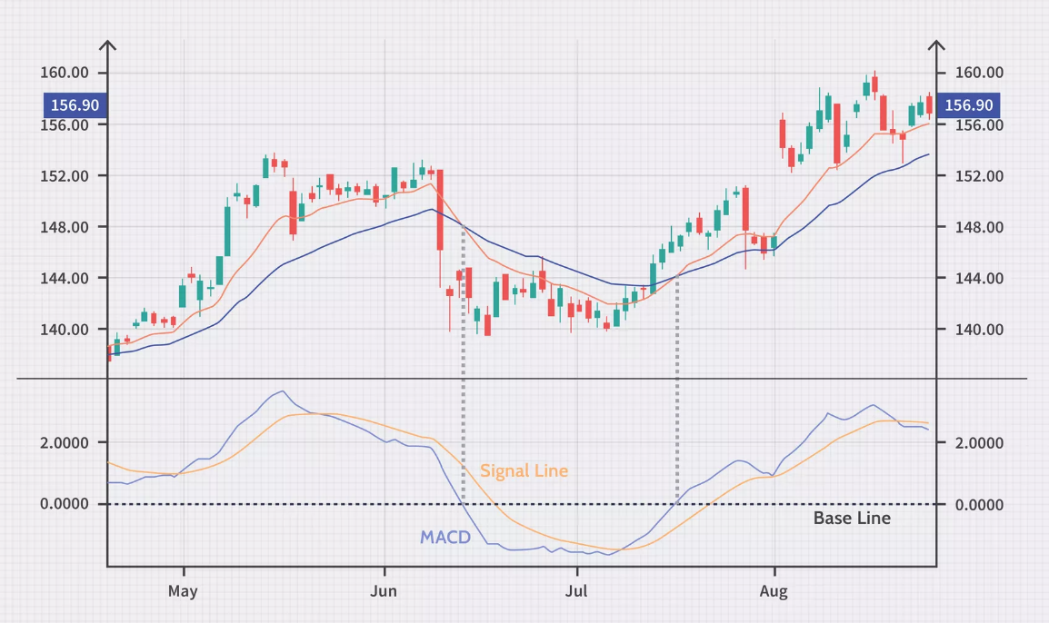

**Figure 2** MACD Indicators and Signal Line

The MACD indicator measures the rate of change of a price chart. There is a zero line in this chart. If the histogram pierces this line or reaches an upper or lower point, it gives buy or sell signals. This shows us what we should do at this point of the chart. Likewise, depth and speed of change create decision situations for us.

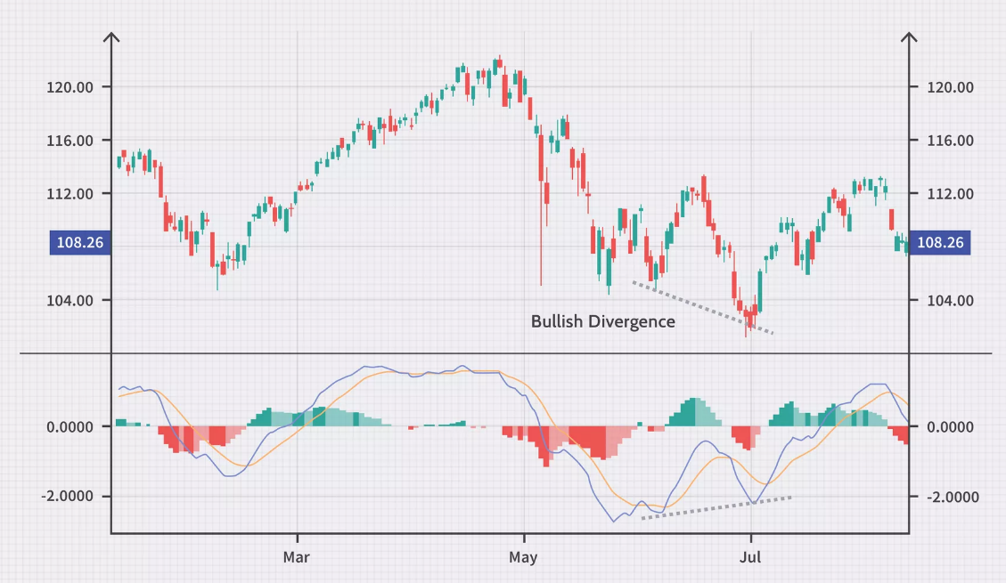

**Figure 3** Buy and Sell Signal in MACD

##### 1.1.1.1.2. 50-Day EMA and 200-Day EMA

Moving Average takes the average of the movement over a certain number of days. It works the same whether it is 50 days or 200 days. The difference between them is the average of 50 days of data in the 50-day EMA, while the 200-day data is averaged at the 200-day EMA. In this way, an algorithm can be written by examining the 200 or 50-day averages, and in this way, it can be taught to the computer. So if the computer has experienced a similar situation before, it will act this way. At the 50 and 200 day EMAs, we can examine the histome from both sides and create a ratio between them and add that to our bot's strategy and the bot can trade certain amounts accordingly. Many traders predict prices using the 50-days EMA mostly.

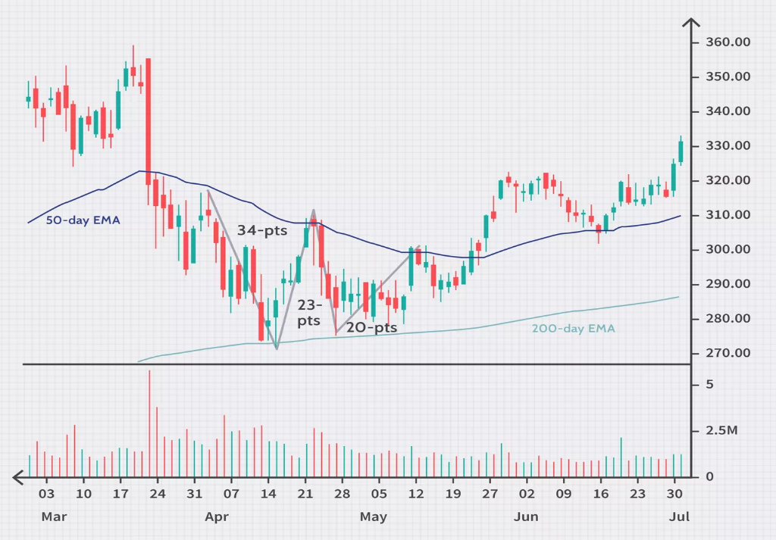

**Figure 4** 50-day and 200-day EMA

##### 1.1.1.1.3. Relative Strength Index (RSI)

RSI is a momentum indicator that analyzes overbought and oversold situations in a price histogram. RSI is calculated by a formula. This formula has 2 parts:

RSIstep one ​= 100 − [ 100 / (1+( Average loss / Average gain )) ​​]

A standard system first uses a 14-day calculation for the first step. For example, let's assume that these 14 days closed with 1% gain in 7 days and 0.8% loss in the other 7 days. The calculation is as follows:

55.55=100−[100/(​1+(-0.8%​/14)/(1%​/14))]​​  
The second part of the calculation is to smooth the results:

RSIstep two​=100−[100**/**(1+(Previous Average Gain×13) + Current Gain **/ -**(Previous Average Loss×13) + Current Loss)​​]

After these calculations, the RSI line can be drawn. In this line chart, if there is an increase in the system and it closes positively, the line will rise, and if there is a decrease and negative closure, the line will decrease.

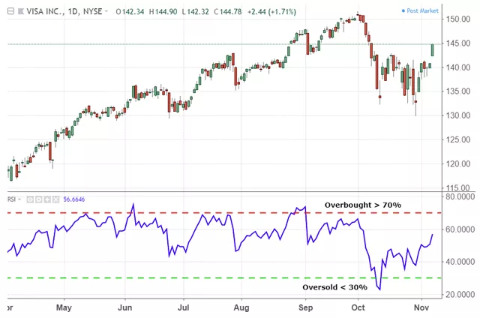

**Figure 5** RSI Chart

##### 1.1.1.1.4. On-Balance-Volume (OBV)

Obv-balance trade quantity is a volume-based indicator. The change in prices and volume are evaluated together and drawn. The calculation is as follows:

1. If today's closing price is higher than yesterday's closing price, then:

Current OBV = Previous OBV + today's volume

1. If today's closing price is lower than yesterday's closing price, then:

Current OBV = Previous OBV - today's volume

1. If today's closing price equals yesterday's closing price, then:

Current OBV = Previous OBV

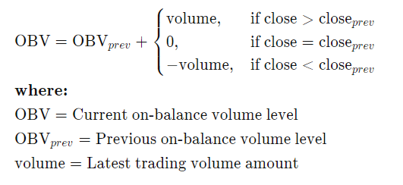

##### 1.1.1.1.5. Bollinger Bands

Bollinger bands are the volatility band that was developed by John Bollinger in 1980 and placed above and below moving averages and is often used in technical analysis. Volatility is a variable that depends on the standard deviation, and the rise or fall in volatility affects the standard deviation. Bollinger bands expand when volatility increases, bollinger bands narrow when volatility decreases. Bollinger bands show whether prices are relatively high or low. According to Bollinger, the bands contain 88-89% of the price movements. For this reason, he states that price movements outside the bollinger bands are unusual. Technically speaking, if prices are close to the upper band, prices are relatively high, and if prices are close to the lower band, prices are considered to be relatively low. However, relatively high prices should not be interpreted as a buy or sell signal. The calculation is as follows:

Middle Band: 20-day simple moving average

Upper Band: 20-day simple moving average + (standard deviation of the 20-day price x 2)

Bottom Band: 20-day simple moving average - (standard deviation of the 20-day price x 2)

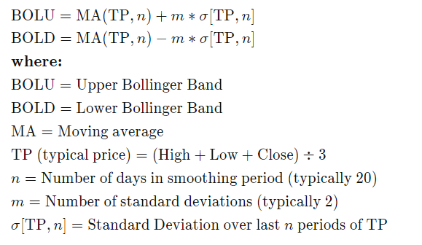

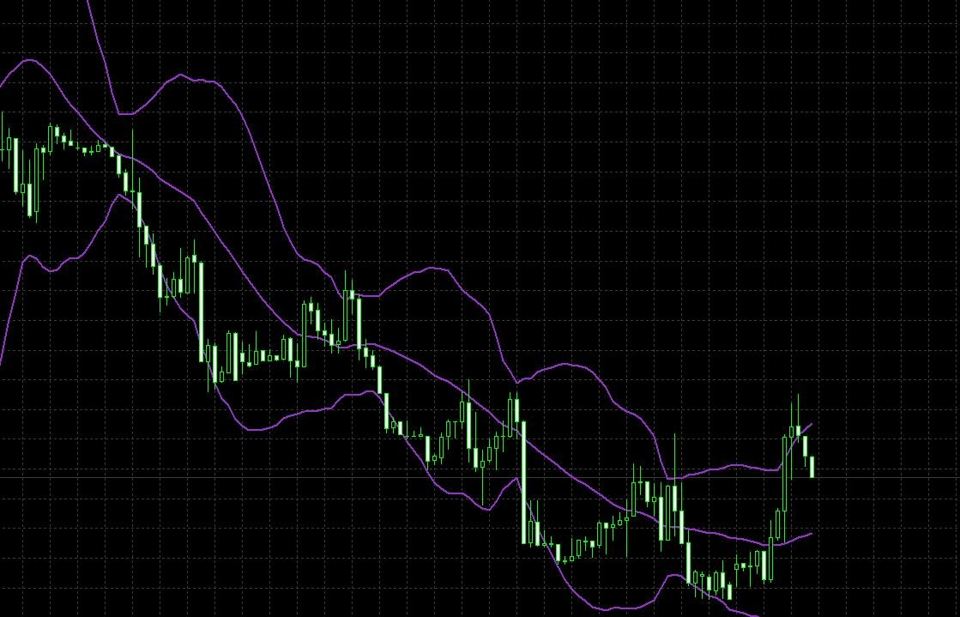

**Figure 6** Bollinger Bands

An example of the bollinger band is shown in the graph above. For the example here, the line in the middle shows the 20-day moving average. There are two lines above and below this line. The line at the top; the middle one is above the standard deviation of the moving average by K, and the lower line indicates the middle moving average below the standard deviation of K. In general, the standard deviation in bollinger bands is accepted as 2 and the period as 20.

The most important reason for using Bollinger bands is to know the high and low levels of the financial product and to predict between which band the relevant product will fluctuate. In general, when a financial product touches the upper level of the bollinger bands, it can be interpreted as overbought levels, and when it touches the lower band it can be interpreted as excessive selling levels. However, it should not be forgotten that no technical analysis indicator alone gives meaningful results. Bollinger bands can also give meaningful results when used with other indicators.

#### 1.1.1.2. Results and Analysis

In this study, it was learned what the indicators do and the combination of indicators to be used was analyzed. Multiple indicators should be used in a trading bot because 1 indicator will never give the correct result, but when working with more than one indicator, the desired result is achieved.

### 1.1.2. Data For Trading Bots

There are many different stock trading platforms out there, some with their own APIs. Many of these platforms allow trading with crypto and other currencies. These platforms also keep the data of the amount of change such as the increase and decrease in these currencies over a period of time. Whenever a transaction is desired, it is possible to benefit from the data here.

First of all, we start by logging into our existing account on one of the platforms that allow trade bot trading.

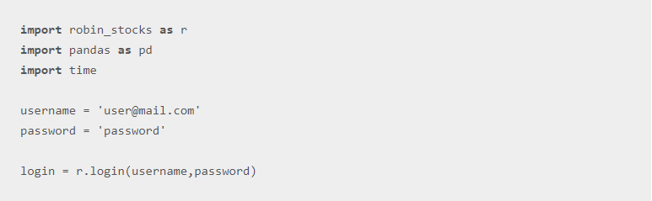

**Figure 7** Login to Trade Platform

When we pull the data from this platform we are logged in, an output like in Figure 8 appears.

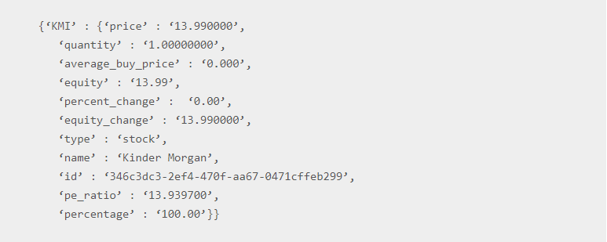

**Figure 8** Data Output

In Python, we can do data extraction in this way and then write an algorithm that analyzes this data and create a graph. However, it is much easier to access this data with the MetaTrader platform made for trading.

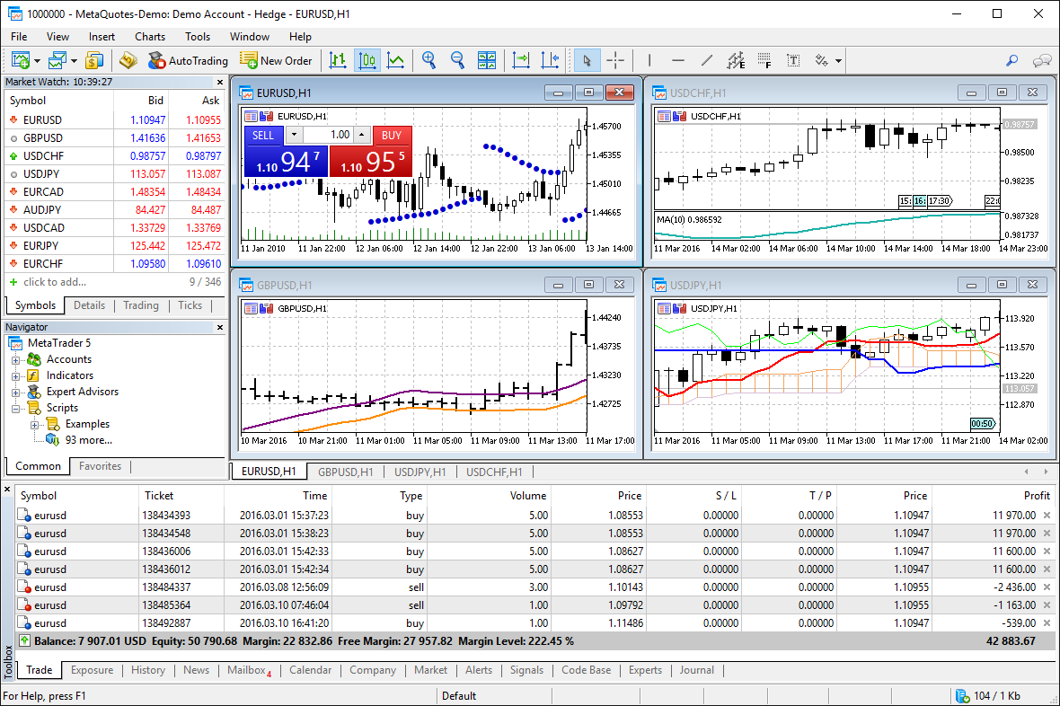

**Figure 9** MetaTrader

# 2. MATERIAL and METHODS

In this work, I will build an Expert Advisor algorithmic trading robot written in MQL4 language in MetaTrader. Due to easy-to-use features and general support for financial software, I use MQL4 (it is the main language of MetaTrader 4) to write algorithmic trading robots.

## 2.1. MetaTrader 4

There Although there are many software for performing transactions in the Forex market, MetaTrader 4 platform is preferred. The reason for this is that the platform is simple to use, more than 30 special indicators are included in the platform and there are online transactions and 9-time interactive graphics. Meta Trader 4 trading platform is built according to the structure of the Forex market; It offers rich opportunities such as technical analysis advantages, flexible investment opportunity, algorithmic investment and expert consultancy in accordance with all investor and investment levels.

In order for you to make successful transactions, Meta Trader 4 has functions of generating signals with Expert Advisor software and algorithmic programming functions that make automatic trading. If there is a movement in the market, it detects it and reacts in a timely manner so that you can catch and trade the investment opportunities in the market without being on the screen 24 hours a day. It has everything you need to invest in the Forex market.

# 3. EXPECTED BENEFITS

Trade harms those involved, such as indecision, fear of losing, or ambition to gain more. It also requires yourfull attention and time throughout the day. With this project, I aim that people can make trades without spendingthe whole day in front of the screen, without making losses due to indecision and emotions. While people cannot catch the sudden fluctuations in money inflow or money outflow, we can increase our profit rate with the help of a computer.

# 4. IMPACT

Nowadays, it has become quite common to invest, buy and sell through bots in stock exchanges. Especially it has become a common occurrence in crypto money exchanges because, as you know, crypto exchanges do not sleep, just like the enemy. Crypto money exchanges, which are waiting for 24/7 interest and relevance, cause most people to be sleep deprived, their nerves not worn out, and much more physical or emotional damage.

# 5. CONCLUSION

With this trade bot, I will provide investors with a higher trading performance by drawing a roadmap with algorithms in the complexity of the market where hundreds of data flows and affects each other at every moment. With the buy and sell algorithm I added, computers will decide on these transactions and thus investors will both save time and increase their profits.

# 6. PROBLEMS, DIFFICULTIES AND SOLUTIONS

Until an ordinary trader decides to buy and trade a trade, there is a lot of change in the trading system. Because it is possible to have huge falls and rises in trading systems within seconds. This could mean missing out on a more profitable situation for traders. Such situations have led people to program computers. For these situations, traders program a bot and ask the computer to make a decision for it and process it in seconds instead. Of course traders had a difficulty with this tradebot programming. Trade bots do not act with their emotions, they learn from the algorithm you have created, and they trade with this information. This means that when creating the tradebot, the combination of the algorithm to be created and the indicators to be used is very well thought out.

Traders want to write the best algorithm for tradebots. Because a bigger gain is the goal of all. So they should try every algorithm, every combination of indicators. In these cases, platforms such as Metatrader emerge as a solution. On such platforms, you can try the algorithms you have created in the demo version for a long or short time, and new solutions can be created from the results.

I aim to get rid of the complexity of data pollution that will occur when trading in this project. We will get rid of the confusion that occurs between the project I created and multiple data. With the algorithm I created, we will exit the positions we have entered profitably. In fact, the solution to all problems is to understand the system well and to write the best sell, buy, stop algorithms for this system.

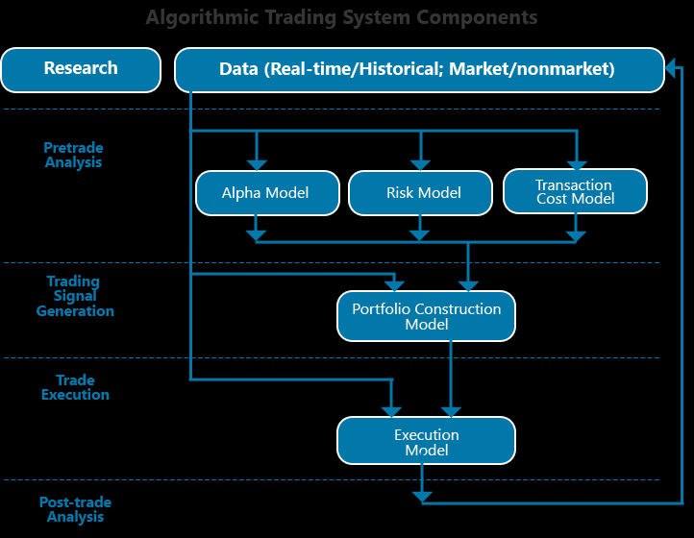

# 7. DATASET

In a tradebot design, you get data from exchange platforms. This platform contains a large number of classic currencies, stocks and cryptocurrency charts and data. In these cases, you introduce your bot to what to do in fluctuations in these graphs with your algorithm. Based on your strategy, the situations you have previously trained, and the experience gained afterwards, your bot will trade for you. Generally, the datasets used by traders are taken from Binance, Bitfinex, Poloniex, GDAX etc. The data in these datasets trades according to the strategy and as a result the bot creates a database in the form of buy and sell, average earnings.

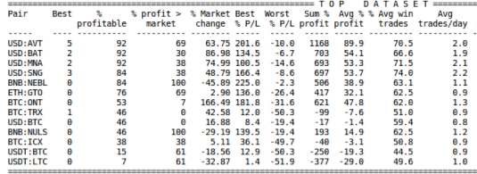

**Figure 10** Example Gekko Trade Bot DataSet

In fact, whatever currency you will trade in a tradebot, you use that unit's dataset and you expect your bot to trade with that data. You can determine a date range with the previous dates of these datasets in your project and pass the test phase. In this case, your dataset will be that date range.

# 8. PLATFORMS

Nowadays, a trading bot can be written in many languages ​​and many platforms can support it. These platforms and languages ​​obviously have their advantages and disadvantages. In this article, I will examine the most used platforms Metatrader4 and TradingView. In order to see the differences between these two platforms and to make a choice, we must examine them from all sides. These considerations should primarily be tools, design and performance. Considering the advantages in the following section, I decided the platform in my project as MetaTrader4.

## 8.1. MetaTrader 4

The first advantage of MT4 is direct access to market. This situation allows traders to enter the market directly with the project. The second advantage is simplicity and ease of access. MT4 is one of the first platforms made for trading. That's why its design is a bit simpler. This makes it a little outdated. However, its simplicity makes it easy to access and learn. When we consider the performance of MT4, it has a really great performance. This is because he has 15 years of experience and is constantly working to make the platform better. Today, these studies are still continuing, and the sites share information about these patches.

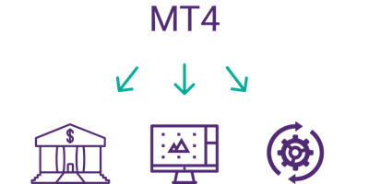

**Figure 11** MetaTrader4 Pros

## 8.2. TradingView

When you think of Tradingview, the community comes to mind first. Many experts using Tradingview share their experiences in this field. If you are a beginner trader, you can use these experiences to create an idea and use it in your projects. Another advantage of Tradingview is that it does not require registration. It is possible to perform many transactions without registration on the Tradingview platform. Registration only gives you access to extra features. The more you pay for the amount, the more tool usage you get. The last advantage I will mention in this article is almost every instrument. This means it does not need to be associated with any broker. You do not need to register anywhere and combine it with this platform to view currency charts, indicators or bands.

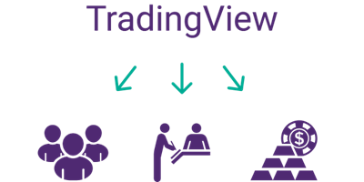

**Figure 12** TradingView Pros

# 9. REFERENCES

Sblendorio, D. (2020, June 11). How to Build an Algorithmic Trading Bot with Python. Retrieved December 20, 2020, from https://www.activestate.com/blog/how-to-build-an-algorithmic-trading-bot/

Sean, &amp; Crawley, P. (2020, December 11). Top 4 Indicators You Should Know About For Trend Trading. Retrieved December 20, 2020, from https://www.warriortrading.com/riding-the-trend-top-indicators-for-trend-trading/

Murphy, C. (2020, August 29). How Do 50-Day, 100-Day and 200-Day Moving Averages Differ? Retrieved December 20, 2020, from https://www.investopedia.com/ask/answers/06/differencebetweenmas.asp

MetaTrader 4 Nasıl Kullanılır? - Makale Arşivi. (2016, April 13). Retrieved December 20, 2020, from https://www.gcmforex.com/egitim/makale-arsivi/metatrader-4-nasil-kullanilir/

Fernando, J. (2020, December 07). Moving Average Convergence Divergence (MACD) Definition. Retrieved December 20, 2020, from https://www.investopedia.com/terms/m/macd.asp

Barone, A. (2020, October 26). Tackling Technicals for Beginners. Retrieved December 20, 2020, from https://www.investopedia.com/articles/active-trading/011815/top-technical-indicators-rookie-traders.asp

Admin. (2014, April 03). OBV (On Balance Volume) İndikatörü ve Yorumlanışı. Retrieved December 20, 2020, from https://www.bilgeyatirimci.com/i/on-balance-volume-obv-ve-yorumlanisi/

(n.d.). Retrieved December 20, 2020, from https://www.fiyatneder.com/?pnum=70