Engr421 Fall21

HW7: Expectation Maximization

İrem Demir, 69563

1. I imported data, initial centroids
2. I initialized D as dimension parameter
3. I defined update_memberships and update_centroids methods as in in the lab11.
   1. For the update memberships I also added one_K_coding so that it can be compatible with h matrix
4. For the E-M algorithm first h values are updated athrn meansicovs and priors are updated with respect to formulas given in the lecture notes.
5. H_calculator updates h matrix values with given formula, means calculate new means but uses h values instead of filtering with 1 or 0 for a class it has now values ranging between 0 to 1. Covariances and priors works with same logic.
6. I initialized variables and iterate em algoritm 100 times.
7. I plotted the graph with wanted features as given in the pdf file.

Formulas I used to drive h_calculator, means, covariances and priors:

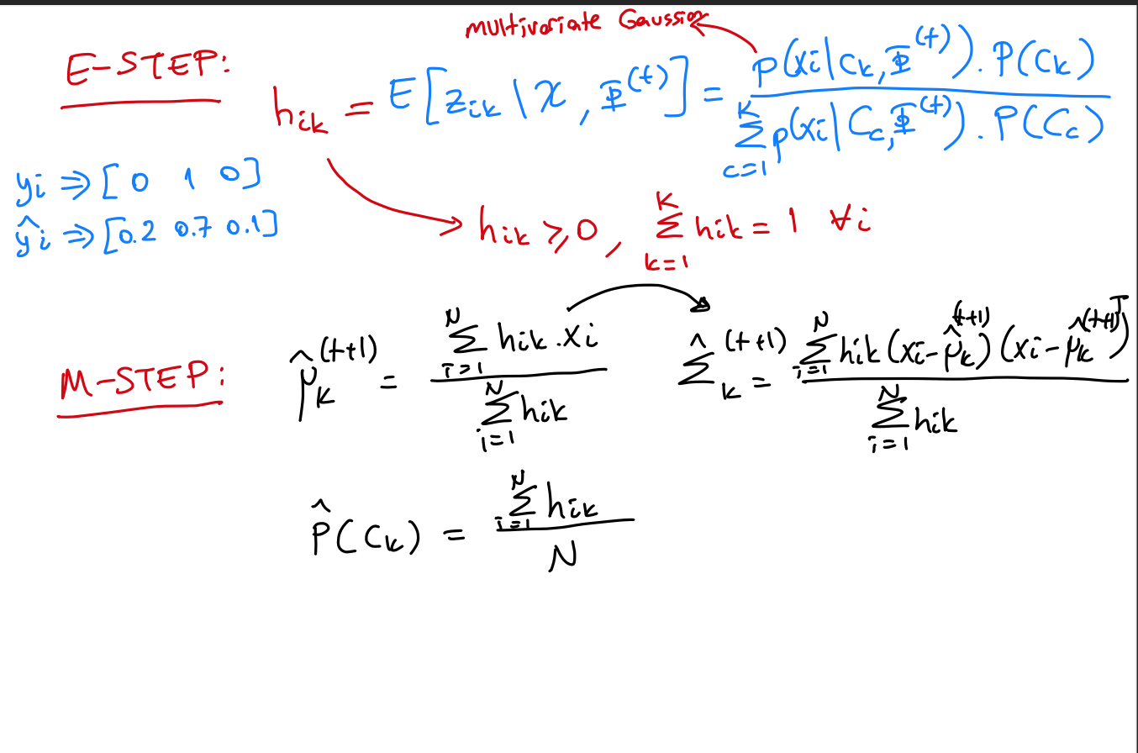

I plotted two different versions, one of them uses initialized means and covariances and priors calculated using initial_centroids other takes thm as given in the pdf. I understand that we should do the first one but the one I found using initial_centroids plots very different from pdf file and other plots same figure with the pdf I included both of them.