Comp 306- Group Project: OdinLibrary

*Alp Özaslan, İrem Demir, Özlem Şerifoğulları*

Project Repository: [OdinLibrary](https://github.com/iremddemir/odinlibrary)

Project Description:

OdinLibraryis a library application that a user can find books, authors, periods and can save their favorite books into lists that created by themselves. Books, authors, and periods have little information that a user can enjoy reading. Moreover, we generated a database that consists of books frequently asked in Turkish University Exam (AYT). One of our aims is to help students to get this exam related information in a structured way rather than mixed up PDFs and blogs that they can find on internet.

Entity-Relationship Diagram:

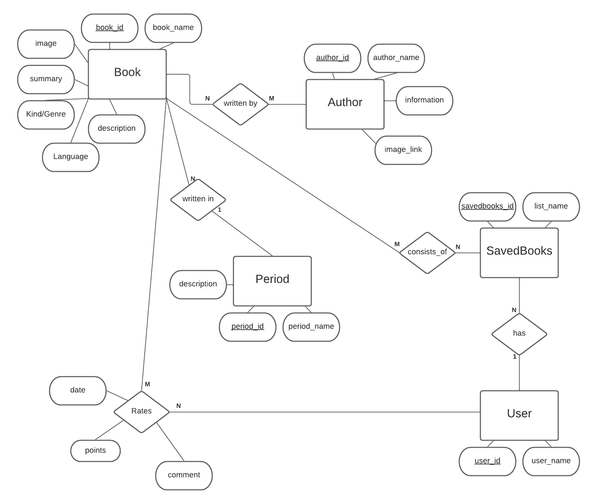

Relational Database Design:

Following the ER to Relational Model conversion algorithm we have obtained the following relations to create our OdinLibraryDB.

CREATE TABLE book

(

book_id INT,

book_name VARCHAR(500),

description VARCHAR(500),

summary VARCHAR(500),

image VARCHAR(500),

kind_genre VARCHAR(100),

language VARCHAR(100),

period_id INT,

PRIMARY KEY (book_id),

FOREIGN KEY (period_id) REFERENCES period(period_id)

);

CREATE TABLE author

(

author_id INT,

author_name VARCHAR(100),

information VARCHAR(500),

image_link VARCHAR(500),

PRIMARY KEY (author_id)

);

CREATE TABLE period

(

period_id INT,

period_name VARCHAR(100),

description VARCHAR(500),

PRIMARY KEY (period_id)

);

CREATE TABLE savedBooks

(

savedbooks_id INT,

list_name VARCHAR(100),

user_id INT,

PRIMARY KEY (savedbooks_id),

FOREIGN KEY (user_id) REFERENCES user(user_id)

);

CREATE TABLE user

(

user_id INT,

user_name VARCHAR(100),

PRIMARY KEY (user_id)

);

CREATE TABLE author_book

(

book_id INT,

author_id INT,

FOREIGN KEY (book_id) REFERENCES book(book_id),

FOREIGN KEY (author_id) REFERENCES author(author_id),

PRIMARY KEY (book_id, author_id)

);

CREATE TABLE user_book

(

book_id INT,

user_id INT,

date timestamp,

points INT,

comment VARCHAR(100),

FOREIGN KEY (book_id) REFERENCES book(book_id),

FOREIGN KEY (user_id) REFERENCES user(user_id),

PRIMARY KEY (book_id, user_id)

);

CREATE TABLE book_savedBooks

(

book_id INT,

savedbooks_id INT,

FOREIGN KEY (book_id) REFERENCES book(book_id),

FOREIGN KEY (savedbooks_id) REFERENCES savedBooks(savedbooks_id),

PRIMARY KEY (book_id, savedbooks_id)

);

Data Sources:

Our first aim was to populate a database that will be a good representative of university exam (AYT) questions so that students can benefit from a more structured, organized data rather than long websites. In the light of this, AYT related information is gathered from online resources and using various tools it is formatted in the MySQL insert into statements. We created a database that fits our aim. As a future expansion of our application, we are planning to add books and authors from different literatures and make our platform usable with various purposes.

Complex SQL Queries:

1) highest rating books by their period

select b.book_name, a.author_name, p.period_name, mt.total_points

from book b

join (select book_id, sum(points) as total_points

from user_book

group by book_id) bp on bp.book_id = b.book_id

join author_book ab on ab.book_id = b.book_id

join author a on ab.author_id = a.author_id

join period p on p.period_id = b.period_id

join (select p.period_id, max(total_points) as total_points

from book b

join (select book_id, sum(points) as total_points

from user_book

group by book_id) bp on bp.book_id = b.book_id

join author_book ab on ab.book_id = b.book_id

join author a on ab.author_id = a.author_id

join period p on p.period_id = b.period_id

group by p.period_id) mt on mt.total_points = bp.total_points;

2) authors that wrote in more than one period

select a.*

from author_book ab

join author a on a.author_id = ab.author_id

join book b on b.book_id = ab.book_id

join period p on p.period_id = b.period_id

group by a.author_id

having count(distinct(p.period_id)) >1;

3) fuzzy search on book_name with wanted book display information & this can be also applied to other searches

select ban.book_name, ban.description, ban.author_name, abr.average_bookrating from

(select avg(user_book.points) as average_bookrating, user_book.book_id from user_book group by user_book.book_id)abr right join

(select author.author_name, baid.book_name, baid.description, baid.book_id from author

join (select book.book_name, book.description, author_book.author_id, book.book_id from book

join author_book on book.book_id = author_book.book_id) baid on author.author_id = baid.author_id) ban

on ban.book_id = abr.book_id

where ban.book_name like '%hay%'

4) users with highest activity is in the last 3 month in order

-- can give limit function to limit number of records that will be shown

select u.user_name, COUNT(book_id) as book_count

from (select *

from user_book

where date > now() - interval 3 month) ub

join user u on u.user_id = ub.user_id

group by ub.user_id

order by book_count DESC;

5) most saved books in order

-- can give limit function to limit number of records that will be shown

select b.book_id, b.book_name, p.period_name, count(*) as book_saved_count

from savedBooks sb

join book_savedBooks bsb on sb.savedbooks_id = bsb.savedbooks_id

join book b on b.book_id = bsb.book_id

join period p on p.period_id = b.period_id

group by bsb.book_id

order by book_saved_count DESC;

Screenshots:

Ad