Analyzing Data Distributions: Histogram Creation and Normality Testing via

Kolmogorov-Smirnov Method

To derive a histogram from a dataset and check for normality using the Kolmogorov-Smirnov (K-

S) method, we can follow these steps:

**Step 1: Choose and Create the Dataset**

Let's create a synthetic dataset of 30-40 points. For simplicity, we can generate a dataset that is normally

distributed.

import numpy as np

import matplotlib.pyplot as plt

#Generate a dataset

np.random.seed(42)

#for reproducibility

data = np.random.normal(loc=50, scale=10, size=40) #mean=50, std=10, n=40

**Step 2: Create the Histogram**

Next, we will create a histogram of the dataset.

#Create a histogram

plt.hist(data, bins=10, alpha=0.7, color='blue', edgecolor='black')

plt.title('Histogram of Normally Distributed Data')

plt.xlabel('Value')

plt.ylabel('Frequency')

plt.grid(axis='y', alpha=0.75)

plt.show()

**Step 3: Check Normality Using the Kolmogorov-Smirnov Method**

To check for normality, we will use the Kolmogorov-Smirnov test, which compares the sample distribution

with a specified distribution, in this case, the normal distribution.

from scipy import stats

#Perform the Kolmogorov-Smirnov test

ks_statistic, p_value = stats.kstest(data, 'norm', args=(np.mean(data), np.std(data)))

#Display the results

print (f'K-S Statistic: {ks_statistic}')

print (f'P-value: {p_value}')

if p_value > 0.05:

print ("Fail to reject the null hypothesis - data is normally distributed.")

else:

print ("Reject the null hypothesis - data is not normally distributed.")

**Interpretation of Results:**

• The histogram provides a visual representation of the data distribution. For a normally distributed

dataset, we expect the histogram to be roughly bell-shaped and symmetric around the mean.

However, since our dataset contains only 40 points, the shape of the histogram may deviate

slightly from this ideal due to sampling variability. Small sample sizes can lead to irregularities in

the histogram, and the curve may not perfectly resemble the classic bell shape of a normal

distribution. This is a common occurrence with small datasets, as random fluctuations are more

prominent. As the sample size increases, these deviations tend to diminish, and the histogram

more closely approximates a bell curve.

• The K-S test results will help determine if the data significantly deviates from a normal

distribution. If the p-value is greater than 0.05, we fail to reject the null hypothesis, indicating that

the data can be considered normally distributed.

**Complete Code Example:**

Here’s the complete code to generate the histogram and perform the K-S test:

import numpy as np

import matplotlib.pyplot as plt

from scipy import stats

#Generate a dataset

np.random.seed(42)

#for reproducibility

data = np.random.normal(loc=50, scale=10, size=40) #mean=50, std=10, n=40

#Create a histogram

plt.hist(data, bins=10, alpha=0.7, color='blue', edgecolor='black')

plt.title('Histogram of Normally Distributed Data')

plt.xlabel('Value')

plt.ylabel('Frequency')

plt.grid(axis='y', alpha=0.75)

plt.show()

#Perform the Kolmogorov-Smirnov test

ks_statistic, p_value = stats.kstest(data, 'norm', args=(np.mean(data), np.std(data)))

#Display the results

print (f'K-S Statistic: {ks_statistic}')

print (f'P-value: {p_value}')

if p_value > 0.05:

print ("Fail to reject the null hypothesis - data is normally distributed.")

else:

print ("Reject the null hypothesis - data is not normally distributed.")

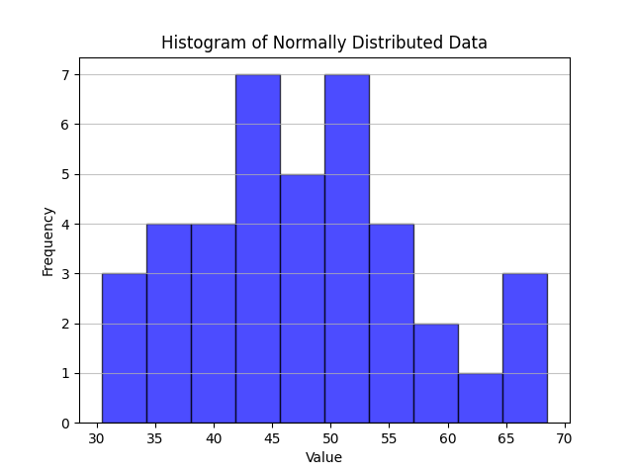

**Conclusion:**

This process will allow you to visualize your dataset's distribution and statistically assess its

normality. Adjust the normal distribution parameters in the dataset generation step to explore different

scenarios as needed.

**References:**

• Montgomery. D.C., & Runger, G.C. Applied Statistics and Probability for Engineers.

• Conover, W.J. Practical Nonparametric Statistics.

• Python.