# 

# **MOBILE PROGRAMMING HOMEWORK**

# **THIS REPORT IS PREPARED FOR**

# **İBRAHİM ATLI**

# **1105011023 İREM NUR SERDAR**

# **17.04.2016**

First screen is below

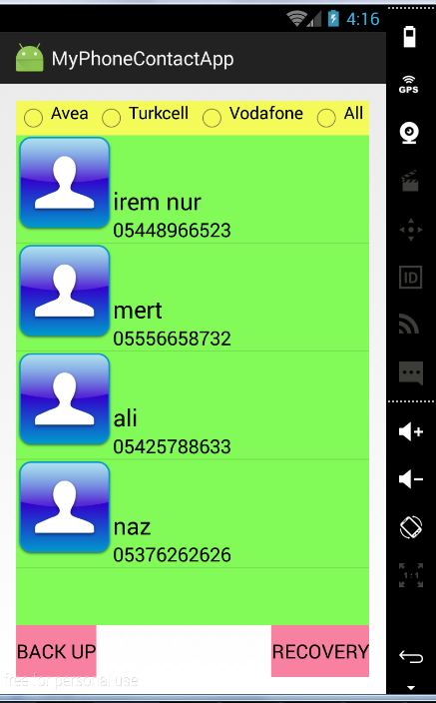

User can select Avea operator:

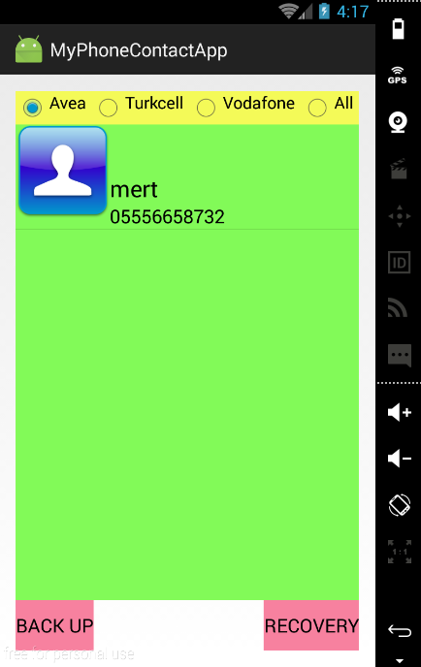

For filter Turkcell operator, click only Turkcell radiobutton;

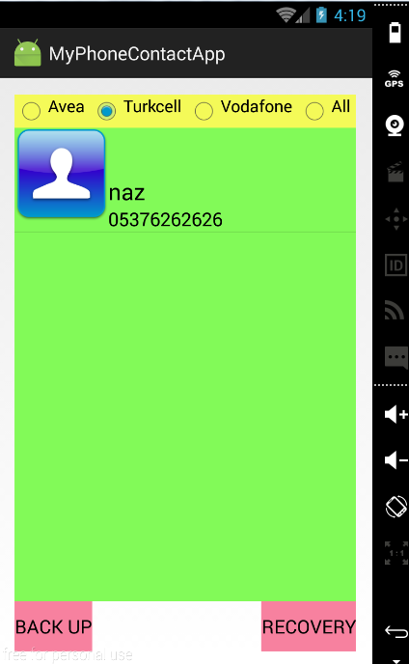

For filter Vodafone operator, click only Vodafone radiobutton;

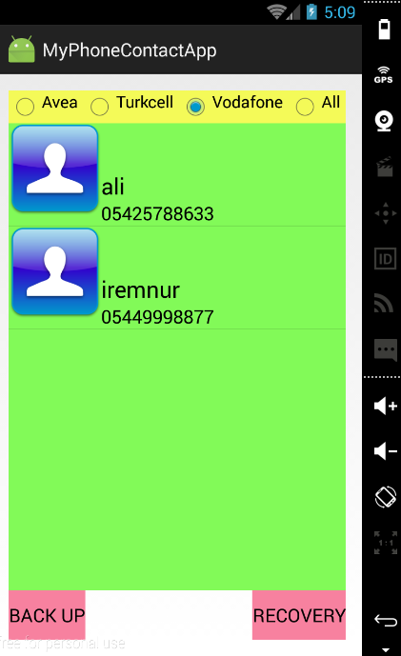

For see all contacts click all button;

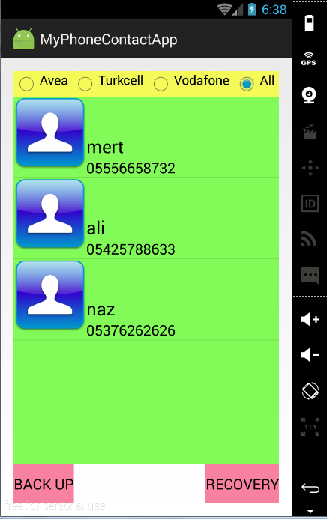

When person want to back up current contacts;

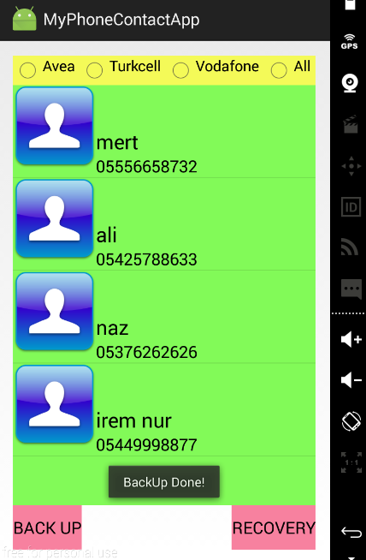

Then go to person and delete irem nur;

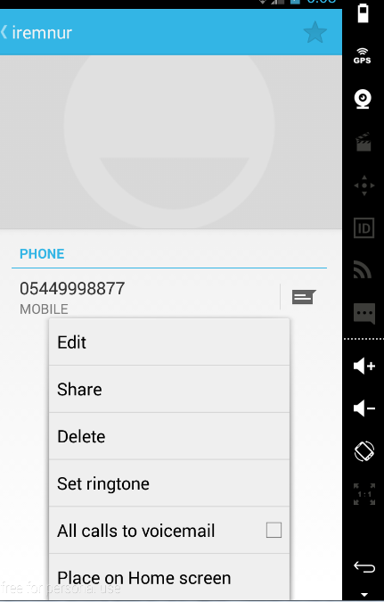

Now, current state is below;

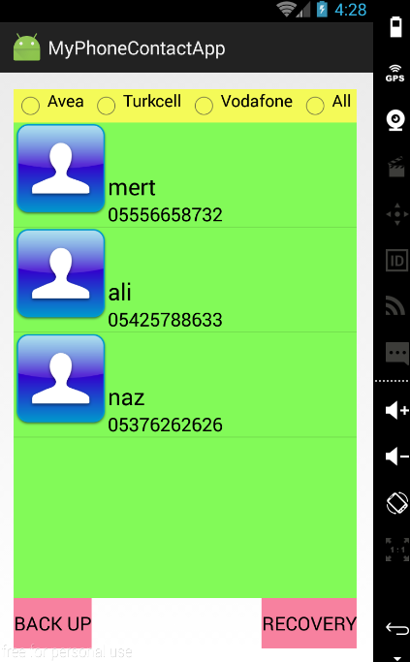

And then if you want to do recovery contacts;

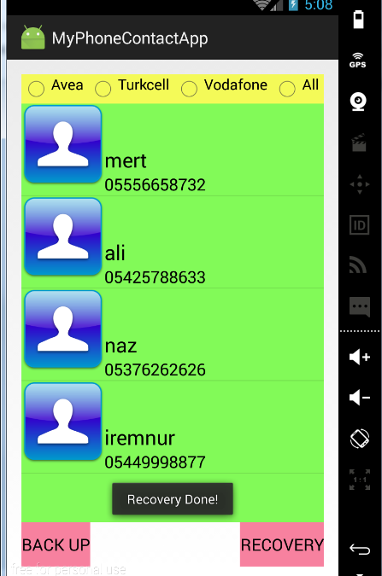

If we want to call someone , just click it.

