Food Ordering System (Database Project Report)
İremsu Ümit
Database Project – Mete Yaganoğlu

Project Purpose and Description
This project is a database-driven application developed for a Food Ordering System.
The main purpose of the project is to allow users to browse restaurants, view food menus, place orders, and submit reviews, while enabling restaurant owners to manage their products and customer orders efficiently.
The system is implemented using Microsoft SQL Server, and includes the use of tables, Stored Procedures, Triggers, Functions, and Views. The application is designed to operate based on different user roles, namely Admin, Restaurant Owner, and Customer.

Tables Descriptions:
dbo.User : Stores information about all users registered in the system.
This table inclüudes users with Admin, Restaurant Owner, and Customer roles.
dbo.Restaurant: Contains information about restaurants registered in the system.
Restaurant name, address, contact details, and ownership relationships are stored in this table.
dbo.Food: Stores information about food items offered by restaurants.
Food name, price, description, and the related restaurant information are included in this table.
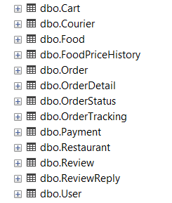
dbo.FoodPriceHistory: Keeps a history of price changes for food items by trigger.
When a food price is updated, the old and new prices are recorded in this table.
dbo.Cart: Stores the products added to the cart by users before placing an order.
Temporary cart information associated with each user is kept in this table.
dbo.Order: Contains general information about orders placed by users.
Order date, user details, and total amount information are stored in this table.
dbo.OrderDetail: Stores detailed information for each order.
Food items included in an order and their quantities are recorded in this table.
dbo.OrderStatus: Defines the status information of orders.
Order statuses such as Preparing, On the way, and Delivered are stored in this table.
dbo.OrderTracking: Used to track order status changes over time.
Each update of an order’s status and the corresponding timestamp are recorded in this table.
dbo.Payment: Stores payment-related information for orders.
Payment method, payment status, and relationships with orders are kept in this table.
dbo.Review: Contains user reviews and ratings for restaurants.
Each review is associated with a specific user and restaurant.
dbo.ReviewReply: Stores replies given by restaurant owners to user reviews.
This table allows restaurants to respond to customer feedback.

Stored Procedures (SP) Descriptions:
dbo.sp_AddFood: Allows restaurant owners to add new food items to the system.
Basic information related to the food item is inserted into the database through this procedure.
dbo.sp_UpdateFood: Used to update the information of an existing food item.
Changes such as price updates or other food details are handled by this procedure.
dbo.sp_AddToCart: Allows users to add selected food items to their shopping cart.
Product and user relationships during cart operations are managed through this procedure.
dbo.sp_ClearCart: Clears all items from a user’s shopping cart.
This procedure is used after an order is completed or when the user chooses to empty the cart.
dbo.sp_CreateOrderFromCart: Creates an order based on the items in the user’s cart.
Cart contents are converted into an order and related order records are generated.
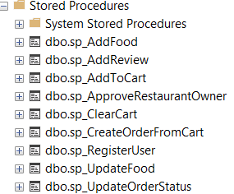
dbo.sp_UpdateOrderStatus: Used to update the status of an order.
Order statuses such as Preparing, On the Way, or Delivered are updated through this procedure.
dbo.sp_AddReview: Allows users to add reviews and ratings for restaurants.
Review information is stored and associated with the relevant user and restaurant.
dbo.sp_ApproveRestaurantOwner: Allows an administrator to approve a restaurant owner.
Once approved, the user becomes an active restaurant owner in the system.
dbo.sp_RegisterUser:Used to register a new user in the system.
Basic user information is inserted into the database through this procedure.

Triggers (TRG) –Descriptions
trg_AnonymizeReviewsOnUserDelete (User):When a user is deleted from the system, this trigger anonymizes the reviews created by that user. Reviews are preserved while the user’s identity is removed, ensuring data integrity.
trg_UpdateRestaurantRating (Review):This trigger is executed when a new review is added or an existing review is updated. It automatically recalculates and updates the average rating of the related restaurant.
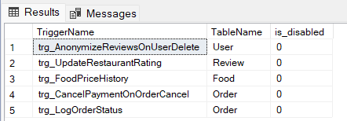
trg_FoodPriceHistory (Food): This trigger is activated when the price of a food item is updated.
It records the old and new prices in the FoodPriceHistory table to keep a history of price changes.
trg_CancelPaymentOnOrderCancel (Order):When an order is cancelled, this trigger automatically cancels the related payment record. This ensures consistency between order and payment statuses.
trg_LogOrderStatus (Order): This trigger is executed whenever the status of an order changes.
It logs the status change into the OrderTracking table to track the order’s progress over time.

Functions Descriptions
dbo.fn_SearchRestaurantsByCity (Table-Valued Function):Used to list restaurants based on the specified city information. It allows users to search for restaurants by city.
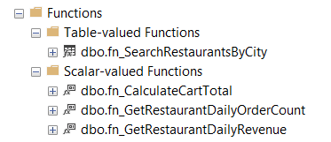
dbo.fn_CalculateCartTotal (Scalar-Valued Function):Calculates the total price of the items in a user’s shopping cart. The function returns the overall cart total based on the prices of the items.
dbo.fn_GetRestaurantDailyOrderCount (Scalar-Valued Function):Calculates the total number of orders received by a restaurant on a specific day. It is used to analyze daily order volume.
dbo.fn_GetRestaurantDailyRevenue (Scalar-Valued Function):Calculates the total revenue of a restaurant for a specific day. This function is used for daily revenue analysis.

Views Descriptions
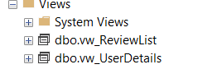
dbo.vw_UserDetails:This view is created to display detailed information about registered users in a single structure. It combines user-related data from multiple tables, enabling efficient and convenient usage on the application side.
dbo.vw_ReviewList: This view is created to list user reviews in the admin panel.
It allows restaurant reviews to be displayed together with user information through a single query.

ER Diagram Summary
The Entity Relationship (ER) diagram represents the overall database structure of the Food Ordering System. It illustrates the relationships between the main entities such as User, Restaurant, Food, Order, OrderDetail, Review, Payment, and OrderStatus.
A user can place multiple orders, while each order is associated with a single restaurant and consists of multiple order details. Restaurants can offer multiple food items, and users are able to submit reviews and ratings for restaurants.
Order statuses and payment information are managed through separate tables to ensure data normalization and maintain data integrity. Foreign key constraints are used to define relationships between tables and to preserve consistency within the database.

