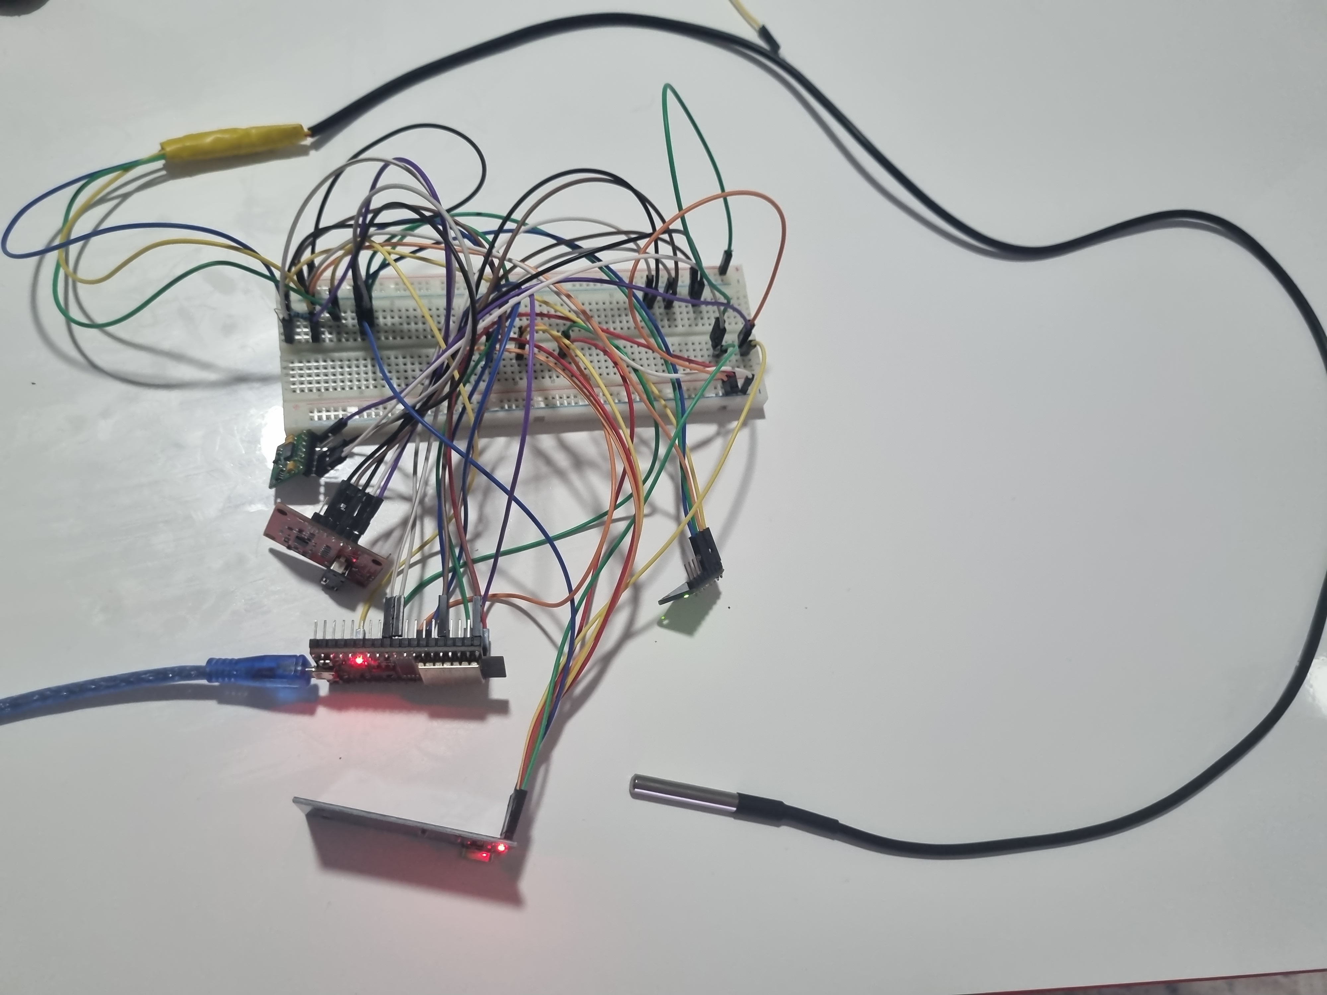

KULLANILAN SENSÖRLER
ESP32
MPU6050
DS18B20
AD8232
MAX30102
BUZZER
RFID

MEDIATRACK İÇİN KULLANILAN KÜTÜPHANELER
#include <WiFi.h>
#include <HTTPClient.h>
#include <ArduinoJson.h>
#include <Wire.h>
#include <MPU6050.h>
#include <OneWire.h>//Tek hat haberleşme spı
#include <DallasTemperature.h>//Sıcaklık
#include "MAX30105.h"
#include "spo2_algorithm.h"
#include <SPI.h>
#include <MFRC522.h>
#include <time.h>

