AKILI CL
Governed Procedural Memory for AI Agents
Public Technical Brief - v0.1 Alpha
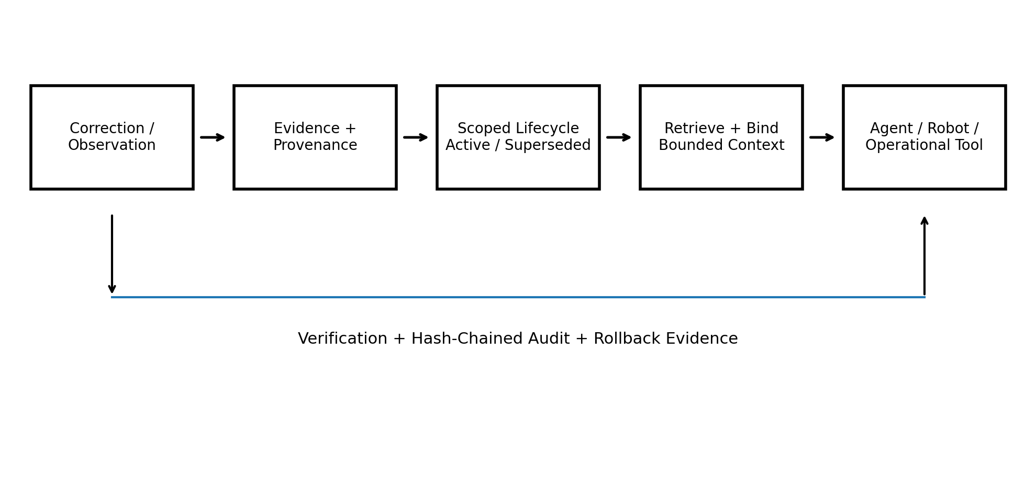
Prepared by Irénée Akilimali
shukranimungu@gmail.com
29 July 2026

1. Executive summary
Akili CL is a scoped, versioned and auditable procedural-memory runtime for AI agents. It is designed for situations where an agent must remember the currently valid user preference, repository convention, operating procedure or tool rule without replaying the complete interaction history.
The project now has a frozen evidence portfolio covering controlled coding-agent capability, procedural-memory mechanism, cross-model verified-procedure transport and long-horizon lifecycle stability. The results are reported separately because they answer different questions.
The public alpha provides a small local runtime, Python package and CLI. The next build adds the service API, MCP server and coding-agent adapter. Commercial products will focus on hosted infrastructure, enterprise controls, private integrations and vertical applications in SOC/security, energy, robotics and edge systems.

2. Problem and design
Long conversation history and conventional vector retrieval can return relevant text, but they do not inherently govern which version is active, which scope owns it, whether an older rule was superseded, or how the retrieval can be audited. Akili treats memory as governed state rather than an unstructured archive.
- Scope isolation: Memories are separated by repository, user, organisation, site, robot or another explicit scope.
- Versioned lifecycle: New admitted procedures supersede older active versions instead of silently overwriting them.
- Provenance: Every active record identifies where it came from.
- Bounded retrieval: Only the active relevant state is assembled into the agent context.
- Auditability: State changes and retrievals are recorded in a hash-chained audit log.
- Model independence: The memory runtime can sit around different LLMs, tools, coding agents or robotics systems.

3. Evidence portfolio
Evidence | Frozen result | Claim supported | Boundary
Controlled real-repository coding agent | 144/144; ~77.5% prompt reduction | Repository-specific procedural memory under executable hidden tests | Controlled multi-file fixture repositories, not arbitrary public GitHub projects
V3.1.1a | 57/57 held-out code tasks; ~88.1% prompt reduction | Immediate teaching, restoration, specificity and bounded prompts | Controlled protocol
V4-MA-E2.2 transport | 432/432 across Qwen and Mistral; ~78% reduction | Cross-model restoration and transport of verified procedures | Not autonomous program synthesis
V4 generation | 101/108 frozen held-out; formal near-miss | Structural generation from restored conventions | Underspecified argument roles plus genuine model errors; result not rerun
Mac Horizon | 500,000 episodes; bounded and audit-valid | Long-horizon deterministic lifecycle stability | Not production networking, concurrency or LLM quality

3.1 Permanent integrity rule
The V4 structural-generation result and the V4-MA-E2.2 verified-contract transport result must never be merged into one narrative. V4 remains a frozen near-miss. E2.2 is a complete pass for a different and narrower question.
“Post-run analysis found both an underspecified interface around argument roles and genuine model-generation errors. The frozen result was not modified or rerun.”

4. Public alpha and product pathway
The first public release is deliberately small. It provides a local SQLite lifecycle store, explicit memory admission, automatic supersession, provenance, hash-chained audit, a Python package and a CLI that emits an agent context bundle. It does not yet call an LLM.
- Build a stable service API around the same lifecycle implementation.
- Expose the API through an MCP server rather than creating a second memory engine.
- Connect the MCP/API to a coding agent and show which memories influenced each patch.
- Recruit three to five developers using repeated tasks in real repositories.
- Build the Isaac Lab flagship using verified procedure contracts, scope isolation and audit.
- Develop SOC/security, energy, edge/vision and personal-AI adapters on the shared platform.

5. Open-core and commercial model
The public repository is Apache License 2.0. Commercial use of that public code is permitted. Paid products are separate services and private extensions rather than restrictions that contradict the open-source licence.
- hosted persistence and managed infrastructure;
- private-repository and team integrations;
- enterprise authentication, encryption, policy and audit controls;
- advanced retrieval, ranking and memory-quality controllers;
- SOC/security, energy, robotics and edge integrations;
- support, deployment and custom engineering.

6. Isaac Lab flagship
The proposed flagship is an Akili Warehouse Apprentice. A robot receives a corrected placement or safety procedure, performs an unrelated task, returns later, restores the active procedure, suppresses a superseded rule and exposes the provenance and audit chain. The first demonstration is about procedural memory and governance, not robotics policy-learning SOTA.

7. Long-term neural continual learning
The earlier neural track is parked with a diagnosed problem map rather than abandoned. Stable and plastic states were useful separately, while forced consolidation damaged both; routing also remained far below oracle selection. When the track resumes, Akili will govern adapter or expert artifacts instead of immediately merging weights.
- router problem <-> Akili scoped retrieval;
- merge problem <-> lifecycle governance;
- stable/plastic separation <-> governed adapter bank;
- unsafe consolidation <-> promotion, rejection and rollback.
This research resumes only after the public runtime, coding-agent alpha and early commercial pathway are established.

