Vorticity Curvefit

From the Batchelor Model of vortex, the equation of X-vorticity was obtained by taking the curl of Batchelor model velocity.

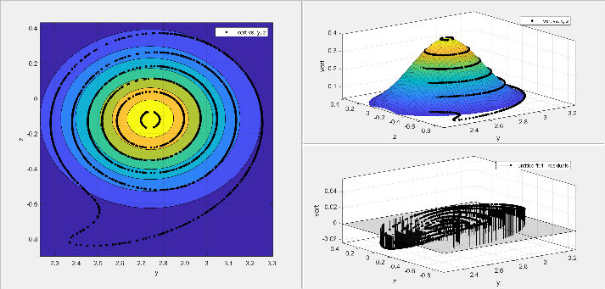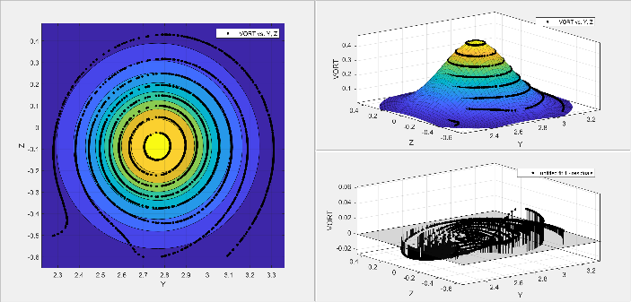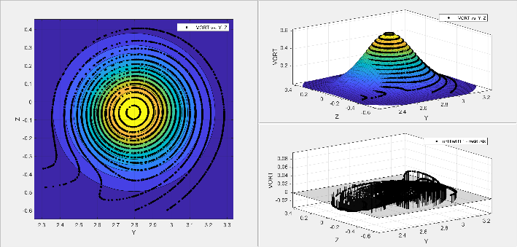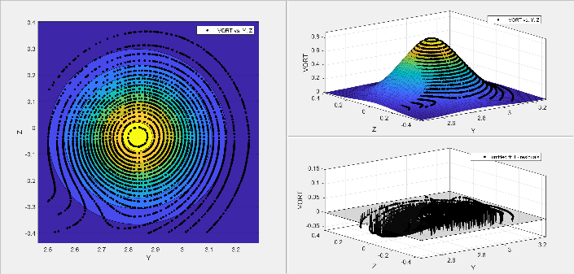

At X/c= 20

Core: Y=2.7685, Z=-0.08635

At X/c= 15

Core: Y=2.798, Z= -0.05823

At X/c=10

Core: Y=2.834,,Z=0.034425

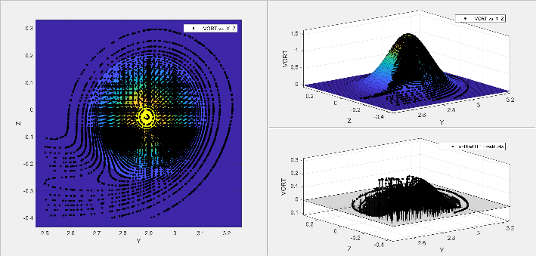

At X/c= 5

*Core: Y=2.8915,Z=-0.03034*

At X/c= 25

Core: Y=2.741, Z=-0.1155

General model used for the curvefit:  
 f(x,y) = (a/b^2)* exp(-((x-2.8915)^2+(y+0.03034)^2)/b^2)

|  |  |  |  |  |  |
| --- | --- | --- | --- | --- | --- |
|  | X/c= | X/c= | X/c= | X/c= | X/c= |
| a | 0.04017 | 0.0438 | 0.04591 | 0.04729 | 0.04822 |
| b | 0.1619 | 0.2271 | 0.277 | 0.3181 | 0.3537 |

Velocity Curvefit

From the Batchelor model, the equation of X-velocity is .

The curve fit was performed to this equation using the data extracted from simulations and it was concluded to be right as the free constant in the curvefit was approaching 1 corresponding to the free stream velocity.

At X/c= 15

Core: Y=2.86, Z=0.915

At X/c= 20

Core: Y=2.871, Z=1.168

At X/c= 5

Core: Y=2.918, Z=0.3507

At X/c= 10

Core: Y=2.88, Z=0.659

At X/c= 25

Core: Y=2.855, Z=1.376

|  |  |  |  |  |  |
| --- | --- | --- | --- | --- | --- |
|  | X/c=5 | X/c=10 | X/c=15 | X/c=20 | X/c=25 |
| a | 0.989 | 0.9947 | 0.9937 | 0.9869 | 0.9825 |
| b | 0.005885 | 0.004812 | 0.06786 | 0.05933 | 0.05704 |
| c | 0.1043 | 0.1281 | 0.1406 | 0.1482 | 0.1567 |

General model used to curvefit:

f(x,y) = a+b*(0.221/c)^2*exp(-((x-y0)^2+(y-z0)^2)/(c^2))

From the data of the curve fit, this 3D plot of velocity was obtained, and further the 2d data along Y and Z axis shows that the velocity drops significantly at r=0.1040 which was predicted as the core radius from the curve fit.

2D Plot along Y-axis

2D Plot along Z-axis

It was observed that the vorticity center and velocity center do not coincide especially the Z coordinate.

Y coordinate comparison

Z Coordinate comparison

Azimuthal Velocity Curvefit

Using the Y velocity and Z velocity at a particular X/c position, the Azimuthal velocity was found taking the vortex center as the origin of polar coordinates. The azimuthal velocity equation from the Batchetor model to which the data was curvefit to is

At X/c= 10

Core: Y=2.834, Z=-0.034425

At X/c= 5

Core: Y=2.8915, Z=-0.03034

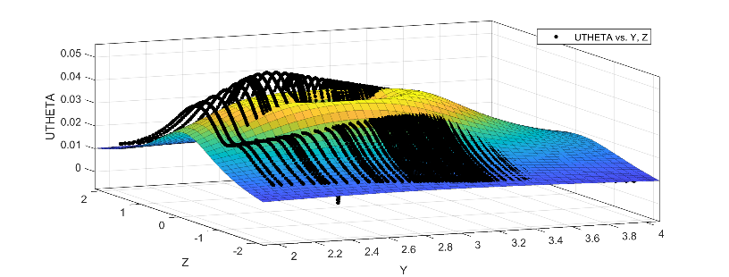

At X/c= 15

Core: Y=2.798, Z=-0.05823

At X/c= 20

Core: Y=2.7685, Z=-0.08635

At X/c= 25

Core: Y=2.741, Z=-0.1155

|  |  |  |  |  |  |
| --- | --- | --- | --- | --- | --- |
|  | X/c=5 | X/c=10 | X/c=15 | X/c=20 | X/c= 25 |
| c | 0.185 | -0.2547 | 0.3015 | -0.34 | 0.3735 |
| k | 0.02238 | 0.02387 | 0.02436 | 0.02461 | 0.02473 |

General model used to curve fit: f(x,y) = (k/sqrt((x-2.8915)^2+(y+0.03034)^2)) * (1-exp(-((x-2.8915)^2+(y+0.03034)^2)/c^2))

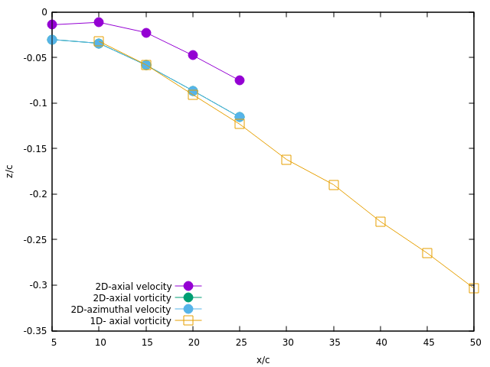

The vortex core size from the three different curve fits in comparison to the 1D data in a research paper

The core center Y coordinates from the three curve fits

The core center Z coordinates from the three curve fits