Ballin-nemesis

Ireneo Mercado III

CS270 Project

## Motivation

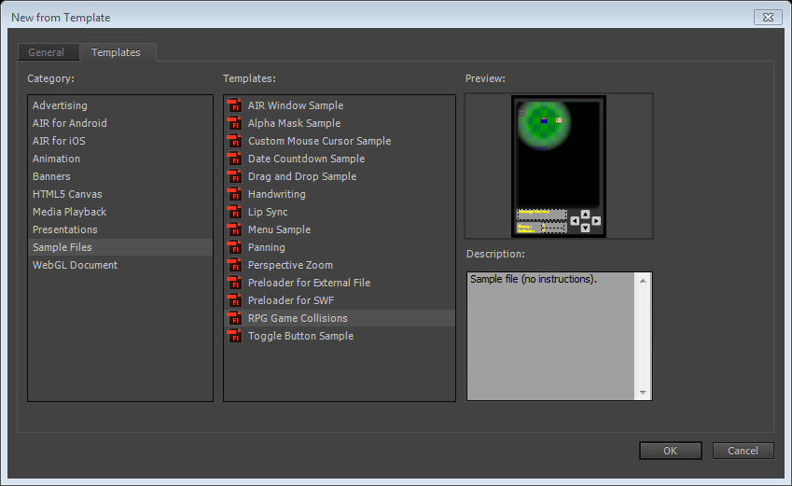

Figure 1 Flash CC Professional sample files

## Animation

https://helpx.adobe.com/flash/how-to/create-character-animation.html

* It is recommended that any animated symbols should have its own layer.
* Two types of quick animations are ready in flash just by setting the starting and end frames:

1. Motion tween – automatic positioning in between key frames.
2. Shape tween – automatic shaping in between key frames. No symbol objects.

## Adobe Air

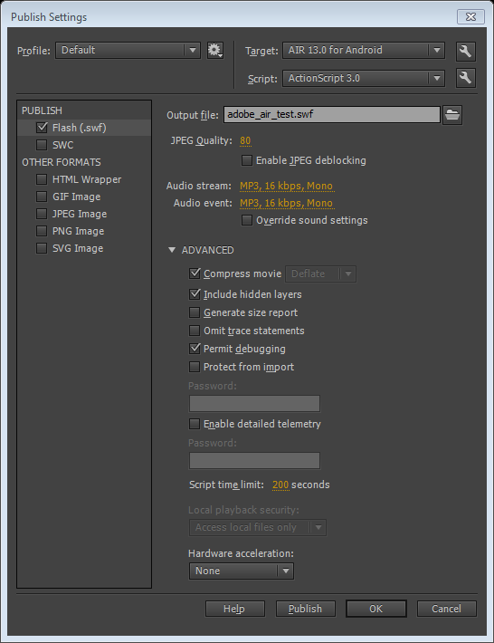

Figure . Adobe Air publish settings

Tutorial for setting up a simple application in Adobe Air.

http://help.adobe.com/en_US/air/build/WS901d38e593cd1bac-2ae4ef8612b2d078909-8000.html

Few bugs getting it to work in my own device. Fixed with checking the tick box to always allow USB debugging in my android phone and in adobe air publish settings, enabling permit debugging allowed my device to install the sample application instead of looping the publishing window endlessly.

## SmartFoxServer

http://www.smartfoxserver.com/docs/1x/docPages/as3/html/index.html

Following the instructions on the website. Found a way to test the basic examples is by using incognito windows from google Chrome, using basic windows doesn’t seem to work like the SFS documentation say.

## Game Login Screen (SmartFoxBits)

<http://bits.smartfoxserver.com/overview>

Watch video after installing the extension.

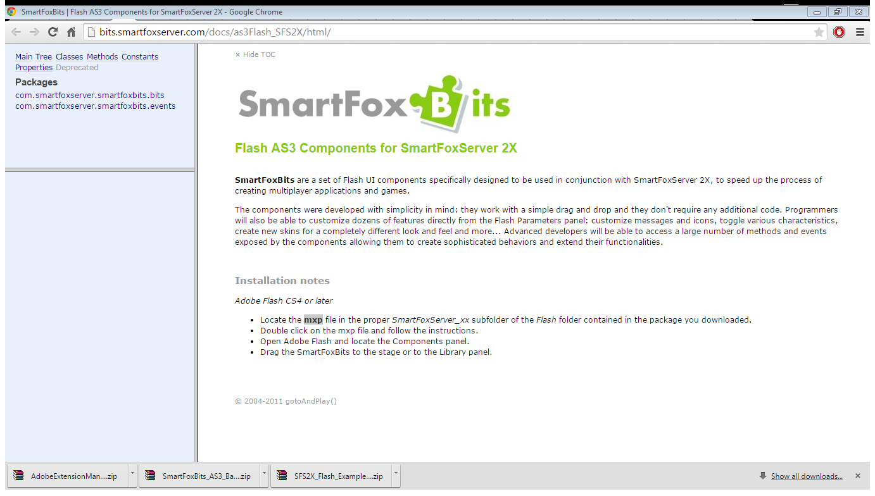

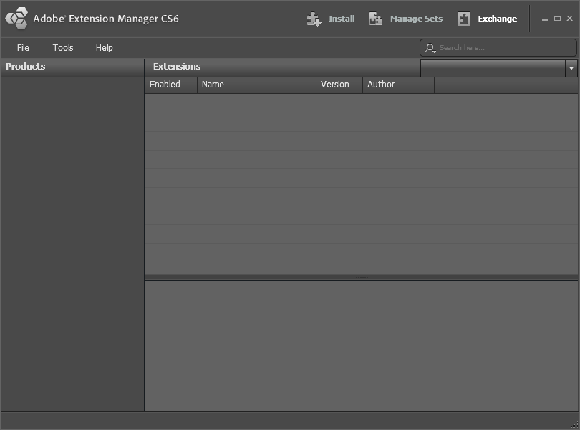

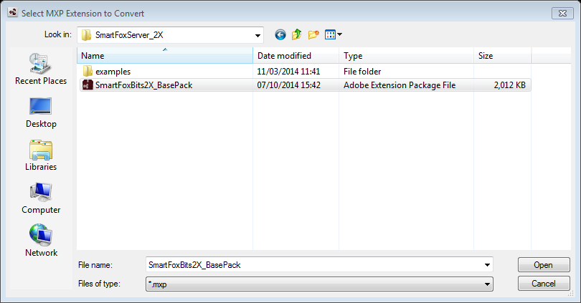

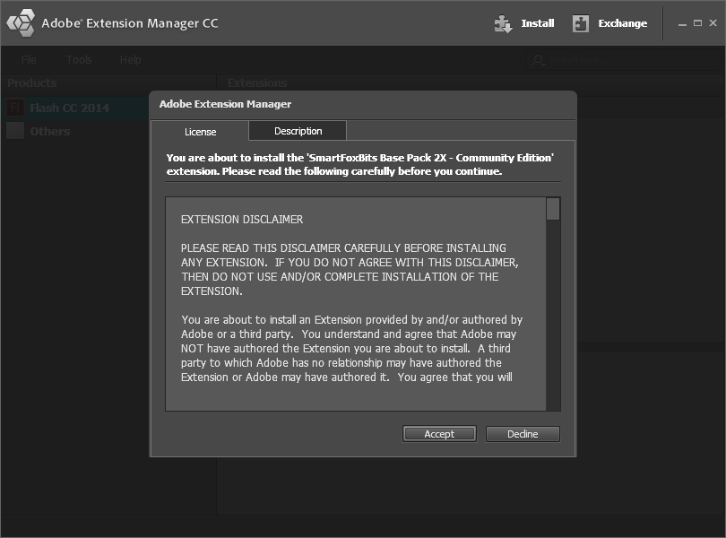

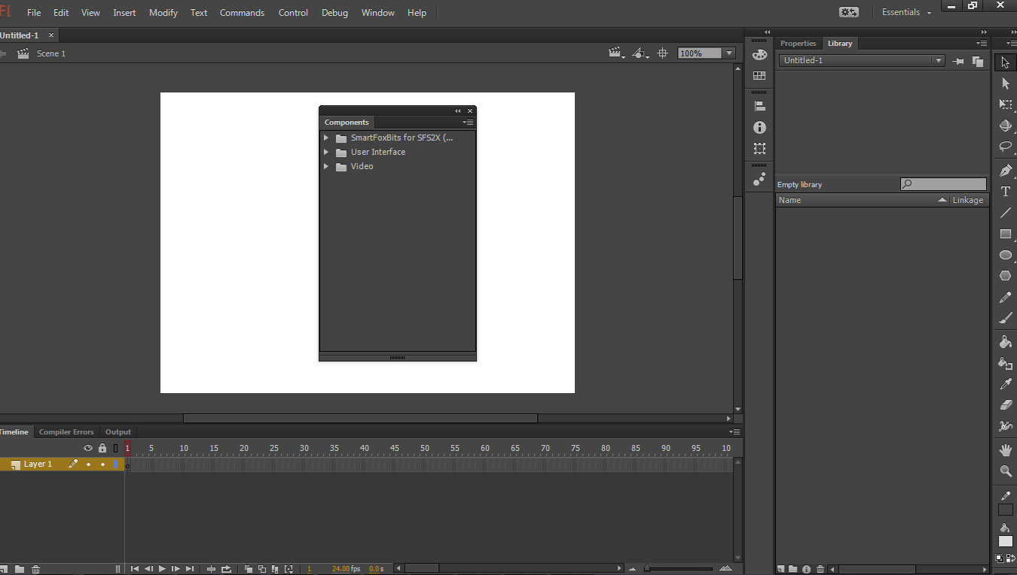

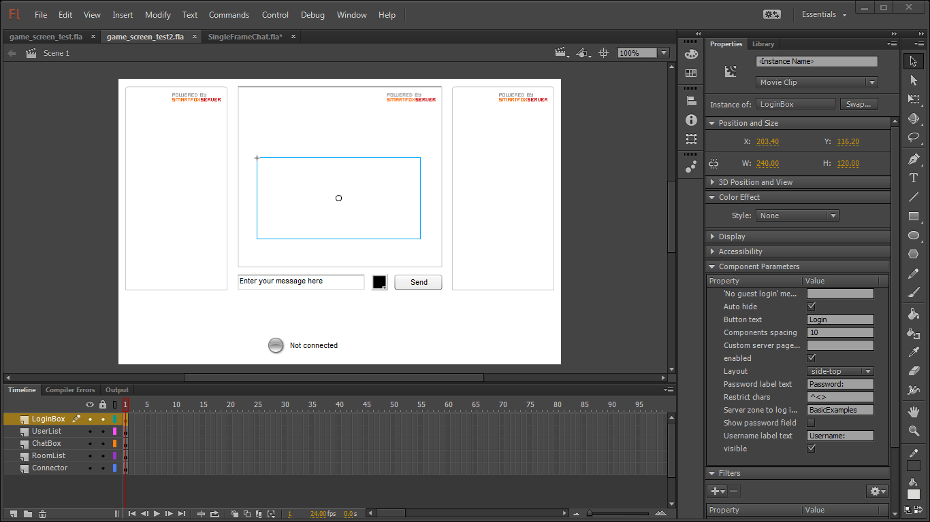

## Port-Forwarding

Setuprouter.com

<http://setuprouter.com/router/cisco/epc3925/port-forwarding.htm>

Doesn’t work if both client and server are in the same network

http://www.smartfoxserver.com/forums/viewtopic.php?p=48343#48343

## ActionScript 3.0

<http://www.adobe.com/devnet/actionscript/learning.html>

Objects and classes – new, one purpose

Writing classes – capital letter

Inheritance – extending classes. Override

Encapsulation – hiding complexity.

Composition and aggregation – combining classes.

Polymorphism and interfaces- contracts