

Discussion Forums Guide

|  |  |
| --- | --- |
| Document Version: 1.0 | University of Phoenix |
| June 2012 | Online |
|  | (800) 366-9699 |
| © 2012, University of Phoenix | |

Help and tips for online students of University of Phoenix

Contents

Navigating the Discussion Forums u4

Getting to the Discussion Forums 4

The Discussion Forums 6

The Main Forum 6

Chat Room 6

Course Materials 6

Learning Team Forums 6

Individual Forum 7

My Items 7

Posting to the Discussion Forums 8

Creating Threads 8

Replying to a thread 8

Using the Word Processing Tools 9

Spell Checking your Post 16

Attaching a File to a Post 17

Sorting and Organizing Threads 18

Selecting the Forum View 19

Navigating Threads 19

Appendix A – Posting Tips 21

Appendix B – Setting up your Signature 22

Figures

Figure 1 - Classroom access from the Home page. 4

Figure 2 - The Discussion Forum. 5

Figure 3 - The Class List 5

Figure 4 - The reply screen 9

Figure 5 - Numbered List of Functions 10

Figure 6 - The Paste dialog box. 12

Figure 7 - The Find dialog box. 13

Figure 8 - The Replace dialog box. 13

Figure 9 - The Table Properties dialog box. 14

Figure 10 - The Smiley dialog box. 15

Figure 11 - The Symbol dialog box. 16

Figure 12 - The Spell Checker dialog box. 17

Figure 13 - The File Open dialog box. 18

Figure 14 - Forum Preferences dialog. 22

# Navigating the Discussion Forums

The discussion forum is the section of the classroom dedicated to online class work. As the name implies, the discussion forum is the place where you will post your responses to discussion questions and reply to the posts from other students and your instructor..

## Getting to the Discussion Forums

Once you have logged in, access the classroom from the **eCampus Home** page, and click on the **Discussion** link to access the discussion forums for your course. If you need to access previous or future classes, click on the **Previous** or **Future** tab first. See Figure 1 for an example.

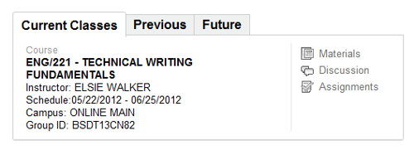

pFigure - Classroom access from the Home page.

**Course Name:** Clicking the course name on the left, ENG/221 – Technical Writing Fundamentals in Figure 1, brings you to the **Materials** section of the classroom.

**Materials**: This link also takes you to the **Materials** section of the classroom.

**Discussion**: This link takes you to the **Discussion Forums** for the currently selected class. We will discuss the contents of this tab in depth.

**Assignments**: You will use this section to upload the papers, PowerPoint presentations, and other documents that you will create for your classes.

Once you have entered the classroom, you will be presented with an image similar to Figure 2. In the upper left-hand corner you will see the name of the class.

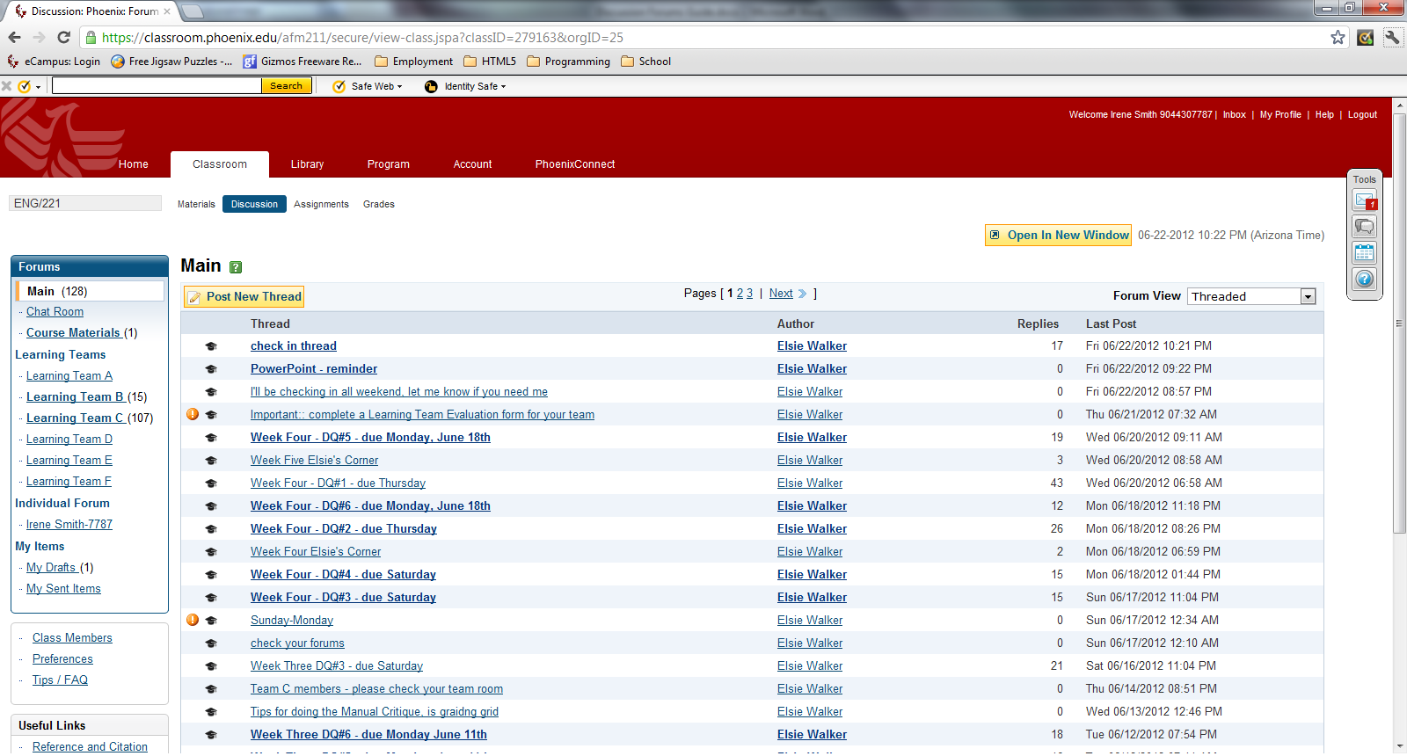

Figure - The Discussion Forum.

There are several things on the page that you will find useful for navigating within the classroom, including:

* **Course Name** – The course name is also a drop-down list that includes previous classes and/or future classes. (See Figure 3 for an example.)

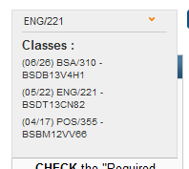

Figure - The Class List

* **University of Phoenix website sections** – Home, Classroom, Library, Program, Account, and PhoenixConnect. (See Figure 2.)
* **Classroom Sections** – The classroom sections including: Materials, Discussions (the currently selected section), Assignments, and Grades. . (See Figure 2.)
* **Open in New Window** – This button will open the discussion forums page in a new browser window.
* **The current date and time in Arizona** – This comes in handy if you don’t live in the same time zone. This will help you keep track of the time so you don’t end up missing the deadline for posting, which is always midnight in Phoenix, on whatever day a project or post is due.

## The Discussion Forums

The discussion forums are where you interact with your fellow students. Part of your time every week will be spent answering the discussion questions posed by your instructor.

### The Main Forum

The main forum is where you will find and answer the weekly discussion questions. The number discussion questions, the day by which they must be answered, and how many words constitute a complete answer, will vary by course. The details should be posted by the instructor. If not, make sure to ask what your instructor expects.

### Chat Room

The chat room is often where you will post your biography. It is also the location for discussions with your fellow classmates and teachers that are not directly related to class work.

### Course Materials

Your instructor may post further information here about your course material. For example, the teacher may create a PowerPoint presentation or Word document that will give you further information about working on a project or expand on information in your readings.

### Learning Team Forums

You will be assigned to a learning team for each course. There are up to six forums lettered A through F. Access your forum to participate in team discussions and to upload work done for team assignments so that the rest of the team can review and discuss it.

### Individual Forum

The Individual Forum is where you will interact directly with your instructor. Posts made in this section are only available to you and your instructor.

If you have anything you wish to discuss privately with your instructor, post it here by clicking on **Post New Thread** directly above the list of threads in this forum. The contents of this forum are specific to the course associated with the current classroom. *Only the instructor for that course can view your posts.* Instructors for other courses you have taken or will take cannot access the individual forum threads for the current course.

### My Items

This section shows the items you have posted to the discussion forums, to the team forum, and to your individual area. This is a good place to check your participation to make sure that you have made the appropriate number of posts to the main forum for the week.

# Posting to the Discussion Forums

This section will teach the user how to create and reply to posts. It is important that you become comfortable with posting to the Discussion Forum in order to satisfy the participation requirements for your courses.

The discussion section automatically loads to the Main discussion module. The differences between the modules have been explained in the previous chapter. You will need to become comfortable with the functionality of the Discussion Forum. In this section you will learn to:

* Create and reply to threads
* Use the word processing functions to create posts
* Sort and organize the threads for easier navigation

## Creating Threads

In order to participate in the forum, you will need to learn how to create and reply to threads.

NOTE: It is not appropriate for students to create a new thread in the man forum unless the instructor tells you to do so.

To create a new thread, perform the following steps:

1. Click **Post New Thread**
2. Enter a subject in the **Subject** field
3. Type your message in the **Body** section
4. Click **Post Message**
5. Follow directions for spell check

The steps for replying to a thread are very similar. Replying to discussion question threads will count for most of the class participation grade.

## Replying to a thread

1. Left click on the thread
2. Locate the message requiring a reply
3. Left click on the “Reply” hyperlink
4. Enter a subject in the “Subject” field
5. Type message in the “Body” section
6. Left click on Post message
7. Follow directions for spell check
8. Close window

NOTE: All posts should include a signature. This usually includes the student’s name, email address, and location. To learn how to set up a signature that will be applied to every post you make, see Appendix B – Setting up your Signature.

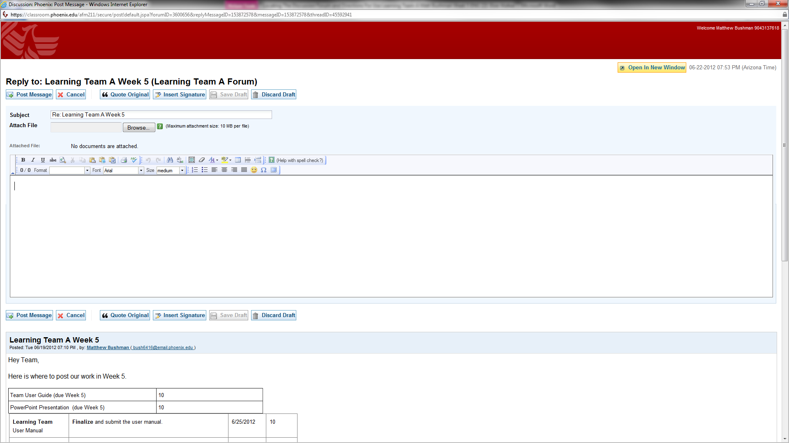

Figure - The reply screen

## Using the Word Processing Tools

Once you have created a new post or replied to an existing post, you will see an editing screen similar to Figure 4.

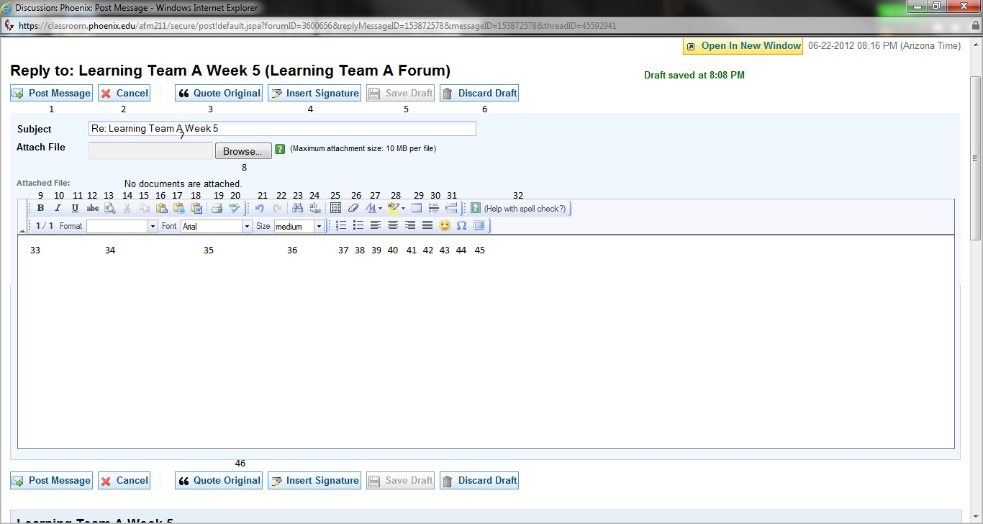

Figure - Numbered List of Functions

In order to allow students to express their opinions, answer questions and maintain communication, common word processing functions have been included in the post editor. Figure 5 shows the post editor with the function numbered for easy reference.

1. **Post Message –** Click **Post Message** to post it to the forum. If Auto Spell Check has been enabled in your forum preferences, a spell check will be performed. If Auto Spell Check is turned off, the message will be posted to the forum immediately.
2. Cancel Message – Cancels editing of the message. The contents will be lost if the draft was not saved.
3. **Quote Original Message –** Inserts the text of the original message into your reply.
4. **Insert Saved Signature- I**nserts the text of your signature at the cursor position.
5. **Save Draft –** Saves a copy of your message in My Drafts for future use. This comes in handy if you have to close the browser or otherwise navigate away from the page. Once save to My Drafts, you can return to the message and finish editing it before you actually post it to the forum.
6. **Discard Draft –** This button cancels editing of the post but it also removes any draft copy of the message from the My Drafts folder.
7. **Subject Field –** This will be filled in with the subject of a thread if you are replying to an existing post. You can edit it if you want to, but that is not required.
8. **Browse Button –** Click this button to browse and attach files from your computer to your post. (See Attaching a File to a Post for details on how to attach a document to your post.)
9. **Bold –** This works just like the Bold button in a Word Processor like Microsoft Word. If the selected text is not bold, it will be formatted as bold; if it is already bold, the bold formatting will be removed. If not text is selected, clicking this button toggles bold on or off.
10. **Italics –** The same as bold. Toggles whether or not the selected text is italic. If no text is selected, the next text typed will be formatted as italic.
11. **Underline –** The same as bold. Toggles whether or not the selected text is underlined. If no text is selected, the next text typed will be underlined.
12. **Cross Out –** The same as bold. Toggles whether or not the selected text is formatted with a line through it.
13. **Preview –** Opens a new browser window or tab with the text of the reply as it will look when posted.
14. **Cut –** Copies the selected text to the clipboard and then removed it from the post. If no text is selected, there is not effect.
15. **Copy –** Copies the selected text to the clipboard.
16. **Paste –** Pastes the current contents of the clipboard into the post. Instead of pasting directly into the post, a dialog box will appear into which you must post your text. (See Figure 6.) It is actually faster to use the keyboard shortcut Ctrl-V, which pastes the contents of the clipboard directly into memory. Any formatting applied to the contents of the clipboard will be retained in either case.

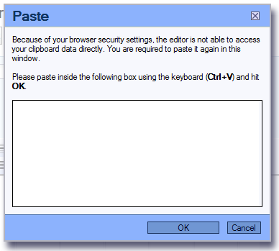

Figure - The Paste dialog box.

1. **Paste as Plain Text** – Pastes the contents of the clipboard as plain text with no special formatting. Once again, the paste dialog box will appear. The only difference is the title which would be “Paste as Plain Text.” (See Figure 6.)
2. **Paste from Microsoft Word** - Pastes the contents of the clipboard as plain text with no special formatting. Special Microsoft Word formatting will be removed. Once again, the paste dialog box will appear. The only difference is the title which would be “Paste from Word.” (See Figure 6.)
3. **Print Post** – Prints the contents of the editor.
4. **Spell Check** – Checks the spelling of what you have written. This will be done automatically when you post your message, but you can use this button to perform the spell check without posting the message. See Spell Checking your Post for details on using the Spell Checker.
5. **Undo** – Undo the last action you performed on the contents of the text box.
6. **Redo** – Redo the last thing that you undid using the **Undo** button.
7. **Find** – Pops up a dialog box into which you can type the text you wish to find. The checkboxes will allow you to optionally match the case of the found text to what you have typed into the dialog box. You can also elect to match whole words only so that “for” will only match the word “for” but not “force”, “enforce”, or “fortune”.

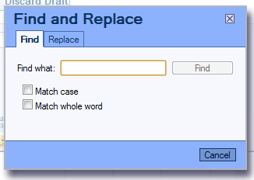

Figure - The Find dialog box.

1. **Replace** –Once you have entered the text for which you wish to search and the text with which to replace it, click **Replace** to find the next instance and replace it. Click Replace All to find and replaces all instances of the search text in your post.  
     
   As with Find, you can match the case to what you have typed and you can also choose to find whole words only.

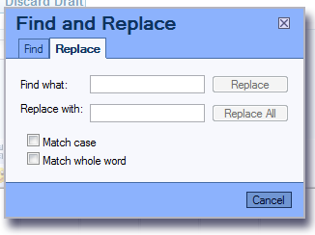

Figure - The Replace dialog box.

1. **Select All** – Selects all of the text in the post.
2. **Remove Format** – Removes any special formatting from the selected text.
3. **Text Color** – Sets the color of the selected text. If no text is selected, any text typed will have the newly selected color applied to it.
4. **Background Color** – Sets the background color of the selected text. If not text is selected, any text typed will have the newly selected background color applied to it.
5. **Insert/Edit Table** – Allows you to insert a table into your post or edit the properties of an existing table. When you click this button, a dialog box will appear allowing you to define the properties of your table as shown in Figure 9.

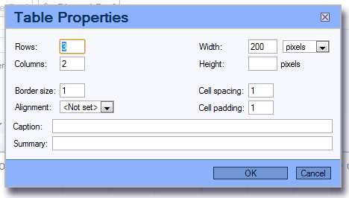

Figure - The Table Properties dialog box.

1. **Insert Horizontal Line** – Inserts a horizontal line into your post.
2. **Insert Page Break** – Inserts a page break into your post. A page break appears in the edit box as a light blue, double line and will not create an actual page break until you print the post.
3. **Help with Spell Check** – Opens a separate window with help for using the spell checker.
4. **Word Count/Char** – Shows the number of words and the number of characters in your post.
5. **Format Dropdown List** – Allows you to select from a few pre-defined formats for the current paragraph. There are 10 pre-defined formats: Normal, Heading 1 through Heading 6, Formatted, and Address. The default format is Normal.
6. **Font Dropdown List** – Allows you to pick the font for the selected text. If no text is selected, the next text typed will be formatted using the selected font. Note that not all of the fonts on your computer will be made available. There are only six fonts: Arial, Comic Sans, Courier New, Tahoma, Times New Roman, and Verdana. The default font is Verdana.
7. **Font Size drop down** – Allows you to select a font size from xx-small to xx-large.
8. **Numbered List** – Toggles the format of the current paragraph to and from a numbered list.
9. **Bulleted List –** Toggles the format of the current paragraph to and from a bulleted list.
10. **Left Justify** – Left-aligns the text of the current paragraph.
11. **Center Justify** – Centers the text of the current paragraph.
12. **Right Justify** – Right-aligns the text of the current paragraph.
13. **Block Justify** – Formats the text of the current paragraph so that both margins are aligned by adding additional spaces between words.
14. **Insert a Smiley** – Pops up a list of all the possible smiley faces. Click on one to insert it at the current cursor position as in Figure 10.

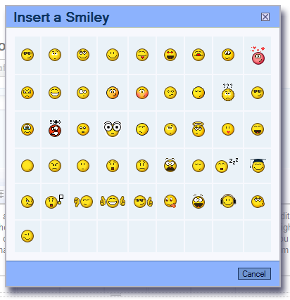

Figure - The Smiley dialog box.

1. **Select Special Character** – Pops up a dialog box containing symbols that you can insert in your document as in .

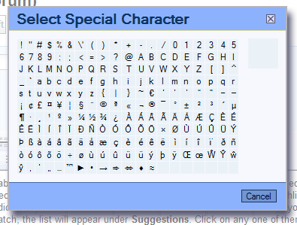

Figure - The Symbol dialog box.

1. **Maximize/Minimize the Editor Size** – Another toggle button that toggles between the default page view and a view that shows only the editing area and the buttons.
2. **Same as 1 – 6** – These are the same as the buttons describe in 1 through 6 above. They are repeated here so that you don’t have to scroll up to the top of the screen to post if you have written a post long enough to scroll the screen.

## Spell Checking your Post

You can spell check your post one of two ways. You can click the Spell Check button described above. This allows you to check your spelling and then continue editing your document. When you post your message by clicking on Post Message, you will also have an opportunity to check the spelling of your post if you have enabled Auto Spell Check in your forum preferences.

Either way, a special spell checker dialog box will open. (See Figure 12 for an example of the **Spell Checker**.) This dialog box will highlight each questionable word in your post. Click **Change** to use one of the selections, **Ignore** to leave the word as is, or **Add to Dictionary** to add the selected word to the dictionary. If there is more than one instance of the selected word, you can also click **Change All** to change all instances of the word to one of the suggestions or **Ignore All** to leave all instances as they are. If there is more than one possible match, the list will appear under **Suggestions**. Click on any one of them if the suggestion chosen by the spell checker is not the one you want to use. You can also type text directly into the text box if none of the suggestions is correct.

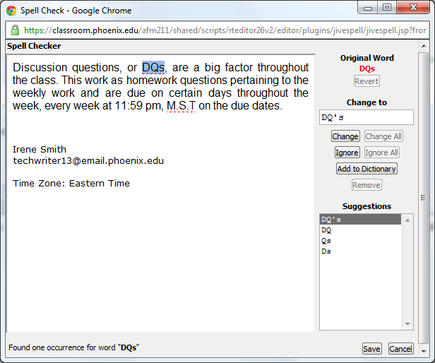

Figure - The Spell Checker dialog box.

The **Save** button save a draft with any changes you have made while using the spell checker. If the Spell Checker appeared because you posted the message, the **Save** button will be labeled **Post** instead. The Cancel button will cancel the spell check and return to editing your post.

## Attaching a File to a Post

Attachments are files or folders containing various pieces of information that you want to send to your fellow students or instructor along with your post. To attach a file to a post you are editing:

The Choose File button will open your Documents Library, shown in

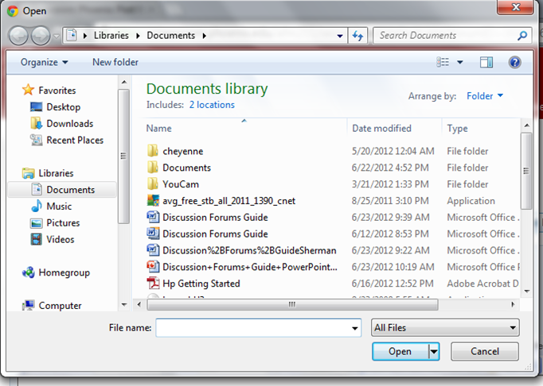

Figure - The File Open dialog box.

You must choose which file you will be attaching by clicking on the name of the file, this file will appear in the File name box. Once your file is selected, click the **Open** button, to send your file as an attachment to your post.

**NOTE:** The maximum attachment size is 10 Mb per file. If you exceed the limit, you will receive an error message indicating that you exceeded the limit and the attachments will not be transmitted.

Once the attachment is received and showing in your Reply to: thread you can now click on the Post Message button and your reply will be sent along with your attached file.

## Sorting and Organizing Threads

In order to make navigation through the threads easier and to assist students in locating important messages, the threads offer several sorting and visual options to keep the student up to date. The amount of messages that accumulate throughout a class can be overwhelming, if the student loses track of their progress. The following options are available to students.

It is important to note the icons that may appear next to a post.

|  |  |
| --- | --- |
| Icon | Meaning |
|  | This means that a post was by the currently logged in student |
|  | This means that the post contains an attachment |
|  | This means the post was created by the instructor |
|  | This means the post was substantive |
|  | This means that the post is of a high priority |

## Selecting the Forum View

The forum view drop down box allows the student to sort the forums discussion threads in the following ways:

|  |  |
| --- | --- |
| Sort Option | Result |
| Threaded | Sorts by thread. Threads with the most recent posts will appear at the top of the list. |
| Message by Date | Shows every post in the module in reverse chronological order, from the newest to the oldest. |
| Unread Messages | Shows messages that have not been read or that have been marked as unread.  The subject of unread messages and threads with unread message appear in bold. In order to mark a message as read, right click on the message. In order to mark the message as unread again, click on the “Mark as unread” hyperlink. |
| Flagged Messages | Shows all messages that have been marked with a flag.  To mark a message with a flag, click on the “Flag Message” hyperlink. |

## Navigating Threads

When in a discussion forum module, right click on the desired thread.

When in a thread, right click on “Previous” or “Next” hyperlink to go to other threads.

Only 20 threads appear on a page. If module has more than 20 threads, use the “Pages” hyperlink to navigate to older and newer threads.

Familiarizing yourself with the location and functionality of the Discussion Forum will be an important skill to master during your time at the University of Phoenix. It will make class participation, team work, and even casual communication more efficient. New students are required to participate in the New Student Orientation, which will enforce the students’ acumen with the system.

# Appendix A – Posting Tips

Discussion questions, or DQs, are a big factor in all your classes. The questions usually pertain to the weekly reading, and are due on certain days every week. The day it is due, a post must be submitted before 11:59 pm, Arizona time.

* **Every class has different requirements for discussion questions.** The number and schedule you must follow will be given to you in a document or post with a title similar to “Instructor’s Policies.” If you don’t receive the information from your instructor, please contact him or her early to clarify what will be expected from you. You wouldn’t want to lose points because you didn’t know when something was due.
* **There is usually a minimum length for discussion questions and sometimes a different minimum for participation posts.** Again check the rules set out by your instructor and if you can’t find the information, ask.
* **The point value for discussion questions and class participation also varies from class to class.** Consult your syllabus and the instructor’s policies for details.

When you post keep the following in mind:

* **Always consider your audience and their feelings.** In an online environment nobody can see the smile on your face; they can only read your words. You cannot see the effects your comments have on others either. Be mindful of the audience. It is unlikely that everyone will agree with you, but we learn to communicate, understand, and solve for a common interest.
* **An important aspect of the online classroom environment is diversity.** You should talk to others as you would like to be spoken to. Negative online language and behavior disrupt from the learning experience and this can affect not only yourself but others you communicate with, robbing them of an enriched learning environment.

# Appendix B – Setting up your Signature

Below the list of forums on the left side of the discussion forums screen, you will find a link to Preferences. Click on that link and you will be able to create a signature that will automatically be added to each of your posts.

On the preferences page, you can set the way you want your name to appear on the thread lists, you can set the default format and font for posts, and whether the spell checker should run automatically when you post your message. Finally, if you wish, you can have new posts created in a new and separate window.

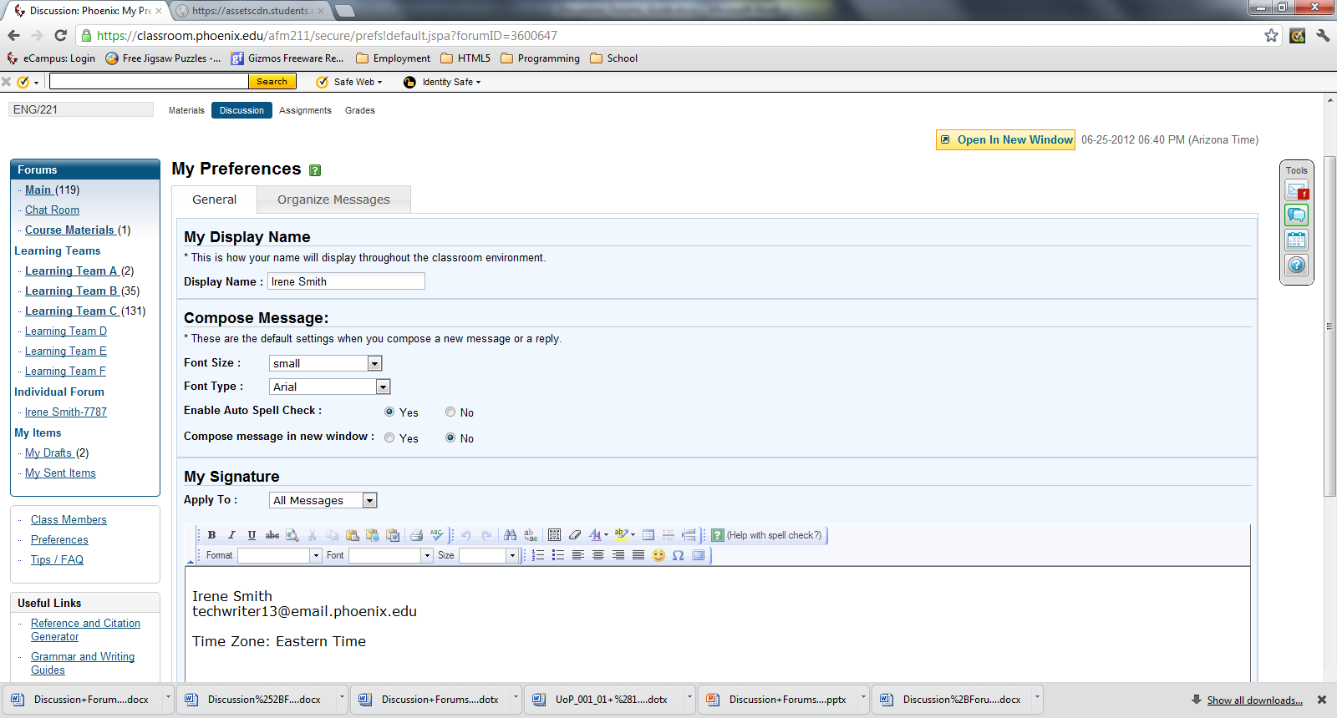

Figure - Forum Preferences dialog.

At the bottom of the screen, under “My Signature” you can edit and format the text you want to use for your signature. The tools are exactly the same as those you use to edit your posts. When you have finished, click **Save Preferences**. And you will be ready to go.