Solecito y felicidad

Irene Tornero Pinilla

28 de marzo de 2019

## INTRODUCTION

It is well-known that climate influences people happiness (Rezende *et al.* 2007)

## METHODS

datos<-read.table("data.txt", header=TRUE)

modelo<-lm(happiness~sunshine, data=datos)

We interviewed 100people and fitted a linear model.

## RESULTS

We found that happiness is positively related to sunshine hours (0.0100228).

library(visreg)

## Warning: package 'visreg' was built under R version 3.5.3

visreg(modelo)

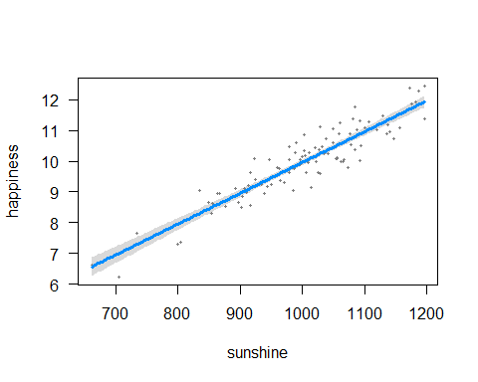

library(knitr)

## Warning: package 'knitr' was built under R version 3.5.3

library(xtable)

## Warning: package 'xtable' was built under R version 3.5.3

kable(xtable(modelo))

|  |  |  |  |  |
| --- | --- | --- | --- | --- |
|  | Estimate | Std. Error | t value | Pr(>|t|) |
| (Intercept) | -0.0651657 | 0.4264970 | -0.1527928 | 0.8788758 |
| sunshine | 0.0100228 | 0.0004232 | 23.6833264 | 0.0000000 |

## DISCUSSION

Sunshine is good for happiness.

## REFERENCES

Rezende, E.L., Lavabre, J.E., Guimarães, P.R., Jordano, P. & Bascompte, J. (2007). Non-random coextinctions in phylogenetically structured mutualistic networks. *Nature*, 448, 925–928.