Rough notes

Visual classification

(talk about other models, but go more in depth for one model)

Visual recognition tasks:

Semantic segmentation
--> tension between recognition and localization
--> amount (and therefore speed) of computation
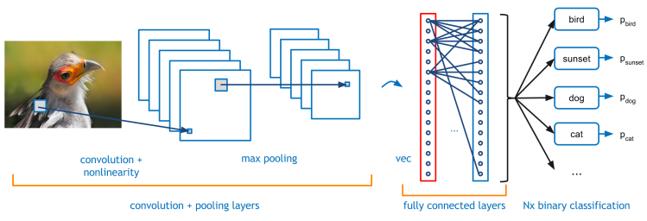
source: Caffe in a Day tutorial

Deep learning:
- stacking layers
- learning end-to-end

layer is a transformation
deep networks stack different layers of different types of transformation,
networks run layer-by-layer
learning: the error is passed back from the output back to the input, and goes through the layers again to fine tune

important question: what kind of layers to stack:

Types of layers:

Matrix multiplication, learns linear transformation
x' = Wx + b
= [weight][input] + [bias]
sometimes, it's not a straight line that passes through to classify data --> non-linearity

y = [weight2] max( 0, [weight1(x)])

but linear steps collapse and stay linear, not meaningful to stack

Rectified linear unit vs sigmoid

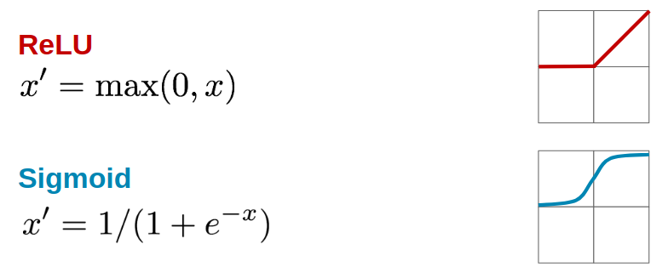

Issues as of July 10th, 2018:

Png not high resolution, loses

want script to automatically export xml too, in the format of ImageNet

Want to attempt to use dt1 files, the arrays themselves as numpy arrays, issue is that tensorflow does not support

^ further improvements(???)

rip resolution not very high

