“Application of Machine Learning Models as a Solution to Hyperbola Identification in Ground Penetrating Radar Data”

University of Waterloo
Work Term Report

Sensors & Software Inc.
Mississauga, Ontario

Written by:
XiangYi (Irene) Chen
ID 20707344
xy29chen

1B Software Engineering
August 20, 2018

Implementation

Memorandum of Submittal
Irene Chen
x
x
x

August 20, 2018

Dear ___,

The following work term report, entitled “Application of Machine Learning Models as a Solution to Hyperbola Identification in Ground Penetrating Radar Data”, has been prepared for Sensors & Software Inc as my first work term report for my 1B term. The objective of this work term report is to explore the feasibility of different machine learning models to the problem of hyperb

I’d like to thank Sensors & Software Inc for providing for the data set and other resources needed to retrain the models

And my supervisor Adam Fazarri for the guidance along the way.

As well as my coworkers

Dave Redman

and the Training department Greg Johnson, ____ for furthering my understanding of GPRs.

Disclaimer
The pre-trained models and their retraining modules are publicly available on github. They’ve been applied with proprietary GPR data provided by Sensors and Software, Inc.

The following assumes that the reader has a base knowledge in computer science and statistics, as well as a general awareness of machine learning. Terminology and theory will be explained as necessary.

Abstract

Introduction
Interpretation of Ground Penetrating Radar (GPR) data is one of the most error prone aspects of using GPR solutions.

Sensors & Software Inc’s software is able to apply velocity fitting and other transformations to improve and simplify data interpretation. However, the first step is being able to locate a hyperbola: evidence of a disturbance in the soil caused by an object.

However, recently, machine learning has been making many advances in the field of image classification.

Machine learning (ML), in the broadest of terms, is a subset of computer science which allows programs to improve and “learn” without explicitly being told what exactly to do—the construction of algorithms that is able to make predictions based on recognition of patterns on a data set.

Specifically, classification ML problems generally involve dividing inputs into two or more categories. Learning to classify images is done by associating certain features of the image with different weights. Through different steps and transformations, features are extracted and ____, to ultimately obtain an image classifier. In this case, the presence, or lack thereof, of hyperbolas in ground penetrating radar (GPR) data will be explored with ML solutions.

However, no ML model is a one-fit-all solution: different processes lead to different fits depending on the classification problem. Hence, different machine learning models will be compared, taking into account of the following main criteria:

- Correctness of learning, based on their core transformations
- Ease of being transferred for real time detection, based on their cost of memory and processing on Sensors & Software Inc’s ARM systems.

For the sake of quickly creating a proof-of-concept model, a technique called Transfer Learning will be applied to an existing open-source pre-trained model. Transfer learning entails modifying existing mature models _______, will be used to accelerate the solution while fully taking advantage of the data resources available.

Specifically, the following pre-trained models will be explored, chosen for their current popularity and abundant availability in terms of support and resources:
- Inception V3
- MobileNet
- VGG 19

Testing the results

Using supervised learning, giving labeled data to distinguish hyperbolas in the image, then testing the model with unlabeled data.

Retraining Neural Networks
In the most intuitive sense, neural networks is an imitation of how the human brain works. Each layer performs a transformation on their input, and the learning process is achieved by chaining these layers together, either cyclically or linearly, to extract
As for deep learning, it refers to the number of layers of transformations,
The penultimate layer—the bottleneck—summarizes the extracted features, to allow the last layer to perform the classification task.

Convolutional Neural Networks (CNN)

A CNN is a type of multi-layer neural networks, characterized by their convolution process—the union of integrals, or how much two functions overlap as one passes over the other--usually used for image classification. Processing is achieved with inputs of images as matrices, exactly like nested arrays, and picking up their union through multiplication.

Concatenation step

The softmax function normalizes the output to be between 0 and 1, as a sigmoid function, similar to a categorical probability distribution. In this case, it brings the model closer to indicating the probability of the pre

Pooling is a transformation specific to convolutional neural networks: it combines clusters into a single entity to be used in the next layer, to summarize and condense _____.
As for max pooling, it takes the largest value from the prior cluster, effectively reducing the volume of data to process.

Inception V3
Retrain.py removes the existing last layers, and transfers
to be able to distinguish new categories of objects.

For Inception V3, retraining the last layer

Inception V3:
paper https://arxiv.org/abs/1409.4842

The core processes of this model

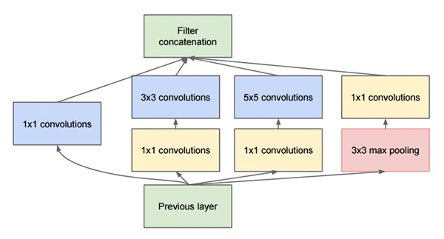

Inception V3’s main characteristic is that it extracts features at multiple levels, computing 1x1, 3x3, as well as 5x5 convolutional layers. These outputs are then concatenated before

V3 brings forth updates on ______ to improve classification accuracy.
The weights for Inception V3 are small, coming in at 96MB.

Implementations of Convolution Neural Networks with Keras: https://www.pyimagesearch.com/2017/03/20/imagenet-vggnet-resnet-inception-xception-keras/

VGG:
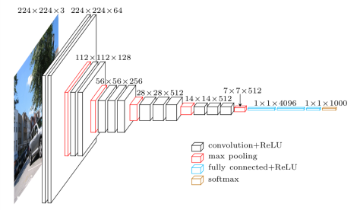
https://www.cs.toronto.edu/~frossard/post/vgg16/

Paper VGG:
https://arxiv.org/abs/1409.1556

VGG uses 3×3 convolutional layers stacked on top of each other in increasing depth. Reducing volume size is handled by max pooling. Two fully-connected layers, each with 4,096 nodes are then followed by a softmax classifier (above).

The “16” and “19” stand for the number of weight layers in the network.

The smaller networks converged and were then used as initializations for the larger, deeper networks — this process is called pre-training.

It only performs 3×33\times 33×3 convolutions and 2×22\times 22×2 pooling all the way through. It is currently the most preferred choice in the community for extracting features from images.

It is painfully slow to train.
- The network architecture weights themselves are quite large (in terms of disk/bandwidth).
Due to its depth and number of fully-connected nodes, VGG is over 533MB for VGG16 and 574MB for VGG19. This makes deploying VGG a tiresome task.
We still use VGG in many deep learning image classification problems; however, smaller network architectures are often more desirable (such as SqueezeNet, GoogLeNet, etc.).
Hence, the biggest drawbacks of VGG, despite its good depth and accuracy, would be hard to deploy onto Sensors and Software Inc’s GPR systems, and would only be something usable in EKKO Project, a post-processing software product.

