Framework: codeignitor

Please download the project and host the project or add to localhost.

Please create sql databse named “sltc” and run sltc.sql file which is in the folder

**Manu**



In the database there are 4 tables for menu

Manu_level1 –> Add main menu data to manu_level1 table with the order

`name`, `url`,`menu_order`

Manu_level2 –> Add sub level data to manu_level2 table with the level1_id and the menu order

`name`, `url`,`menu_order`, `level1_id`

Manu_level3 –> Add level 3 data to manu_level3 table with the level2_id and the menu order

`name`, `url`,`menu_order`, `level2_id`

Manu_level1 🡪 Add level 4 data to manu_level4 table with the level3_id and the menu order

`name`, `url`,`menu_order`, `level1_id`

**Images**

Add images to slct -> asserts -> img -> home folder

Enter img(image name) , url , and img_order to page_image table

Order numbers are following

Pop up window img_order = 10

Other images order as follow



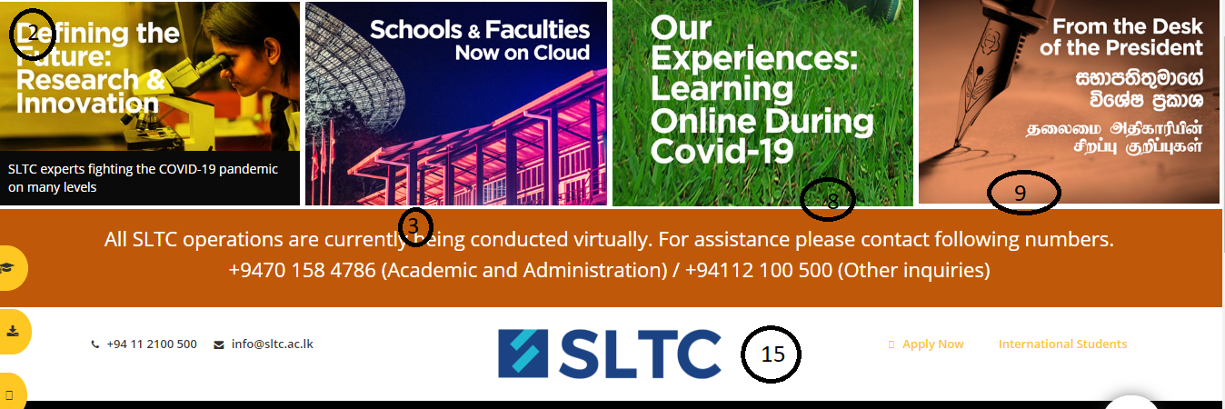

**Text**

Enter image txt , url , and txt_order to page_text table

Order numbers are following



