GitHub project Link - : <https://github.com/ireshasandamali/SPIMS.git>

**The Streamlined Procurement and Inventory Management System (SPIMS) For the Special Task Force**

***Introduction***

Procurement and Inventory Management System will address the specific challenges and requirements faced by the procurement team in managing and tracking procurement processes and inventory. It will provide flexible searching capabilities, a highly visible and fair procurement process, and secure data facilities in an efficient, reliable, and user-friendly manner. As the system is web-based, all the procurement staff and suppliers can access it from anywhere at any time. Since the system uses many of the latest technologies, users will get a user-friendly environment in their procurement process

Use the bellow link to download all files of Streamlined Procurement and Inventory Management System (SPIMS)

GitHub Repository Link - : <https://github.com/ireshasandamali/SPIMS.git>

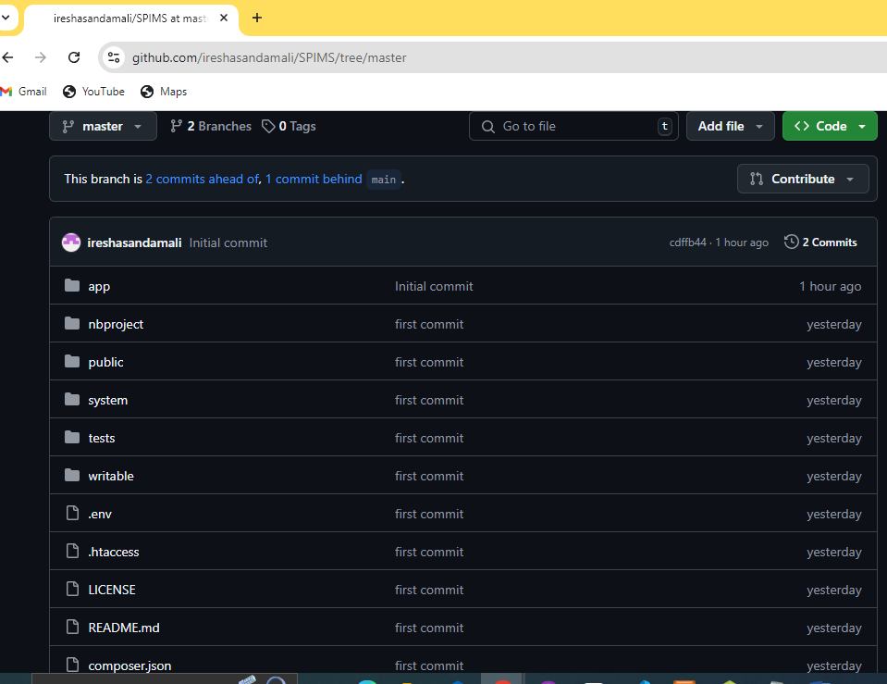

Figure R1: GitHub page

By clicking the down arrow near “code” can download a zip file of the project.

The following table provides the software and hardware verifications, installation, and information that are required to implement the system on the client site.

**Software Requirement**

|  |  |
| --- | --- |
| Operating System | Windows 10 64-bit |
| XAMPP | Control panel v3.3.0 |
| Web Browser | Any Web Browser |
| Code Editor | Net Beans IDE 18 |

Table R1: Software Requirement

**Installing XAMPP**

Download XAMPP for Windows 64 bit operating system (refer Table R1 for the Minimum Version) from https://www.apachefriends.org/index.html and install to the C:\ drive of the computer.

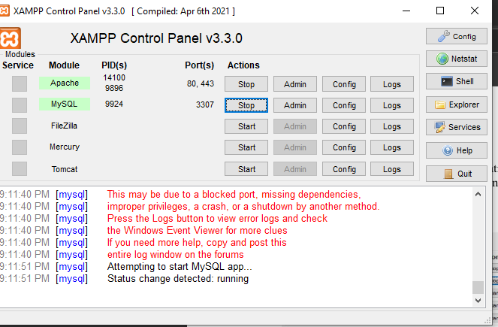

Figure R2: XAMPP Control Panel

**File Extraction**

GitHub Link for the project -: <https://github.com/ireshasandamali/SPIMS.git>

Download Zip file and extract it.

Make a new folder in “C” drive “htdocs” folder in xampp folder and named it as SPIMS.

Following figure shows the folder path.

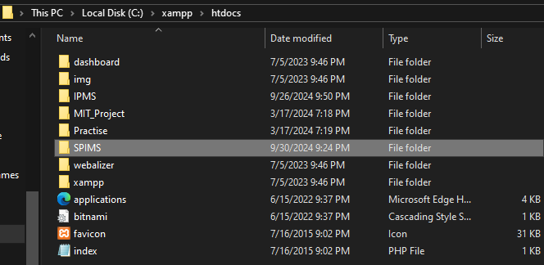

Figure R3: Project file Path

Open the installed web browser and type the URL <http://localhost/IPMS/Sys> and press “Enter” button to access the system by providing bellow User name and Password

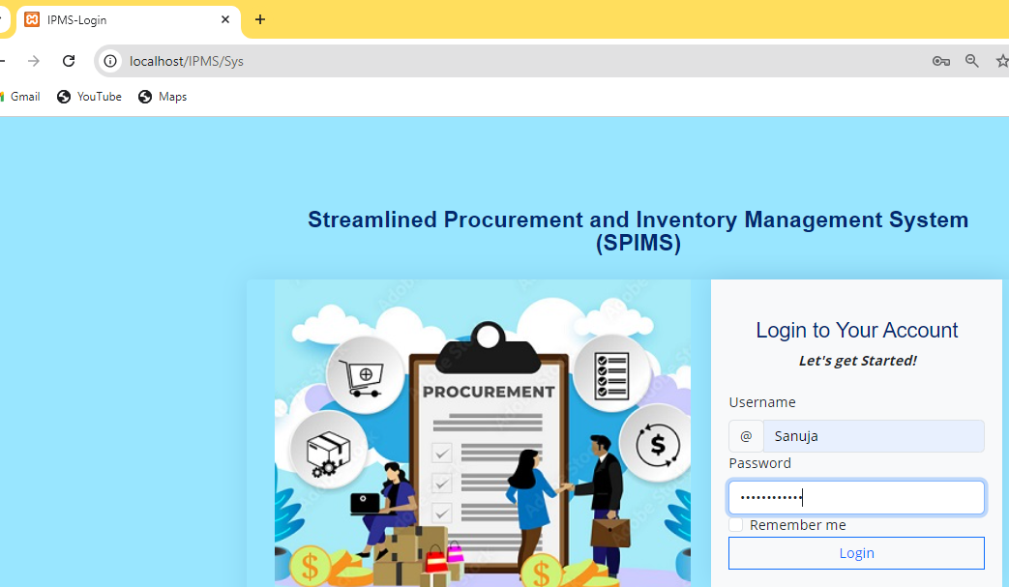

User Name – Sanuja

Password – Qazxsw@1234