**Exp.No: 5**

**Install Hive and Create Tables in Hive and write queries to access the data in the table**

**AIM:**

To install Hive, design and test various schema models to optimize data storage and retrieval using Hive.

**PROCEDURE:**

**Step 1:** Start Hive Open a terminal and start Hive by running:

**hive**

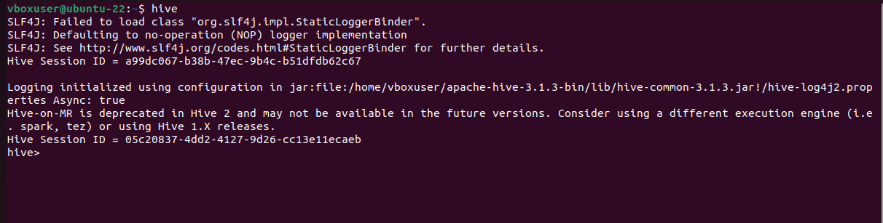

**Step 2: Create a Database:** Create a new database in Hive:

**hive> CREATE DATABASE courses;**

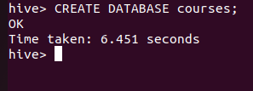

**Step 3: Use the Database:** Switch to the newly created database:

**hive> USE courses;**

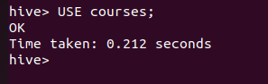

**Step 4: Create a Table:** Create a simple table in your database:

**hive> CREATE TABLE course_table( course_id INT, course_name STRING );**

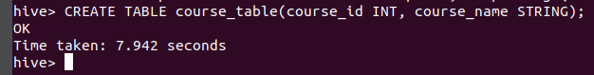

**Step 5: Load Sample Data:** You can insert sample data into the table:

**hive> INSERT INTO course_table VALUES (1, ‘Cloud Computing’), (2, 'Data Analytics'), (3, 'Deep Learning Concepts');**

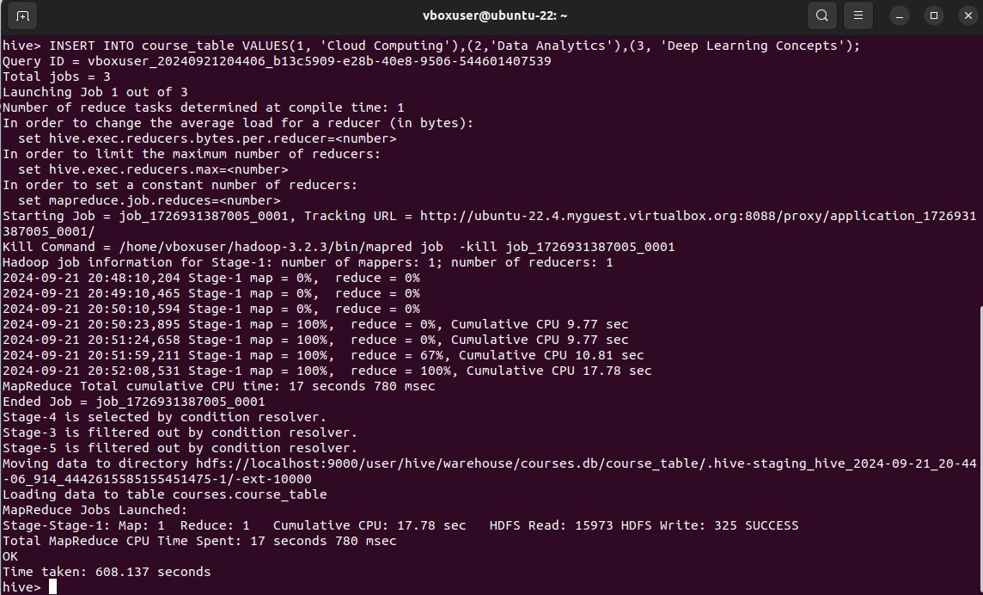

**Step 6: Query Your Data:** Use SQL-like queries to retrieve data from your table: **hive> CREATE VIEW mycourse AS SELECT course_id, course_name FROM course_table;**

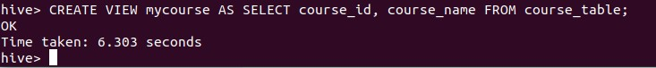

**Step 7: View the data:** To see the data in the view, you would need to query the view

**hive> SELECT * FROM mycourse;**

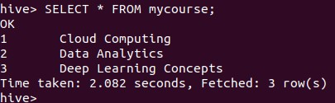

**Step 8: Describe a Table:** You can describe the structure of a table using the DESCRIBE command:

**hive> DESCRIBE course_table;**

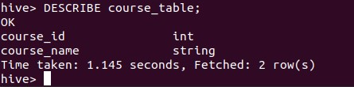

**Step 9: Alter a Table:** You can alter the table structure by adding a new column: **hive> ALTER TABLE course_table ADD COLUMNS (students_enrolled INT);**

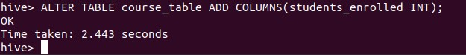

**Step 10: Quit Hive:** To exit the Hive CLI, simply type:

**hive> quit;**



**RESULT:**

Thus, the usage of various commands in Hive has been successfully completed.