**Exp.No: 6**

**Import a JSON file from the command line. Apply the following actions with the data present in the JSON file where, projection, aggregation, remove, count, limit, skip and sort**

**AIM:**

To import a JSON file from the command line and apply the following actions with the data present in the JSON file where, projection, aggregation, remove, count, limit, skip and sort using jq tool.

**PROCEDURE:**

● Create a json file ‘emp.json’ and provide data in it.

**[**  
 **{**

**"name" : "Anu",**

**"age":12,**

**"dept": "Computer",**

**"salary":10000**

**},  
{**

**"name" : "Bob",**

**"age" :14,**

**"dept" : "HR",**

**"salary":15000**

**},  
{  
"name": "Jane Smith",**

**"age": 25,**

**"department": "IT",**

**"salary": 60000  
},  
{  
"name": "Alice Johnson",**

**"age": 35,**

**"department": "Finance",**

**"salary": 70000  
},  
{  
"name": "Bob Brown",**

**"age": 28,**

**"department": "Marketing",**

**"salary": 55000  
}**

**]**

● Open the command prompt.

● Navigate to the folder where emp.json is stored.

● Load and view the JSON data with jq.

● Use the jq commands for projection, aggregation, removal, counting, limiting, and sorting operations.

**OUTPUT:**

**Running jq queries:**

1. ***Projection:***

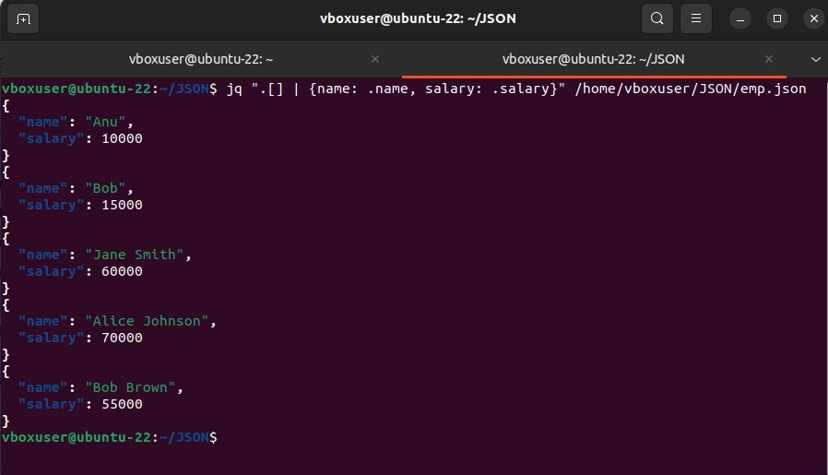

1. ***Aggregation:***

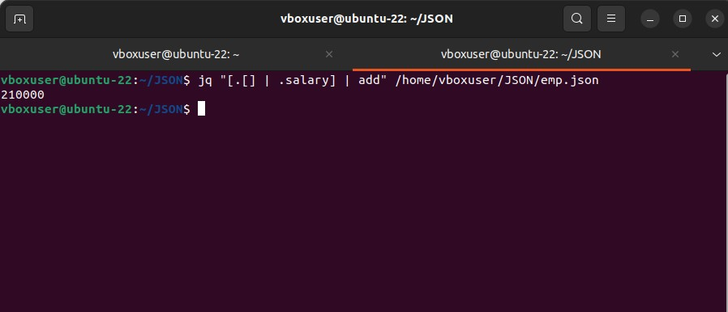

1. ***Remove:***

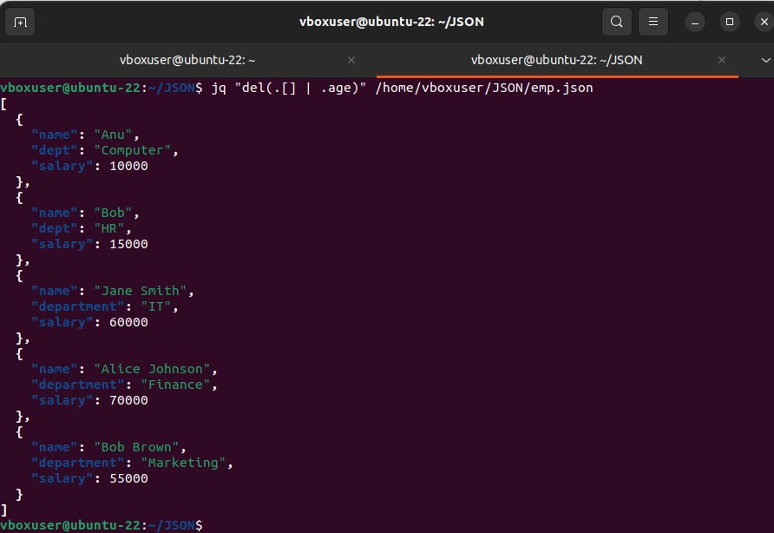

1. ***Count:***

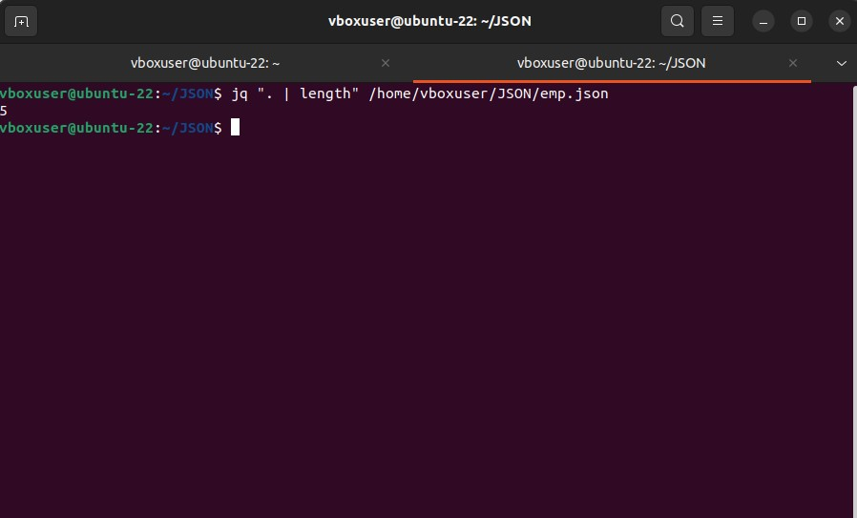

1. ***Limit:***

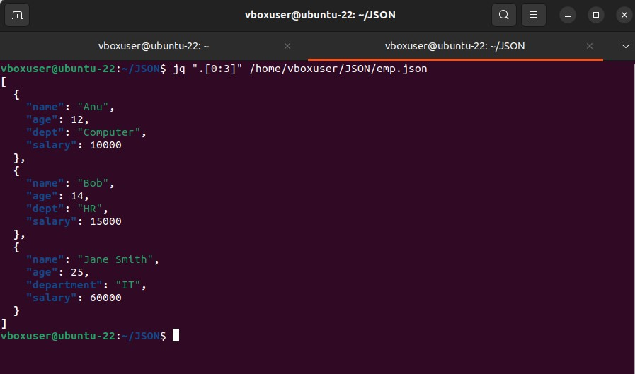

1. ***Skip:***

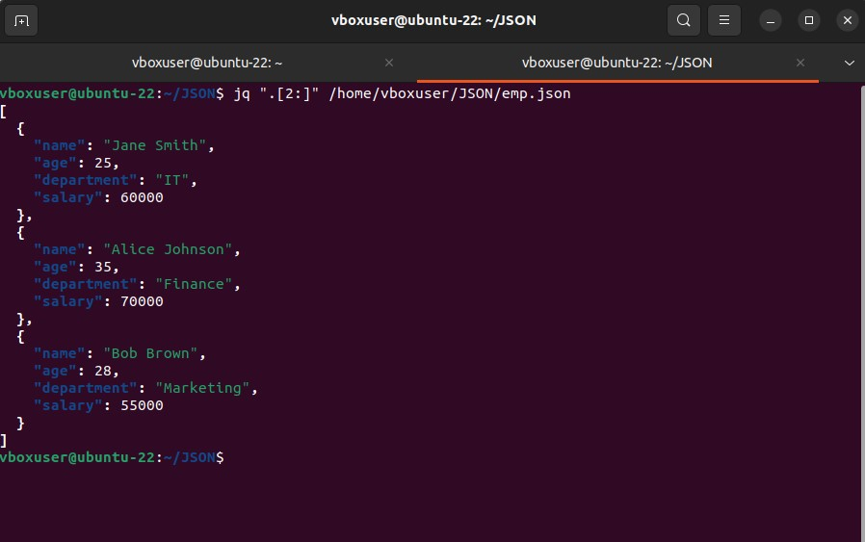

1. ***Sort:***

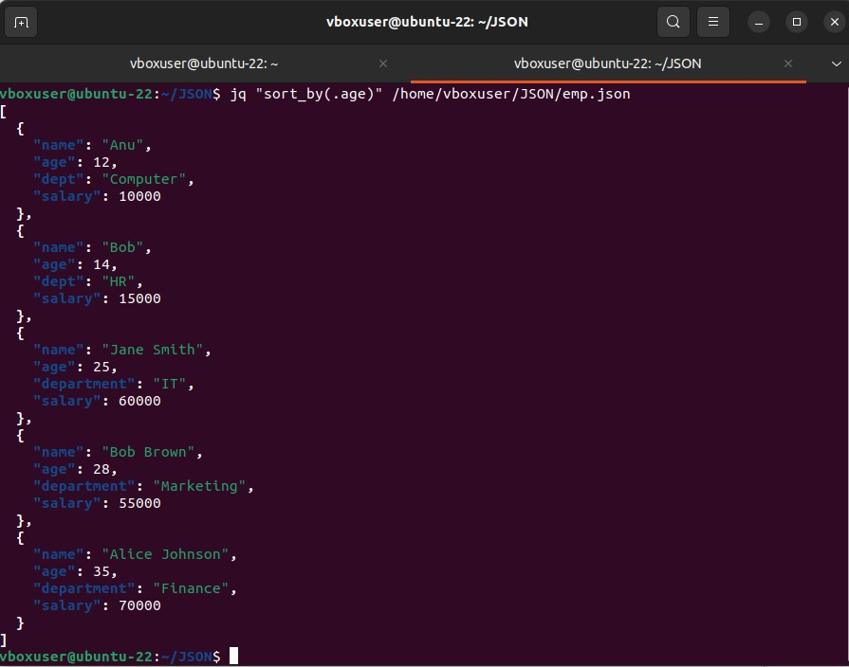

**RESULT:**

Thus to import a JSON file from the command line and apply the following actions with the data present in the JSON file where, projection, aggregation, remove, count, limit, skip and sort using jq tool is completed successfully