**Exp.No: 7**

**Implement Linear and Logistic Regression in R**

**AIM:**

To Implement Linear and Logistic Regression using R

**PROCEDURE:**

* Load the dataset from external sources, such as CSV files or databases, using appropriate libraries.
* Perform data cleaning and preprocessing, addressing missing values and encoding categorical variables as needed.
* Split the dataset into training and testing sets to evaluate model performance.
* Standardize or normalize the dataset to ensure all features are on a consistent scale.
* Select the most suitable model, such as Linear Regression for predicting continuous values.
* Train the selected model on the training set using the fit function.
* Generate predictions on the test set using the predict function.
* Assess the model’s accuracy using metrics like Mean Squared Error (MSE) for regression or a confusion matrix and accuracy score for classification models.
* Visualize model results using relevant graphs, such as scatter plots for regression or decision boundaries for classification.
* Improve the model's performance by tuning hyperparameters or applying regularization methods.

**PROGRAM:**

**LinearRegression.R:**

# Sample data

heights <- c(150, 160, 165, 170, 175, 180, 185)

weights <- c(55, 60, 62, 68, 70, 75, 80)

# Create a data frame

data <- data.frame(heights, weights)

# Fit a linear regression model

linear_model <- lm(weights ~ heights, data = data)

# Print the summary of the model

print(summary(linear_model))

# Plotting the data and regression line

plot(data$heights, data$weights,

main = "Linear Regression: Weight vs. Height",

xlab = "Height (cm)",

ylab = "Weight (kg)",

pch = 19, col = "blue")

# Add regression line

abline(linear_model, col = "red", lwd = 2)

**LogisticRegression.R:**

# Load the dataset

data(mtcars)

# Convert 'am' to a factor (categorical variable)

mtcars$am <- factor(mtcars$am, levels = c(0, 1), labels = c("Automatic", "Manual"))

# Fit a logistic regression model

logistic_model <- glm(am ~ mpg, data = mtcars, family = binomial)

# Print the summary of the model

print(summary(logistic_model))

# Predict probabilities for the logistic model

predicted_probs <- predict(logistic_model, type = "response")

# Display the predicted probabilities

print(predicted_probs)

# Plotting the data and logistic regression curve

plot(mtcars$mpg, as.numeric(mtcars$am) - 1,

main = "Logistic Regression: Transmission vs. MPG",

xlab = "Miles Per Gallon (mpg)",

ylab = "Probability of Manual Transmission",

pch = 19, col = "blue")

# Add the logistic regression curve

curve(predict(logistic_model, data.frame(mpg = x), type = "response"),

add = TRUE, col = "red", lwd = 2)

**OUTPUT:**

**Linear Regression:**

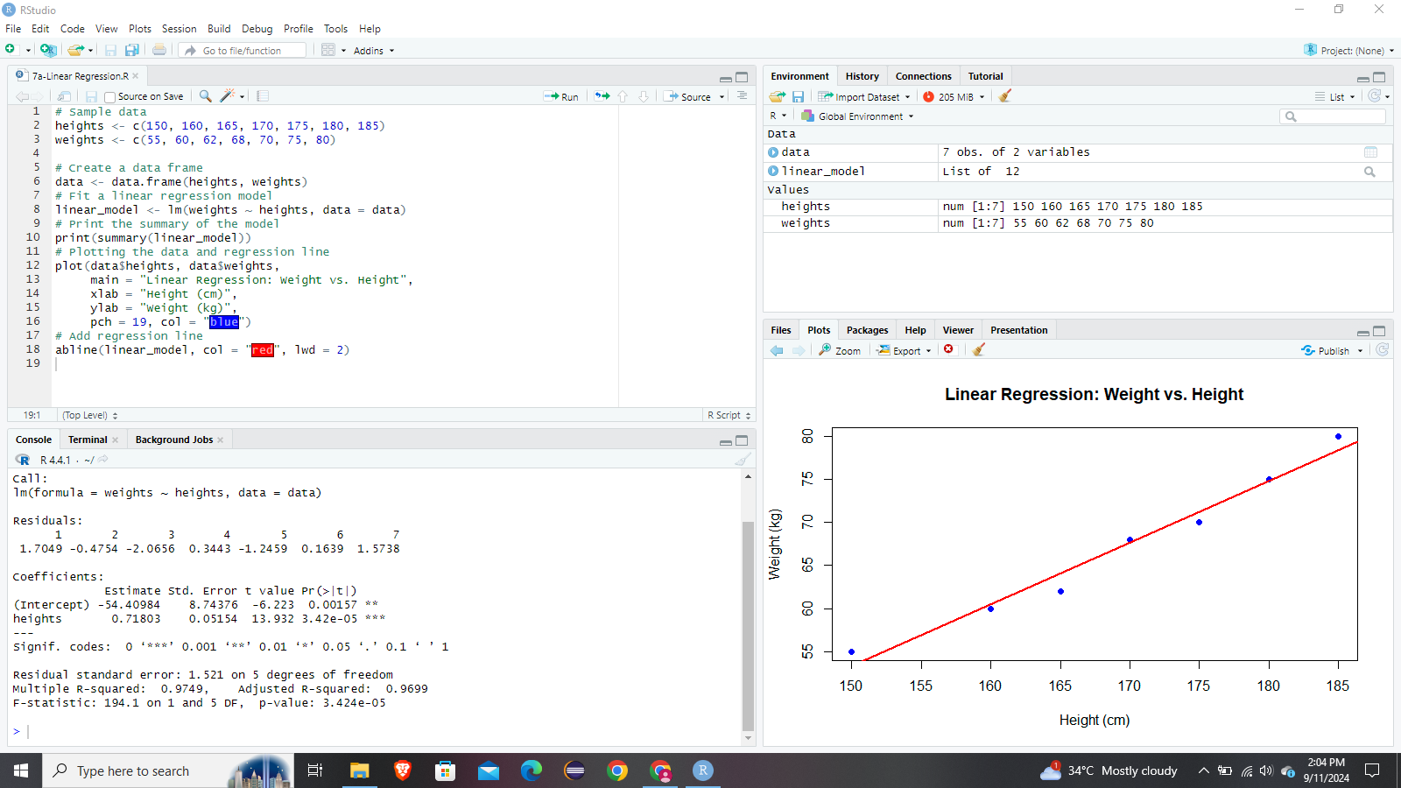

**Logistic Regression:**

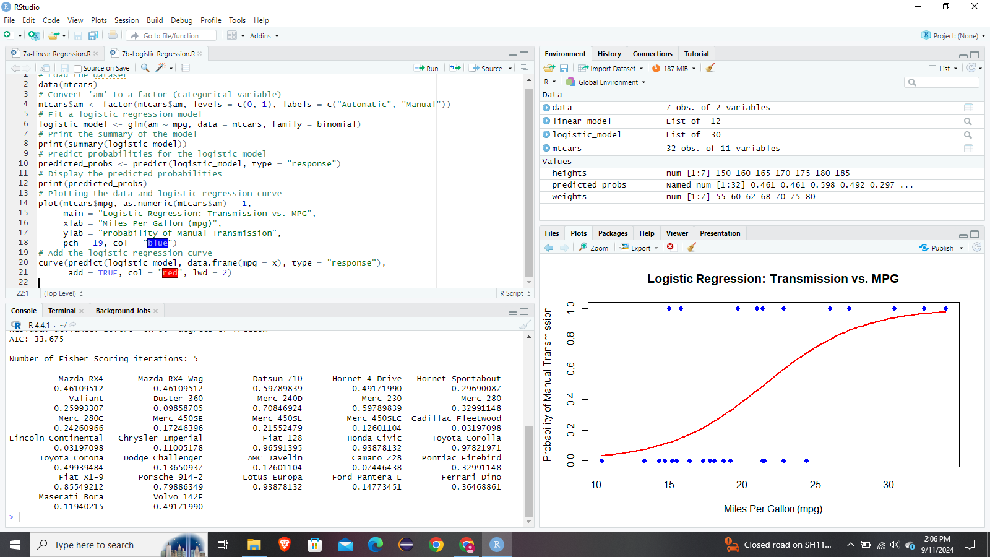

**RESULT:**

Thus Linear and Logistic Regression using R has been successfully executed.