**Ian Reymond**

**CPSC 131**

**Assignment 3**

**Due: 5/8/15**

**Screen Shots:**

Input:

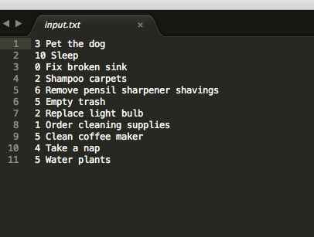

Output: