Programming Assignment Uni 5

Irfan Manzoor

University of the People

CS 1101-01: Programming Fundamentals – AY2025-T1

Alok Parihar

11 October 2024

# Assignment 5

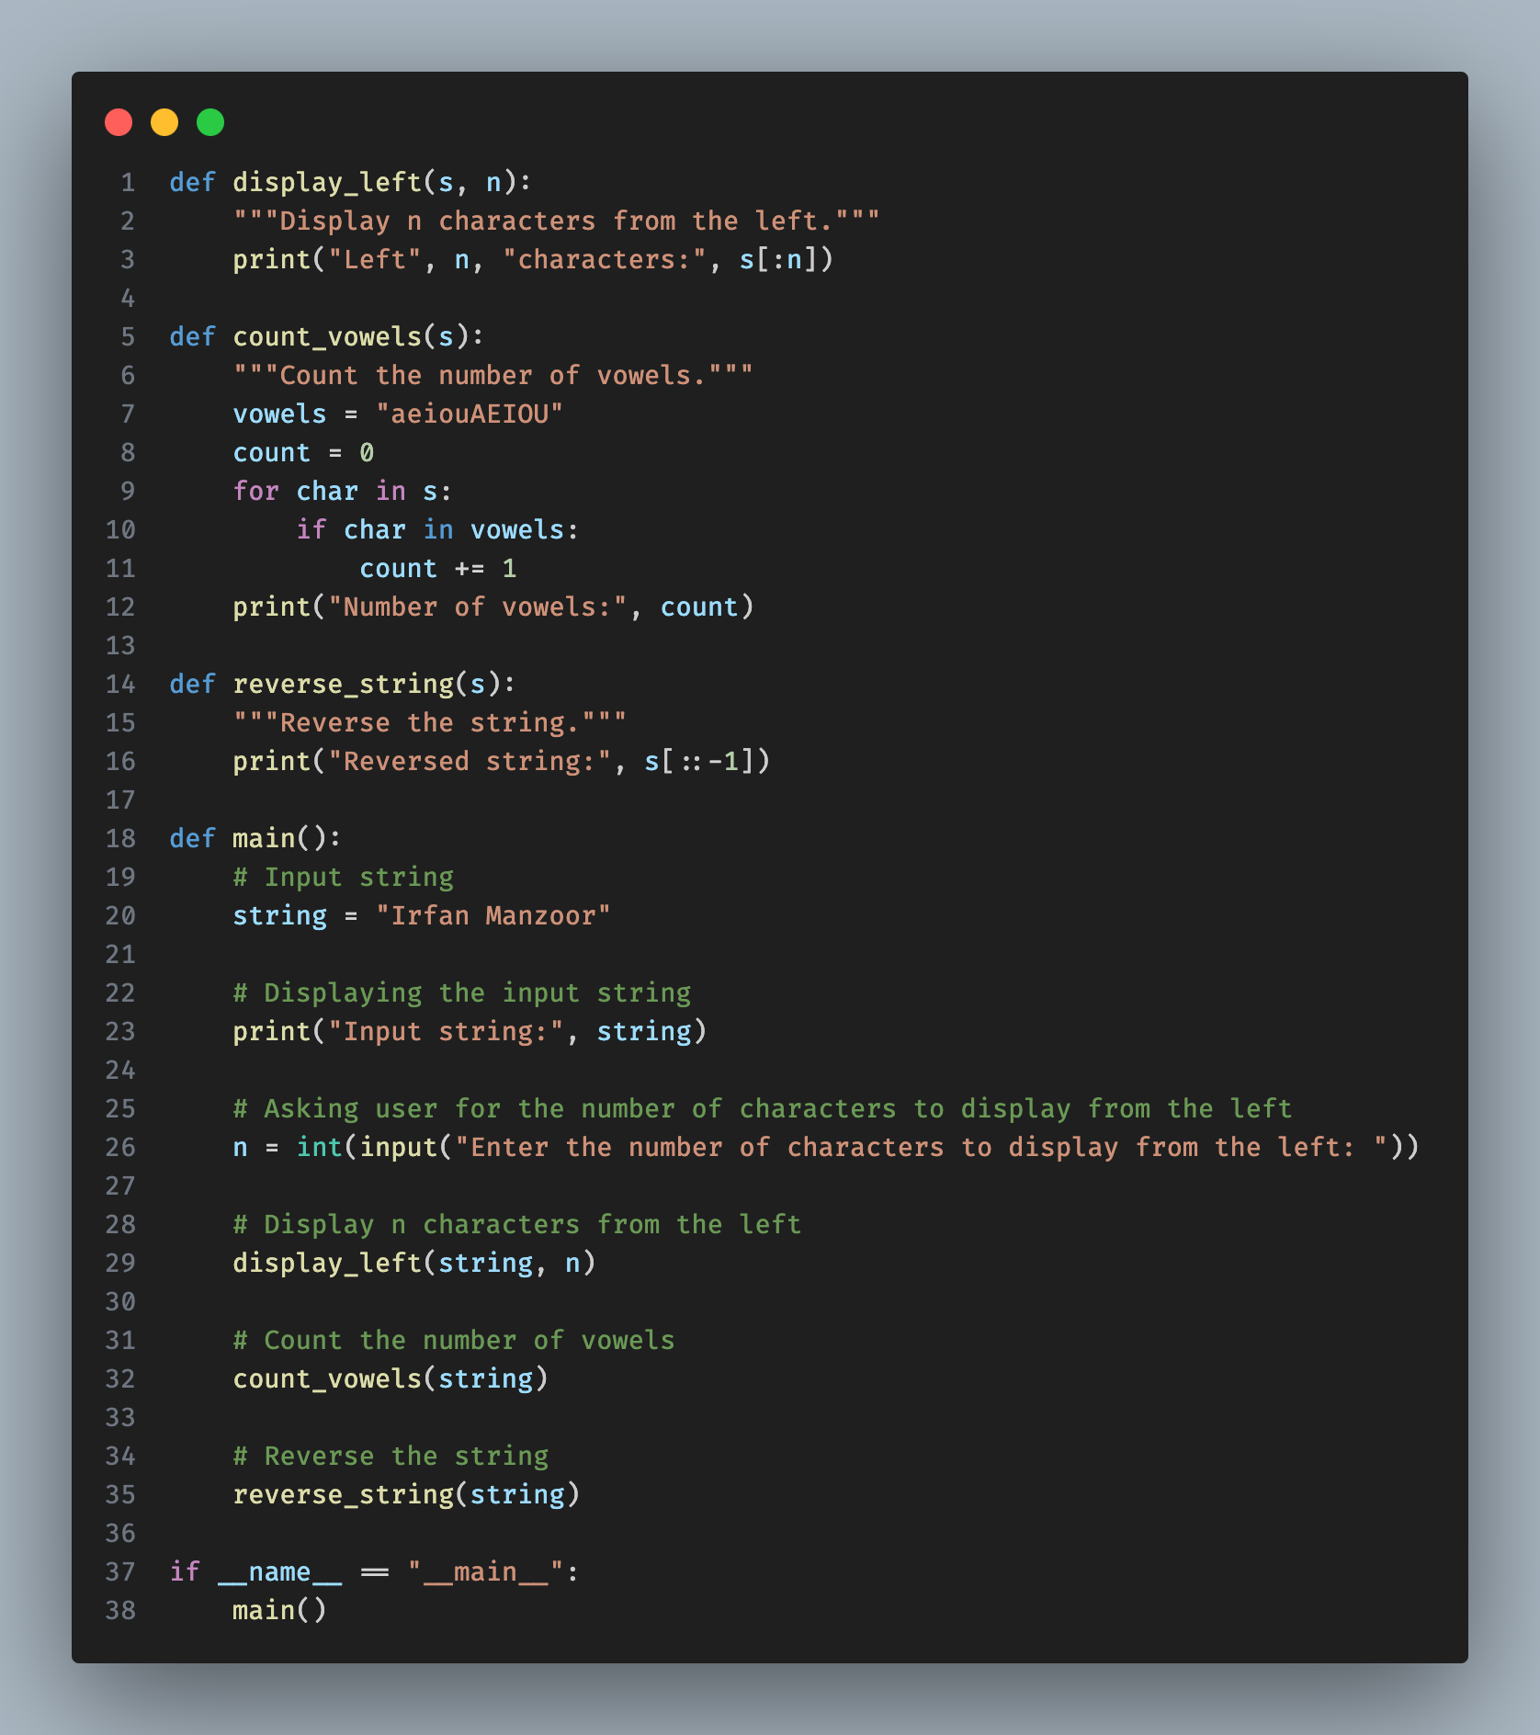

# Explanation:

1. `**display_left**` function takes two parameters, the string `s` and the number `n`, and then slices the string from the left up to `n` characters and prints it.
2. `**count_vowels**` function takes a string `s`, iterates through each character of the string, and counts the vowels using a loop and an if condition.
3. `**reverse_string**` function simply reverses the input string using slicing and prints it.
4. `**main**` function is where the actual execution of the program begins. It initializes the input string, takes user input for the number of characters to display from the left, and then calls the three functions to perform the specified tasks.
5. In the `**main**` function, the input string "Irfan Manzoor" is displayed, then user input is taken for the number of characters to display from the left. Finally, the `**display_left**`, `**count_vowels**`, and `**reverse_string**` functions are called with the input string to perform the respective operations.

# Output

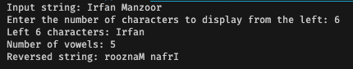

**References**

Programiz.com. *Python string slicing*. <https://python.org>.

<https://www.programiz.com/python-programming/string-slicing>

W3schools.com. *Python string methods*. <https://python.org>.

<https://www.w3schools.com/python/python_ref_string.asp>