Programming Assignment Uni 6

Irfan Manzoor

University of the People

CS 1101-01: Programming Fundamentals – AY2025-T1

Alok Parihar

18 October 2024

# Assignment 6 (a)

1. **Initial Employee Names:** `employee_names` is a list containing the names of 10 employees.
2. **Creating Sub-Lists:**

- `subList1` and `subList2` are created by slicing `employee_names`.

- `subList1` contains the first 5 names.

- `subList2` contains the remaining names.

1. **Printing Sub-Lists:** The names in each sub-list are printed individually. Each sub-list is preceded by a header to distinguish it from the other sub-list.
2. **Adding a New Employee:**

- "Kriti Brown" is appended to `subList2`.

- The amended `subList2` is printed to reflect the addition of the new employee.

1. **Removing an Employee:**

- The second employee ("Adnan M. Ahmad") from `subList1` is removed using the `pop()` method.

- The amended `subList1` is printed without the removed employee.

1. **Merging Sub-Lists:**

- `merged_list` is created by concatenating `subList1` and `subList2`.

- The merged list is printed to display all employee names together.

1. **Sample Salary List:** `salary_list` contains sample salary data for each employee.
2. **Giving Raises:** A 4% raise is given to each employee by multiplying their salary by 1.04. This is done using a loop that iterates over each salary in the `salary_list`.
3. **Sorting and Printing Top Salaries:**

- The salaries in `salary_list` are sorted in descending order using the `sort()` method with `reverse=True`.

- The top 3 salaries are then printed. This is accomplished by iterating over the first 3 elements of the sorted list and formatting each salary to display two decimal places using f-strings.

# Output

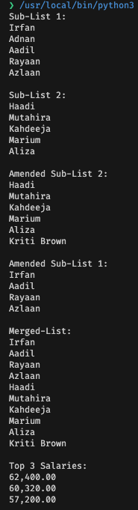

# Assignment 6 (b)

# Function Definition:

# The function `sentence_to_reversed_wordlist` is defined, which takes one argument `sentence`.

# A docstring is provided to explain what the function does, its arguments, and its return value.

# Splitting the Sentence:

# Inside the function, the `sentence` string is split into a list of words using the `split()` method.

# By default, `split()` splits the string using whitespace characters (spaces, tabs, newlines, etc.).

# Reversing the Word List:

# After obtaining the list of words, the order of the elements in the list is reversed using slicing.

# The syntax `word_list[::-1]` creates a reversed copy of the list `word_list`.

# Return Statement: The reversed word list is returned as the output of the function.

# Example Usage:

# An example sentence is defined: `"This is a sample sentence."`

# The `sentence_to_reversed_wordlist` function is called with this sentence, and the result is stored in the variable `reversed_words`.

# Printing Results:

# The original sentence and the reversed words list are printed to the console for demonstration purposes.

**Output**



**References**

Downey, A. B. (2015). *Think Python: How to Think Like a Computer Scientist*. O'Reilly Media.