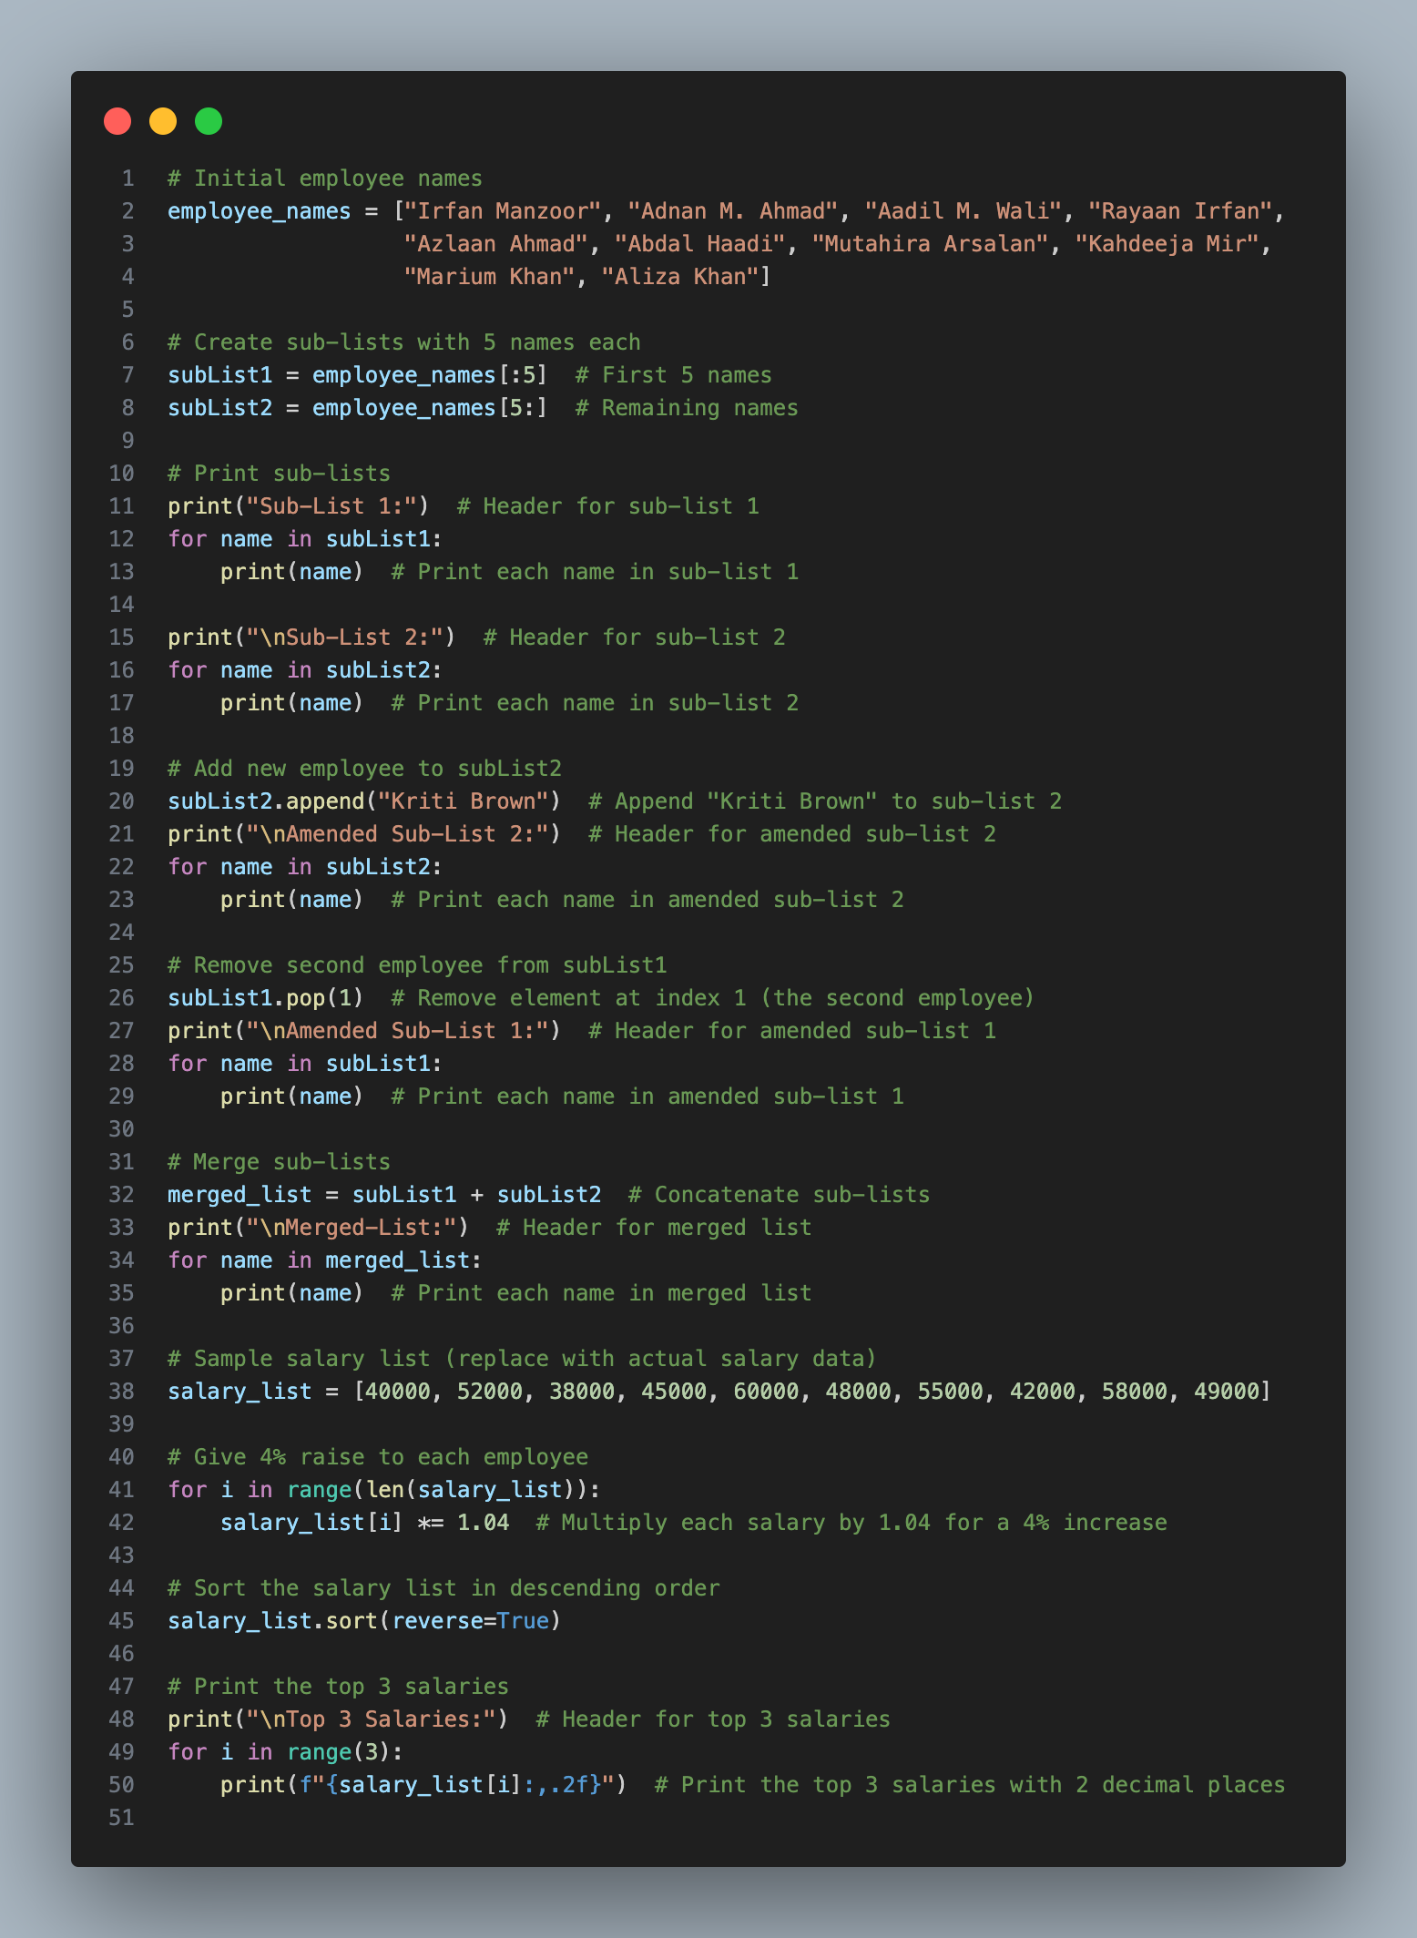
(a)
Explanation:
1. Initial Employee Names: `employee_names` is a list containing the names of 10 employees.
2. Creating Sub-Lists:
- `subList1` and `subList2` are created by slicing `employee_names`.
- `subList1` contains the first 5 names.
- `subList2` contains the remaining names.
3. Printing Sub-Lists: The names in each sub-list are printed individually. Each sub-list is preceded by a header to distinguish it from the other sub-list.
4. Adding a New Employee:
- "Kriti Brown" is appended to `subList2`.
- The amended `subList2` is printed to reflect the addition of the new employee.
5. Removing an Employee:
- The second employee ("Adnan M. Ahmad") from `subList1` is removed using the `pop()` method.
- The amended `subList1` is printed without the removed employee.
6. Merging Sub-Lists:
- `merged_list` is created by concatenating `subList1` and `subList2`.
- The merged list is printed to display all employee names together.
7. Sample Salary List: `salary_list` contains sample salary data for each employee.
8. Giving Raises: A 4% raise is given to each employee by multiplying their salary by 1.04. This is done using a loop that iterates over each salary in the `salary_list`.
9. Sorting and Printing Top Salaries:
- The salaries in `salary_list` are sorted in descending order using the `sort()` method with `reverse=True`.
- The top 3 salaries are then printed. This is accomplished by iterating over the first 3 elements of the sorted list and formatting each salary to display two decimal places using f-strings.
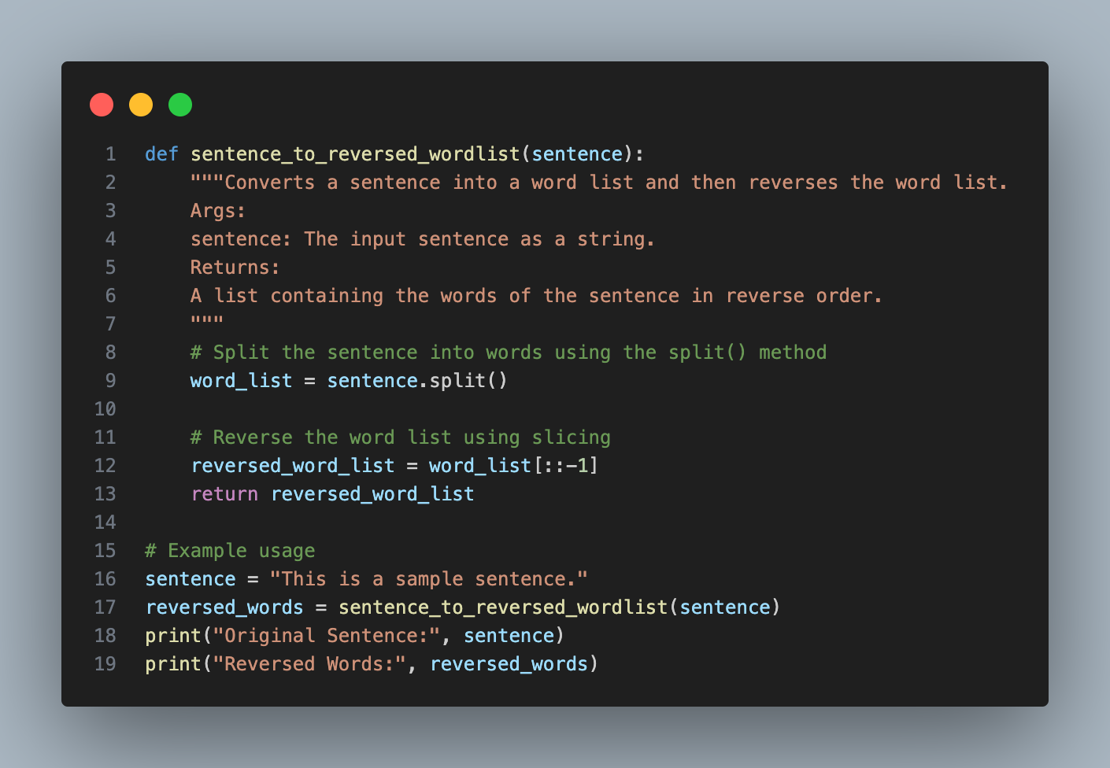
(b)

Explanation:
1. Function Definition:
- The function `sentence_to_reversed_wordlist` is defined, which takes one argument `sentence`.
- A docstring is provided to explain what the function does, its arguments, and its return value.
2. Splitting the Sentence:
- Inside the function, the `sentence` string is split into a list of words using the `split()` method.
- By default, `split()` splits the string using whitespace characters (spaces, tabs, newlines, etc.).
3. Reversing the Word List:
- After obtaining the list of words, the order of the elements in the list is reversed using slicing.
- The syntax `word_list[::-1]` creates a reversed copy of the list `word_list`.
4. Return Statement: The reversed word list is returned as the output of the function.
5. **Example Usage:
- An example sentence is defined: `"This is a sample sentence."`
- The `sentence_to_reversed_wordlist` function is called with this sentence, and the result is stored in the variable `reversed_words`.
6. Printing Results:
- The original sentence and the reversed words list are printed to the console for demonstration purposes.

