Task 1

"I will provide expert Git and GitHub consultation for efficient code management."

Task 2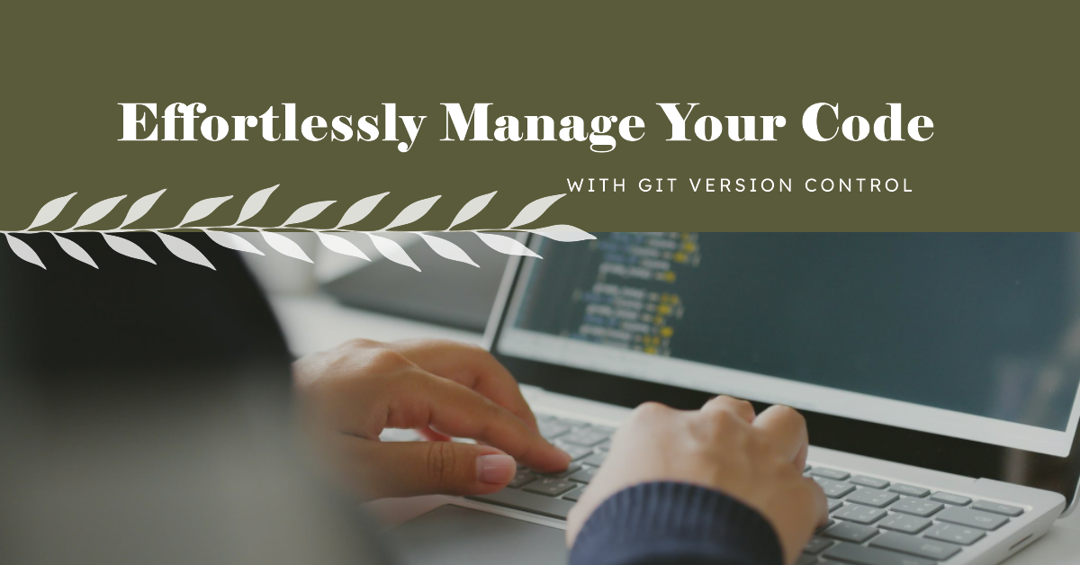

Task 3

Service Description:

Are you struggling with version control in your software development projects? Look no further! With my expert Git and GitHub consultation service, I offer you a comprehensive solution to streamline your version control process and enhance collaboration within your development team.

Requirements:

To get started, all I need from you is access to your project repositories, a brief description of your current version control challenges, and your goals for improvement. Whether you're a beginner seeking guidance or an experienced developer looking to optimize your workflow, I can tailor my services to meet your specific needs.

Deliverables:

1. I will provide you with expert guidance on Git, helping you understand its fundamental concepts, commands, and best practices.
2. I will assist you in harnessing the power of GitHub, ensuring efficient repository management, issue tracking, and pull request workflows.
3. You'll receive personalised recommendations for version control best practices, including commit message conventions, branching strategies, and code review techniques.
4. I'll help you improve collaboration within your development team by setting up effective workflows and ensuring seamless communication on GitHub.
5. If you encounter version control issues, I'll be there to troubleshoot and guide you through resolution steps.
6. I will provide documentation and best practices tailored to your project, ensuring that you have a clear reference for maintaining an organised and efficient version control system.

Task 4

Git, GitHub, Version Control, Code Management, Collaboration, Repository Management, Code Review, Troubleshooting, Team Collaboration

Task 5

1. Basic Package (Rs 5000 - Rs 15000):

- 1-hour consultation session

- Basic troubleshooting

- Suitable for clients with small-scale projects or beginners seeking guidance.

2. Standard Package (Rs 20000 - Rs 40000):

- 2 to 3-hour consultation session.

- In-depth guidance, including best practices, workflow optimisation, and code review strategies.

- Suitable for teams working on moderately complex projects.

3. Premium Package (Rs 50000 - Rs 150000):

- 4 to 6-hour consultation session or multiple sessions.

- Personalised solutions, advanced Git strategies, and assistance with setting up CI/CD pipelines.

- Advanced developers, larger projects, or clients looking for ongoing support.