1)

2)



3)

Abstract

Pakistan is urbanizing at the fastest pace in South Asia, and if left unplanned, it will not only reduce adaptive capacity of its residents rather it will be a chaos for its residents. The aim of this study is to answer the question on how urbanites of Pakistan are coping with climate change and which part of the society required support to cope with changing climate? To answer this questions, this study conducted survey through a structured questionnaire, from the urban residents of Islamabad, to explore their coping mechanisms towards climate change. Survey collected information on demographic, social, economic, and physical aspects, using Hackman’s Treatment effect model. The sample selection equation is conditional on the adaptations to climate change in the outcome equation. Main independent variables are income, age, education, and occupation. Selection equation is based on perceptions of individuals about climate change which contains dependent variables of changes in temperature of summers and winters, changes in rain fall pattern, fog, hailstorm, and information received from social media and peer groups. With the result of 57.55, the Wald test shows that overall, there exists goodness of fit at the 99 percent confidence level. The value of rho in the Heckman model is 0.40 which implies the Heckman model provides more consistent and more efficient estimates. The results are suggesting that increasing age enhances the likelihood of adaptations as the positive and significant coefficient of age implies that age has probability to adapt to climate change. The positive and significant coefficient of income, education, and occupation implies that urbanites have higher probability to adapt to climate change. Perception is the essential foundation of adaptation, and differences in perception can be transferred to the adapted strategies. Households that experience a greater variation in annual mean temperature are more likely to adopt any adaptation strategy to cope with climate change. Essentially, poverty encompasses the majority of the characteristics that reduce respondents’ adaptation capacity and increase their susceptibility to climate change. The major contextual disparities were discovered across union councils in the form of financial, personal, social, physical, and natural capitals of families. Therefore, obligation is on government to offer greater support for individuals who are less affluent in terms of these assets. For this city, officials must offer subsidy schemes to less privileged and marginalized people of urban dwellers to enhance their adaptive capacity.

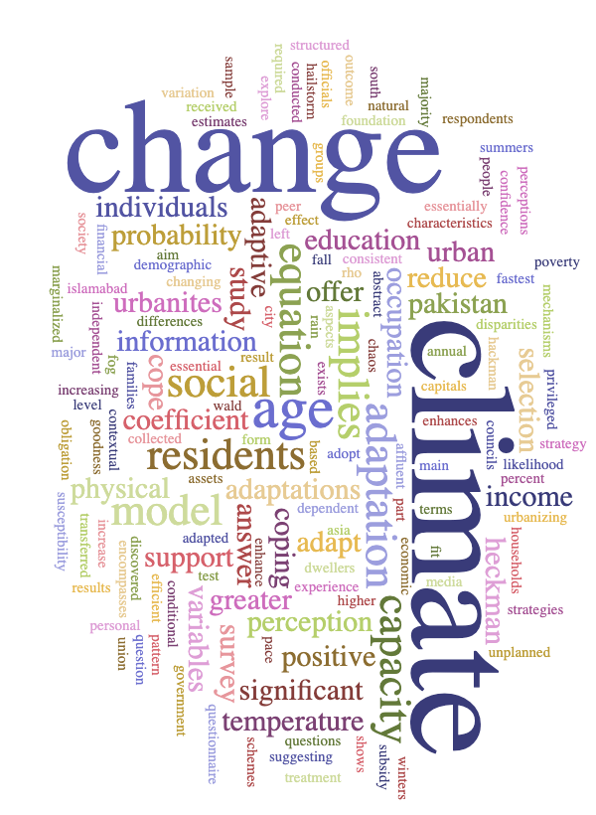

4)

1. Climate
2. Change
3. Adaptation
4. Implies
5. Age