Task 1

To pursue a freelancing career in Version Control (VC), it's crucial to develop a comprehensive knowledge about various VC tools. Amongst the most popular today, is mastering Git, understanding its repository management, branching, and merging strategies, and collaborating effectively with team members using the platforms like GitHub, GitLab, or Bitbucket. Additionally, familiarity with version control best practices, continuous integration/continuous deployment (CI/CD) pipelines, scripting for automation, and security measures for access control is essential. Soft skills like communication and collaboration are equally important for effective teamwork. Whether working on web development, mobile app development, or data science projects, a solid grasp of version control tools and practices ensures efficient management of code, collaboration with others, and maintaining project stability.

Task 2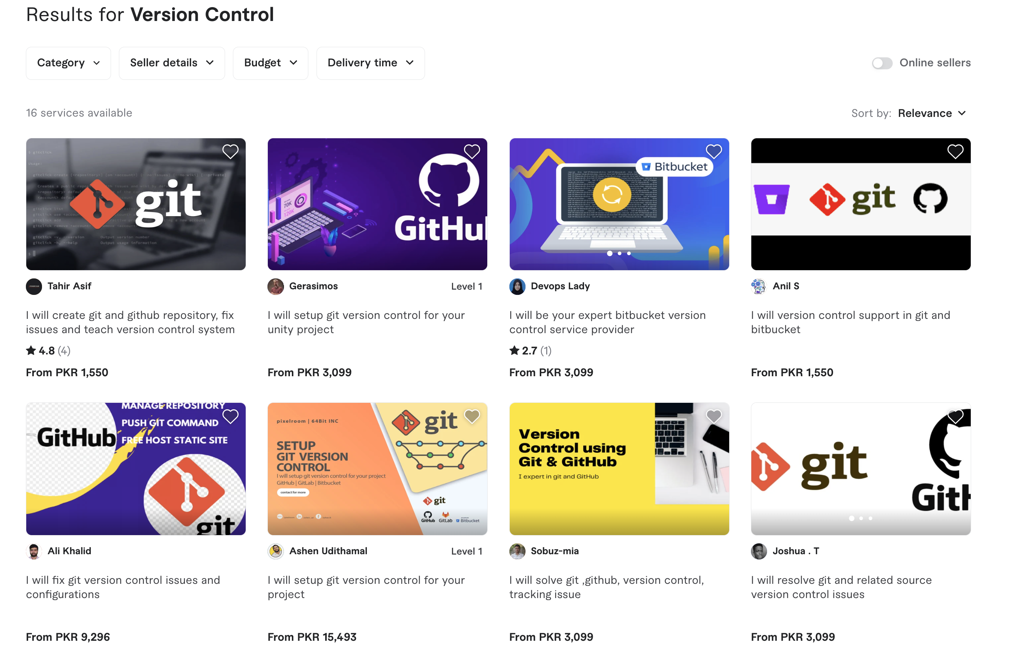

Task 3

1. I will create git and github repository, fix issues and teach version control system
2. I will setup git version control for your unity project
3. I will be your expert bitbucket version control service provider
4. I will version control support in git and bitbucket
5. I will fix git version control issues and configurations