**Configuration steps to follow before provisioning MongoDB cluster using Jenkins pipeline.**

**MongoDB console configurations:**

* Login to [**MongoDB Atlas**](https://account.mongodb.com/account/login?nds=true&_ga=2.69614165.437647968.1671524933-1655760700.1667291338) console using ibm-ID.

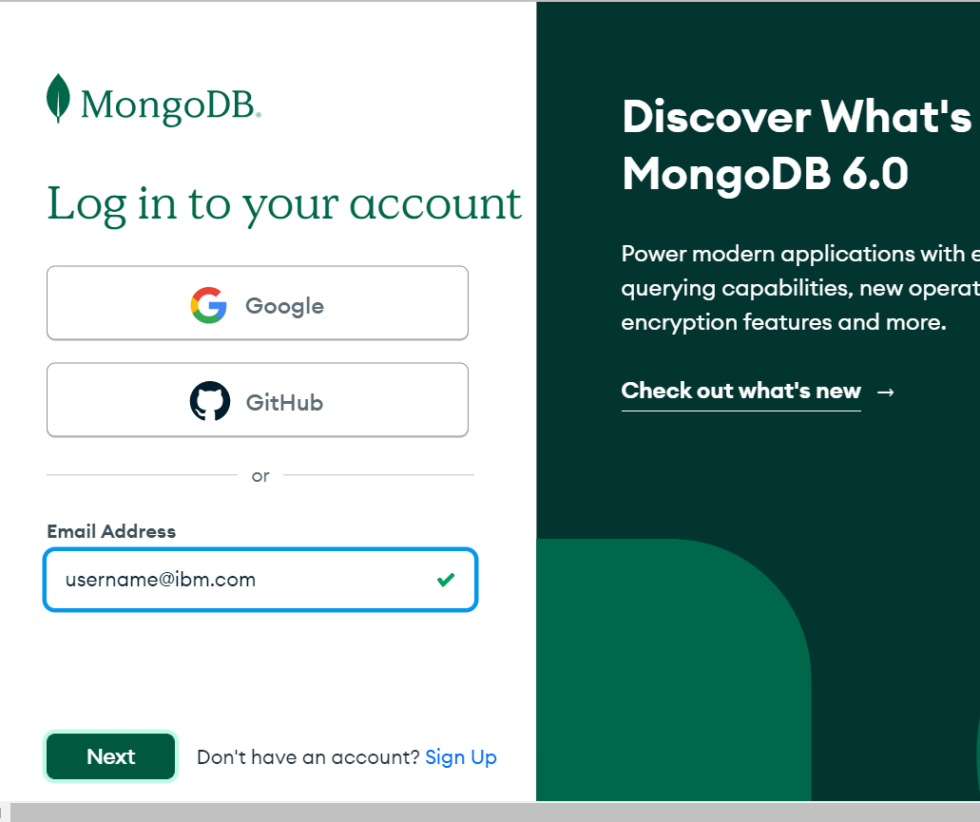

* Create organization after logging into the console.

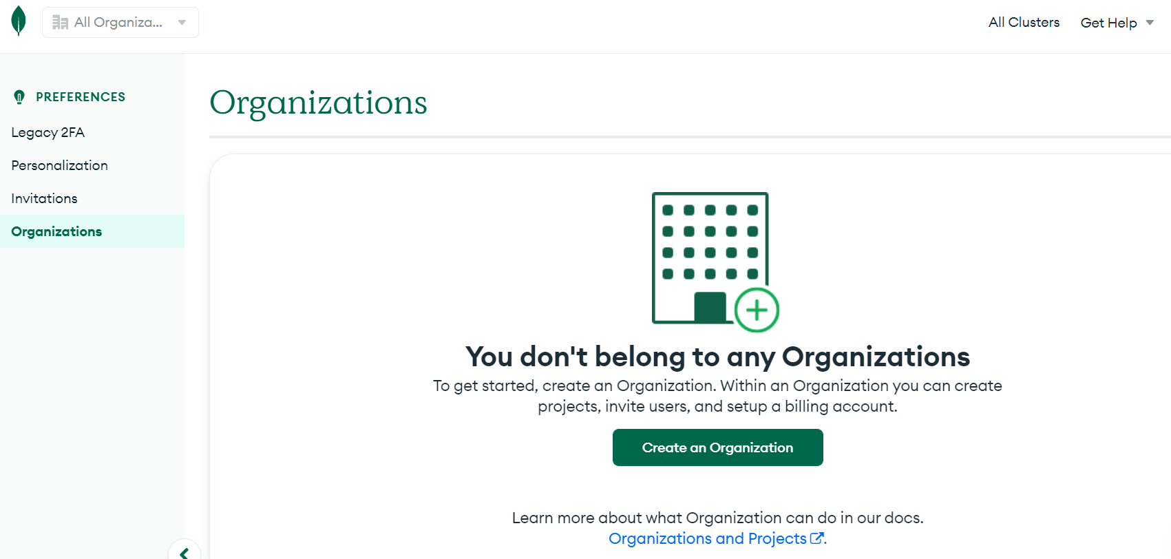

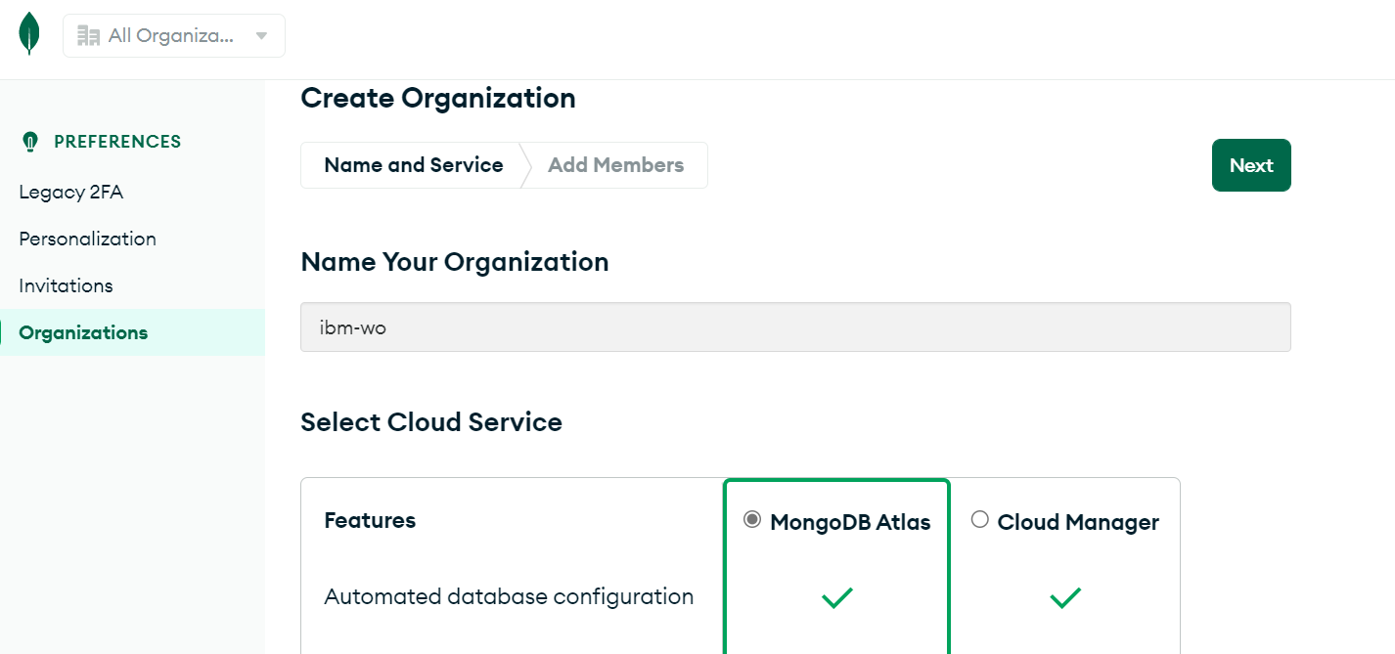

* To get the Organization ID click on the settings tab in the left panel.
* If you don’t find any user in the Users tab, then [**create user**](https://www.mongodb.com/docs/atlas/access/manage-org-users/)**.**
* From inside the organization click on Access Manager and from the console click on API Keys tab and then click on Create API Key
* Add description and the required permissions and click “Next”

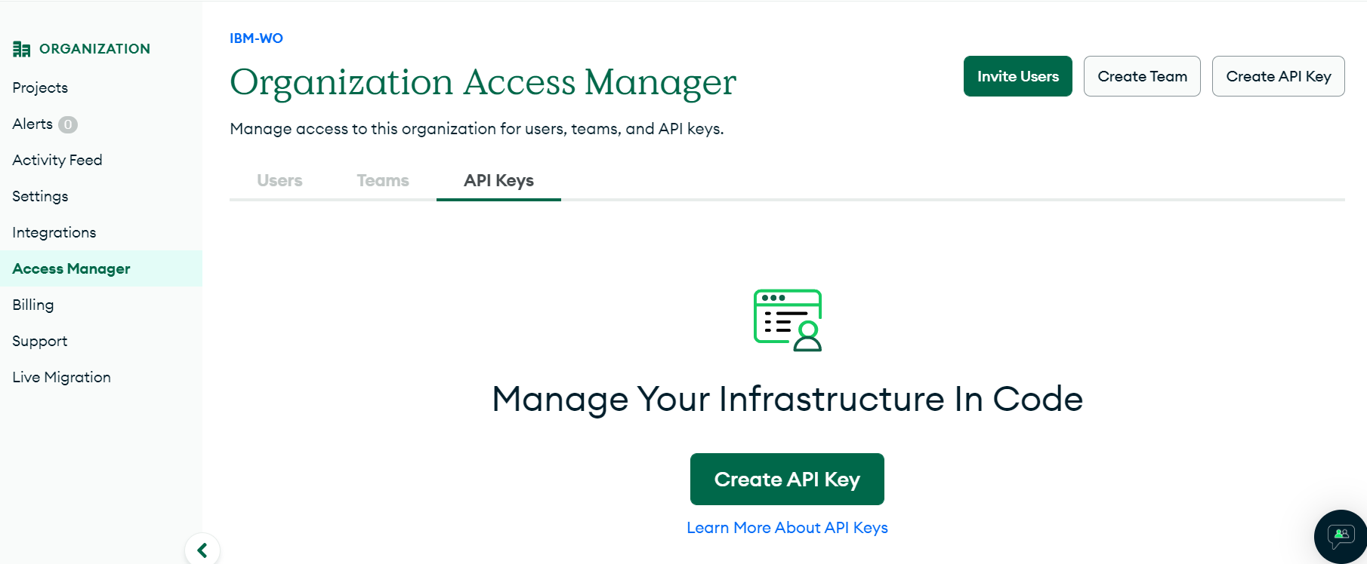

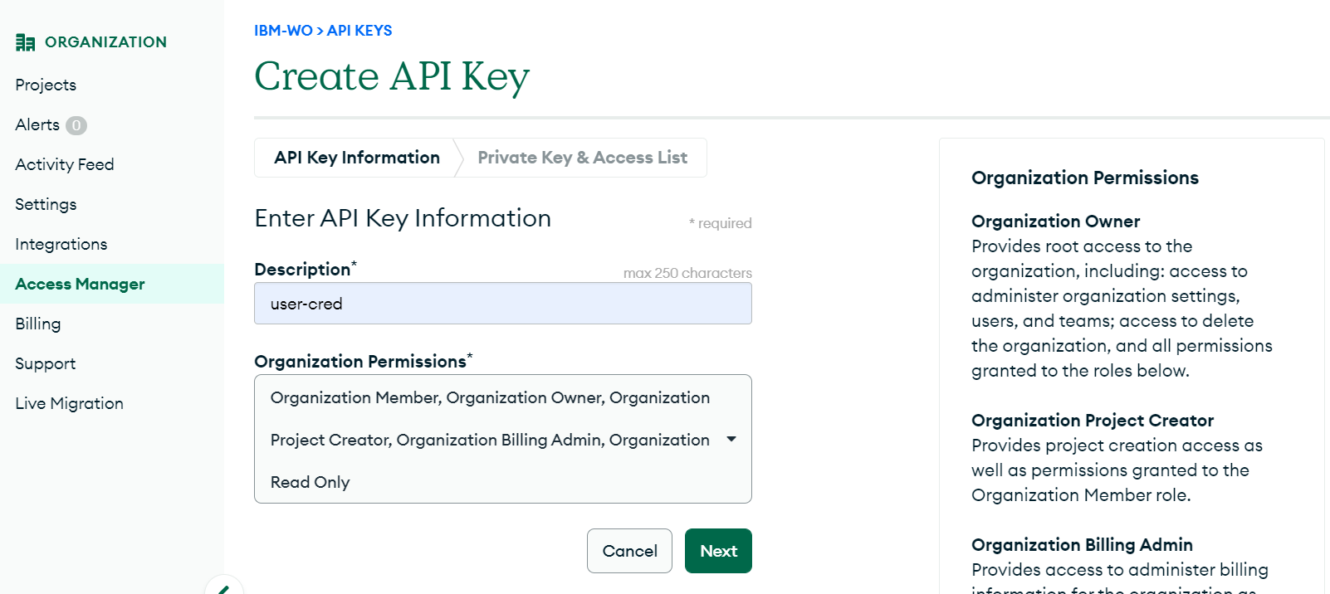

**Note:** After creating the API Key you need to Copy your private key and store it in a secure location. After you leave page, the full private key will not be unavailable again.

* In the same tab you will see the API Access List, you need to Add the public IP of the instance or machine from where you want to access the MongoDB for creation of projects, cluster, and Database etc. and click on Done.
* You can add multiple IP’s also.

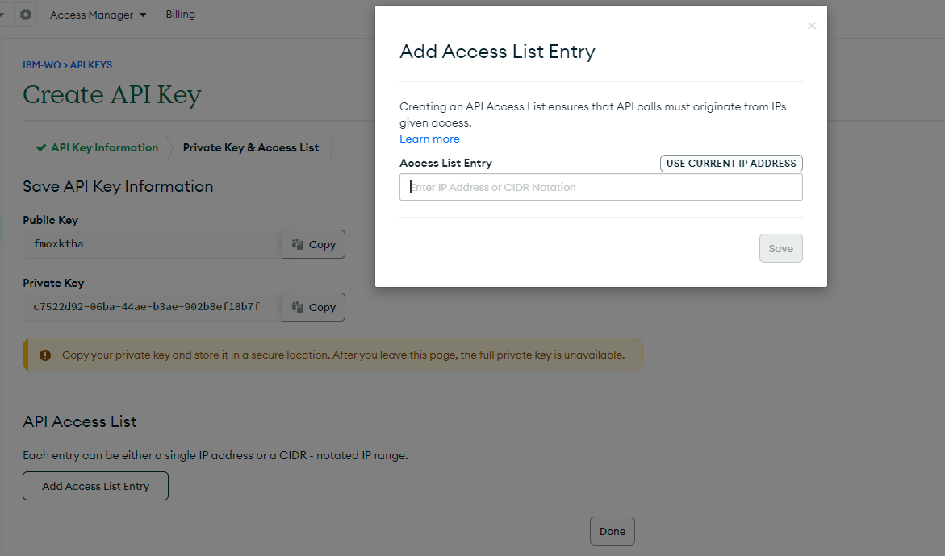

**Jenkins console configurations:**

* Login to Jenkins console using Jenkins instance <publicDNS>:8080 port.
* Click on Manage Jenkins option in the left panel of the Jenkins console.

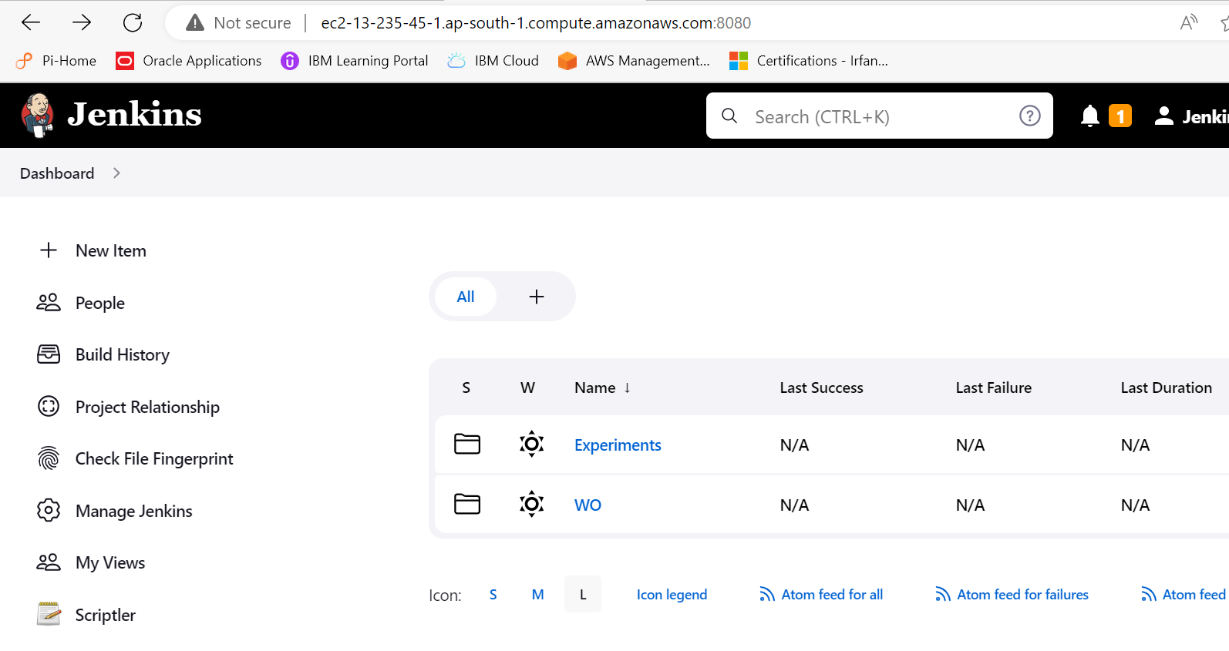

* On the console you will see an option Manage credentials under security section, click on Manage credentials.

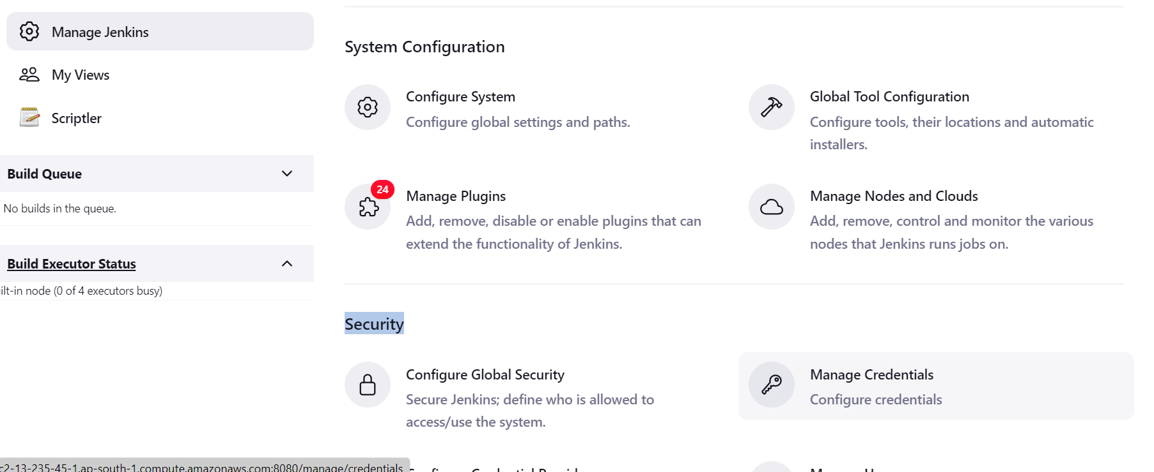

* You will see the console of credentials were in you will have all the update all the credentials before provisioning the cluster.
* Following are the list of credentials which you need to update.
  + AWS_ACCESS_KEY_ID
  + AWS_SECRET_ACCESS_KEY
  + AWS_SESSION_TOKEN
  + ATLAS_PUBLIC_KEY
  + ATLAS_PRIVATE_KEY

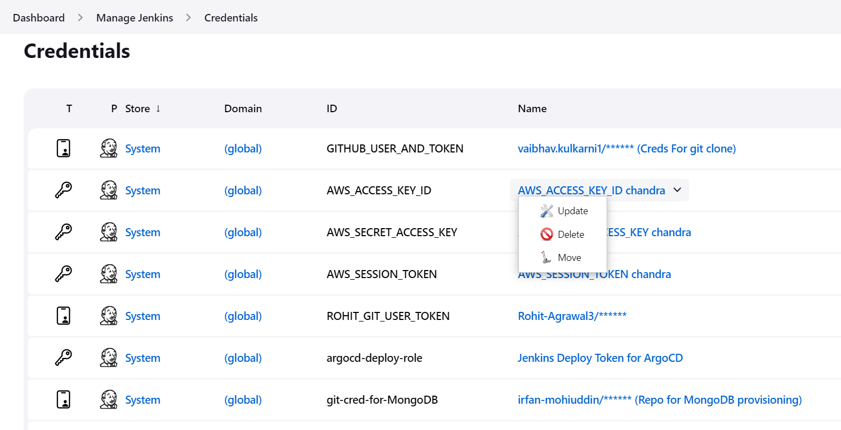

* You can get the AWS credentials by following the [**link here**](https://d-90676794b7.awsapps.com/start#/)
* select the AWS account where you want to provision the cluster and there select **Command line or programmatic access** to see the AWS credentials and by following the above MongoDB configuration steps you will get the Atlas API keys.