📘 UDS Multi-Agent QA System Documentation

Overview
This project implements a multi-agent system for querying and comparing Unified Diagnostic Services (UDS) documentation. I Split the ISO-14229 UDS protocol to Text files using Regex expression. It uses the LlamaIndex framework, Google Gemini models, and a Streamlit interface.
- Document-specific agents for semantic search and summarization
- Top-level agent orchestrates tool usage with reranking
- Baseline RAG pipeline for comparison
- Streamlit interface for file uploads and question answering

🗂️ Architecture Overview
The system is composed of multiple per-document agents and a top-level orchestrator agent. Each document agent can perform semantic search and summarization. A central ReActAgent retrieves the most relevant tools (agents) for a user query using a retriever + reranker combination.
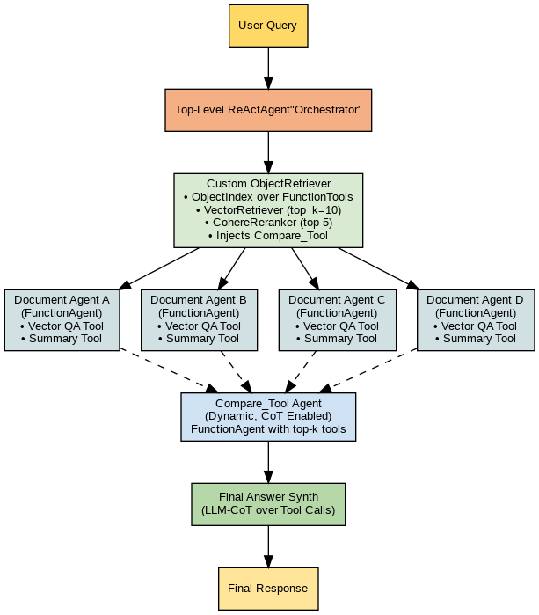

⚙️ Component Breakdown

📂 File Upload & Initialization
- Users upload `.txt` UDS files through Streamlit.
- Files saved to `DATAN/` directory.
- On 'Initialize Services': each file is turned into a document and indexed.
- Per-document FunctionAgents are created and stored.
- Top-level ReActAgent and baseline query engine are initialized.

🧱 Per-Document Agent Creation
- VectorStoreIndex: Semantic search per document (stored in `storage/{service}/vector_index`).
- SummaryIndex: Tree-based summarization (stored in `storage/{service}/summary_index`).
- FunctionAgent: Handles 2 tools – vector-based search and summarization.
- Summaries are cached to `summaries/{service}.pkl`.

🧠 Top-Level Agent (ReActAgent)
The top-level `ReActAgent` retrieves tools relevant to the query, using an `ObjectIndex` + reranking strategy.
🔍 CustomObjectRetriever
- Uses vector retriever over tool summaries.
- Ranks top 10 candidates using semantic similarity.
- Applies CohereRerank (top 5) to improve tool selection.
- Injects `compare_tool` for queries that span multiple documents.
🧠 ReActAgent
- Receives user queries via Streamlit UI.
- Delegates question answering to selected FunctionTools.
- Gemini LLM generates structured responses.

🧪 Baseline RAG
- Combines all document nodes into a single VectorStoreIndex.
- Uses top_k = 4 for naive vector search retrieval.
- Used for comparison with agentic response.

💬 Streamlit Interface
- File uploader for `.txt` UDS files
- Button to initialize all service agents and RAG baseline
- Text input for questions
- Displays responses from:
- ✅ Top-level multi-agent system
- 📎 Baseline vector retriever
- Shows full query history

🧪 Models Used
- LLM: gemini-2.5-pro
- Embedding Model: gemini-embedding-001
- Reranker: Cohere rerank-v3.5

🚀 Running the App
- Install dependencies: `pip install -r requirements.txt`
- Create `.env` file with keys:
- GOOGLE_API_KEY=your_key
- TRACELOOP_API_KEY=your_key
- COHERE_API_KEY=your_cohere_key
- Start the app: `streamlit run app.py`
- Upload `.txt` files and click 'Initialize'

📁 Directory Structure
.
├── DATAN/ # Uploaded UDS text files
├── storage/ # Per-document vector/summary indices
│ └── {service}/
│ ├── vector_index/
│ └── summary_index/
├── summaries/ # Cached summaries per document
└── app.py # Streamlit application

💡 Example Queries
- Compare ECU Reset, Tester Present, Link control services and explain how they are related
- What are the NRC mentioned ECU Reset?
- In a scenario where the ECU is reset frequently, how should Tester Present messages be scheduled?

✅ Notes
- The multi-agent system supports document-specific responses and comparisons.
- `compare_tool` is injected dynamically when a comparison is needed.
- Designed for robust and scalable document QA across UDS services.

