Bangladesh Army University of Engineering & Technology (BAUET)

Qadirabad, Natore-6431

**Department of**

**Computer Science and Engineering (CSE)**

Project Proposal

**Title: “BD- Servant”**

**Course Code:** CSE-3104

**Course Title:** Software Engineering and Information System Design Sessional

**Experiment Date: 07.08.23**

**Submission Date: 21.08.23**

|  |  |
| --- | --- |
| **Submitted By** | **Submitted To** |
| **Name:** Md.Moktadir Ul Islam | Subrata Kumer Paul |
| **ID:** 0812110205101010 | Assistant Professor |
| **Name:** Tanzeem Al Waseq | Dept. of CSE, BAUET |
| **ID:** 0812110205101020 |  |
| **Name:** Toyub Ur Rashid Khan | Mst. Irin Sultana |
| **ID:** 0812110205101006 | Lecturer |
| **Department:** CSE | Dept. of CSE, BAUET |
| **Batch:** 13th |  |
| **Session:** 2020-21 |  |

# Introduction:

The “BD-Servant” is a user-friendly app designed to make our daily lives more convenient by offering online maid or servant services. This innovative apps aims to cater to the needs of individuals seeking domestic help, allowing them to easily hire reliable and professional maids or servants through a hassle-free online process. “BD-Servant” is a revolutionary mobile app designed to make our daily lives more convenient and efficient by offering online maid or servant services. With the ever-increasing demands on our time and busy schedules, “BD-Servant” aims to simplify our lives by providing essential features that cater to our daily needs.

# Objectives:

* Easy Booking: The mobile app will provide a straightforward and efficient booking system, allowing users to find and book maids or servants according to their specific requirements and schedules.
* Verified Profiles: To ensure safety and reliability, all the maids or servants featured on the mobile app will be required to provide authentic background information for authentication. Users can have peace of mind knowing that they are hiring trustworthy individuals.
* Flexible Services: **“**BD-Servant**”** will offer a wide range of services that cater to various household needs, such as cooking, nursing, gardening, and more. Users will be able to customize their service packages based on their preferences.
* Reviews and Ratings: The app will allow customers to leave reviews and ratings for the maids or servants they hire, helping other users make informed decisions and promoting a sense of accountability.

# Problem Statement:

In today’s digital age we rarely have sufficient time to focus on our household activities. While servants may provide some relief to us in our household tasks, they are not always up to our standards or may not provide customer satisfaction. In the context of the proposed mobile app "BD-Servant" and its online maid or servant services, we can tackle some of these issues with home-level services. This study aims to address the problem of user satisfaction, availability and flexibility of services, security and professionalism of the service holders. Through a combination of user service demands, data analysis of geographical location and service needs in those locations, and feedback collection, this research seeks to identify design and functionality enhancements that can optimize an user’s journey when seeking their desired services and increase efficiency in seeking services a freelance manner, while upholding trust of the users.

* **Online Maid or Servant Services:** The study will focus exclusively on the provision of online maid or servant services through the “BD-Servant” mobile app. It will not cover other types of service marketplaces or platforms.
* **Daily Life Services:** The research will concentrate on features and services that cater to everyday needs, such as household chores, cleaning, cooking, and related tasks that are commonly required in a residential setting.
* **Geographical Limitations**: The scope of the study will be restricted to a specific geographical area or region where “BD-servant” will operate its services. The impact of cultural and regional variations may also be considered.
* **Service Efficiency:** The research will examine the efficiency and effectiveness of the platform in matching users with appropriate maids or servants and providing timely and satisfactory services.
* **Security and Trustworthiness:** The study will address the security measures implemented by “BD-Servant”, ensuring that both customers and service providers feel safe while using the platform.
* **Payment and Pricing:** The scope will include an analysis of the transparency of pricing, the payment process, and any additional costs associated with the services.
* **Customer Support:** The research will evaluate the quality and responsiveness of “BD- Servant” customer support in addressing queries, concerns, and resolving issues.
* **Impact on Daily Life:** The study will explore the impact of using online maid or servant services on the daily lives of customers, including how it affects time management and overall convenience.

# Literature Review:

The introduction of digital platforms has transformed the way consumer access and engage with household services, such as cleaning, repairs, and maintenance. This literature review aims to solve some of the problems seen in an existing system “sheba.xyz”. One of the design flaws of “sheba.xyz” mentioned by the author in [3] is that often times the personnel providing services are not trained in customer management. At the lowest this can lead to an embarrassing situation for the client and the servant, and at worst it can turn into a dangerous situation for the customer. If they continue to deliver poor service, it may have a negative impact on the brand [3]. In light of these suggestions we are going to create a dedicated team for customer service management who will prioritize service quality and filtering.

There is also the matter of having a strong reliance on the third-party vendors for services in our app. If we can earn the loyalty of the service providers, we can improve service quality, and thus earn the trust of our customers.

A strategy to develop personal and household services can ease the burden on informal carers and the welfare state with beneficial effects for the life satisfaction of carers and the cared, enabling a self-determined life and helping to maintain links to the labor market, particularly for women. In particular, women would benefit from the implementation of a sustainable strategy of personal and household services in several ways: they would have the possibility to return to their job, increase their working hours and formalize their undeclared work in the area of supportive services, which they were probably already providing (formalization of existing jobs and creation of new jobs). [2] Our mobile app will provide a sustainable platform for these third-party vendors to return to for jobs and opportunities and this will provide the service givers a sense of security and dedication toward their services. This can be a way of improving the quality of service.

# Requirement Specification:

## Software Requirements:

* + - Java
    - php
    - My SQL

## Hardware Requirements:

* + - Processor: Intel Core i3 or equivalent AMD processor
    - Processor Speed: 1.8 GHz or higher
    - RAM: 4 GB or higher
    - Hard-disk: 10 GB or higher
    - Operating System: Windows 7 or higher

# Methodology with Flowchart:

The “BD-Servant” mobile app will be developed using the Agile methodology, with the development process divided into sprints, each focusing on specific sets of features. The system will be designed with a modular approach, where each module will be responsible for managing a specific aspect of the online maid or servant services. The key modules to be developed are:

* Maid or Servant Registration and Enrollment Management
* Rating and Feedback Management
* Maid or Servant Profile and Scheduling
* Billing and Payment Management
* Customer Information Management
* Communication and Support Management

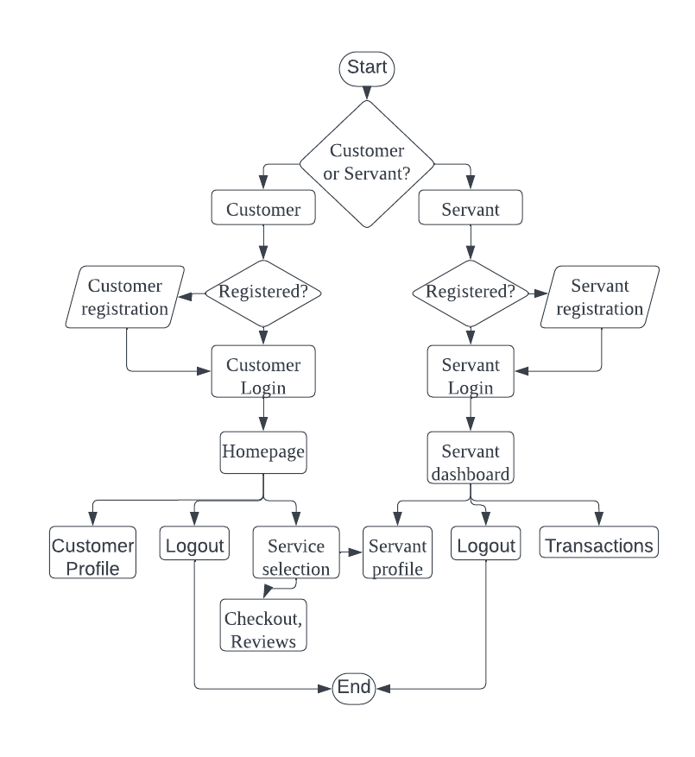

Figure 6.1: Methodology (Flowchart).

# Project Scheduling:

The proposed project will be completed in 6 phases, with a total duration of 6 weeks:

* Phase 1: Recognition of need – 1 week
* Phase 2: Feasibility study – 3 weeks
* Phase 3: Analysis – 4 weeks
* Phase 4: Design – 4 weeks
* Phase 5: Implementation – 1 week
* Phase 6: Post-Implementation – 1 week

To develop our mobile app, we have made a Gantt chart and we will develop our app. There are two parts to this Gantt chart, first is week and second is phase. How much time will be required to complete each phase is illustrated by the Gantt chart.

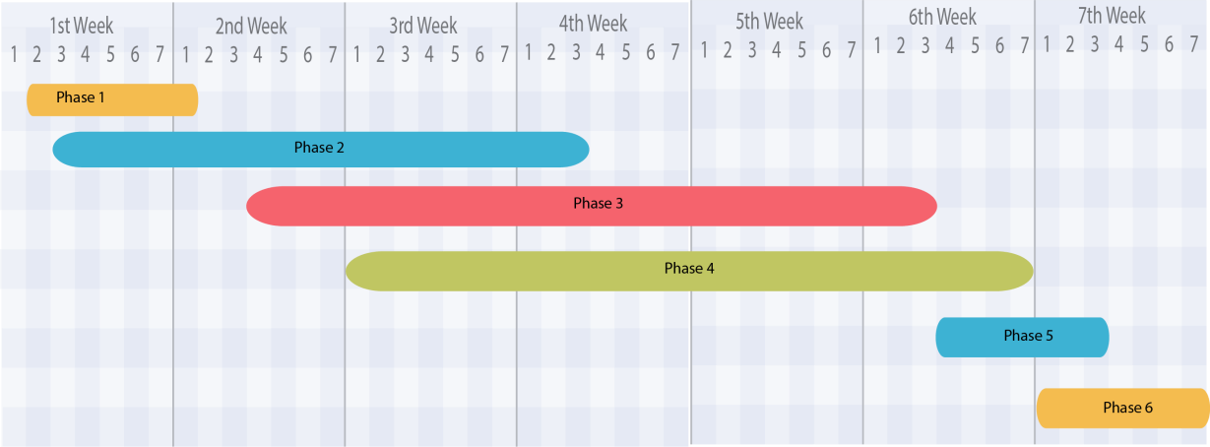

Figure 7.1: Project Development Schedule (Gantt chart).

# Environment and Sustainability:

The “BD-servant” app will adopt the following services to provide sustainable services to our customers:

* Reduce waste production and use recycle worthy materials while providing services.
* Use online systems for customer management, invoicing and payments and fully utilizing digital systems to reduce paper usage.
* Educate our employees and clients in eco-friendly practices.
* Measure and monitor waste generation, energy and consumption and regularly assess sustainability goals.
* Offer eco-friendly services such as efficient energy installation, plumbing solutions, green cleaning services.

# Conclusion:

In conclusion, the “BD-Servant” is a highly efficient and user-friendly platform that will revolutionize the way we access online maid or servant services. Through its modular approach and adoption of the agile methodology, the mobile app will ensure seamless development and delivery of essential features to meet users' daily life needs.

With features like easy online booking, flexible scheduling, and verified, “BD- Servant” will guarantee a hassle-free experience for customers seeking household assistance. The transparent pricing and secure payment options will also add to the platform's credibility, instilling trust in users.

**References:**

|  |  |
| --- | --- |
| [1] | Kaf Afari, Final Project in IT – “University Management System”,MBA,Sikkim ManipalUniversity, 2021 |
| [2] | Angermann, A., & Eichhorst, W. (2013). Who cares for you at home? Personal and household services in Europe |
| [3] | Hossain, F. (2022). *Improving the Livelihood of Blue-Collar’s Population by Uplifting GIG Economy: A Study of the Largest Online Service Platform Sheba. XYZ*. Department of Business and Technology Management (BTM), Islamic University of Technology (IUT), Board Bazar, Gazipur-1704, Bangladesh. |

8