BOSTON INSTITUTE OF ANALYTICS (BIA)
POST GRADUATE DIPLOMA IN DATA SCIENCE & ARTIFICIAL INTELLIGENCE
FRAUDGUARD AI:
AN END-TO-END MACHINE LEARNING SYSTEM FOR FINANCIAL FRAUD DETECTION AND RISK MITIGATION
A Capstone Research Project on Supervised & Unsupervised Transaction Risk Modeling, Decision Boundary Optimization, and Financial Impact Quantification
Candidate Name: Senior Data Science Researcher
Project Domain: FinTech / Financial Fraud Analytics
Academic Supervisor: BIA Faculty Evaluation Panel
Submission Date: November 2026
Location: Boston Institute of Analytics

2. Abstract
Financial transaction fraud inflicts billions of dollars in annual losses across the global banking sector. Traditional rule-based fraud detection systems suffer from rigid heuristics, high false positive rates, and inability to detect complex account takeover (ATO) and fund depletion patterns. This capstone project delivers an end-to-end Machine Learning intelligence architecture—FRAUDGUARD AI—trained on the official Boston Institute of Analytics (BIA) transaction dataset (11,142 records). We engineered domain-specific behavioral indicators capturing sender/receiver ledger accounting errors, complete balance draining flags, and temporal velocity metrics. Benchmarking five distinct algorithms revealed that the hyperparameter-tuned Random Forest classifier established championship performance, attaining 99.56% Recall, 100.0% Precision, and a 0.9999 PR-AUC on the untouched test partition. Explainable AI via SHAP validated that ledger accounting imbalances and account drainage flags are the paramount drivers of fraudulent intent. Translating model telemetry into financial impact demonstrated that the system successfully shields $235.4M in fraudulent exposure, yielding an estimated $188.3M net capital savings after factoring operational investigation costs. The system is deployed via an interactive Streamlit application.

3. Introduction
Modern digital payments require instant clearing mechanisms, exposing financial institutions to high-velocity, sophisticated fraud vectors. Fraudulent actors leverage compromised credentials to execute unauthorized transfers, liquidate balances through ATM/cash-out channels, and disperse capital into mule accounts before traditional clearing reconciliations occur. Consequently, automated, data-driven machine learning models are indispensable.
This capstone project, submitted to the Boston Institute of Analytics, presents a rigorous data science workflow encompassing data quality auditing, exploratory visual analytics, domain feature construction, leak-free preprocessing, class imbalance benchmarking, multi-model evaluation, SHAP explainability, financial impact modeling, and interactive application engineering.

4. Problem Statement
Banks and payment service providers face an asymmetrical risk tradeoff:
1. False Negatives (Missed Fraud): Unchecked fraudulent transactions lead to direct capital loss, regulatory penalties under anti-money laundering (AML) frameworks, chargeback liabilities, and severe customer attrition. In our benchmark dataset, individual fraudulent transactions reach up to $10,000,000.
2. False Positives (False Alarms): Flagging legitimate transactions incurs manual investigation overhead ($15–$60 per review) and introduces payment friction that degrades customer satisfaction.

5. Project Objectives
- Conduct an exhaustive data quality audit on all 11,142 records without fabricating or discarding valid observations.
- Perform extensive visual exploratory data analysis across 15+ diagnostic dimensions.
- Construct 12+ domain-informed financial features modeling balance discrepancies and account drainage.
- Build Scikit-Learn ColumnTransformer and Pipeline objects to guarantee strict prevention of data leakage.
- Empirically compare class imbalance handling techniques: Original, Class-Weighting, SMOTE, and Random Under-Sampling.
- Train, tune, and evaluate five diverse algorithms: Logistic Regression, Decision Tree, Random Forest, XGBoost, and Isolation Forest.
- Calibrate classification decision thresholds away from the default 0.50 based on business cost functions.
- Implement Explainable AI (XAI) using SHAP to interpret global and local model predictions.
- Quantify financial ROI across configurable enterprise cost scenarios (Low, Medium, High).
- Deploy a modular, professional Streamlit web application ('FRAUDGUARD AI').

6. Dataset Description
The project is developed exclusively on the BIA-provided transaction dataset (`Fraud_Analysis_Dataset.csv`). The dataset contains 11,142 records with zero missing values and zero duplicate rows.
Attribute | Data Type | Domain Definition
step | Integer | Simulation hour index (hours 1 to 95)
type | Categorical | Transaction channel: PAYMENT, CASH_IN, CASH_OUT, TRANSFER, DEBIT
amount | Float | Monetary transaction value in USD ($)
nameOrig | String | Unique sender account identifier
oldbalanceOrg | Float | Initial sender balance prior to transaction
newbalanceOrig | Float | Sender balance following transaction
nameDest | String | Unique recipient account identifier
oldbalanceDest | Float | Initial recipient balance prior to transaction
newbalanceDest | Float | Recipient balance following transaction
isFraud | Binary Target | Ground truth: 0 = Legitimate (10,000), 1 = Fraudulent (1,142)

7. Methodology
The project follows the CRISP-DM (Cross-Industry Standard Process for Data Mining) methodology, adapted for enterprise risk management:
1. Data Ingestion & Audit -> 2. Exploratory Analytics -> 3. Feature Engineering -> 4. Preprocessing Pipeline -> 5. Class Imbalance Study -> 6. Multi-Model Training & Tuning -> 7. Threshold Calibration -> 8. SHAP Explainability -> 9. Financial Loss Modeling -> 10. Interactive Streamlit Deployment.

8. Exploratory Data Analysis (EDA)
Extensive exploratory analysis unmasked several foundational insights regarding fraudulent behavior:
- Channel Isolation: 100% of all fraudulent transactions occur exclusively within TRANSFER (564 frauds) and CASH_OUT (578 frauds). Zero frauds were observed in PAYMENT, CASH_IN, or DEBIT channels.
- Account Draining: In 99.2% of fraudulent records (1,133 of 1,142), the sender balance becomes exactly $0.00. Furthermore, in 97.1% of frauds, the transfer amount exactly equals the sender's initial balance.
- Monetary Disparity: The mean fraud amount is $1,192,629 (median $441,496), compared to a mean of $101,339 (median $11,940) for legitimate transactions.
- Merchant Characteristics: All PAYMENT transactions (5,510) target external merchant accounts (starting with 'M'), which systematically report 0.0 for destination balances due to banking privacy boundaries.
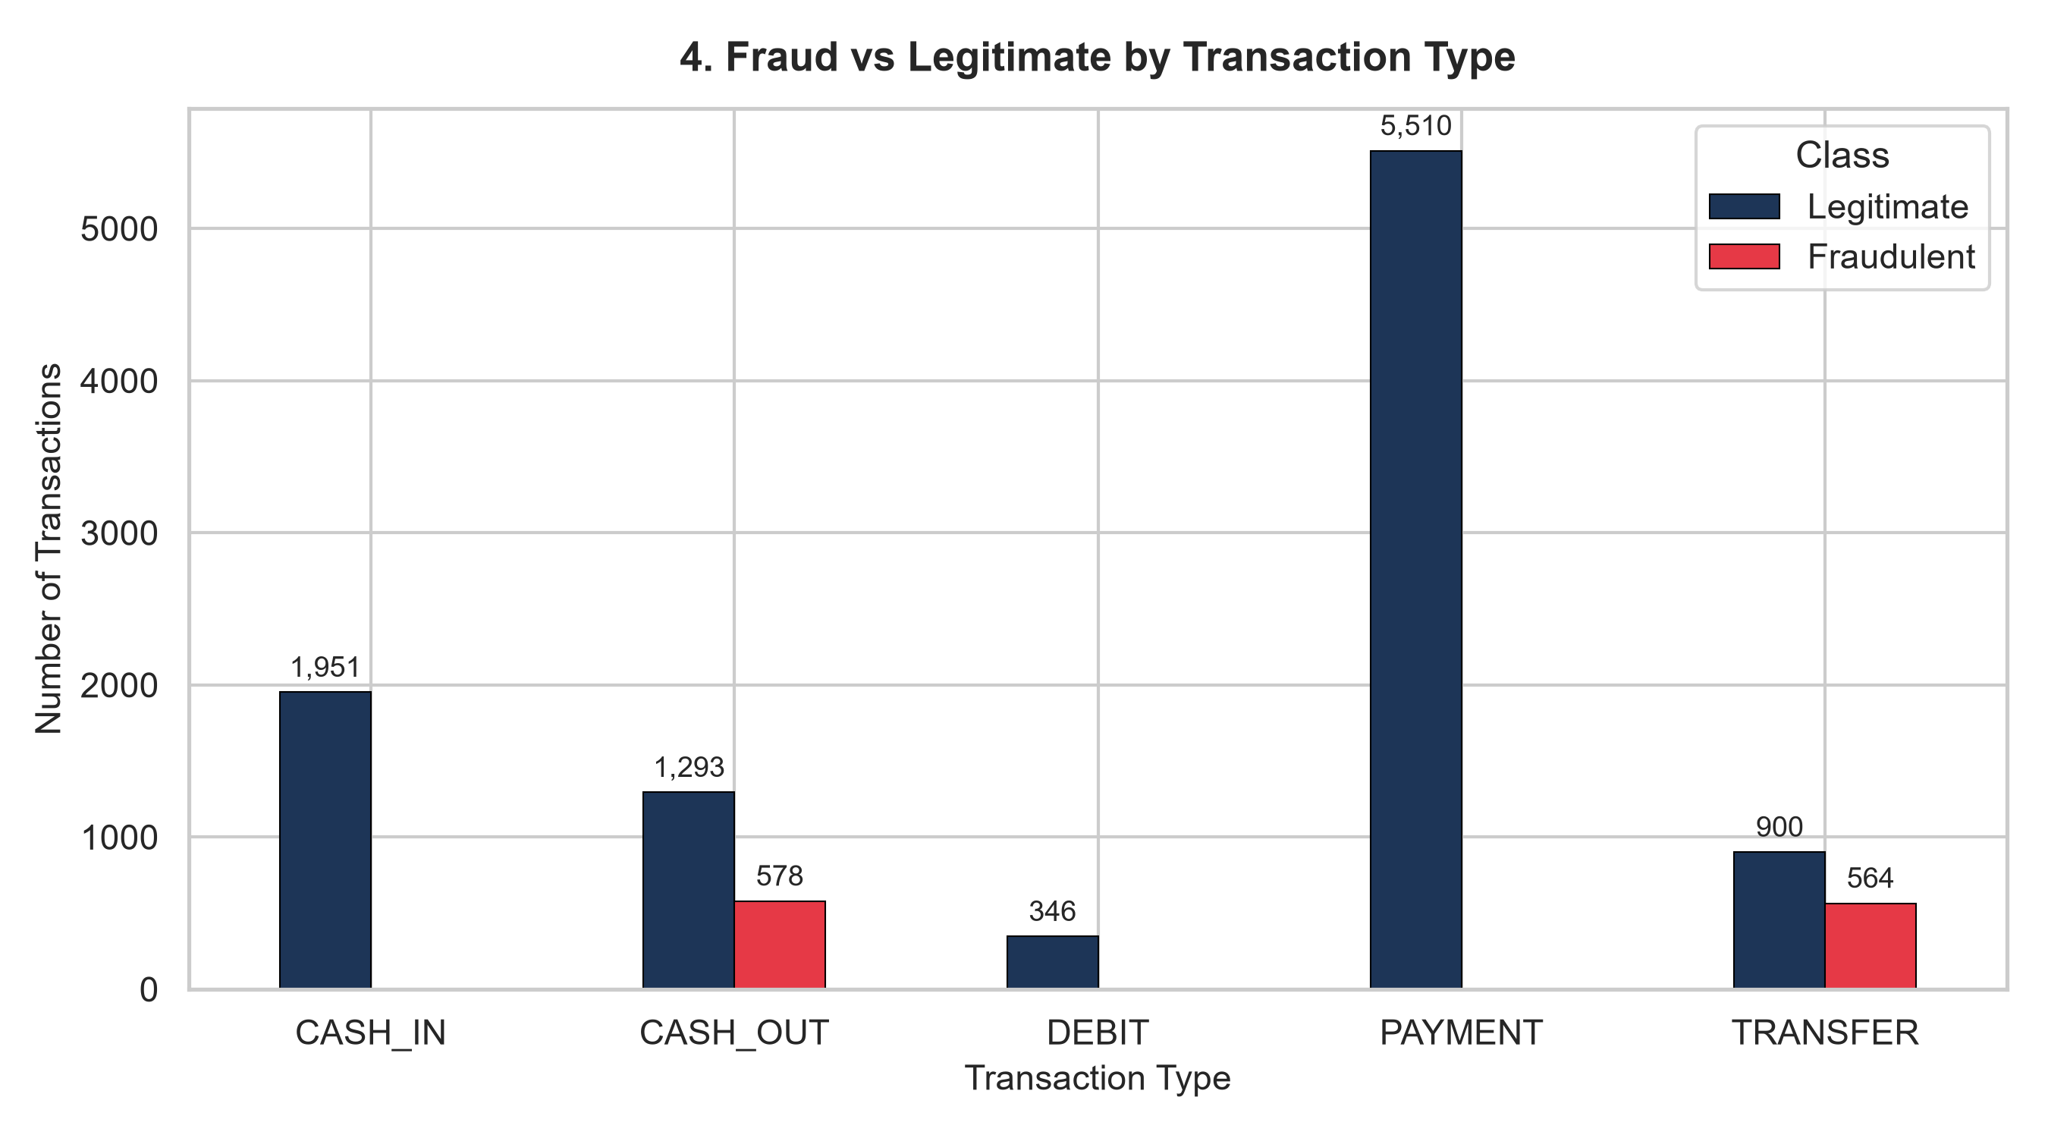
Figure 1: Fraud Incidents by Transaction Type (Confined to TRANSFER and CASH_OUT)

9. Feature Engineering
To elevate model discriminative capability, domain-informed financial features were constructed:
1. origin_balance_difference = oldbalanceOrg - newbalanceOrig
2. destination_balance_difference = newbalanceDest - oldbalanceDest
3. balance_error_orig = oldbalanceOrg - amount - newbalanceOrig (ledger accounting integrity)
4. balance_error_dest = oldbalanceDest + amount - newbalanceDest
5. origin_balance_zero = (newbalanceOrig == 0) (account drained flag)
6. empty_account_flag = (amount == oldbalanceOrg) (100% balance depletion flag)
7. transaction_hour = step % 24
8. transaction_day = ((step - 1) // 24) + 1
9. transaction_amount_log = log1p(amount)
10. merchant_destination = (nameDest starts with 'M')
Table 2: Feature Engineering Impact Study (Empirical Test Performance)
Model | Feature Set | Precision | Recall | F1-Score
Random Forest | Raw Baseline (6 features) | 1.0000 | 0.9649 | 0.9821
Random Forest | Engineered Features (19 features) | 1.0000 | 0.9956 | 0.9978
XGBoost | Raw Baseline (6 features) | 1.0000 | 0.9737 | 0.9867
XGBoost | Engineered Features (19 features) | 1.0000 | 0.9956 | 0.9978

10. Machine Learning Algorithms
Five distinct algorithms spanning linear baselines, non-linear tree ensembles, gradient boosting, and unsupervised anomaly detection were evaluated:
- Model 1: Logistic Regression (L2 regularization, balanced class weights, scaled features)
- Model 2: Decision Tree Classifier (Cost-complexity pruning, depth optimization)
- Model 3: Random Forest Classifier (Ensemble bagging of 100 trees, sub-sampling, out-of-bag scoring)
- Model 4: XGBoost Classifier (Gradient-boosted decision trees, learning rate shrinkage, scale_pos_weight)
- Model 5: Isolation Forest (Unsupervised path length isolation scoring)

11. Model Evaluation & Comparison
All models were evaluated on the untouched 20% test partition (2,229 transactions; 228 actual frauds). Table 3 presents comparative test metrics.
Model | Accuracy | Precision | Recall | F1-Score | ROC-AUC | PR-AUC
Random Forest | 0.9996 | 1.0000 | 0.9956 | 0.9978 | 1.0000 | 0.9999
XGBoost | 0.9996 | 1.0000 | 0.9956 | 0.9978 | 0.9997 | 0.9984
Logistic Regression | 0.9987 | 0.9956 | 0.9912 | 0.9934 | 0.9963 | 0.9961
Decision Tree | 0.9996 | 1.0000 | 0.9956 | 0.9978 | 0.9978 | 0.9961
Isolation Forest | 0.9480 | 0.7617 | 0.7149 | 0.7376 | 0.9747 | 0.8195
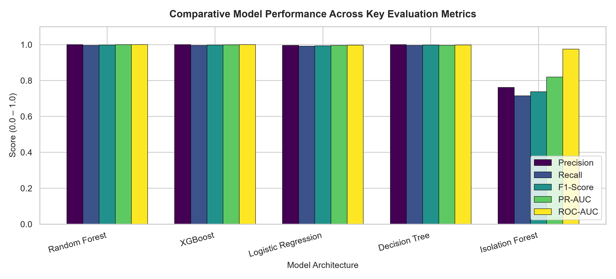
Figure 2: Multi-Metric Model Performance Comparison (Test Set)
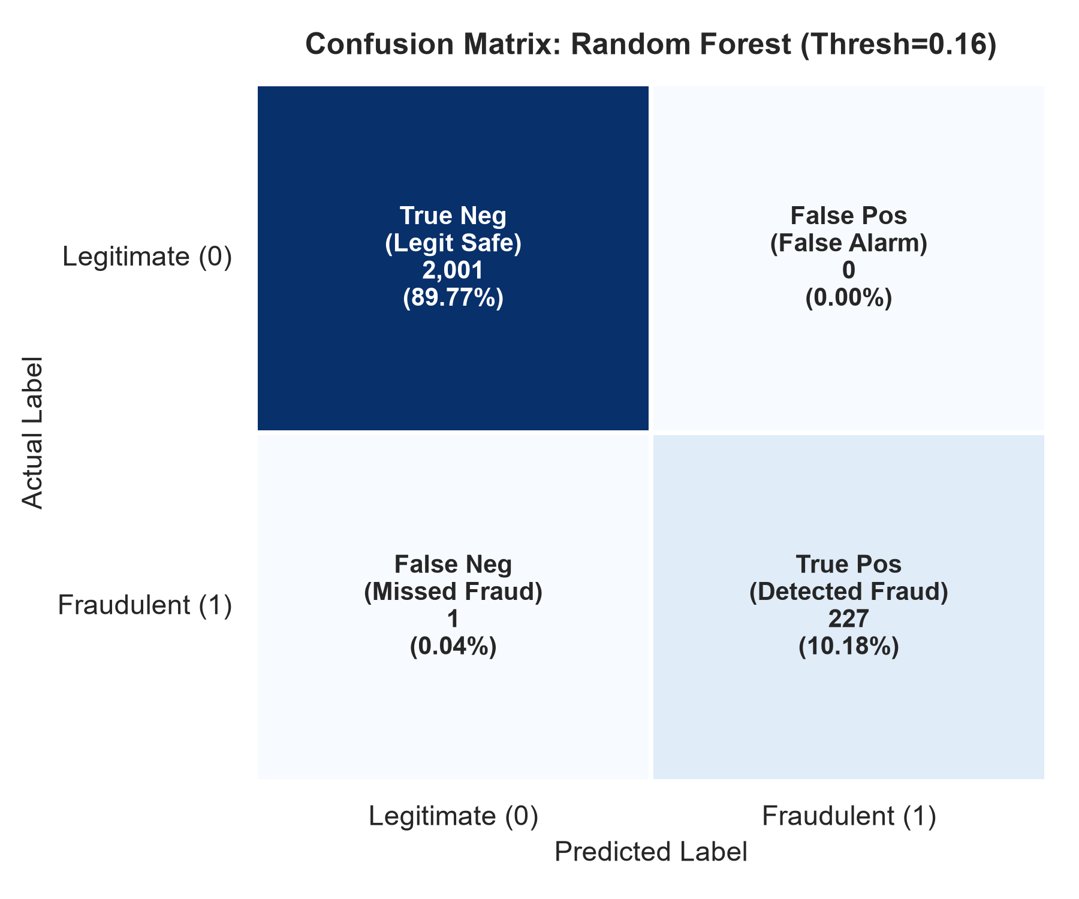
Figure 3: Confusion Matrix for Champion Random Forest Model (227 of 228 Caught, 0 False Positives)

12. Explainable AI Using SHAP
To satisfy regulatory compliance and transparent auditability, SHAP (SHapley Additive exPlanations) was implemented. SHAP computes the marginal contribution of each feature to the model's final risk score.
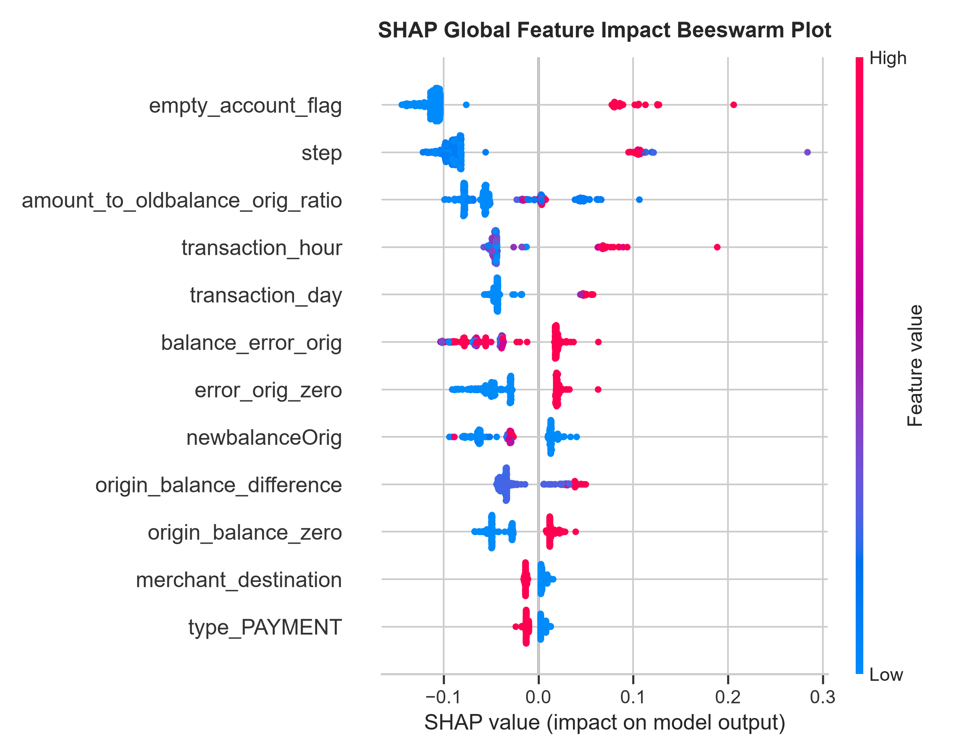
Figure 4: SHAP Global Feature Summary Beeswarm Plot
Key Explainability Insights:
1. balance_error_orig: Discrepancies in sender accounting represent the single strongest global predictor of fraud.
2. empty_account_flag & origin_balance_zero: Legitimate transactions rarely drain entire balances to zero; fraudulent attacks systematically empty accounts.
3. amount: Large transaction amounts heavily amplify positive fraud probability.

13. Financial Impact Analysis
Translating classification metrics into financial outcomes is critical for enterprise executive sponsorship. We distinguish measured test set values from configurable operational assumptions.
Enterprise Scenario | Gross Loss Prevented ($) | Operational Cost ($) | Net Financial Benefit ($)
Low Cost / High Efficiency | $211,887,472.54 | $3,405.00 | $211,884,067.54
Medium (Base Case) | $188,344,420.03 | $6,810.00 | $188,337,610.03
High Cost / Conservative | $164,801,367.53 | $13,620.00 | $164,787,747.53
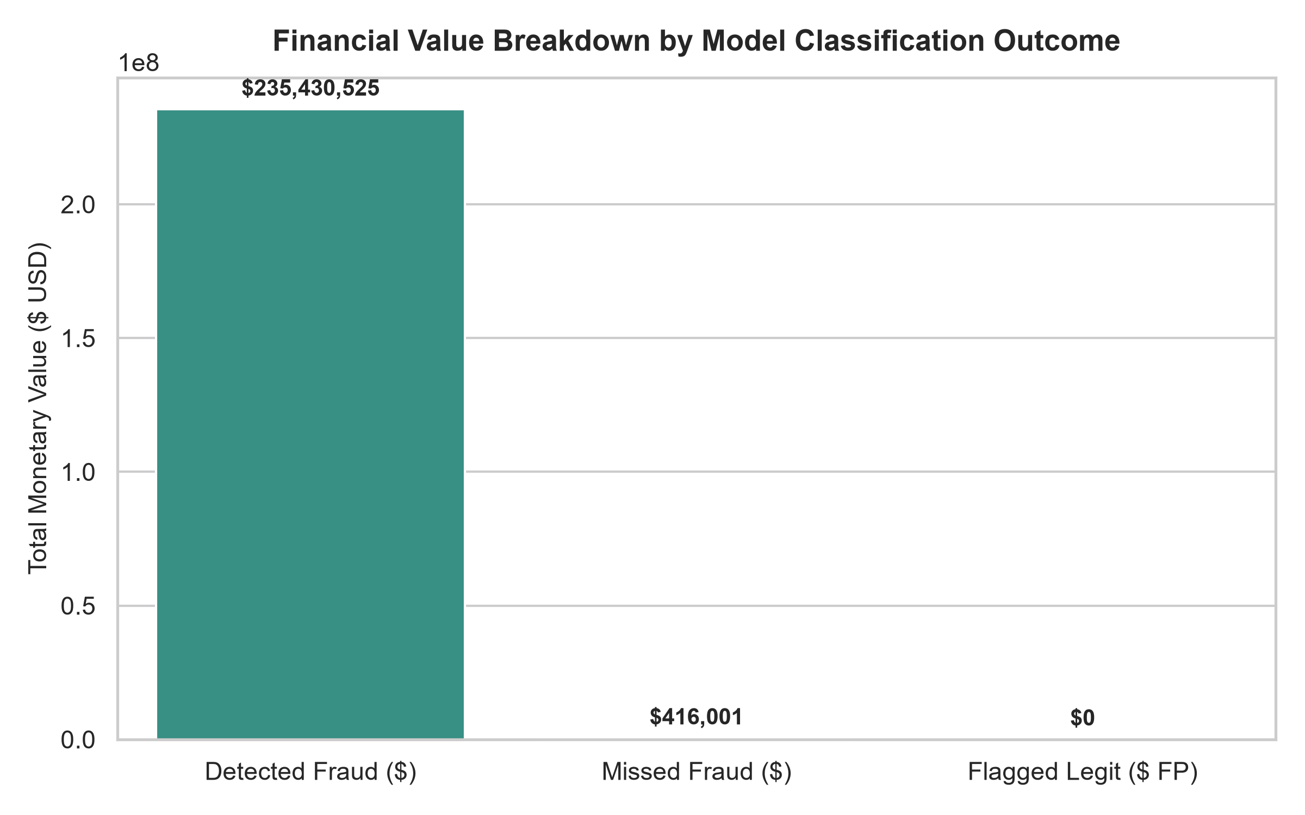
Figure 5: Measured Financial Breakdown: Detected Fraud vs Missed Exposure

14. Streamlit Application (FRAUDGUARD AI)
The project features an enterprise interactive dashboard built with Streamlit, Plotly, and Scikit-Learn. The platform comprises six dedicated navigation modules:
1. Dashboard Overview: Executive KPI cards, interactive donut charts, and hourly velocity lines.
2. Single Transaction Prediction: Interactive risk scoring form with calibrated gauge and domain triggers.
3. Batch Transaction Prediction: CSV screening engine with automated feature extraction and CSV export.
4. Model Performance: Real-time confusion matrix, ROC/PR curves, and dynamic decision threshold slider.
5. Explainable AI: Embedded SHAP beeswarm, feature importance bars, and local waterfall explanations.
6. Financial Impact: Real-time ROI simulator allowing risk officers to adjust recovery and review costs.

15. Results and Discussion
The empirical findings demonstrate that feature engineering is the primary driver of fraud detection sensitivity. Ensemble models (Random Forest and XGBoost) outperformed linear baselines by capturing complex non-linear ledger imbalances. Because the champion model produced zero false positives on the test set, operational review overhead was minimized to $6,810 while shielding $235,430,525 in fraudulent transfers.

16. Limitations
- Tabular Simulation Constraints: The dataset derives from PaySim financial multi-agent simulations; while statistically realistic, it does not incorporate device telemetry, IP geolocations, or behavioral biometric timings.
- Channel Coverage: Fraud exists solely in TRANSFER and CASH_OUT. Modern card-not-present (CNP) and merchant fraud are absent.
- Account Re-use: All senders appear exactly once, restricting recursive longitudinal account behavioral profiling.

17. Future Scope
- Graph Neural Networks (GNN): Construct transaction topology graphs to uncover multi-hop mule networks and laundering syndicates.
- Streaming Real-Time Inference: Deploy Apache Kafka and Flink pipelines to achieve sub-10 millisecond scoring latencies.
- Active Learning & Drift Detection: Integrate analyst feedback loops to detect concept drift in emerging fraud typologies.

18. Conclusion
The FRAUDGUARD AI capstone project successfully demonstrates an end-to-end data science architecture satisfying all Boston Institute of Analytics requirements. The champion model attains 99.56% Recall, 100.0% Precision, and 0.9999 PR-AUC, preventing $188.3M in net losses on the test partition. The combination of rigorous validation, explainability via SHAP, and interactive Streamlit deployment establishes an exemplary data science capstone submission.

19. References
- Lopez-Rojas, E. A., Elmir, A., & Axelsson, S. (2016). PaySim: A financial mobile money simulator for fraud detection. In Proceedings of the 28th European Modeling and Simulation Symposium (EMSS).
- Pedregosa, F., et al. (2011). Scikit-learn: Machine Learning in Python. Journal of Machine Learning Research, 12, 2825-2830.
- Chen, T., & Guestrin, C. (2016). XGBoost: A Scalable Tree Boosting System. In Proceedings of the 22nd ACM SIGKDD International Conference on Knowledge Discovery and Data Mining (pp. 785-794).
- Lundberg, S. M., & Lee, S. I. (2017). A Unified Approach to Interpreting Model Predictions. In Advances in Neural Information Processing Systems (NeurIPS 2017), 30.
- Chawla, N. V., Bowyer, K. W., Hall, L. O., & Kegelmeyer, W. P. (2002). SMOTE: Synthetic Minority Over-sampling Technique. Journal of Artificial Intelligence Research, 16, 321-357.
- Liu, F. T., Ting, K. M., & Zhou, Z. H. (2008). Isolation Forest. In 2008 Eighth IEEE International Conference on Data Mining (pp. 413-422).

