Predicting SLA Breaches in IT Incident Management Systems

Introduction
In large-scale environments of DevOps and IT operations, the outages, configuration violations, or errors of the system are captured and addressed via the organized workflows. Service Level Agreements (SLAs) - contractual or internal performance targets which define the maximum time in which an issue should be solved often determine the effectiveness of these processes.
Agreement violations occurring due to non-adherence with these agreements, or violation of the SLA, may break deployment lines, last longer before producing a fix, and undermine ability to win the trust of a clientele. Anticipatory controls of SLA breaches would be beneficial in assisting teams to efficiently schedule their resources, and avoid negative downtime of operations.
This paper aims at preparing and transforming a real world Incident Event Log Dataset to predict SLA breach. The task is related to the Data Pipeline phase of the MLOps lifecycle that prepares the groundwork of future model development, CI/CD integration, and performance monitoring in Task 2.
2. Dataset Overview
It is based on the 141 712 incident records that were obtained by Kaggle by the way of a ServiceNow type of incident management system. Every record is a complete account of an incident between its inception to its closure where operation and human interaction information is found.
The data set contains categorical and numerical data of workflow of service incidents.
A condensed view of key columns is shown below:
Attribute | Description
number | Unique identifier of the incident
incident_state | Lifecycle stage (New, Active, Resolved, Closed, etc.)
reassignment_count, reopen_count, sys_mod_count | Activity indicators showing team hand-offs and updates
made_sla | Boolean variable representing SLA compliance
caller_id, opened_by | Entities initiating or reporting incidents
opened_at, resolved_at, closed_at | Temporal markers of progress
impact, urgency, priority | Subjective and operational severity levels
This dataset mirrors real DevOps and ITSM workflows, making it highly suitable for analyzing operational efficiency, team responsiveness, and the temporal behavior of service processes.
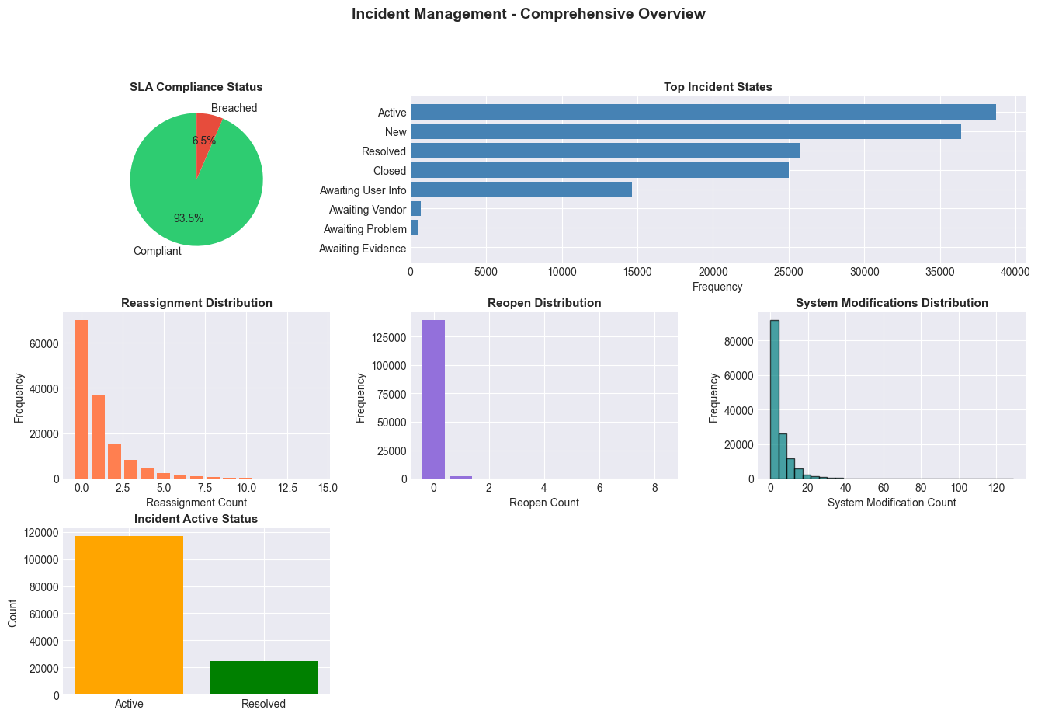
Figure 1 Incident Management Overview
Interpretation:
The figure illustrates overall SLA performance and workload distribution. The dataset exhibits strong SLA adherence (≈ 93.5 % success), yet the frequency of modifications and reassignments highlights operational friction in certain workflows, justifying deeper predictive analysis.

Rationale for Dataset Selection
The choice of using this dataset is justified by the fact that it has a genuine DevOps setting and can be directly applied to the reliability engineering field.
It is similar to all the measures in DevOps like Mean Time to Resolve (MTTR), Change Failure Rate, and Service Uptime, which are the core of performance assessment.
From a research and practical perspective, this dataset offers:
- Operational diversity – incidents span multiple states, users, and time periods.
- Real-world complexity – frequent hand-offs, updates, and mixed outcomes mirror production environments.
- Analytical depth – categorical and time-based attributes provide support of feature engineering, encoding and correlation studies.
This also makes it a perfect starting point to building machine-learning pipelines that will be capable of determining risk factors that result in SLA violations and enhancing incident throughput of automation systems.

Data Profiling and Initial Audit
Qualitative investigation prior to describing the data contents has confirmed that the dataset was well-structured previously, though there was a high level of variability of the main metrics.
A few core findings from the audit phase were:
- Data Integrity: There were no blank values or repeat records to clean and less overhead was incurred.
- Feature Types: 30 object columns, 4 boolean flags, and 3 integer features.
- SLA Balance: Out of 141 712 records, 132 497 met SLA (93.5 %), while 9 215 breached (6.5 %).
- Workload Statistics: Mean reassignment_count = 1.10 , max = 27; average sys_mod_count = 5.08.
- Outliers: There are some complex cases that were indicated by the fact that about 13.9 per cent of records recorded an unusually large reassignments.

Cleaning and Transformation
Contrary to the traditional datasets which are necessitated to be aggressively imputed, the present log file only needed to be standardized as opposed to being corrected.
Key transformation procedures included:
- Temporal derivation of opened_at converting it to a datetime object.
- Mapping the convert state of boolean variables (active, made slavery) into binary 0/1.
- Rechecking duplicates to check individual incident IDs.
- Validating data types, e.g. ensure data is similar across categorical fields.

Step | Transformation Applied | Impact
Timestamp Parsing | Converted to datetime | Enabled hour/day/month extraction
Boolean Standardization | TRUE/FALSE → 1/0 | Simplified target creation
Duplicate Validation | None detected | Data integrity confirmed
Outlier Identification | IQR method | Quantified extreme workload behavior
After this stage, the dataset retained 141 712 records and was ready for feature construction.

Feature Engineering and Encoding
The next phase enriched the dataset with analytical features necessary for predictive modelling:
- Target Variable:
A binary variable SLA_Breach was generated, where 1 indicates breach and 0 indicates compliance.
- Temporal Context:
From opened_at, new features were extracted — open_hour, open_day, open_month, is_weekday, and is_business_hours — capturing workload timing effects.
- Derived Indicators:
Composite metrics such as workload_score, reassigned, reopened, and complexity_flag quantified operational pressure on the support teams.
- Categorical Encoding:
incident_state, caller_id, and opened_by were label-encoded to allow numerical correlation analysis.
- Post-engineering, the feature count rose from 37 to 50, creating a high-resolution view of workflow patterns.

Breach Behaviour Exploration
Statistical comparison between SLA-compliant and breached incidents revealed clear operational contrasts:
Metric | Compliant | Breached | Relative Increase
Reassignments | 1.06 | 1.69 | + 59 %
Reopens | 0.02 | 0.03 | + 63 %
System Modifications | 4.59 | 12.13 | + 164 %
Workload Score | 1.54 | 2.94 | + 90 %
The highest concentration of breaches appeared in Closed, Active, and Awaiting User Info states, often during extended hand-offs or overnight automation cycles.
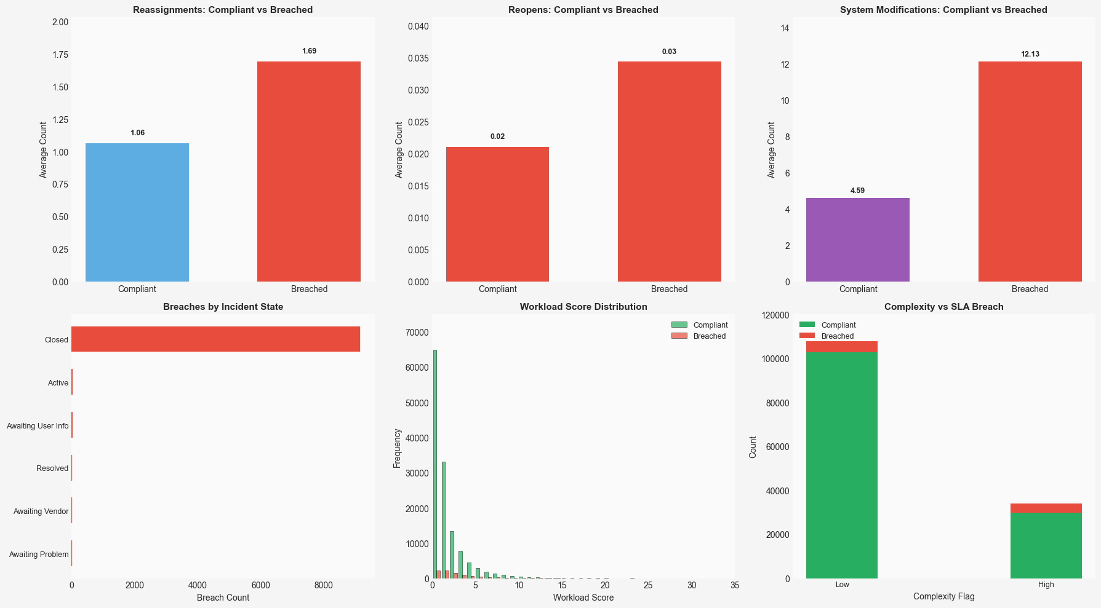
Figure 2 SLA Breach Pattern Visualization
Interpretation:
The panels illustrate the functional difference in the incident of success and failure. Limitations on workflow complexity and SLA risk are always correlated with the increased reassignments and changes in the system, which was proven in breached cases.
The Complexity vs SLA Breach subplot further supports the fact that high complex tasks have much greater breach counts.

Correlation and Feature Scaling
Numerical features were investigated related to SLA Breach after normalization with the help of Min-Max Scaler.
Although the individual correlation was little (e.g., sys_mod count 0.24, workload score 0.15), the group trends showed a systemic impact on resolution performance.
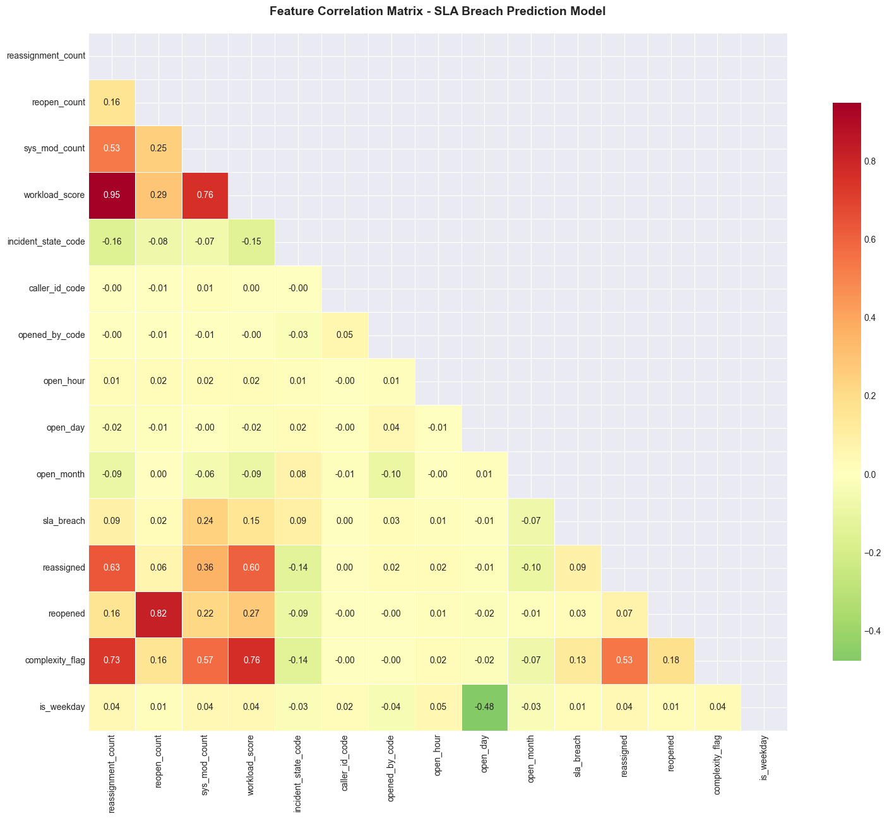
Figure 3 Feature Correlation Matrix
Interpretation:
The heatmap uses interdependencies as a visualization of engineered features. The correlation coefficients among sys_mod_count, workload-score, and complexity-flag are high, which proves that a high frequency of modifications and multitasking environment have considerable impacts on the results of SLA.

Consolidated Dataset Summary
The dataset was preprocessed and feature engineered after which it became analytically ready and fully structured. It has 141,712 records and 50 refined features that represent almost 24,900 incidences in 9 discrete incident states and reported by 5,245 callers and handled by 208 openers. It is a one year synopsis of operation covering 2016-2017 i.e. February 2016 to February 2017. The last breach rate of SLA is 6.5 percent, visibly showing that the majority of incidences were in line with performance targets with a small percentage being delayed. The final dataset is saved in the file called sla_breach_prediction_dataset.csv, it is clean, richly-featured, and can be used in successive MLOps processes, which might involve modeling and deployment.

Discussion and Insights
The study identified that violations of SLA are not accidental but caused by the inefficiency of the work operations and imbalance of the workload. Constant transfers and overmodifications are highly associated with slow resolutions, which could take place in the late-night or absent working hours.
These insights highlight specific DevOps challenges:
- Improving task ownership to reduce reassignment loops.
- Automating root-cause tagging for high-complexity cases.
- Monitoring after-hours pipelines more rigorously.
Measuring these actions allows the dataset to become an input ready to be used in machine-learning models that will predict breaches and cause anticipated interventions in subsequent steps of MLOps.

Conclusion
The Incident Event Log dataset was ultimately converted into a predictive modeling basis by the use of organized preprocessing, focused feature generation, and multi-level analysis.
This paper summarizes the Data Pipeline step of MLOps the transformation of raw operational data into a format that is reproducible, analyzable and provides guarantees guaranteed data quality, lineage, and scalability.
The cleansed dataset and exploration insights lead to the next Task 2 where supervised learning methods and CI/CD automation are going to be used to predict SLA violations and improve service and reliability in DevOps ecosystems.

