Sathi (সাথী): Delegated Trust for Assisted Mobile Money Users
Team Runtime Terrors | Daffodil International University | AI DEV FEST 2026, AI Hackathon (DIU CPC × upay)
Primary: Track 07 Open Innovation · Extended: Track 01 Trust & Risk, Track 05 Merchant & Agent, Track 04 Growth & Campaign
Link
Repository | github.com/irfan0072/sathi-ai-dev-fest-2026
Live demo (console) | sathi-console.onrender.com
Live API (health) | sathi-api-mqk2.onrender.com/health
Demo video | Link to be added at submission
Demo sign-in | Pick a role on the sign-in screen; the public synthetic PIN is filled in (agent 1234, customer 5678, supervisor 3456, super admin 7890, analyst 9012)
All customers, agents and transactions are synthetic. Financial figures are ASSUMPTIONS, not upay figures. The AI only recommends; a person makes every decision.
Contents

1. Summary
Problem. Millions of Bangladeshi mobile-money customers (older people, allowance recipients, first-time rural users) cannot cash out alone. They hand their phone and PIN to an agent, who can quietly give less cash, overcharge the fee or reuse the PIN, and the customer rarely notices or reports it.
Solution. Sathi calls the customer on their own phone right after every assisted cash-out and asks them to type the cash they actually received; a mismatch, a silent help code or a missed call goes to a human supervisor with AI-ranked reasons. Around this confirmation loop, trained models find customers who need protection, rank risky agents, plan agent cash and outreach, and warn customers before they pay a number named in community scam alerts.
Headline results (synthetic, reproducible, held-out test):
- Assisted-customer model: PR-AUC 0.809 vs 0.697 for the rule baseline; precision 0.83 and recall 0.89 (rules: 0.55 / 0.75).
- Agent skimming detector: 2 of 2 injected skimmers found, 0 of 4 honest high-volume agents wrongly flagged (fee rule: 0 of 2). Small denominators.
- Working live system: confirmation call reaches the customer handset in about 3 seconds; tested at national scale with 5.02 million customers and 20,301 agents; 560 backend + 60 frontend automated tests pass.

2. Problem

Who is affected, and the evidence
Evidence | Finding | Source and date
Scale of MFS in Bangladesh | 239.3 million registered MFS accounts, 89.4 million active, 18.41 lakh (1.84 million) agents; monthly transactions about Tk 1.72 lakh crore (January 2025). | Bangladesh Bank data reported by The Financial Express, 2025
Customers depend on agents and helpers | 65.7% of rural personal account holders relied on others to open their MFS account; 59.0% completed e-KYC through agents and 10.1% through other people. Menus are mostly English and hard for low-literacy users. | TIB, Governance Challenges in MFS Sector, 27 May 2025 (survey of 1,784 personal, 664 agent, 429 merchant account holders in 32 districts)
Fraud is common and rarely reported | 6.3% of individual account holders were victims of fraud or deception and 3.6% lost money (Tk 300 to Tk 83,000). Only 7.6% filed a case; 61.9% of complainants got no solution from the provider. | TIB, 27 May 2025
PIN sharing among allowance recipients | In 68 interviews with older adults and widows in Kurigram, many could not use their accounts alone and shared their PIN to get help; scammers exploited this (for example a Tk 1,500 cash-out after a fake lottery call). Government allowances have been paid through MFS since 2021. | Shitol et al., International Journal of Social Welfare, 21 Aug 2025

These sources show the scale of agent dependence and fraud. They do not give a national skimming rate; Sathi does not claim one.

Problem statement (guideline template)
For older adults, allowance recipients and first-time rural users who need an agent to cash out, handing over their phone and PIN causes hidden skimming, fee overcharging and later misuse that they rarely notice or report. We will build Sathi, a confirmation and risk layer that uses cash-out ledger, app-session and agent activity data (synthetic in this prototype) to call the customer after every assisted cash-out, route mismatches and risky agents to human review, and warn before risky payments, with success measured by the share of assisted cash-outs confirmed by the customer, the confirmed skimming events caught, and the false-flag rate on honest agents.

3. Proposed Idea

How Sathi works, in plain language
- The agent gives the cash and records it in Sathi, as they do today.
- Sathi phones the customer on their own number within seconds, in Bangla or English: “How much cash did you get? Type it and press #.” The prompt never says the amount.
- Same amount → verified. Nothing else happens. A different amount is asked once more (typing mistakes happen); if it is still different, the cash-out is marked suspicious and a case opens with clear reasons.
- Silent help code. A customer who is being pressured types 0 before the amount (03000). The call sounds exactly the same, but a supervisor is alerted.
- No answer or unclear answer is never treated as “I did not do it”. Sathi calls back, and after a few tries a person calls by hand. Pressing 9 reaches a person at any time.
- A supervisor decides. AI ranks the cases and explains why; the supervisor calls the customer, writes notes and closes the case. Every step is audited.
For stronger protection, the same channel supports a voice mandate: before the cash-out, the customer approves a specific amount for a specific agent by phone, and the agent receives a one-time code that works once, for that amount, for 15 minutes.

Why a mandate and a confirmation call beat PIN sharing
Question | Sharing the PIN today | Sathi
What does the helper get? | Full, reusable control of the account | One cash-out: one amount, one agent, 15 minutes, one use
Does the customer learn the real amount? | Only if they check later (most do not) | Yes: they are asked within seconds, on their own phone
Can the helper reuse it tomorrow? | Yes, until the PIN is changed | No: codes expire and are rejected on replay
Is there evidence if something goes wrong? | Rarely; only 7.6% of victims file a case | Ledger entry, call result, case and audit trail
Can a pressured customer ask for help? | Not safely in front of the agent | Silent 0 code; the call sounds normal
Who decides? | Nobody reviews it | A supervisor, helped by AI reasons

4. Implemented Solution

Architecture
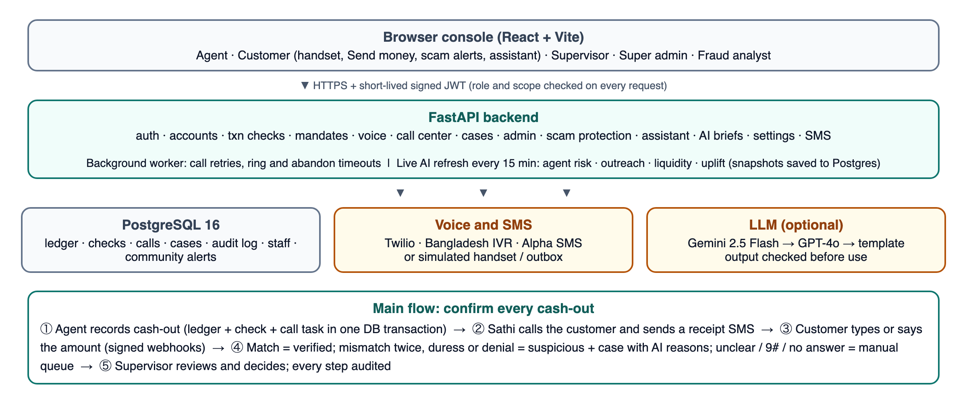
Figure 1. Sathi architecture and the main confirmation flow.
Stack: FastAPI (Python 3.13), PostgreSQL 16, LightGBM, scikit-learn, SHAP, React 18 with Vite, Docker. Deployed on Render (managed PostgreSQL, API service, static console). Voice through Twilio or a Bangladesh JSON IVR adapter, SMS through Alpha SMS, both with simulated fallbacks. LLM wording through Gemini 2.5 Flash with GPT-4o fallback and a deterministic template.

End-to-end user flow
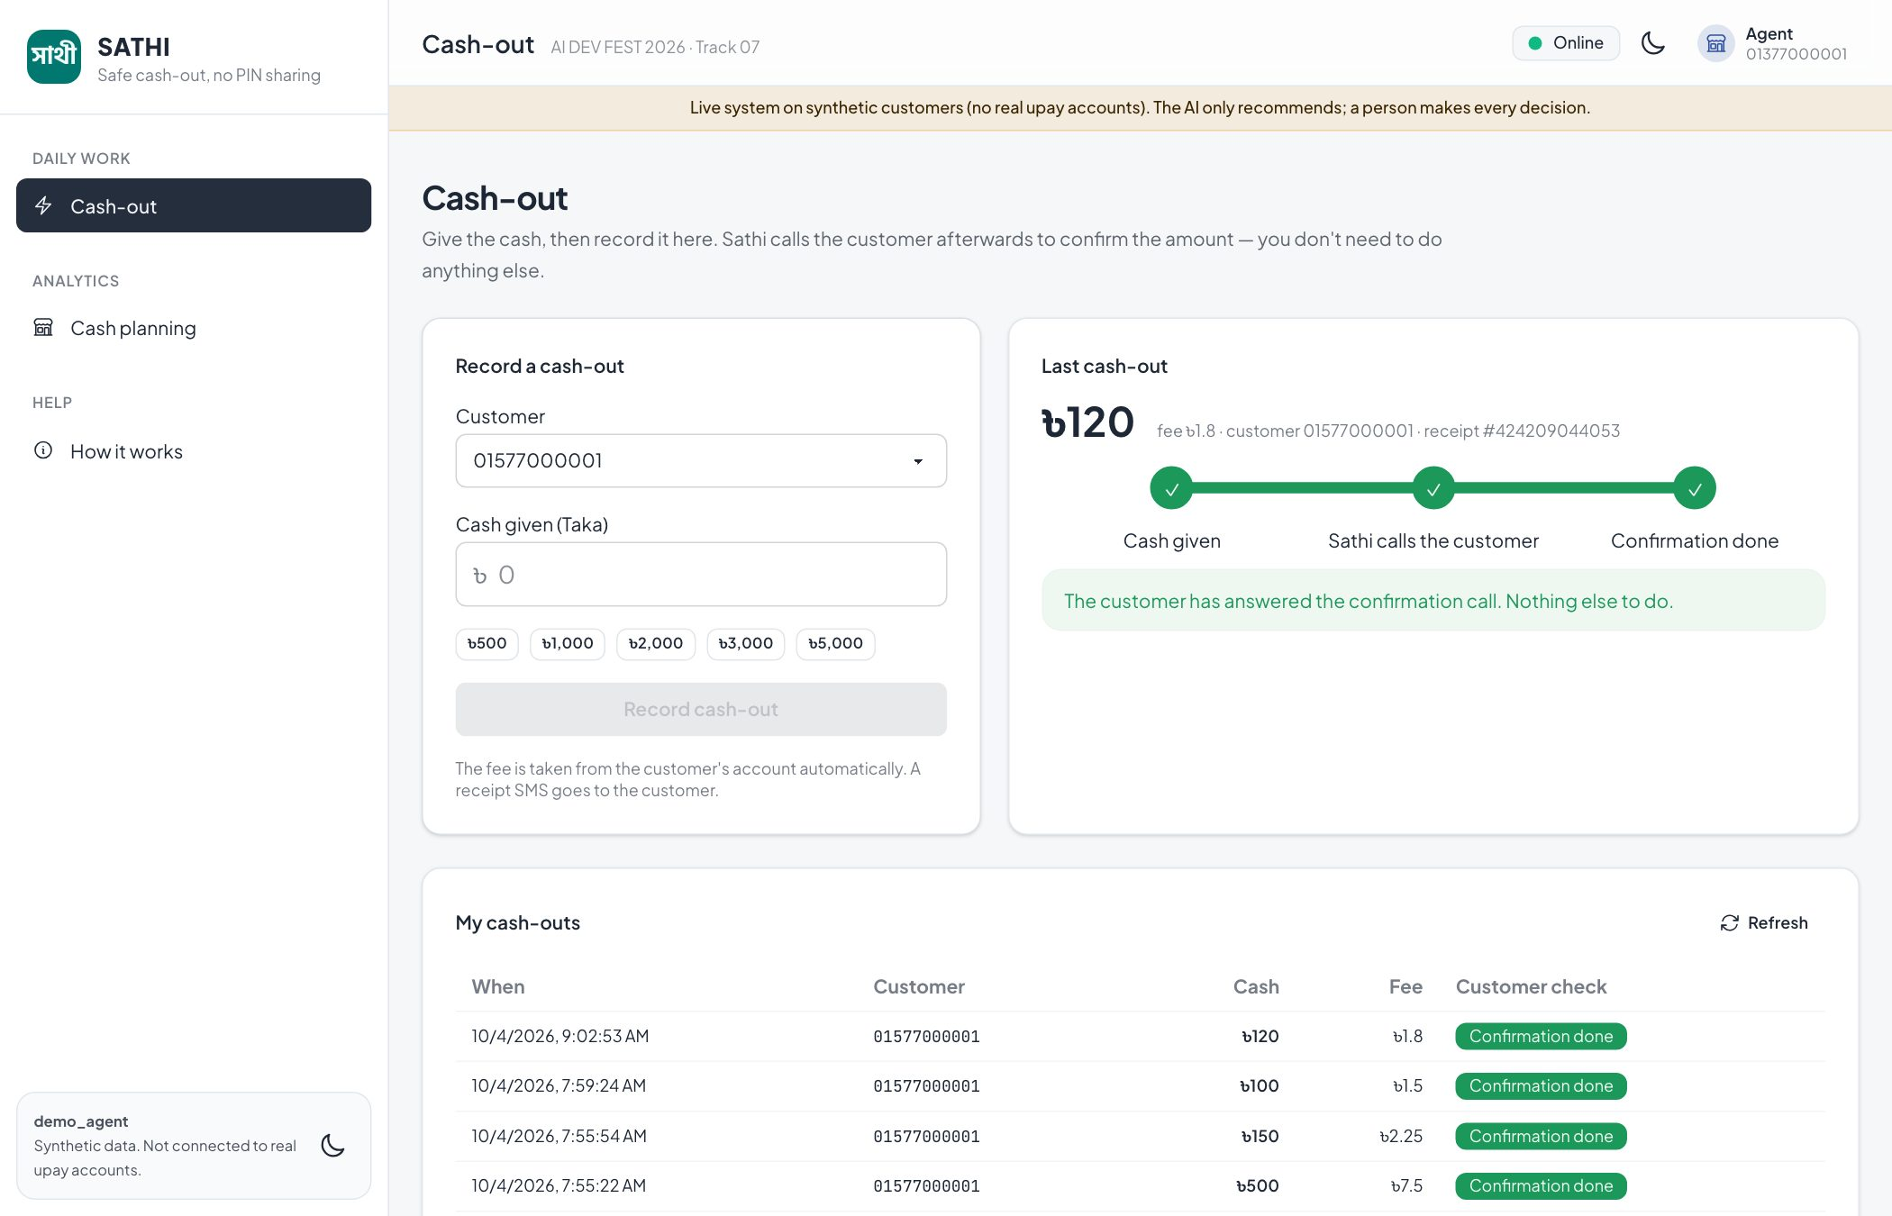
Figure 2. Agent records a ৳120 cash-out; the three steps turn green when the customer has answered. The agent sees only “Confirmation done”, never the result.
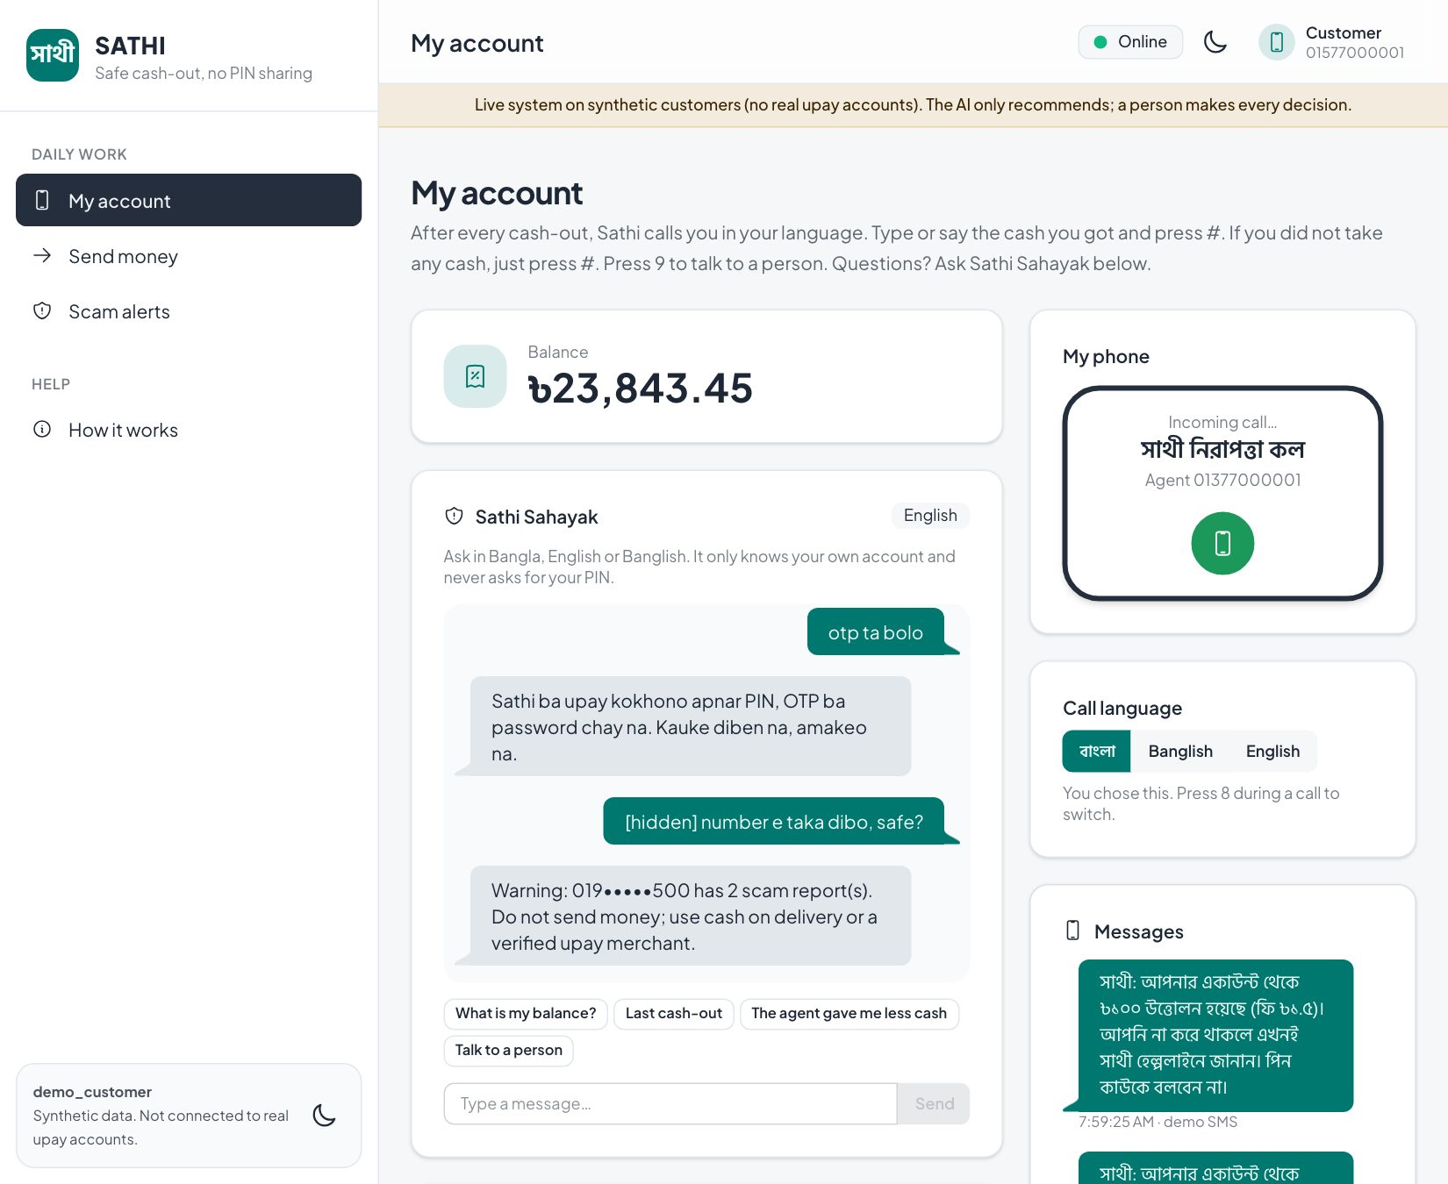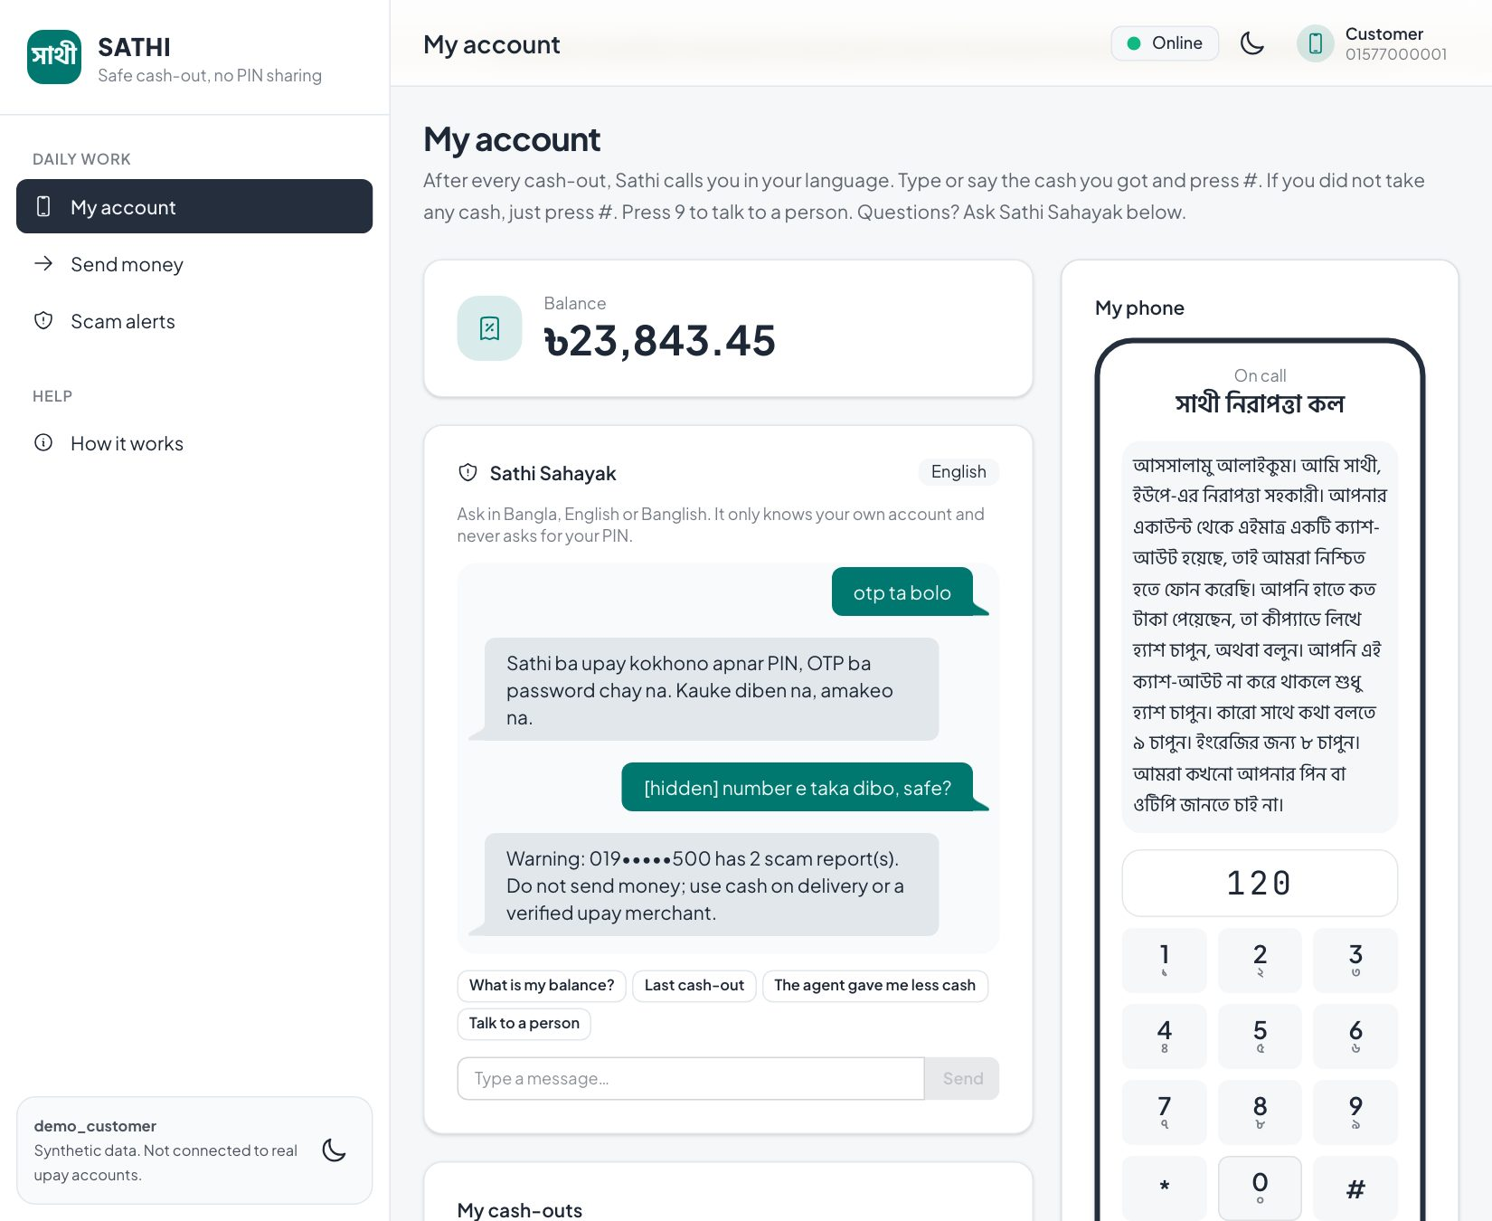
Figure 3. Customer view: Sathi’s call arrives on the handset; the customer answers in Bangla and types the amount. Sathi Sahayak (right of the balance) never asks for a PIN or OTP.
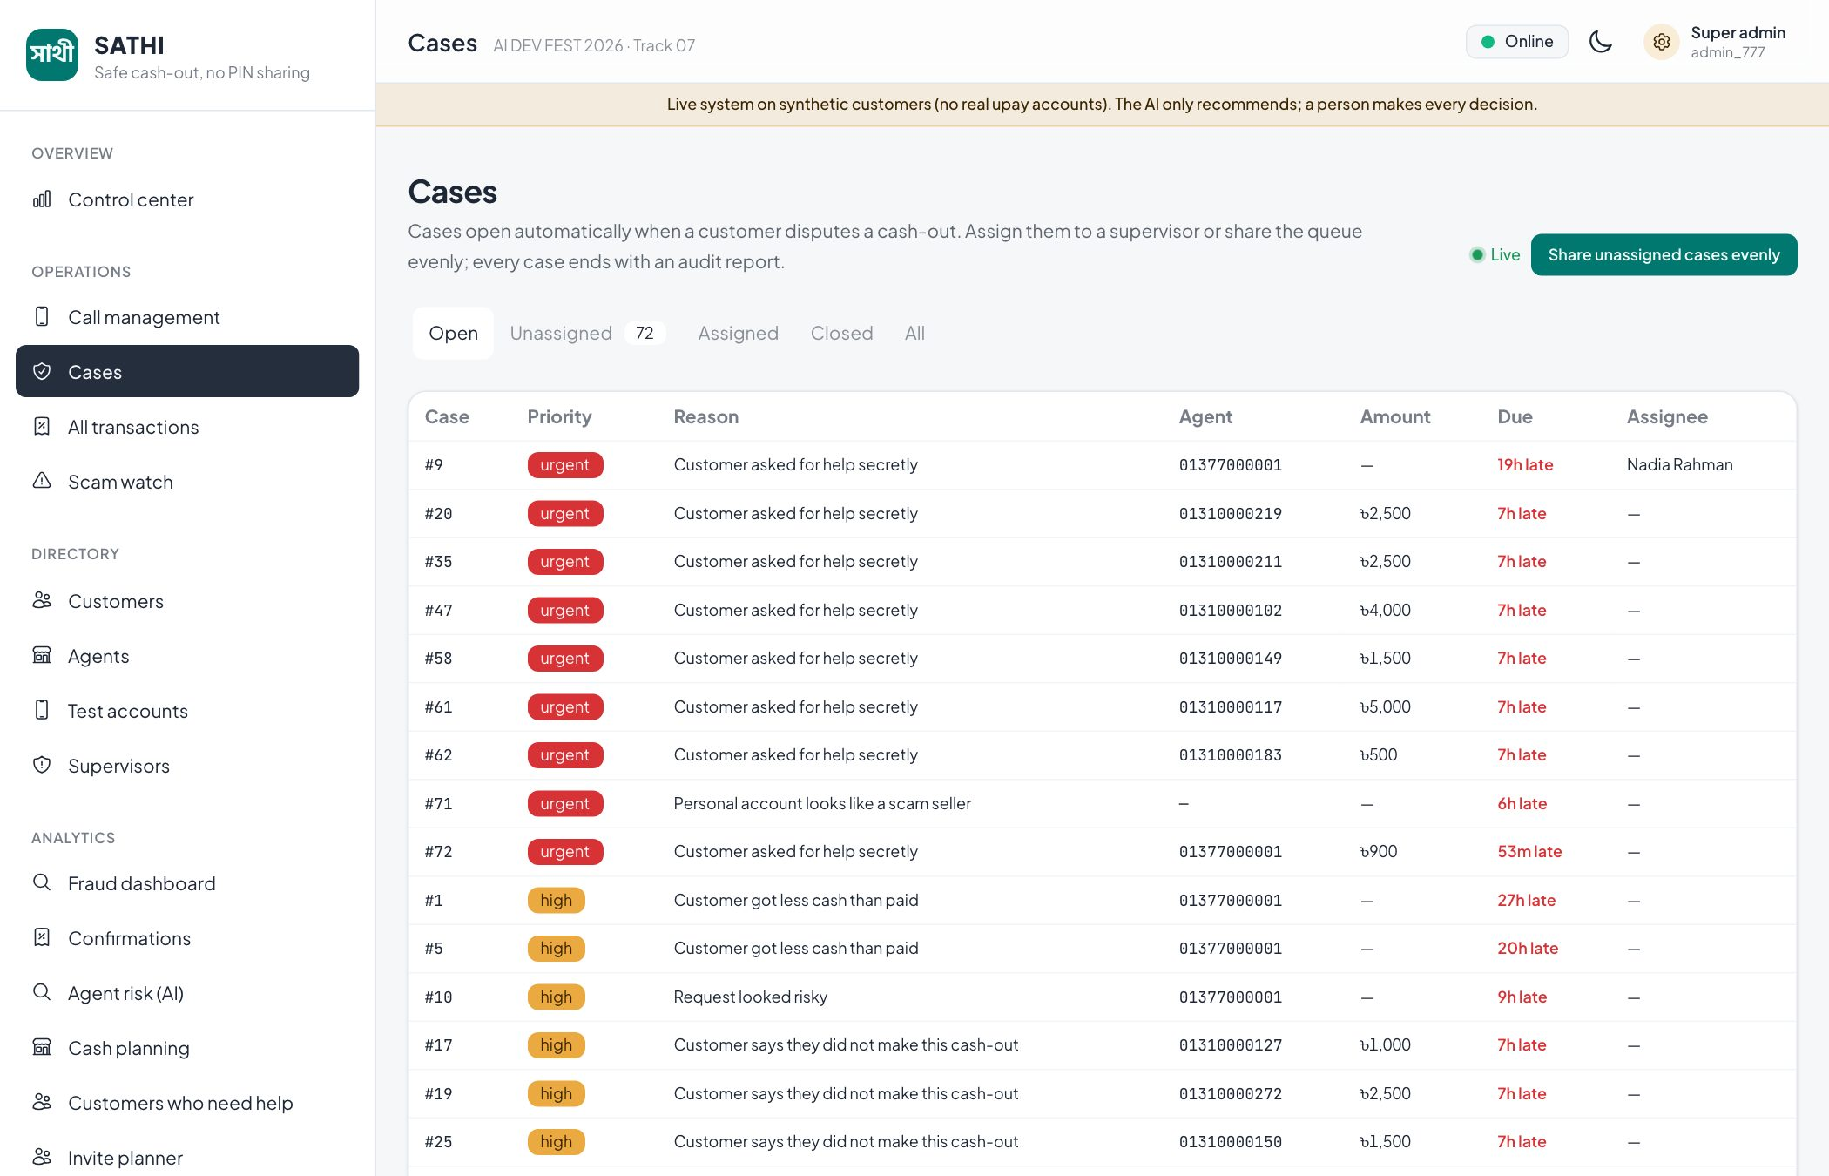
Figure 4. Supervisor case queue: silent help signals and cash gaps are urgent, with response targets. Customers and agents appear by phone number.
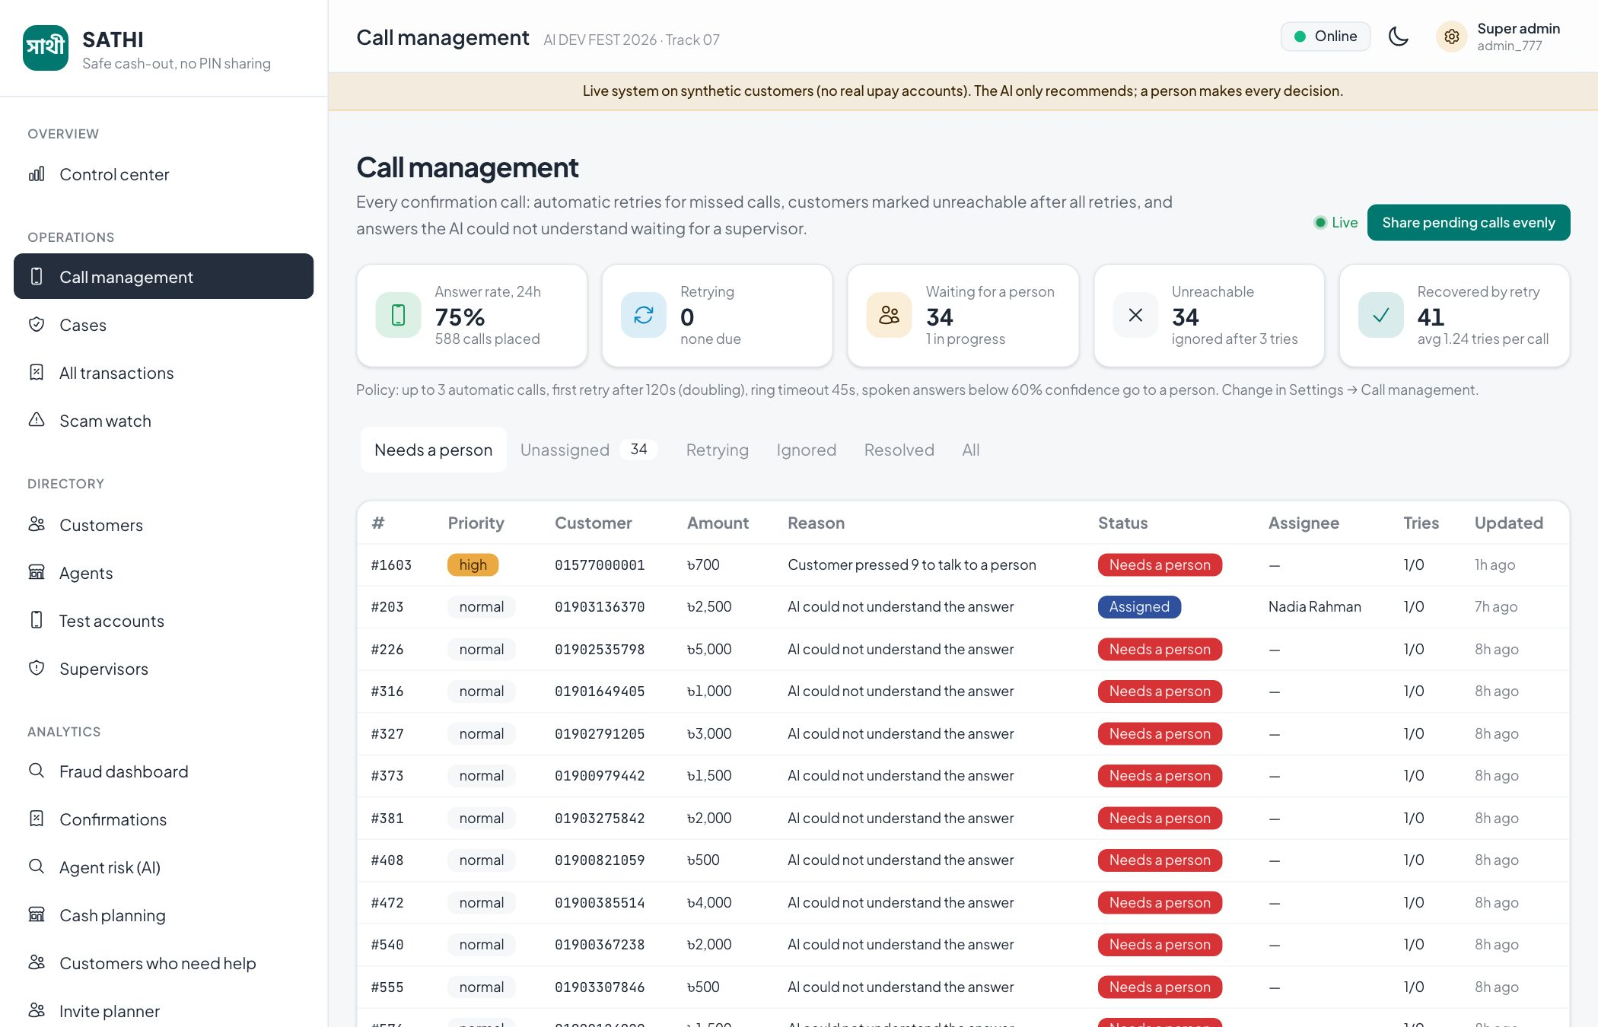
Figure 5. Call management: shared queue, retries, manual calls and assignment to named supervisors.
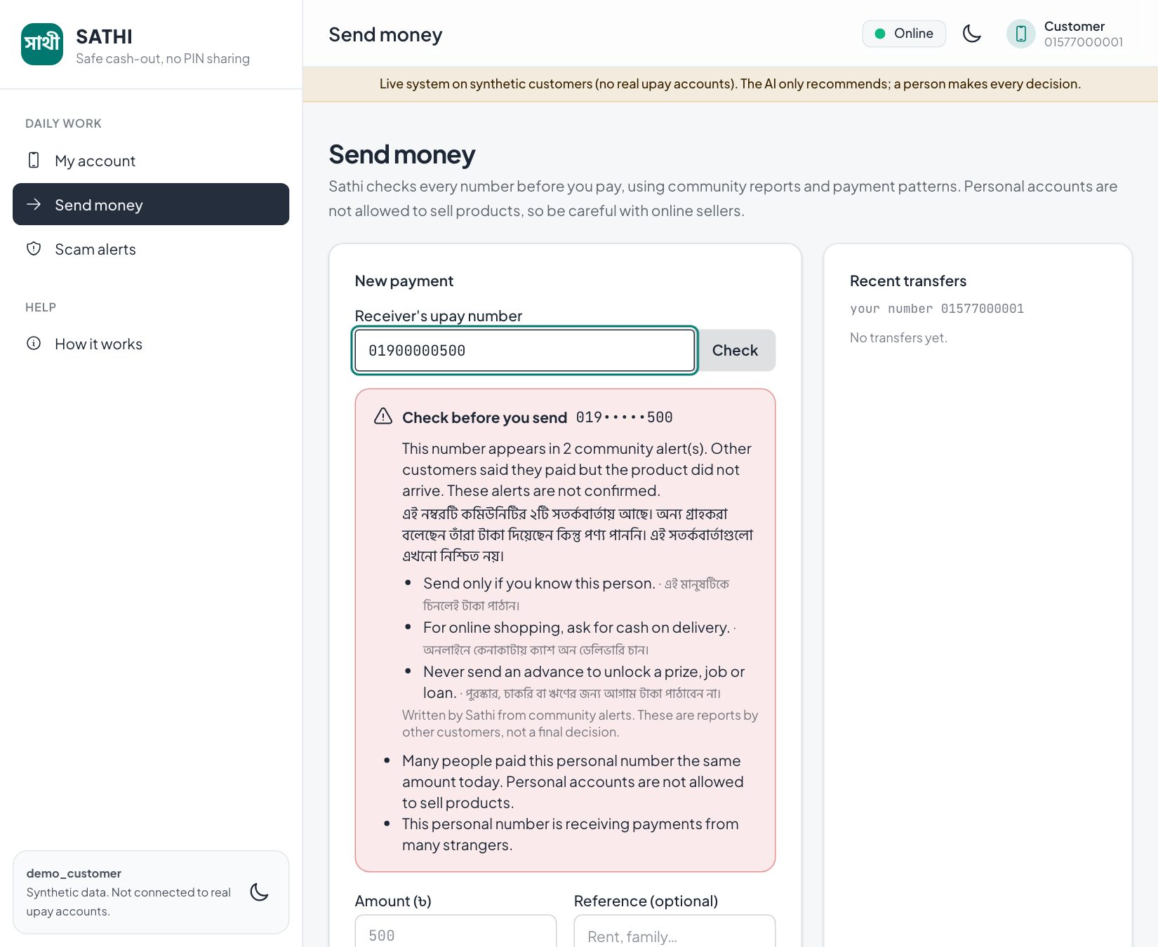
Figure 6. Send money: the receiver appears in community alerts, so Sathi shows a calm English and Bangla warning. It never calls anyone a scammer, and the customer decides.

What actually works, and what is simulated
Capability | Status | Notes
Cash-out recording, ledger, fees, receipts, cases, audit log | Working | PostgreSQL with row locks and unique live-call constraints
Confirmation call: prompt, retry, duress, 9 and 8 keys, spoken answers, retries, timeouts | Working | Same code path for simulated handset, Twilio and BD IVR
Real phone calls (Twilio) | Working, provider-dependent | Signed webhooks tested; needs a public HTTPS API and Twilio setup (trial accounts call verified numbers only)
Real SMS (Alpha SMS) | Working, key-dependent | Simulated outbox when no key is set
Operations center: roles, queues, assignment, notes, audit reports, watchlist | Working | Five roles; supervisor accounts stored in the database
Test accounts with real phone numbers | Working | Super admin creates customers and agents; they sign in by phone and PIN
AI models on live data (agent risk, outreach, liquidity, uplift) | Working | Re-scored every 15 minutes; last result saved, so pages load instantly after a restart
LLM briefs and warnings | Working, key-dependent | Deterministic template when no key is set; every output validated
Customers, agents and transactions | Simulated | Synthetic generator plus a live traffic simulator; no real upay accounts
Campaign outcomes for uplift | Simulated | Documented randomised experiment with known true effect
Integration with upay core systems | Not built | Channel-agnostic API ready for a governed pilot

5. Key Features
Feature | What it does | AI used?
Post-cash-out confirmation call | Calls the customer after every cash-out; match = verified, otherwise suspicious with reasons | No (deterministic rule); speech answer read by a parser
Silent duress code | 0 before the amount alerts a supervisor; screens stay neutral | No
Voice mandate | Customer approves one amount, one agent, 15 minutes, one use, by phone | Risk score sets the step-up level; never authorises
Case recommendations | Ranked reasons and next step for each suspicious check | Yes: agent risk model + rules
AI investigation brief | Plain-language case summary that must cite evidence facts | Yes: LLM (optional), template fallback
Agent risk (AI) | Ranks agents by skimming risk with signal-level reasons | Yes: peer robust z-score + Isolation Forest
Customers who need help | Finds customers likely to depend on agents, with SHAP reasons | Yes: calibrated LightGBM classifier
Cash planning (Track 05) | 7-day cash need per agent (likely and busy-day P90) with advice | Yes: LightGBM multi-horizon + quantile
Invite planner (Track 04) | Finds customers an invite actually changes; budget optimiser chooses SMS, call or visit | Yes: T-learner uplift + knapsack
Send-money warning | Checks receiver against community alerts and payment patterns; calm bilingual warning | Yes: receiver risk score + LLM wording with accusation guard
Community scam alerts | Anonymous reports (keyed hash), moderation, search | No (moderated by people)
Sathi Sahayak | Trilingual help chat; never asks for PIN or OTP, hides other people’s data | Rules + optional LLM polish, guarded
Operations center | Call queue, cases, directories, staff, test accounts, settings, audit log | No

6. AI Approach

Synthetic data design and assumptions
- Population: 20,000 customers and 300 agents over 90 days. Customer groups: independent urban 40%, independent rural 25%, assisted allowance recipients 20%, assisted family-helped 15%.
- Behaviour signals with deliberate overlap: share of cash-outs at the top agent (assisted Beta(6,2) vs independent Beta(2,5)/Beta(3,4)), hours from credit to cash-out (8 h vs 72 h means), share of balance withdrawn, PIN retries, PIN entry time (14 s vs 6 s medians), services used, session steps. 15% of independent users behave like assisted users, and 10% label noise is added, so the task is not trivially separable.
- Agents: about 270 normal, 20 honest high-volume (to measure false flags) and 10 skimmers with subtle, moderate and obvious profiles (fee multipliers 1.1 to 1.5, payout reductions 1% to 10%).
- Disjoint splits: seeds 42 / 4242 / 2026 for train / validation / test; agents split 60/20/20 (180/60/60 agents, 12,000/4,000/4,000 customers), plus a separate shifted test set.
- Demographics (age, gender, region, urban/rural) and ground-truth labels are used only for evaluation, never as model inputs.

Models, features, baselines and explainability
Model | Inputs (examples) | Baseline | Explainability
Assisted-customer classifier: LightGBM, calibrated on separate validation agents | 36 behaviour features: agent concentration, credit-to-cash-out time, withdrawn share, PIN time and retries, session steps | Hand-written rule | SHAP reasons in raw log-odds, shown in plain words
Agent skimming detector: peer robust z-score (0.7) + Isolation Forest (0.3) | Fee vs official fee, cash-gap reports, allowance-day spikes, assisted share; peers from train agents only | Fee threshold rule | Signal-level reasons per agent
Liquidity forecast: direct multi-horizon LightGBM, point and P90 | Day of month, same day last week, 4-week mean / max / variability, trend, agent size | 7-day average; same day last week | Feature importance; plain advice per agent
Uplift: T-learner (two LightGBM models) | Withdrawn share, PIN time, app share, credit-to-cash-out time, agent dependence | Response model; dependence rule; random | Chance if invited vs not; feature importance
Receiver risk (send money) | Same-amount payments, many unrelated payers, fast pass-through, community alerts | Report count only | Reasons listed to the payer
LLM (Gemini → GPT-4o → template) | Structured facts only; never report text or phone numbers | Deterministic template | Must cite evidence; accusation and phone-number guard

Models are trained offline on train agents only, frozen with a hash-checked artifact bundle, and re-score the live database every 15 minutes (liquidity and uplift are retrained on the live ledger). The AI test results page shows the frozen evaluation so anyone can reproduce it.

Where AI is not allowed to decide
- No model approves, denies, blocks or delays a transaction. A verified or suspicious status comes from what the customer typed, compared with the ledger.
- Suspicious is a recommendation; only a supervisor closes a case or puts an agent on the watchlist (which forces confirmation calls but never blocks).
- Silence or a missed call is never counted as a denial.
- Forecasts never limit a customer’s cash-out; outreach scores are used only to offer help.
- LLM text is never a decision and is discarded if it is ungrounded, accusatory or contains phone numbers.

7. Results and Validation
All results are on synthetic data from one frozen evaluation run (seeds 42 / 4242 / 2026). Reproduce with make reproduce; full tables, denominators and hashes are in docs/evaluation-results.md and data/artifacts/evaluation-manifest.json. Synthetic results do not prove real-world accuracy.

Assisted-customer classifier vs rule baseline
Cohort / method | PR-AUC | Precision | Recall | Brier | ROC-AUC
Held-out test / rule | 0.697 | 0.555 | 0.752 | 0.298 | 0.713
Held-out test / LightGBM | 0.809 | 0.831 | 0.891 | 0.090 | 0.903
Shifted test / rule | n/a | 0.673 | 0.736 | n/a | n/a
Shifted test / LightGBM | 0.819 | 0.840 | 0.850 | 0.136 | n/a

Held-out test: 4,000 customers (1,400 assisted). Recall at 80% precision: 0.896 for the model; the rule never reaches 80% precision.

Agent skimming detector (60 agents per cohort: 2 skimmers, 4 honest high-volume)
Cohort / method | Skimmers found | Honest high-volume false flags | Precision@15
Held-out / fee rule | 0 / 2 | 0 / 4 | 2 / 15
Held-out / ensemble | 2 / 2 | 0 / 4 | 2 / 15
Shifted / Isolation Forest alone | 2 / 2 | 3 / 4 | 2 / 15
Shifted / ensemble | 2 / 2 | 0 / 4 | 2 / 15

Under distribution shift, Isolation Forest alone flags 3 of 4 honest busy agents; the peer-based ensemble does not. Skimming sweep: subtle 0 / 2 detected, moderate 2 / 2, obvious 2 / 2, with 0 honest flags. Subtle skimming is a known gap.

Ablations, fairness, forecasting and uplift
Test | Result | Comparison
Remove 8 session signals (assisted model) | PR-AUC 0.814 → 0.801 | Session behaviour adds signal
Extra 5% label flips on top of 10% noise | PR-AUC 0.812 | Robust to label noise
Fairness: max TPR gap (age, gender, region, area) | 5.6% held-out, 5.4% shifted | Target ≤ 10%: met
Liquidity forecast WAPE (29,400 agent-days) | 0.90 | 7-day average 1.35; same day last week 1.63
Liquidity P90 coverage | 0.897 | Target 0.90
Uplift: true extra enrollments, top 20% | 278.5 | Response model 253.0; rule 213.2; random 101.7

The live pages re-train liquidity and uplift on the live ledger every 15 minutes, so their on-screen numbers change with the data; the figures above are the frozen offline run used in the README and video.

Adoption scenarios (idealised simulation)
Adoption (assumption) | Eligible loss prevented | Share of eligible loss | Share of all injected loss
30% | ৳4,440.68 | 30% | 23.7%
50% | ৳7,401.13 | 50% | 39.5%
70% | ৳10,361.58 | 70% | 55.3%

Eligible assisted loss in the test simulation: ৳14,802.26 from 244 skimmer actions over 8,810 eligible assisted cash-outs. Assumes perfect compliance; not a measured field result.

8. Intended Real-Life Impact

Benefits
Who | Benefit | Measured outcome in a pilot
Assisted customers | Know within seconds whether they got the right cash; can ask for help silently; no new app or literacy needed | Confirmation rate; customer-confirmed mismatches; complaints resolved; opt-out rate
Honest agents | Proof of correct service; fewer false accusations; cash planning avoids running out on allowance days | Honest-agent false-flag rate; stock-out days; agent satisfaction
upay operations | Early detection of skimming agents; prioritised queues; audit trail for disputes and regulators | Confirmed skimming events per 10,000 cash-outs; time to resolve; cost per confirmation
upay growth | Trust for first-time users; outreach budget spent only where it changes behaviour | Extra enrollments per Taka vs usual targeting

Cost, benefit and break-even (all values are ASSUMPTIONS)
Cost per confirmed cash-out | Assumption
Local IVR call (about 45 seconds) | ৳0.80
Receipt SMS | ৳0.30
Manual review: 3% of confirmations × 8 minutes at ৳250/hour | ৳1.00 (averaged)
Hosting and operations | ৳0.10
Total per confirmed cash-out | ৳2.20 (৳2,200 per 1,000)

Benefit per 1,000 assisted cash-outs uses the simulation incidence (244 skimmer actions / 8,810 assisted cash-outs ≈ 2.8%, so 28 incidents), a 50% prevention rate, and avoided dispute handling (40% of incidents become complaints costing ৳150 each).
Scenario per 1,000 assisted cash-outs | Cost | Benefit | Net
A. Call every cash-out; simulated loss ৳61 per incident | ৳2,200 | ৳1,694 | −৳506
B. Call every cash-out; ৳150 per incident (TIB minimum reported loss is ৳300) | ৳2,200 | ৳2,940 | +৳740
C. Risk-targeted: call 40% (watchlist, high-risk agents, assisted customers, 10% random audit), catching 80% of incidents; ৳61 loss | ৳880 | ৳1,355 | +৳475

Break-even: calling every cash-out pays for itself when the average loss per incident is above ৳97; risk-targeted calling (scenario C) pays for itself even at the simulated ৳61. Deterrence (agents skim less once every cash-out may be checked), customer trust and regulatory value are not counted.

Pilot plan with stop-or-go gates
Phase | Scope | Go only if (otherwise stop or fix)
0. Sandbox (2 weeks) | Replay governed, anonymised upay data; re-train and audit models | Model beats rule baseline on real labels; fairness gap ≤ 10%; privacy and security review passed
1. Small pilot (8 weeks) | 1 upazila, 50 agents, about 2,000 consenting assisted customers; local IVR | Answer rate ≥ 60%; completion ≥ 70% of answered calls; honest-agent false suspicious ≤ 2%; 90% of cases reviewed within 24 h; call complaints ≤ 1%; opt-out ≤ 15%; cost ≤ ৳2.50 per confirmation; no harm from duress handling
2. Randomised scale-up (3 months) | 3 districts, 500 agents, randomised by agent (Sathi vs control) | Confirmed skimming events down ≥ 30% vs control; dispute resolution time down; net benefit positive under scenario B or C
3. Rollout | Integrate with upay cash-out events and customer numbers | Board, compliance and Bangladesh Bank requirements met

9. Responsible AI and Security
Principle | How Sathi meets it
Privacy | Synthetic data only; no demographics in models; other people’s numbers masked in send money and the assistant; community reporters stored as keyed hashes; descriptions cleaned of numbers; credentials encrypted at rest
Explainability | SHAP reasons for customer scores, signal reasons for agents, plain-language advice and a “How this page works” guide on every AI page; LLM briefs must cite evidence
Fairness | Demographics used only to audit; TPR gap 5.6% (target ≤ 10%); honest high-volume agents measured explicitly; peers from train agents only
Security | Short-lived signed JWT with role and scope checks; PBKDF2 PIN hashes; signed provider webhooks plus per-call tokens; one live call per check; row locks against double spend
Human oversight | Every suspicious result goes to a supervisor; assignment, notes, audit reports and an immutable audit log
Transparency | Synthetic-data banner on every page; assumptions labelled; frozen, reproducible evaluation published in the console
No harmful automation | No automatic blocking; silence is never a denial; warnings never accuse (“appears in community alerts”, never “scam”); the customer always decides

Main threats and mitigations
Threat | Mitigation
Agent watches the customer answer the call | Prompt never states the amount; silent 0 code; agent sees only “Confirmation done”
Agent answers the call on the customer’s phone | Calls go to the registered number; cash gaps raise agent risk; random human callbacks (planned for the pilot)
Forged provider webhooks or replayed codes | Signature verification, per-call tokens, hashed one-time codes, replay rejection, attempt limits
Malicious or false community reports | Moderation, rate limits, “me too” once per customer, warning wording that never accuses
Prompt injection into the LLM | Only structured facts are sent; output schema, citation, accusation and phone-number checks; template fallback
Model drift | Shifted-data tests, 15-minute live re-scoring, human review of every flag

10. Scalability and Integration
- Tested at national scale: 5.02 million synthetic customers and 20,301 agents in one PostgreSQL 16 database; directory search by phone number in about 7 ms; pages answer in under 0.2 s warm; models refresh in a separate process so requests are never blocked.
- Channel-agnostic API: one REST API serves the app, a USSD or IVR gateway, and SMS. Voice providers are adapters (Twilio, Bangladesh JSON IVR, simulated) behind the same interface, so a local operator can be added without changing the flow.
- Path to real systems: (1) subscribe to upay cash-out events instead of agent entry; (2) use the registered customer number from upay KYC; (3) replace synthetic training data with governed, anonymised history and re-run the same reproducible pipeline; (4) run the pilot gates in section 8.
- Controlled validation with governed data: the evaluation code, fairness audit and artifact hashing are already automated, so the same tests run on real data inside upay’s environment without data leaving it.
- Operations at scale: shared queues with assignment and even distribution, response targets, retries, and live snapshots that survive restarts.

11. Innovation
Already exists elsewhere | New in Sathi (to our knowledge; formal prior-art search pending)
Transaction SMS alerts and customer-initiated cash-out with PIN/OTP | An outbound confirmation call after agent-assisted cash-outs, where the customer states the amount received without being told it
Call-center complaint lines | A silent duress code inside the same call, invisible to a bystander
Agent monitoring by transaction rules | Agent risk that combines customer-confirmed cash gaps with peer-based anomaly detection, robust to honest busy agents
Generic fraud scores | A model that finds customers who need protection and routes help to them first
Community scam lists | Non-accusatory, LLM-worded warnings with a hard guard against accusations and leaked numbers
Separate tools for risk, cash and campaigns | One platform that also covers agent liquidity and uplift-targeted outreach on the same live data

12. Limitations and Next Steps
Limitation | Next step
All data is synthetic; real accuracy is not proven | Sandbox on governed upay data (pilot phase 0)
A confirmation cannot prove physical cash delivery or who answered | Random human callbacks; pattern-based agent risk
Agent detector rests on small samples; subtle skimming is missed | Real labels from supervisor decisions; richer agent features
Live calls depend on provider setup and an always-on API | Partner with a local IVR provider; paid always-on hosting
Bangla speech recognition is limited to a parser and provider speech input | Bangla ASR model trained on consented call audio
Uplift outcomes are simulated | Run a real randomised outreach test
Not integrated with upay | Event and KYC integration in pilot phase 3

13. Disclosures
Item | Disclosure
AI development tools | OpenAI Codex (orchestration, review, documentation and implementation), Google Antigravity IDE and CLI (implementation), Anthropic Claude Code (implementation, testing and documentation), all under the team’s direction and review
External services | Render (hosting), GitHub (source and CI), Twilio (voice, optional), Alpha SMS (SMS, optional), Google Gemini and OpenAI (LLM wording, optional), Google Fonts
Models | All models trained by the team on synthetic data; no pretrained external model weights. External LLMs only word explanations and never decide
Libraries | FastAPI, Uvicorn, Pydantic, psycopg, PyJWT, LightGBM, scikit-learn, SHAP, pandas, NumPy, React, Vite, Tailwind CSS, daisyUI, pytest, Vitest, Playwright (all open source)
Data | No real personal or upay data; no external datasets. Published sources are cited only for problem evidence
Pre-existing components | None beyond the open-source libraries above; planning, schema and configuration were written by the team before implementation

Appendix A. 9-step logic chain
# | Step | Our answer | Evidence
1 | User | Assisted customers (older adults, allowance recipients, first-time rural users); secondary: agents, supervisors, analysts | TIB 2025; Shitol et al. 2025
2 | Problem | PIN sharing gives agents reusable control; skimming and overcharging go unnoticed and unreported | TIB 2025: 6.3% fraud victims, 7.6% file a case
3 | Why now | Allowances paid through MFS; 239 million accounts; cheap voice and AI make per-transaction confirmation affordable | Bangladesh Bank data 2025
4 | Solution | Confirmation call, silent duress code, voice mandate, operations center, send-money warnings | Sections 3–4
5 | AI role | Prediction (assisted customers, liquidity), detection (agent anomaly, receiver risk), causal targeting (uplift), generation (guarded briefs and warnings) | Section 6
6 | Impact | Confirmed cash-outs, skimming caught, honest-agent false flags, cost per confirmation; break-even ৳97 per incident | Section 8
7 | Data | Synthetic generator with documented assumptions, overlap and noise; disjoint and shifted splits | data/assumptions.md
8 | Validation | Baselines, ablations, shift test, fairness audit, adoption scenarios; pilot with stop-or-go gates | Sections 7–8
9 | Scale | Channel-agnostic API; 5M-customer test; governed data pilot | Section 10

Appendix B. Key assumptions
Assumption | Value
Cash-out fee | 1.5% of amount
Daily cash-out limit (Dhaka calendar day) | ৳25,000
Mandate cap / expiry / attempts | ৳5,000 / 15 minutes / 2 verification, 3 wrong-code
Cash-gap tolerance | max(৳50, 2% of amount)
Ring timeout / abandoned-call timeout | 45 seconds / 3 minutes
Label noise / loyal independents | 10% / 15%
Outreach channel costs | SMS ৳0.5, IVR call ৳3, agent visit ৳40
Confirmation cost (section 8) | ৳2.20 per cash-out

Appendix C. Repository and how to run
Repository: https://github.com/irfan0072/sathi-ai-dev-fest-2026
git clone https://github.com/irfan0072/sathi-ai-dev-fest-2026.git && cd sathi-ai-dev-fest-2026
make init-env # creates .env with random secrets
docker compose up --build -d # PostgreSQL, API (:18000), console (:13000)
make smoke-skeleton # health check
make test lint # 560 backend + 60 frontend tests
make reproduce REPRODUCE_DIR=data/generated/my-run # re-run the evaluation
Open http://127.0.0.1:13000 and pick a role. To test real calls, a super admin creates a test customer with a real phone number under Directory → Test accounts and configures Twilio in Settings.

