DB -
A database is an organized collection of structured information, or data, typically stored electronically in a computer system. A database is usually controlled by a database management system (DBMS).

What Are The 4 Types Of Database Management Systems?
- Relational database.
- Object-oriented database.
- Hierarchical database.
- Network database.

MS SQL

- Created a SQL Server on Azure MSSQL
- Created DBs under same SQL server
- How to connect DB using Azure portal
- Firewall rule set
- Connection string
- SSMS installation and connection with MSSQL
Connection string
Username
Password
- Connect from App Service to MSSQL
- Create an app service → kudu → wwwroot → create a file → db.php → paste the connect string → runt the file → php db.php
- Create/delete DB using SSMS
- Create Tables
- create table
- alter table
- drop table
- insert into
- select
- select top
- like
- User Login
Tomorrow’s Taks

Schema
Create
Modify
Installation to create new tables etc
DB create

Table create

Insert data is table

Search option

Queries

Encryption

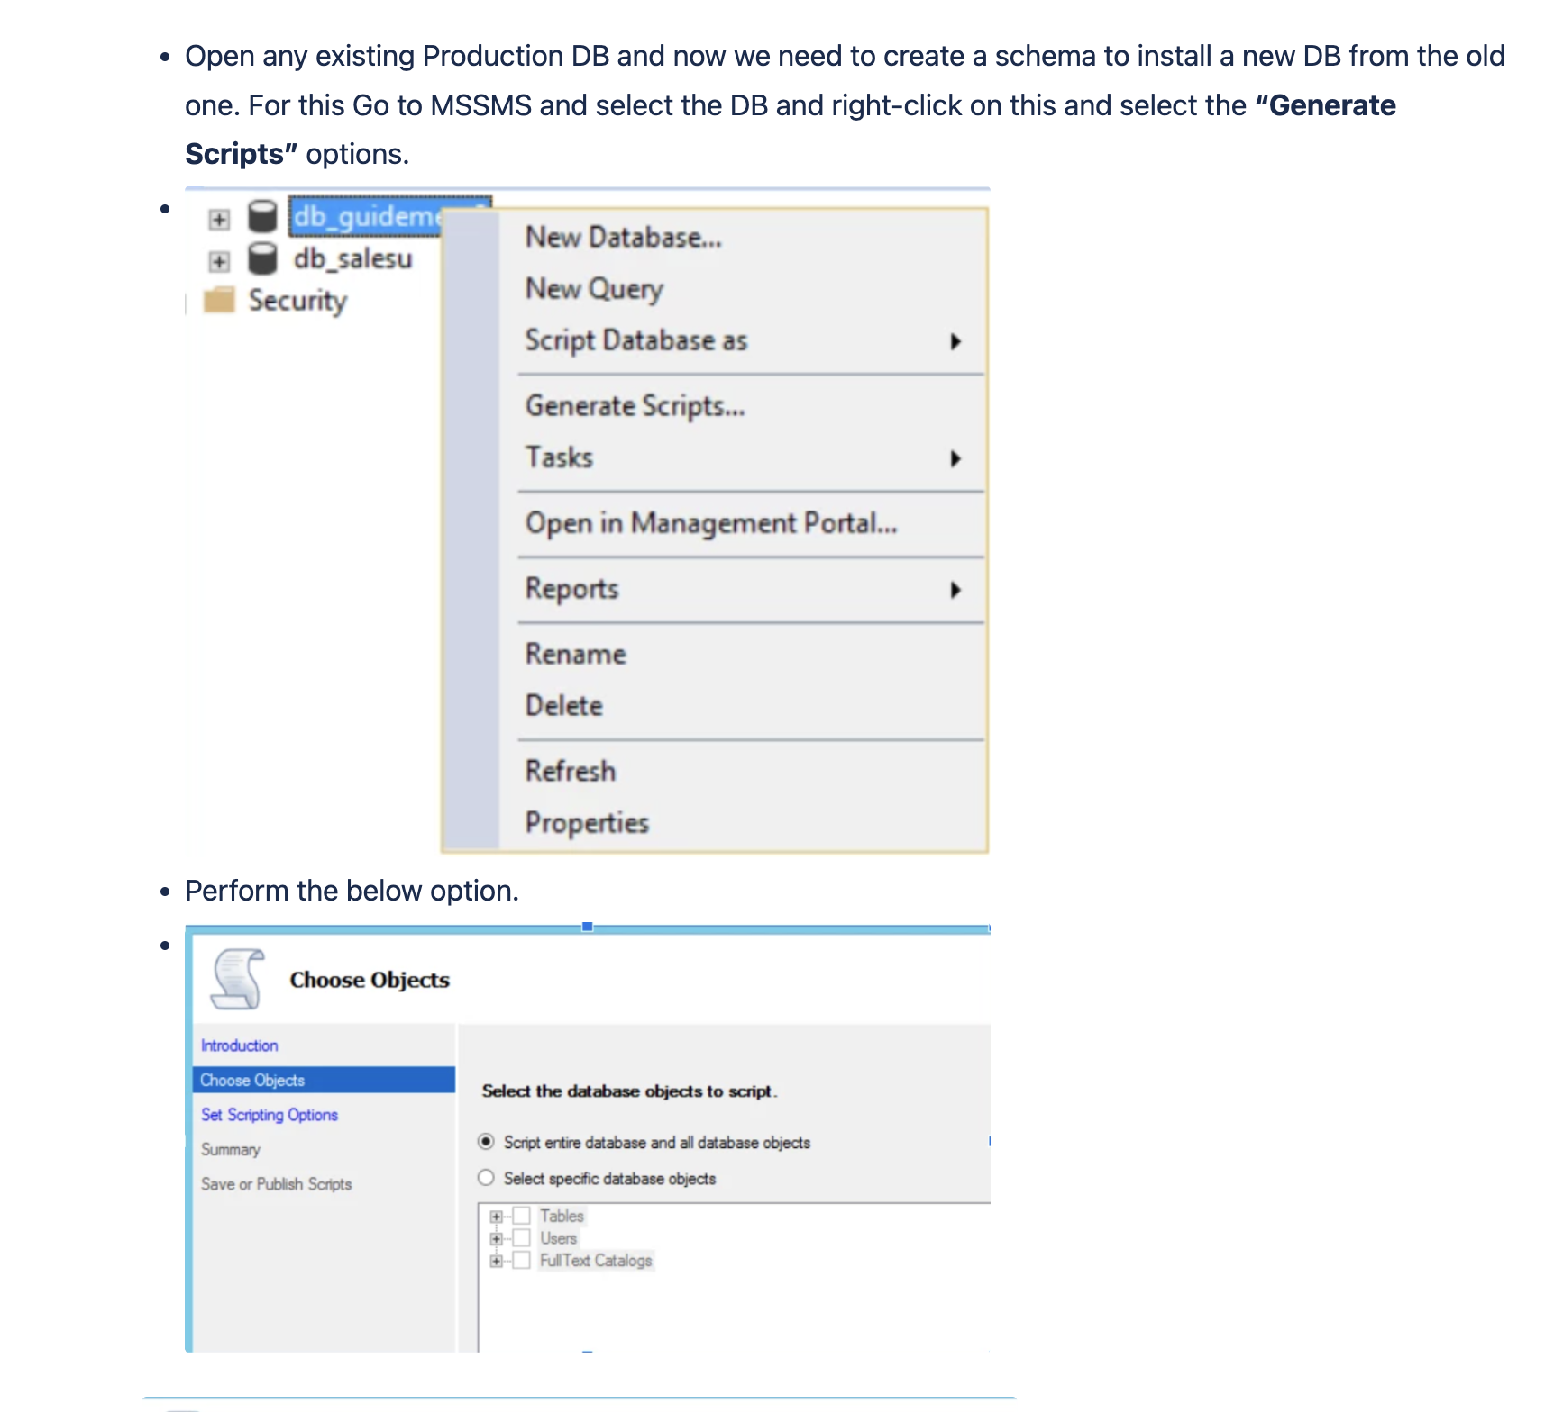

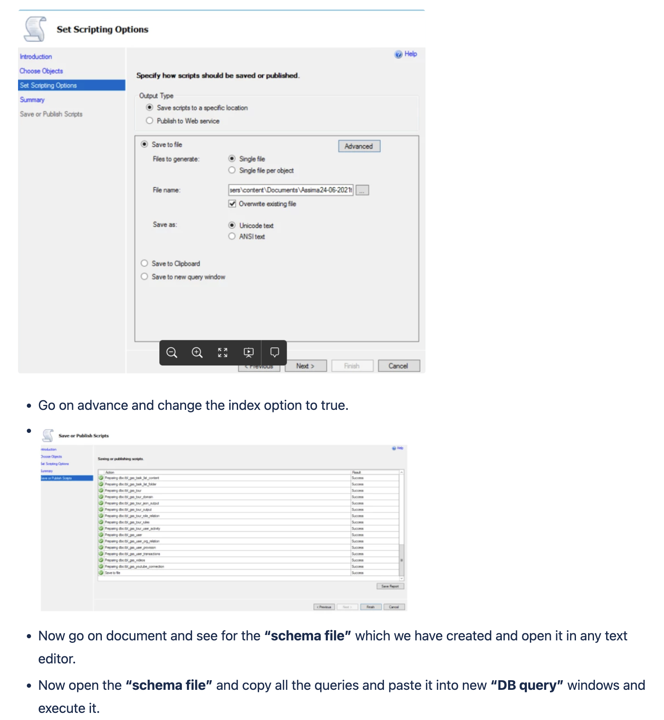

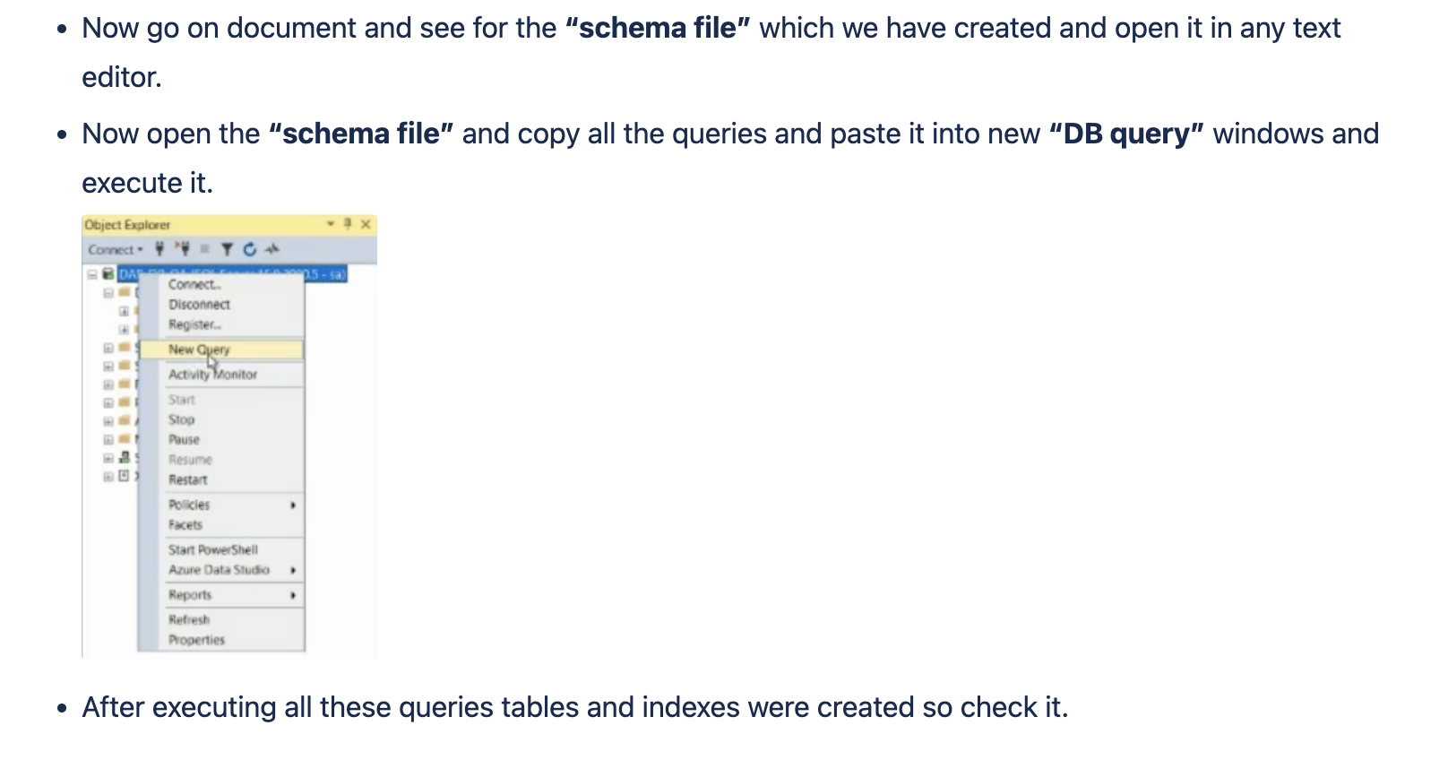

To Create Users on DB use below steps:

To create a User in MSSQL DB with db_owner permission follow the below steps:

Step 1: Connect to your Azure SQL Database server as an admin via SQL Server Management Studio or Azure Data Studio from on premises.

Step 2: Switch the query window’s context to database “master” by switching to the “master” database from the database selection box in SQL Server Management Studio or Azure Data Studio.

Step 3: Create the login with the below T-SQL statement (you can change of course the login name and password accordingly in order to use a strong, secure password)

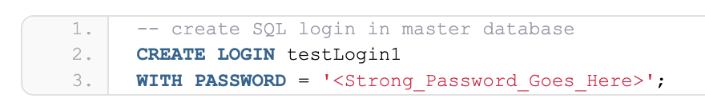

-- create SQL login in master database
CREATE LOGIN testLogin1
WITH PASSWORD = '<Strong_Password_Goes_Here>';
Step 4: In another query window in SSMS or Azure Data Studio which is connected to your Azure SQL Database Server, select the database for which you want to create the user (i.e. in this example “TestDB1”) and grant permissions (i.e. db_owner) and run the below T-SQL statements (you can change of course the below T-SQL in order to grant the permissions/database roles you like):

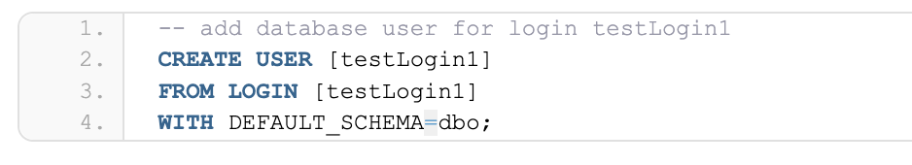

-- add database user for login testLogin1
CREATE USER [testLogin1]
FROM LOGIN [testLogin1]
WITH DEFAULT_SCHEMA=dbo;
Step 5: The last step, is to grant the login with the desired database permissions. In the below example, I will be granting db_owner permissions to testLogin1



-- add user to database role(s) (i.e. db_owner)
ALTER ROLE db_owner ADD MEMBER [testLogin1];

Create Read Only user in DB

CREATE USER yum1 WITH PASSWORD = 'Virtual@12345678';

ALTER ROLE [db_owner] ADD MEMBER yum1;

https://javafun.github.io/create-read-only-user-in-azure-sql/

https://learn.microsoft.com/en-us/sql/relational-databases/security/authentication-access/database-level-roles?view=sql-server-ver16

DB Terminologies:

Tables: A database most often contains one or more tables.

Record: Tables contain records (rows) with data.

Statement: Most of the actions you need to perform on a database are done with SQL statements.
Example: SELECT * FROM Customers;

Queries we need to learn for SQL DB

Select

Where

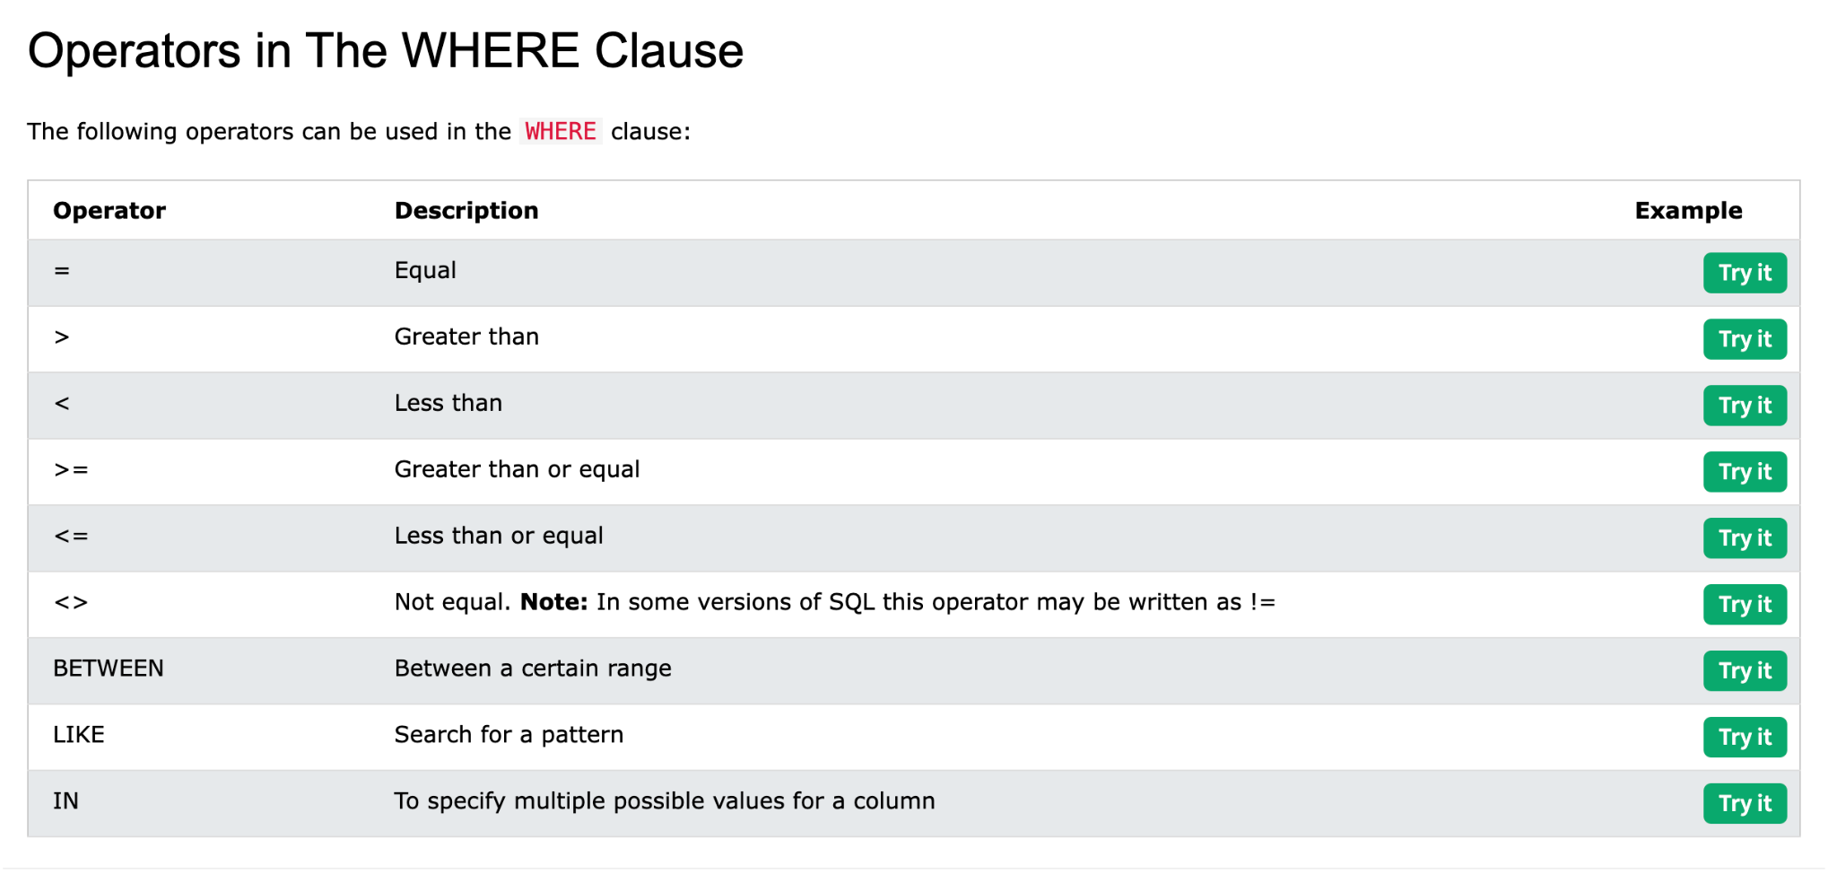

Insert Into

Create Table

MSSQL

PostgreSQL

MySQL

MongoDB

Maria DB
___

DBA

DBMS

