Day-1

Cloud computing has gained nearly universal adoption. Almost every organization is moving to Cloud to become more agile, competitive and productive.

Which in turn enhances job opportunities for candidates knowing Cloud computing.
And the salary range, just the average ranges from $86K - $168K
IT industry growth is booming... In such times, why would you wanna stay behind?

This is an excellent time to learn Cloud and this Live session will help you do just that!
__________________________________________________________________________

Top 10 Organization of India

- TCS
- INFS
- WIPRO
- HCL
__________________________________________________________________________

IAAS - Infrastructure as a service (IaaS) is a form of cloud computing that provides virtualized computing resources over the internet.

PAAS - Host a Website on PAAS platform.
Platform-as-a-service (PaaS) is a type of cloud computing offering in which a service provider delivers a platform to clients, enabling them to develop, run, and manage business applications without the need to build and maintain the infrastructure such software development processes typically require.

SAAS - SaaS is a method of software delivery that allows data to be accessed from any device with an internet connection and a web browser.
__________________________________________________________________________

DevOps: Dev + Ops
DevOps deploy codes on Servers.

Developer:
Developers write codes for example websites and APIs.

DevSecOps: Dev + Sec + Ops

__________________________________________________________________________

Below are the main cloud service provides

- Azure
- AWS
- GCP
- IBM
__________________________________________________________________________

Github
The complete developer platform to build, scale, and deliver secure software.

GitHub is a code hosting platform for version control and collaboration. It lets you and others work together on projects from anywhere. This tutorial teaches you GitHub essentials like repositories, branches, commits, push and pull requests.

GitHub is a website for developers and programmers to collaboratively work on code.
The primary benefit of GitHub is its version control system, which allows for seamless collaboration without compromising the integrity of the original project. The projects on GitHub are examples of open-source software.
Who uses GitHub?
Github is used by developers, programming instructors, students, and enterprises worldwide to create millions of open source projects and enable organized collaboration in one platform. It is a collaborative web-based platform with version control systems that offers a more efficient way to build excellent software.

__________________________________________________________________________

MFA (multi-factor authentication)
MFA secures the environment, the people in it, and the devices they're using without requiring cumbersome resets or complicated policies. Organizations can also make it easier for users by providing them with a variety of factors to choose from or by only requiring additional factors when necessary.
__________________________________________________________________________

Basic Linux Commands:

Command | Description
1. logname | Current user name
2. pwd | Present working directory***
3. uname | Display kernel name
4. d | Print all information
5. date | Display system date and time
6. clear | To clear the screen
7. hostname | Display server name***
8. hostname -i | Display server IP address
9. who | To display how many users connected to server
10. whoami | Display current username
11. uptime | Display how long server is “up &running”, no. Of users connected &avg load on the server.
12. which <command name> | Show the full path of command
13. ls | Viewing list of Files & Directories:***
14. lct | To list files and directories in details***
15. cat > <filename>  ctrl+d (save & quit) | This command is used to create single file with data and also to check the data of exiting file, but we cannot modify the data.***
16. cat <filename> | To see the data of any file
17. touch <filename> | To create empty file
18. rm -i | To delete a file
19. rm -irf | To delete a directory
20. mkdir <dir name> | To create a directory
21. cd <dir name> | To inter in any directory
22. cd .. | To go one step back
23 cd ../.. | To go two steps back
24. cp -rfv <file/dir name> | To copy files and directories
25 mv <file/dir name> | To move files and directories
26. cat .<file name> | To check data of hidden files
27. man | To take help
29. <command> –help | To take help
30. su <user name> | To switch user

Tasks:

- Github ID
- MFA (Gmail)
- 30 commands Linux
- IIS

Day-2

Azure Portal URL:
https://portal.azure.com/

How to create a free trial account on Azure?

Below are the GitHub IDs

GitHub Desktop Application need to be installed on all users system

Use below link to download free website templates
https://freewebsitetemplates.com/

GitHub web interface things we learnt
- GitHub Website - https://github.com/
- How to create a GitHub ID
- How to create a repository
- How to upload/push/commit/pull code on Github Repo using web portal

Day-3

Azure calculator
Azure Pricing Calculator is a tool you can use to gain real-time cost estimates for your services. You can customize these estimates with personal configurations for greater accuracy, and can access and modify the estimates through a central dashboard.

Azure Home Page/Portal
The Azure portal is a web-based, unified console that provides an alternative to command-line tools. With the Azure portal, you can manage your Azure subscription using a graphical user interface. You can build, manage, and monitor everything from simple web apps to complex cloud deployments.

Azure Virtual Machine
Azure virtual machines (VMs) enable you to create dedicated compute resources in minutes that can be used just like a physical desktop or server machine.

https://docs.microsoft.com/en-in/learn/modules/create-windows-virtual-machine-in-azure/

Resource Group
A resource group is a container that holds related resources for an Azure solution. The resource group can include all the resources for the solution, or only those resources that you want to manage as a group.

Email IDs of Users:

Day-4

AppService:
PAAS
Azure App Service lets you create apps faster with a one-of-a kind cloud service to quickly and easily create enterprise-ready web and mobile apps for any platform or device and deploy them on a scalable and reliable cloud infrastructure.

Azure Web Apps is a cloud computing based platform for hosting websites, created and operated by Microsoft. It is a platform as a service which allows publishing Web apps running on multiple frameworks and written in different programming languages, including

What are the three kinds of App Service in Azure?
- Web App – used for hosting websites and web applications (previously Azure Websites)
- API App – used for hosting the RESTful APIs.
- Logic App – used for business process automation, system integration and sharing data across clouds.

9 Awesome Azure App Services Features

- Easiest Way to Deploy Apps to the Cloud. ...
- Combine Multiple Apps to Save Money. ...
- Automatic High Availability & Auto-Scaling. ...
- Low Cost. ...
- Security. ...
- IDE Integration. ...
- Deployment Slots. ...
- No Server Maintenance.

https://stackify.com/top-azure-app-services-limitations/

AppServices is generally as the same as WebApp

App service plan

In App Service (Web Apps, API Apps, or Mobile Apps), an app always runs in an App Service plan.
An App Service plan defines a set of compute resources for a web app to run.

One or more apps can be configured to run on the same computing resources (or in the same App Service plan).
When you create an App Service plan in a certain region (for example, West Europe), a set of compute resources is created for that plan in that region. Whatever apps you put into this App Service plan run on these compute resources as defined by your App Service plan.

The pricing tier of an App Service plan determines what App Service features you get and how much you pay for the plan.
https://docs.microsoft.com/en-us/azure/app-service/overview-hosting-plans

How to create a User in Azure

Login in Portal
Search for User → Select users → New uses → Create/Invite → Fill all required details → Create

When we create a user then always it has a default role as user. So it has limited access and if we want we can change the user role (for example we change to Global Administrator)

How to assign permission

→ Search for subscription → Free Trial → IAM → Role Assignment → add → owner → find the user and select it → ok

Hand-on Practical: Deploy a website on Azure cloud.

- We must have a website to be deployed. (Download)
https://freewebsitetemplates.com/
- Login in Azure Portal
- Create an App service plan (test1)
An App Service plan defines a set of compute resources for a web app to run.
- Create an App service (web app) (yoga1)
- Host the website
Go on App service
Select Advanced Tools
Go
Debug console
CMD
Site
wwwroot
Upload the website code

Day-5

Created a Storage Account

Backup → App Service (PAAS)
App Service → Backups → configure → click storage → select a storage account or create a new one → + Container → give a name → private → select that newly created container → select → Save → Backup now

Day-6

Storage

Day-7

Storage

Day-8

- Buy one domain in Godaddy - Done
- Explain Azure App Service Monitoring section
- Alerts
- Metrics
- Logs

Advisor recommendations

Diagnostic settings

App Service logs

Log stream

Process explorer
- Application Insights

What are Azure alerts?
Alerts help you detect and address issues before users notice them by proactively notifying you when Azure Monitor data indicates that there may be a problem with your infrastructure or application. You can alert on any metric or log data source in the Azure Monitor data platform.

Action groups?
Action groups can trigger notifications or an automated workflow to let users know that an alert has been triggered. Action groups can include:
  - Notification methods such as email, SMS, and push notifications.
  - Automation Runbooks
  - Azure functions
  - ITSM incidents
  - Logic Apps
  - Secure webhooks
  - Webhooks
  - Event hubs

Log Analytics workspace
A Log Analytics workspace is a unique environment for log data from Azure Monitor and other Azure services, such as Microsoft Sentinel and Microsoft Defender for Cloud. Each workspace has its own data repository and configuration but might combine data from multiple services.

Linux Commands:
$ find
$ alias
$ less
$ tail
$ grep
$ echo
$ chmod
$ chown
$ du -sh
$ df -h
$ top
$ kill
$ jobs
$ bg
$ fg
$ vim
$ nano
$ su
$ sudo
$ passwd
$ ping
$ traceroute
$ clear
$ history
$ crontab
$ crontab -l
$ crontab -e
$ crontab -r
$ screen -ls (to list the screens)
$ screen -S <any name> (to create a new screen)
$ screen -R <screen name> (to reconnect the screen)
$ screen -D <screen name> (to detech the screen)
$ exit (to delete the screen)

Date: 21-Sep-2022

How to buy a domain?

→ We bought a domain on Godaddy by creating a new account.

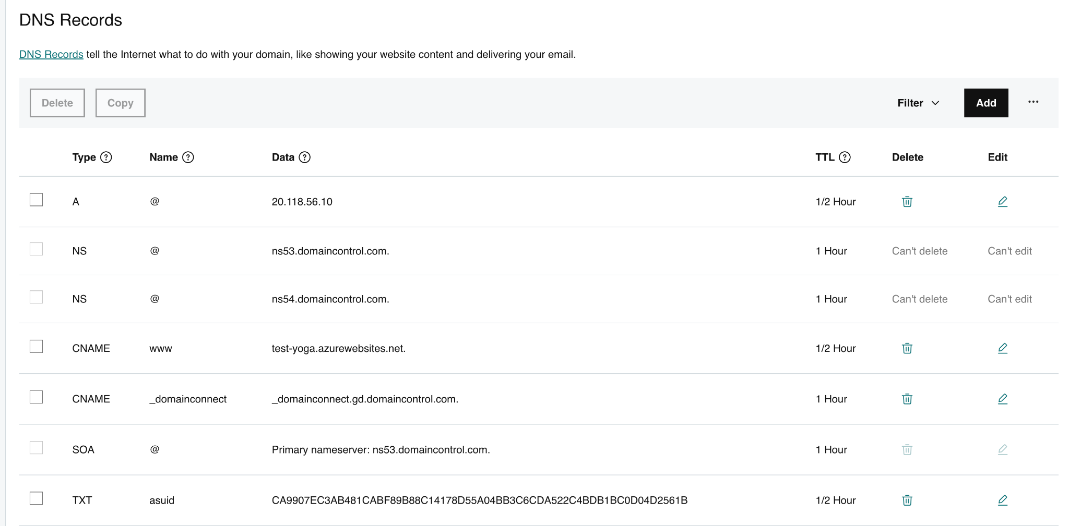

GoDaddy Portal Login

URL
https://account.godaddy.com/

Current username
yogeshazure144@gmail.com

Password
Virtual@12345678

cPanel login

URL: https://yourDomainName/cpanel
Login ID: dw5wzqe1prc8
Password: Virtual@12345678

Latest versions of TLS are
SSL → TLS 1.2, and TLS 1.3

Below are the URLs to check and see your URLs SSL details

https://www.ssllabs.com/ssltest/

https://www.sslshopper.com/ssl-checker.html

Date: 21-Sep-2022

We can deploy Code/Website/Application by using below methods:

- Azure WebApp (AppService)
- GoDaddy cPanel
- VM (Ubuntu/Windows)
- Ubuntu (Apache)
- Windows (IIS)

For Ubuntu use below steps:

- Create a VM
- Login in VM using SSH
- Install Apache2 (Use below command to install Apache)

Installation of Apache on Ubuntu 20.04 LTS

sudo apt-get update -y
sudo apt-get install apache2 -y
sudo service apache2 start
sudo service apache2 status
# sudo a2enmod ssl
# sudo a2enmod headers
# sudo a2enmod rewrite
sudo service apache2 restart
sudo systemctl enable apache2
sudo apache2 -v

- cd /var/www/html (put your code here)
- VM → Networking → add → HTTP, HTTPs
- scp -rv <source> <des>
- scp -rv /Users/yogeshgupta/Downloads/Yoga/upload ubuntu@20.171.111.165:/home/ubuntu/

Date: 22-Sep-2022

Windows IIS

Deploy a website on IIS

Date: 23-Sep-2022

Docker will be started from Tomorrow (24-Sep-2022)

