04-Feb-2024

- How to create an account on GitHub?
- List of top 10 IT organizations in India
- DevOps tools list
- Top 10 cloud providers in the World
- Read about Az-104 certification
- Download → Install → GitHub Desktop Tool
- How to create a repo in Github and upload website code in it?
- Centralized and distributed version control system
- Github
- Bitbucket
- Gitlab
- Git
- https://www.simplilearn.com/tutorials/devops-tutorial/devops-tools
- Download and install Notepad++
- Download and install sublime text
- Download and install Visual Studio
- New Linux commands

—--------------—--------------—--------------—--------------—--------------—--------------
18th Feb 2024

- How do you create an account on Azure?
- Explained the Azure Home page.
—--------------—--------------—--------------—--------------—--------------—--------------

03-Mar-2024

- How to create a RG with tags?
- How to create a VM on Azure for Windows?
- How to create a VM on Azure for Ubuntu?
% ssh yogi@52.170.46.142
- How to create users on Azure?
- How to assign roles and permission to a user on Azure?
Global access
Subscription access
- How to create AppService Plan?
- How to create AppService/WebApp and deploy code in it?
- How to deploy a website on VM (Linux/Ubuntu)
- Create a VM with Ubuntu OS and access it over SSH.
- Check whether Apache2 is installed or not.
- Install Apache2
https://ubuntu.com/tutorials/install-and-configure-apache#2-installing-apache
- Deploy the website code on /var/www/html
- Allow port 80 on VM
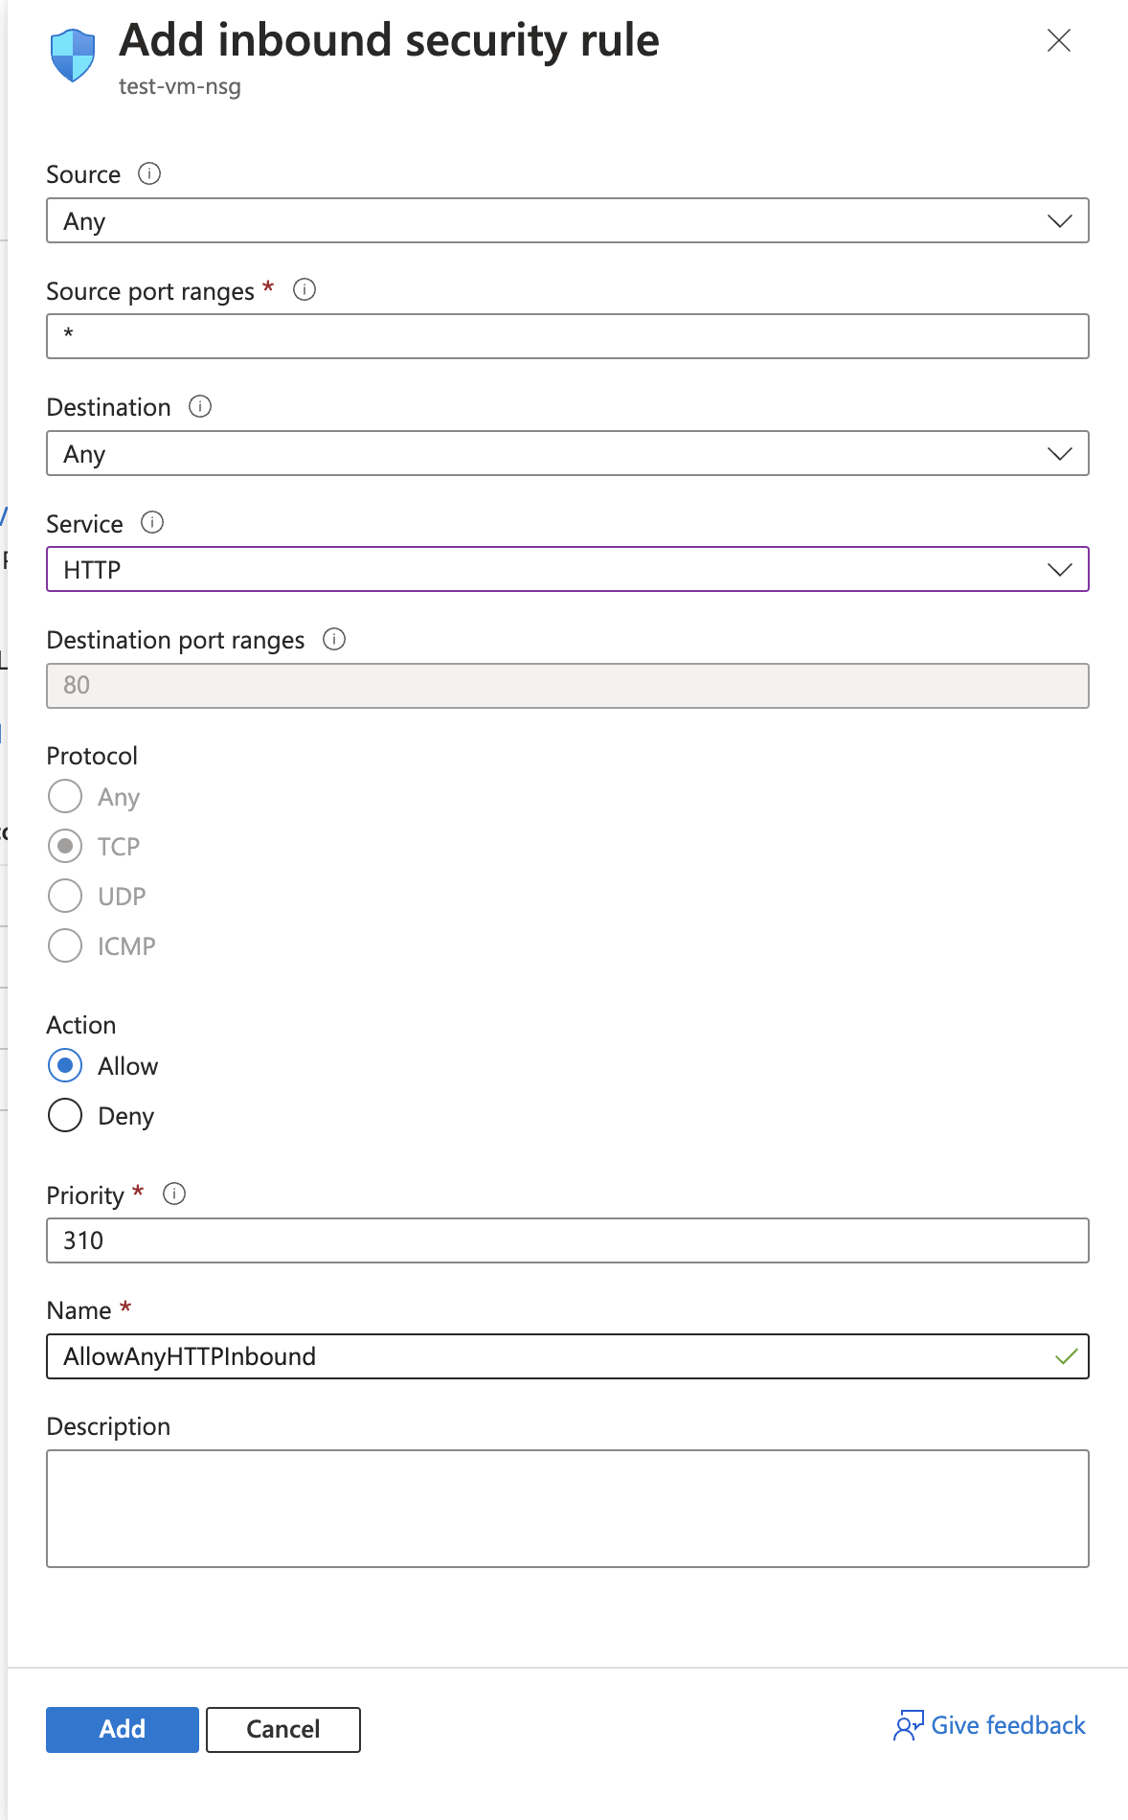
- SCP the local code on VM

—--------------—--------------—--------------—--------------—--------------—--------------

Website Live/Deploy 👍
IAAS:
- VM → Linux/Ubuntu (OS) → Apache2 (Web-server) → Code deploy
- VM → Winodws (Server-OS-2019) → IIS (Web-server) → Code deploy
- Create a VM on Azure portal → Winodws (Server-OS-2019)
- Login into VM using RDP (3389) → Remote Desktop
- Install IIS Role + Feature
- C:/inetpub/wwwroot/ → Deploy the code
- Go on IIS Portal and check the website on Localhost
- Go on Azure portal and allow port 80 in firewall
- Now try to access the website on Public IP

—--------------—--------------—--------------—--------------—--------------—--------------

- VM → Winodws (Server-OS-2019)
- DNS → A record, PTR record, TXT record, SOA record & CNAME
- Dictionary attack
- Domain
- Types of Domain
- Level of Domain

PAAS:
- Azure AppService → Create AppService Plan

SAAS:
- Godaddy → Buy a hosting plan → C Panel
- Docker → deploy code → container
- Kubernetes → deploy code → pod

—--------------—--------------—--------------—--------------—--------------—--------------

10-Mar-2024 (Tuesday)

- Linux
- Redhat
- Ubuntu
- CentOS
- Kali Linux
- Rocky linux
- MAC OS

- How to buy a domain in Godaddy?
—--------------—--------------—--------------—--------------—--------------—--------------

17-Mar-2024 (Tuesday)

- Bastion Service (Windows) (Ubuntu)
- What is Azure alerting/monitoring and how to apply it on VMs?
- Action Group: How to create action group?
- Alerts: How to create an alert?
- What is Azure recovery service vault and how to create it?
https://learn.microsoft.com/en-us/azure/backup/backup-azure-recovery-services-vault-overview

—--------------—--------------—--------------—--------------—--------------—--------------

24-Mar-2024 (Sunday)

- Service Based Vs Product Based
- Static Vs dynamic website
- What is Azure Data centers
https://azure.microsoft.com/en-in/explore/global-infrastructure
- Cost for RSV
- How to take backup of VM in RSV?

How to create a backup policy?

How to restore VM → Replace existing
- How to restore VM → By creating a new VM

Create a storage account (cloud storage) SAAS
- How to upload and download data on storage
- How to connect with Storage using Azure Storage Explorer
- How to access Storage data publicly using URLs
- How to restore deleted data in a storage account using soft-delete

—-------------------------------------------
31-Mar-2024 (Sunday)

- GoDaddy → Custom Domain → AppService/VM
→ Create an AppService and deploy your website on it
→ Login to GoDaddy Portal
→ Go into Manage DNS of your domain
→ AppService → Custom Domain → Add custom domain →
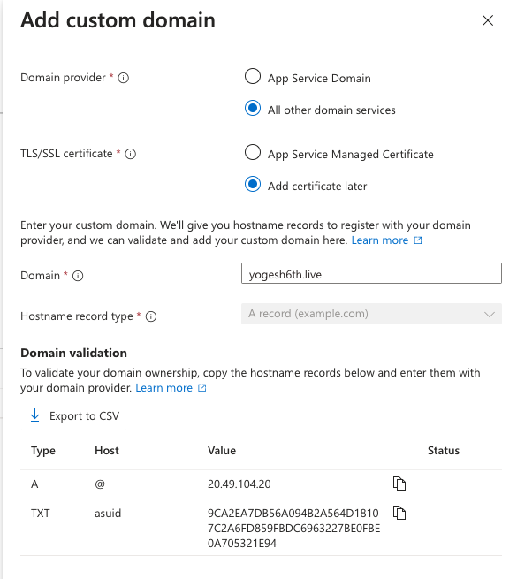
- Adnan - Mon
- Kartik - Tue
- Keshav - Wed
- Danish - Thu
- Naman - Fri
- Nilesh - Sat
- Monitoring → Azure Paid service → Application Insights
- How to Scale AppService Plan → Scale up

What Is Dangling DNS?
https://www.paloaltonetworks.com/cyberpedia/what-is-a-dangling-dns
- Google Analytics
- Auto Scaling → App Service

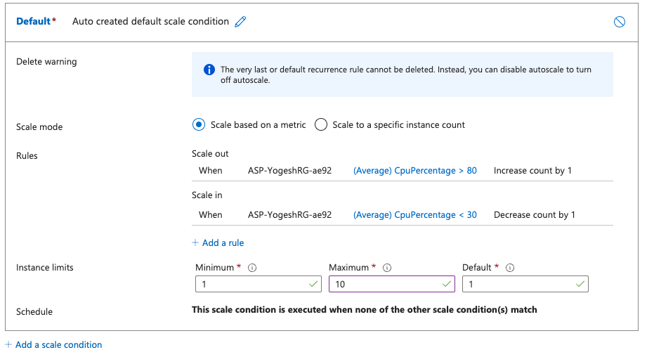

What are Virtual Machine Scale Sets?
https://learn.microsoft.com/en-gb/azure/virtual-machine-scale-sets/overview

Azure Power Shell
- https://learn.microsoft.com/en-us/powershell/azure/?view=azps-11.4.0

- Install PowerShell in your local system

Azure Work

- GUI
- CLI

Azure CLI (Bash) → Local Install → Auth
Azure PowerShell (PS) → Local Install → Auth

Azure Cloud Shell

