Kubernetes

What is Kubernetes?

Kubernetes is an open-source container-orchestration system for automating computer application
deployment, scaling, and management. It was originally designed by Google and is now maintained by the Cloud Native Computing Foundation.

Initial release: 7 June 2014

What problem does Kubernetes solve?

- High availability
- Scalability
- Disaster recovery
- Performance increase
- Fault Tolerance

https://kubernetes.io/docs/home/

16 Best Container Orchestration Tools and Services
https://devopscube.com/docker-container-clustering-tools/

Kubernetes Overview
https://kubernetes.io/docs/concepts/overview/

Kubernetes Components
https://kubernetes.io/docs/concepts/overview/components/
____

Cluster → Control Plane (A) → Node → Services → Kube-proxy → Kubelet → Pods → Containers

Pod:
- K8s does not deploy containers directly on worker nodes. We deploy containers into pod. The containers are encapsulated into a K8s object called pod.
- A pod is a single instance of an application.
- Smallest object we can create in K8s is pod
- To scale up - Create new pods
- You don't add additional containers to an existing pod to scale your application.
- To scale down - delete existing pods
- Pods Usually have one-to-one relationship with the containers but a single pod can have multiple containers. But containers should not be the same kind (application).
- Helper container
- Two containers can also communicate with each other directly by referring Each Other as localhost inside a single pod.
- Multiple containers are a rare use case.
- Generally, we follow a single container per pod architecture of K8s.

Node

A Kubernetes cluster consists of a set of worker machines, called nodes, that run containerized applications. Every cluster has at least one worker node.

Kubernetes runs your workload by placing containers into Pods to run on Nodes. A node may be a virtual or physical machine, depending on the cluster. Each node is managed by the control plane and contains the services necessary to run Pods.
Typically you have several nodes in a cluster; in a learning or resource-limited environment, you might have only one node.
The components on a node include the kubelet, a container runtime, and the kube-proxy.

K8s API

The core of Kubernetes' control plane is the API server. The API server exposes an HTTP API that lets end users, different parts of your cluster, and external components communicate with one another.
The Kubernetes API lets you query and manipulate the state of API objects in Kubernetes (for example: Pods, Namespaces, ConfigMaps, and Events).
Kubectl

The Kubectl command line tool lets you control Kubernetes clusters.

How to deploy Pods:
- $ kubectl run nginx
- $ kubectl gets pods

What is YAML? How to use it and write it?

YAML is a human-readable data-serialization language. It is commonly used for configuration files and in applications where data is being stored or transmitted.

How to Deploy Pods:

- K8s uses YAML files as input to create objects.
- Objects: Pods, Replicas, Deployment, Services, Namespaces etc.
- Definition file: YAML file
- YAML: deployment.yaml
Below are the top level root properties of definition file
API Version: K8s API version → v1, apps/v1
Kind: Defines type of object
Metadata: Data about the object → like name, labels etc
Spec: Addition information → It will be different for different objects

apiVersion: apps/v1
kind: Deployment
metadata:
name: nginx-deployment
labels:
app: nginx
Spec:

# kubectl create -f <file name>

# kubectl create -f deployment.yaml

# kubectl get pods

# kubectl get nodes

# kubectl get replica

# kubectl describe pod <pod name>

Production environment for k8s
https://kubernetes.io/docs/setup/production-environment/

You can deploy a control plane using tools such as
- Kubeadm
- Kops
- Kubespray

K3S (K3S is a light Kubernetes version developed by Rancher)

Installing Kubernetes with deployment tools

Installing Kubernetes with deployment tools

Kubeadm
Kubeadm is a tool built to provide kubeadm init and kubeadm join as best-practice "fast paths" for creating Kubernetes clusters.
https://kubernetes.io/docs/reference/setup-tools/kubeadm/

Kubeadm installation doc:
https://kubernetes.io/docs/setup/production-environment/tools/kubeadm/install-kubeadm/

Minikube

- To test kubernetes on local machine
- Master & Node processes run on one machine
- minikube is local Kubernetes, focusing on making it easy to learn and develop for Kubernetes.

Create a Hypervisor
Run-time environments → Docker
Kubelet

Minikube installation doc:
https://minikube.sigs.k8s.io/docs/start/

https://kubernetes.io/docs/tutorials/hello-minikube/

For Mac

$ brew update
$ brew install hyperkit
$ brew install minikube

Note - It will also install “Kubectl”. No separate installation in necessary

$ hyperkit -v

% minikube version

% minikube start --vm-driver=hyperkit

By using this command minikube will get installed with cluster and now we are ready to use kubectl using minikube.

Minikube has Docker runtime or Docker demon preinstalled. So even if you don’t have Docker in your machine it’s still gonna work.

In the output of this command if there is client and server being displayed that means your minikube is good to use and cluster is created successfully

From here we will work on minikube cluster using kubectl

Pods are the smallest unit but you are not creating pods.

There is an abstraction layer over the pods which is called “Deployment”

% kubectl create deployment nginx-dep1 --image=nginx

Nginx-dep1 = deployment name
--image=nginx = image name

Used to create deployment

READY = 0/1 (menas 0 is working and total no is 1)

Deployment

Blueprint for creating pods, replicas

Most basic configuration for deployment (Name & image)

Deployment is managing the replicas of Pods. We in practice will never have to create replicaset or delete them or update them.

You/we are going to work on deployments directly which is more convenient since we can create a blueprint for deployment.

Here we just updated the deployment config only and rest thing done by kubernetes automatically. This is the magic of k8s and how it works.

Rolling Updates

Undo Changes → Roll Back

Pause Deployment

Resume Changes

Replica sets

High Availability, Load Balancing & Scaling

Layer of Abstraction:

Deployment → manage → Replicasets → manage → pods → container

Kubernetes handles everything below the deployment.

ReplicaSet: The role of the ReplicaSet is to monitor the pods and if any of them were to fail, deploy new ones.

The ReplicaSet is in fact a process that monitors the pods.

Suppose we have set replicas: 3 in ReplicaSet that ensures we have 3 active pos anytime this is the use case of replica set.

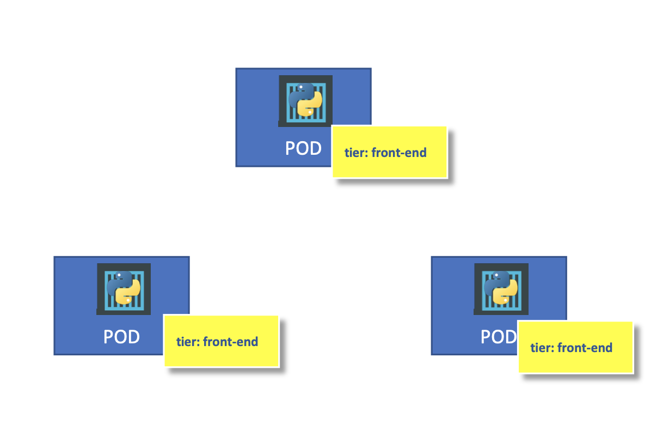
Now, How does the ReplicaSet know what Pods to monitor? There could be 100 pods in cluster running with different applications.
Selector section helps the ReplicaSet to identify what pods fall under it

The match labels selectors simply matches the labels specified under it to the labels on the pod.

This is where labeling our pods during creation comes in handy.

How we scale the ReplicaSets?

Labels & Selector

Why do we Label our Pods & Objects in K8s?

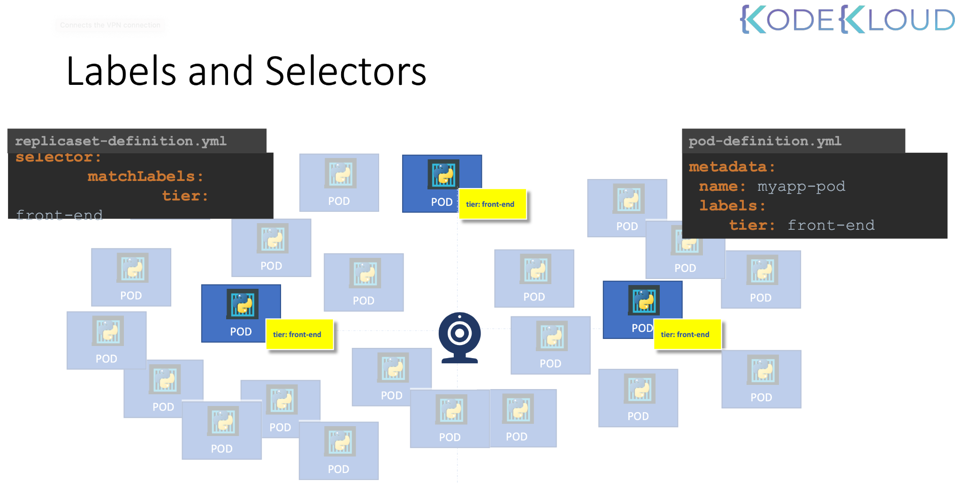

- Selector se ReplicaSet ko pata chalta hai ki kon kon se pods ko monitor karna hai

API

- Namespaces
- Deployment
- Pods → node → API node
- Service

SSO
- Namespaces
- Deployment
- Pods → node → other node
- Service

Background Jobs

Admin Portal

Services:

- Service is an object just like pod, replica-sets and deployments in K8s.
- Services enable communication between various components within or outside of the application.
- Help us to connect applications together with other applications and users.
- Provide connectivity among group of pods. Eg frontend and backend application pods.
- Service enables loose coupling between micro services in our application.
- Cluster has it’s IP address.
- Node has it’s own IP address.
- Pod has it’s own IP address.
- Service has it’s own IP address.
- These are three types of service:
- NodePort
- ClusterIP
- LoadBalancer
- NodePort Service:
Listen to a port on a node and forward a request on that port on the pod running application.
Service is like a Virtual server inside the node.
- Service has its own IP address inside the cluster and that IP address is called cluster IP of the service.
- Node port range is - 30000 to 32767
- Cluster IP: -
- Service creates a virtual IP inside the cluster to enable communication between different services such as a set of frontend servers to a set of backend servers.
- Service will be assigned one IP and name and that is the name that should be used by other pods to access the Service.

Namespaces

- In Kubernetes, namespaces provide a mechanism for isolating groups of resources within a single cluster. Names of resources need to be unique within a namespace, but not across namespaces. Namespace-based scoping is applicable only for namespaced objects (e.g. Deployments, Services, etc) and not for cluster-wide objects (e.g. StorageClass, Nodes, PersistentVolumes, etc).
- There is one Namespace “default” which is created automatically by Kubernetes when the cluster is first setup.
- K8s creates some pods and services for its internal purpose such as for networking solutions and DNS services etc, To isolate these from the uses and to prevent from accidentally deleting or modifying these service K8s creates them under another namespace named “kube-system”.
- The next Namespace created by K8s automatically is “kube-public”. This is where resources that should be made available to all the users are created.
- You can create your own Namespace like dev or production.
- We can assign resource limits in particular namespaces to limit the resource consumption.

apiVersion: v1
kind: Namespace
metadata:
name: website-namespace
labels:
name: website-namespace

Imperative Vs Declarative:

- In the world of infrastructure-as-code there are different approaches in managing the infrastructure and they are classified into Imperative and Declarative approaches.
- Specify what to do, not how to do is the declarative approach.
- Orchestration tools like Ansible, Puppet, or Terraform fall into the declarative approach category.
ConfigMap & Secret

A ConfigMap is an API object used to store non-confidential data in key-value pairs. Pods can consume ConfigMaps as environment variables, command-line arguments, or as configuration files in a volume.

Caution: ConfigMap does not provide secrecy or encryption. If the data you want to store are confidential, use a Secret rather than a ConfigMap, or use additional (third party) tools to keep your data private.

A ConfigMap is not designed to hold large chunks of data. The data stored in a ConfigMap cannot exceed 1 MiB. If you need to store settings that are larger than this limit, you may want to consider mounting a volume or use a separate database or file service.
https://kubernetes.io/docs/concepts/configuration/configmap/

Taint & Toleration:

It is used to set restrictions on what pod can be schedule on a node
Taints set = node
Toleration set = pod

Deploy a website on K8s

Prerequisites:

- Website code: GitHub
- Azure Account: AKS
- CI/CD: Jenkins/Azure-DevOps
- Runtime engine: Docker
- Repo: ACR
- Active Directory: IAM, Authentication & Authorization
- CLI: (kubectl) → Azure CLI
- Storage: Azure-storage (Blob & File-share)
- Domain: Already have a domain name
- DNS: Godaddy DNS Server
- Load Balancer: Azure-load-balancer
- Application Gateway
- YAML: Validate, Create (ChatGPT)
- Editor: Visual Studio
- Monitoring, Alerting, Security - Objects → K8s

K8s:
- Create a cluster
- On-premise: Laptop → Minikube
- Azure: AKS
- AWS: EKS
- GCP: GKE

Repo:
- ACR
- ECR
- Docker Hub

Docker Image:

- Docker Install
- Dockerfile → Keep GitHub
- Run container
- Image - Upload - Docker Hub

AKS:

Creation/setup of Azure Kubernetes Services:

Use Azure Kubernetes Service to create and manage Kubernetes clusters. Azure will handle cluster operations, including creating, scaling, and upgrading, freeing up developers to focus on their applications. To get started, create a cluster with Azure Kubernetes Service.

Connect with AKS

$ az account set --subscription 7fe68156-c37a-4218-b25b-552056d24305

$ az aks get-credentials --resource-group K8s --name test-k8s

kubectl version

- Client

- Server

Need to deploy a Website/Application on Kubernetes

→ Website code → Ubuntu → Apache → Configuration → Image file

Docker → Runtime engine

Azure-DevOps → Image build → push → ACR

ACR (Image pull) → Azure-DevOps → Deploy → K8s

→ Create Base Image and Push it to ACR:

- Dockerfile → upload it to GitHub repo
- Now create an Image using Dockerfile and upload to ACR:
— Machine → Docker Install → Create Image → upload
— Jenkins → Pipeline → Project → Create Image → upload
— Azure DevOps → https://dev.azure.com/ —> Account create
- Azure DevOps → To create a Base Image
→ Login into Azure DevOps https://aex.dev.azure.com/
→ Create a Project
→ Inside the Project → Pipeline → Create Pipeline
→ GitHub connection
→ Docker Integration
→ Now we are inside the Pipeline Configuration + Docker
→ Configure → Pipeline
→ Get Sources → Do nothing
→ Agent Job 1 → Select the 3 options
→ Build an Image → Fill the details
→ Push an Image → Fill the details
→ Publish Pipeline Artifact → Fill the details
→ Run the Pipeline and check the ACR

- Azure DevOps → To create Base Image
- Push the YAML file for K8s deployment
- Let’s configure Release
→ Note down the steps to create the Release pipeline

- Base Image - Dockerfile
- Website code - Dockerfile

Full Application setup with Kubernetes components:

Minikube → Cluster → Node → Pod → Container → Image

Mongo-express
mongo-db

- First we will create a Mongo DB pod and in order to talk to that pod we are gonna need a service and we are gonna create an internal service which basically means that no external request are allowed to the pod only component inside the same cluster and talk to it and that's what we want.
- Create mongo-express pod (deployment). Need an external service to connect with mongo-express pod
- Need credentials → Username, Password

Services - Pods communicate with each other using services.

External service - External services used to access application publicly

Internal Services - Internal service is used to connect pods internally

Ingress - Used for forwarding. Instead of service the request first goes to Ingress and it does the forwarding to service. Ingress route the traffic into cluster.

ConfigMap
1. It is a external configuration of your application
2. it usually contain configuration data like urls of database and some other services
3. Pods will get data that actually configmap contains
4. It contains all environment variable data
- Don't put credentials Data into config map in plain text for this we can use secret

Secret

% kubectl get all

% echo -n 'admin' | base64

% echo -n '12345678a' | base64

% vim mongo-secret.yaml

apiVersion: v1
kind: Secret
metadata:
name: mongodb-secret
type: Opaque
data:
mongo-root-username: YWRtaW4=
mongo-root-password: MTIzNDU2Nzhh

% kubectl get secret

% kubectl apply -f mongo-secret.yaml

% vim mongo.yaml

% kubectl get pod

% kubectl apply -f mongo.yaml

% kubectl get pod --watch

So we have done with MongoDB pod deployment

Mongo-DB internal service

We can create multiple document in single file

% kubectl get service

% vim mongo.yaml

Put service config data

% kubectl apply -f mongo.yaml

% kubectl get service

name: mongodb-deployment
labels:
app: mongodb
spec:
replicas: 1
selector:
matchLabels:
app: mongodb
template:
metadata:
labels:
app: mongodb
spec:
containers:
- name: mongodb
image: mongo
ports:
- containerPort: 27017
env:
- name: MONGO_INITDB_ROOT_USERNAME
valueFrom:
secretKeyRef:
name: mongodb-secret
key: mongo-root-username
- name: MONGO_INITDB_ROOT_PASSWORD
valueFrom:
secretKeyRef:
name: mongodb-secret
key: mongo-root-password
---
apiVersion: v1
kind: Service
metadata:
name: mongodb-service
spec:
selector:
app: mongodb
ports:
- protocol: TCP
port: 27017
targetPort: 27017

% kubectl describe service mongodb-service

% kubectl describe deployment <deployment-name>

Endpoints: 172.17.0.3:27017

IP address of pods

% kubectl get pod -o wide

% kubectl get all | grep mongodb

Mongo-express deployment and service configuration

% vim mongo-configmap.yaml

apiVersion: v1
kind: ConfigMap
metadata:
name: mongodb-configmap
data:
database_url: mongodb-service

% kubectl apply -f mongo-configmap.yaml

% kubectl get configmap

% kubectl get pod

% kubectl apply -f mongo-express.yaml

Put the external service configuration

% kubectl get pod

% kubectl apply -f mongo-express.yaml

% kubectl get pod

apiVersion: apps/v1
kind: Deployment
metadata:
name: mongo-express
labels:
app: mongo-express
spec:
replicas: 1
selector:
matchLabels:
app: mongo-express
template:
metadata:
labels:
app: mongo-express
spec:
containers:
- name: mongo-express
image: mongo-express
ports:
- containerPort: 8081
env:
- name: ME_CONFIG_MONGODB_ADMINUSERNAME
valueFrom:
secretKeyRef:
name: mongodb-secret
key: mongo-root-username
- name: ME_CONFIG_MONGODB_ADMINPASSWORD
valueFrom:
secretKeyRef:
name: mongodb-secret
key: mongo-root-password
- name: ME_CONFIG_MONGODB_SERVER
valueFrom:
configMapKeyRef:
name: mongodb-configmap
key: database_url
---
apiVersion: v1
kind: Service
metadata:
name: mongo-express-service
spec:
selector:
app: mongo-express
type: LoadBalancer
ports:
- protocol: TCP
port: 8081
targetPort: 8081
nodePort: 30000

% minikube service mongo-express-service

https://kubernetes.io/docs/tasks/tools/

https://minikube.sigs.k8s.io/docs/start/

(Commands) --> https://gitlab.com/nanuchi/youtube-tutorial-series/-/blob/master/basic-kubectl-commands/cli-commands.md

Link - https://gitlab.com/nanuchi/youtube-tutorial-series/-/blob/master/kubernetes-configuration-file-explained/nginx-deployment.yaml

_____

$ kubectl get all --namespace=myguide-web-namespace

$ kubectl get pods --namespace=myguide-web-namespace

