## What is Shells?
A Shell provides you with an interface to the Unix system. It gathers input from you and executes programs based on that input. When a program finishes executing, it displays that program's output.
Shell is an environment in which we can run our commands, programs, and shell scripts. There are different flavors of a shell, just as there are different flavors of operating systems. Each flavor of shell has its own set of recognized commands and functions.
## Shell-Scripting
A shell script is a computer program designed to be run by the Unix/Linux shell which could be one of the following:
- The Bourne Shell
- The C Shell
- The Korn Shell
- The GNU Bourne-Again Shell

Shell scripts have several required constructs that tell the shell environment what to do and when to do it. Of course, most scripts are more complex

The shell is, after all, a real programming language, complete with variables, control structures, and so forth. No matter how complicated a script gets, it is still just a list of commands executed sequentially.

The following script uses the read command which takes the input from the keyboard and assigns it as the value of the variable PERSON and finally prints it on STDOUT.

#!/bin/sh
# Author : Yogesh_Gupta
# Copyright (c) DevOps_Study
# Script follows here:

echo "What is your name?"
read PERSON
echo "Hello, $PERSON"

Note:
- All the scripts would have the .sh extension.
- Before you add anything else to your script, you need to alert the system that a shell script is being started. This is done using the shebang construct. For example −

#!/bin/sh

- You can put your comments in your script as follows −

#!/bin/sh
# Author : Yogesh_Gupta
# Copyright (c) DevOps_Study
# Script follows here:
pwd
ls

- The shell script is now ready to be executed −
$./test.sh
or
$ sh <script name>

## Variable Names
A variable is nothing more than a pointer to the actual data. The shell enables you to create, assign, and delete variables.

The name of a variable can contain only letters (a to z or A to Z), numbers ( 0 to 9) or the underscore character ( _).
By convention, Unix shell variables will have their names in UPPERCASE.

## Defining Variables
Variables are defined as follows −
NAME="DevOps"
To access the value stored in a variable, prefix its name with the dollar sign ($) −
#!/bin/sh
NAME="Yogesh"
echo $NAME

# HI="Hello"
# echo $HI
# OS="My OS name is $(cat /etc/os-release | grep -i name)"
# echo $OS
Package installation through Schell_scripting

## Apache2
## Redis
## PHP
## Jenkins
## mongo
## docker

Shell Basic Operators
- Arithmetic Operators :
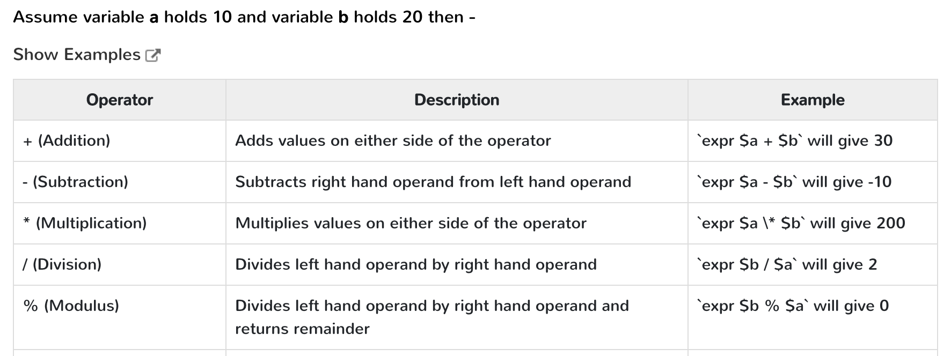
- Relational Operators :
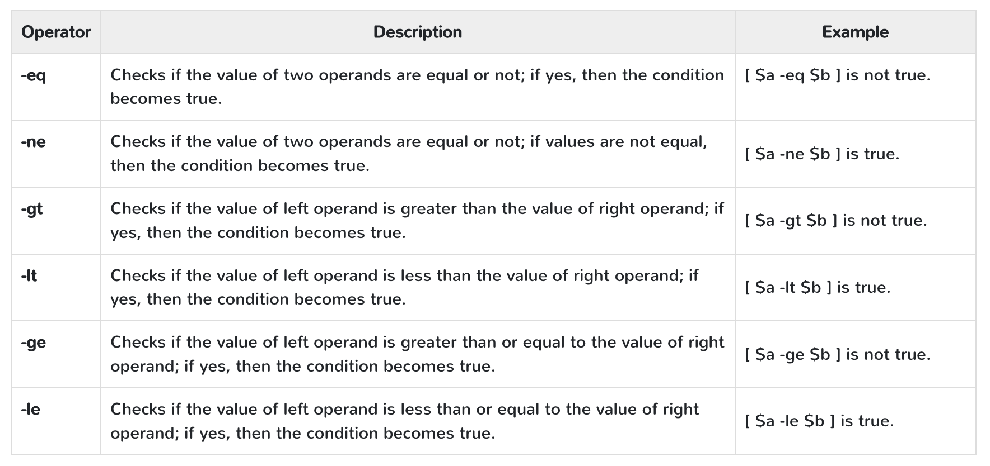

- Boolean Operators :
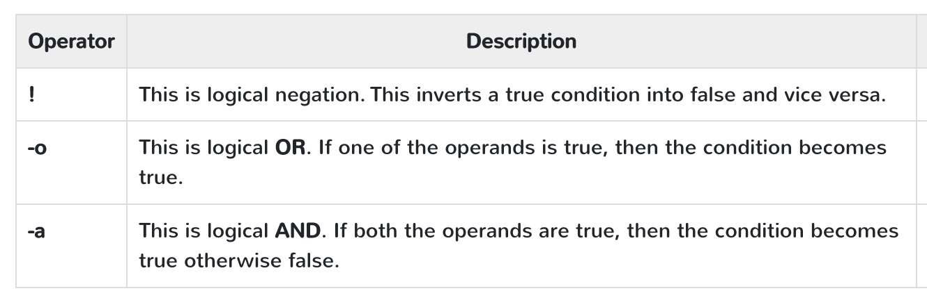
- String Operators :
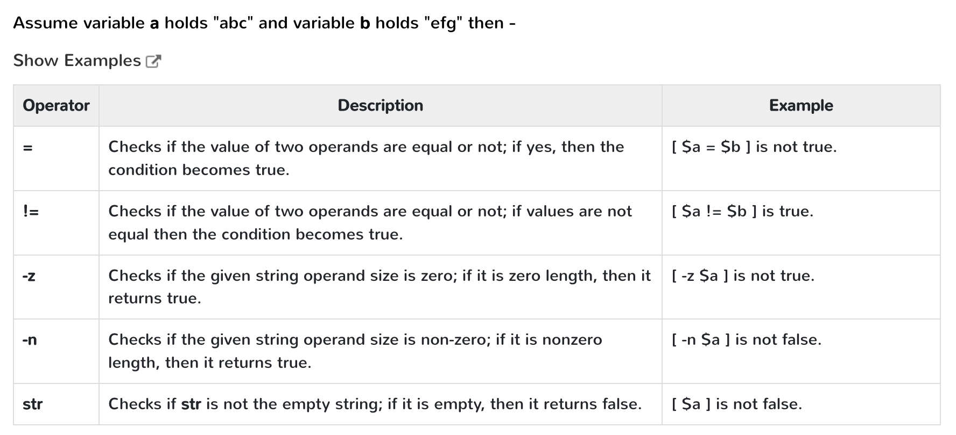

Shell Decision Making
Unix Shell supports conditional statements which are used to perform different actions based on different conditions. We will now understand two decision-making statements here −
- The if...else statement
- The case...esac statement

The if...else statements
If else statements are useful decision-making statements which can be used to select an option from a given set of options.
Unix Shell supports following forms of if…else statement −
- if...fi statement
- if...else...fi statement
- if...elif...else...fi statement

The case...esac Statement
You can use multiple if...elif statements to perform a multiway branch. However, this is not always the best solution, especially when all of the branches depend on the value of a single variable.
Unix Shell supports case...esac statement which handles exactly this situation, and it does so more efficiently than repeated if...elif statements.
There is only one form of case...esac statement which has been described in detail here −
- case...esac statement
The case...esac statement in the Unix shell is very similar to the switch...case statement we have in other programming languages like C or C++ and PERL, etc.

Shell Loop Types
A loop is a powerful programming tool that enables you to execute a set of commands repeatedly.
- while loop
- for loop
- until loop
- select loop
While loop
The while loop enables you to execute a set of commands repeatedly until some condition occurs. It is usually used when you need to manipulate the value of a variable repeatedly.
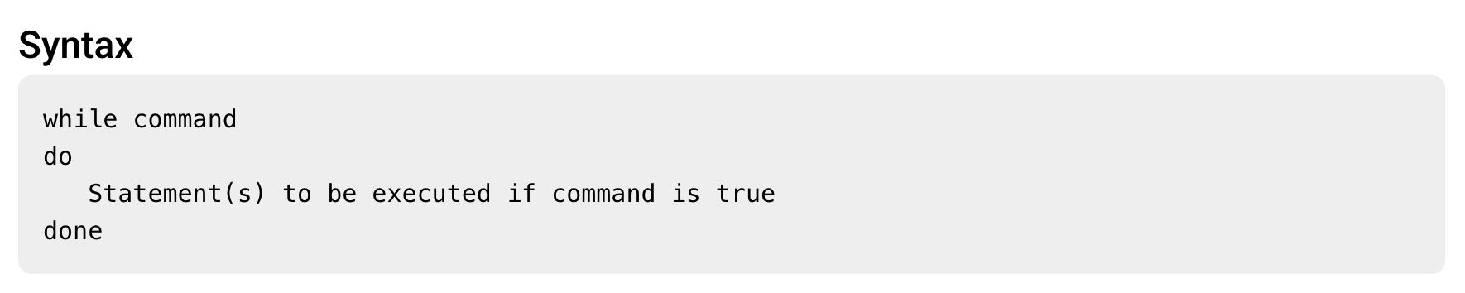
Here the Shell command is evaluated. If the resulting value is true, given statement(s) are executed. If command is false then no statement will be executed and the program will jump to the next line after the done statement.

